Supplementary Tables and figures
Table S1. Communalities of Items in the Parental Satisfaction Questionnaire

Items | Extraction
Communication | 0.772
Family-Centered Care | 0.718
Emotional Support & Compassion | 0.875
Clinical Care & Professionalism | 0.812
Quality of Care and Treatment | 0.831
Environment & Infrastructure | 0.732
Organization | 0.710
Administrative Processes | 0.610
General Satisfaction & Recommendation | 0.735
Acceptance of readmission | 0.696

Suppl. Table S2. Rotated Component Matrix
Rotated Component Matrixª
Domain | Scores
Emotional Support & Compassion | 0.935
Quality of Care and Treatment | 0.911
Clinical Care & Professionalism | 0.901
Communication | 0.878
General Satisfaction & Recommendation | 0.857
Environment & Infrastructure | 0.855
Family-Centered Care | 0.847
Organization | 0.843
Acceptance of readmission | 0.834
Administrative Processes | 0.781

a:Extraction Method: Principal Component Analysis.

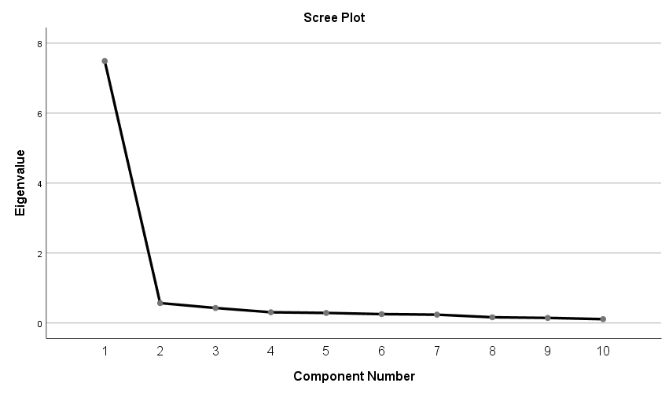
Supplementary Figure S1. Scree plot for the Parental Satisfaction with Newborn Care items

Supplementary Table S3. Reliability of the Parental Satisfaction Scale
S/N | Items scales (Summary) | Cronbach's Alpha (α) | Cronbach's Alpha Based on Standardized Items | N of Items
1 | Communication | 0.828 | 0.828 | 3
2 | Family-Centered Care | 0.892 | 0.893 | 4
3 | Emotional Support & Compassion | 0.917 | 0.918 | 8
4 | Clinical Care & Professionalism | 0.862 | 0.864 | 4
5 | Quality of Care and Treatment | 0.918 | 0.918 | 5
6 | Environment & Infrastructure | 0.832 | 0.835 | 5
7 | Organization | 0.711 | 0.711 | 2
8 | Administrative Processes | 0.830 | 0.831 | 3
9 | General Satisfaction & Recommendation | 0.822 | 0.824 | 2
10 | Acceptance of readmission | 0.783 | 0.809 | 3
11 | Overall Scale Reliability Coefficient | 0.977 | 0.978 | 39

Supplementary Table S4. Item–Total Correlation Analysis
 | Scale Mean if Item Deleted | Scale Variance if Item Deleted | Corrected Item-Total Correlation | Cronbach's Alpha if Item Deleted
Daily Talks with Doctor | 162.2425 | 563.782 | 0.714 | 0.976
Daily Talks with Nurse | 162.2624 | 563.341 | 0.718 | 0.976
Feedback on experiences | 162.3280 | 561.297 | 0.768 | 0.976
Parental Participation | 162.2624 | 564.564 | 0.698 | 0.976
Decision Making Involvement | 162.3201 | 564.103 | 0.706 | 0.976
Encouragement to stay close | 162.2247 | 564.553 | 0.752 | 0.976
Opportunity to stay close | 162.2485 | 566.068 | 0.720 | 0.976
Sympathy from Doctor | 162.2644 | 564.231 | 0.778 | 0.976
Sympathy from Nurse | 162.3857 | 563.010 | 0.731 | 0.976
Respect | 162.3559 | 564.162 | 0.687 | 0.976
Privacy | 162.3598 | 562.063 | 0.684 | 0.976
Confidence in Doctor | 162.1252 | 563.827 | 0.762 | 0.976
Confidence in Nurse | 162.2068 | 562.431 | 0.774 | 0.976
Child Comfort with Doctor | 162.1789 | 563.936 | 0.765 | 0.976
Child Comfort with Nurse | 162.1551 | 564.757 | 0.749 | 0.976
Disease Treatment | 162.1849 | 564.526 | 0.754 | .976
Examination | 162.1889 | 566.094 | 0.746 | 0.976
Drugs | 162.2584 | 563.196 | 0.715 | 0.976
Pain treatment | 162.2485 | 565.211 | 0.759 | 0.976
Doctor's Responsibility | 162.1193 | 565.571 | 0.778 | 0.976
Nurse's Responsibility | 162.1551 | 566.908 | 0.774 | 0.976
Professional Attitude | 162.2724 | 562.693 | 0.798 | 0.976
Teamwork | 162.2406 | 565.000 | 0.779 | 0.976
Quality of care and treatment | 162.1610 | 565.566 | 0.784 | 0.976
Cleanliness | 162.1431 | 567.856 | 0.646 | 0.976
Hygiene | 162.1531 | 567.520 | 0.716 | 0.976
Noise Level | 162.4135 | 564.685 | 0.581 | 0.977
Space | 162.3777 | 565.526 | 0.607 | 0.977
Accessibility | 162.2505 | 563.367 | 0.703 | 0.976
Efficiency | 162.3161 | 564.452 | 0.691 | 0.976
Administrative_Processes | 165.8628 | 582.194 | 0.602 | 0.977
Admission Process | 162.3419 | 563.353 | 0.695 | 0.976
Discharge Process with Nurse | 162.3777 | 565.741 | 0.644 | 0.976
Discharge Process with Doctor | 162.3519 | 566.264 | 0.647 | 0.976
General Satisfaction | 162.2883 | 561.433 | 0.822 | 0.976
Would You Recommend the Ward | 162.3579 | 562.541 | 0.712 | 0.976
Readmission to the ward | 162.7316 | 564.209 | 0.537 | 0.977
Overall Rating of Doctor | 162.1928 | 563.355 | 0.803 | 0.976
Overall Rating of Nurse | 162.2664 | 563.606 | 0.755 | 0.976

Supplementary Table S5. Total Variance Explained
Total Variance Explained
Component | Initial Eigenvalues |  |  | Extraction Sums of Squared Loadings
Component | Total | % of Variance | Cumulative % | Total | % of Variance | Cumulative %
1 | 7.490 | 74.902 | 74.902 | 7.490 | 74.902 | 74.902
2 | 0.571 | 5.705 | 80.607
3 | 0.430 | 4.297 | 84.904
4 | 0.308 | 3.078 | 87.982
5 | 0.288 | 2.882 | 90.865
6 | 0.255 | 2.545 | 93.410
7 | 0.238 | 2.380 | 95.790
8 | 0.164 | 1.644 | 97.434
9 | 0.146 | 1.458 | 98.892
10 | 0.111 | 1.108 | 100.000
Extraction Method: Principal Component Analysis.

