Table A. Regional distribution
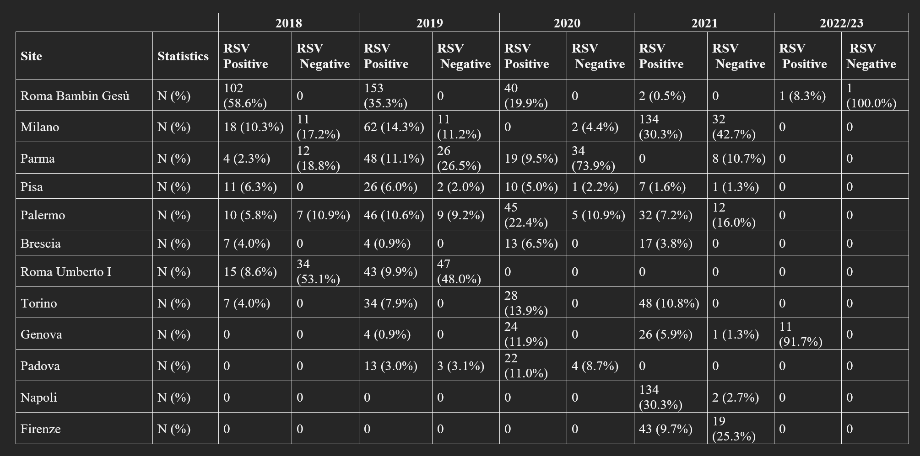

Table B: Enrollment period
Year | Period | Statistics | RSV Positive (N=1263) | RSV Negative (N=284)
2018 | Months: Jan–Mar | N (%) | 16 (1.3%) | 6 (2.1%)
 | Months: Oct–Dec | N (%) | 157 (12.4%) | 52 (18.3%)
 | Other months: Apr–Sep | N (%) | 2 (0.2%) | 6 (2.1%)
2019 | Months: Jan–Mar | N (%) | 299 (23.7%) | 69 (24.3%)
 | Months: Oct–Dec | N (%) | 123 (9.7%) | 23 (8.1%)
 | Other months: Apr–Sep | N (%) | 11 (0.9%) | 6 (2.1%)
2020 | Months: Jan–Mar | N (%) | 197 (15.6%) | 21 (7.4%)
 | Months: Oct–Dec | N (%) | 2 (0.2%) | 24 (8.5%)
 | Other months: Apr–Sep | N (%) | 2 (0.2%) | 1 (0.4%)
2021 | Months: Jan–Mar | N (%) | 2 (0.2%) | 16 (5.6%)
 | Months: Oct–Dec | N (%) | 426 (33.7%) | 54 (19.0%)
 | Other months: Apr–Sep | N (%) | 14 (1.1%) | 5 (1.8%)
2022–2023 | Months: Jan–Mar | N (%) | 12 (1.0%) | 1 (0.4%)

Table C Virilogical Data
Site | Sample type | Collection protocol standardized (Y/N) | Transport & storage standardized (Y/N) | Rapid test consistent across sites (Y/N) | Reported sensitivity (%) | PCR performed (Y/N) | PCR strategy (all samples vs only negative rapid tests) | Type of PCR assay (commercial/in-house) | Multiplex PCR details (panel, manufacturer) | Respiratory viruses  included in multiplex panel | Other viruses tested | Same viral panel across sites (Y/N) | Samples tested in duplicate (Y/N)
Roma Bambino Gesù | Nasopharyngeal swab | Y | Y | Y (Beta Diagnostics: rapid immunochromatographic test for RSV) | Sensitivity > 95% | Y | All samples | Commercial | *Allplex™ Respiratory Full Panel Assay | FluA, FluB, RSV, PIVs 1-4, HRV/EV, HMPV, SARS-CoV-2, HCoV, MERS, BORp, BORpa, Myc, Cla, | None | N | N
Milano | Nasopharyngeal swab | Y | Y | Y (Beta Diagnostics: rapid immunochromatographic test for RSV) | Sensitivity > 95% | Y | All samples | Commercial | FilmArray Respiratory Panel (FilmArray® Respiratory Panel, BioFire Diag-nostics LLC, 390 Wakara Way, Salt Lake City, UT, USA) | FluA, FluB, RSV, PIVs 1-4, HRV/EV, HMPV, SARS-CoV-2, HCoV, MERS, BORp, BORpa, Myc, Cla, | None | N | N
Parma | Nasopharyngeal swab | Y | Y | Y (Beta Diagnostics: rapid immunochromatographic test for RSV) | Sensitivity > 95% | Y | All samples | Commercial | FilmArray Respiratory Panel (FilmArray® Respiratory Panel, BioFire Diag-nostics LLC, 390 Wakara Way, Salt Lake City, UT, USA) | FluA, FluB, RSV, PIVs 1-4, HRV/EV, HMPV, SARS-CoV-2, HCoV, MERS, BORp, BORpa, Myc, Cla, | None | N | N
Pisa | Nasopharyngeal swab | Y | Y | Y (Beta Diagnostics: rapid immunochromatographic test for RSV) | Sensitivity > 95% | Y | All samples | Commercial | FilmArray Respiratory Panel (FilmArray® Respiratory Panel, BioFire Diag-nostics LLC, 390 Wakara Way, Salt Lake City, UT, USA) | FluA, FluB, RSV, PIVs 1-4, HRV/EV, HMPV, SARS-CoV-2, HCoV, MERS, BORp, BORpa, Myc, Cla, | None | N | N
Palermo | Nasopharyngeal swab | Y | Y | Y (Beta Diagnostics: rapid immunochromatographic test for RSV) | Sensitivity > 95% | Y | All samples | Commercial | FilmArray Respiratory Panel (FilmArray® Respiratory Panel, BioFire Diag-nostics LLC, 390 Wakara Way, Salt Lake City, UT, USA) | FluA, FluB, RSV, PIVs 1-4, HRV/EV, HMPV, SARS-CoV-2, HCoV, MERS, BORp, BORpa, Myc, Cla, | None | N | N
Napoli | Nasopharyngeal swab | Y | Y | Y (Beta Diagnostics: rapid immunochromatographic test for RSV) | Sensitivity > 95% | Y | Negative test according to availability | Commercial | FilmArray Respiratory Panel (FilmArray® Respiratory Panel, BioFire Diag-nostics LLC, 390 Wakara Way, Salt Lake City, UT, USA) | FluA, FluB, RSV, PIVs 1-4, HRV/EV, HMPV, SARS-CoV-2, HCoV, MERS, BORp, BORpa, Myc, Cla, | None | N | N
Genova | Nasopharyngeal swab | Y | Y | Y (Beta Diagnostics: rapid immunochromatographic test for RSV) | Sensitivity > 95% | Y | All samples | Commercial | FilmArray Respiratory Panel (FilmArray® Respiratory Panel, BioFire Diag-nostics LLC, 390 Wakara Way, Salt Lake City, UT, USA) | FluA, FluB, RSV, PIVs 1-4, HRV/EV, HMPV, SARS-CoV-2, HCoV, MERS, BORp, BORpa, Myc, Cla, | None | N | N
Brescia | Nasopharyngeal swab | Y | Y | Y (Beta Diagnostics: rapid immunochromatographic test for RSV) | Sensitivity > 95% | Y | All samples | Commercial | FilmArray Respiratory Panel (FilmArray® Respiratory Panel, BioFire Diag-nostics LLC, 390 Wakara Way, Salt Lake City, UT, USA) | FluA, FluB, RSV, PIVs 1-4, HRV/EV, HMPV, SARS-CoV-2, HCoV, MERS, BORp, BORpa, Myc, Cla, | None | N | N
Firenze | Nasopharyngeal swab | Y | Y | N | Sensitivity > 95% | Y | All samples | Commercial | TaqPath™ 1‐Step RT‐qPCR Master Mix(Life Technologies, The Netherland | FluA, FluB, RSV, PIVs 1-4, HRV/EV, HMPV, SARS-CoV-2, HCoV, MERS, BORp, BORpa, Myc, Cla, | None | N | N
Torino | Nasopharyngeal swab | Y | Y | Y (Beta Diagnostics: rapid immunochromatographic test for RSV) | Sensitivity > 95% | Y | All samples | Commercial | CE-IVD marked | FluA, FluB, RSV, PIVs 1-4, HRV/EV, HMPV, SARS-CoV-2, HCoV, MERS, BORp, BORpa, Myc, Cla, | None | N | N
Roma Umberto I | Nasopharyngeal swab | Y | Y | Y (Beta Diagnostics: rapid immunochromatographic test for RSV) | Sensitivity > 95% | Y | All samples | Commercial | TaqPath™ 1‐Step RT‐qPCR Master Mix(Life Technologies, The Netherland | FluA, FluB, RSV, PIVs 1-4, HRV/EV, HMPV, SARS-CoV-2, HCoV, MERS, BORp, BORpa, Myc, Cla, | None | N | N
Padova | Nasopharyngeal swab | Y | Y | Y (Beta Diagnostics: rapid immunochromatographic test for RSV) | Sensitivity > 95% | Y | All samples | Commercial | TaqPath™ 1‐Step RT‐qPCR Master Mix(Life Technologies, The Netherland | FluA, FluB, RSV, PIVs 1-4, HRV/EV, HMPV, SARS-CoV-2, HCoV, MERS, BORp, BORpa, Myc, Cla, | None | N | N

* Allplex™ Respiratory Full Panel Assay – Real-Time PCR for the diagnosis of respiratory infections through the detection of 26 bacterial and viral pathogens. A comprehensive test for the detection and identification of 26 respiratory pathogens, based on a one-step real-time RT-PCR. Clinically significant respiratory infections caused by various viral and bacterial pathogens commonly occur in symptomatic adult and pediatric patients. In order to guide strategies for effective treatment and control the spread of disease, clinicians need to know which pathogens are present in the early stages of infection, even in cases of multiple infections. However, traditional methods are slow, incomplete, and inaccurate. Patients are often discharged without specific treatment, or are prescribed empirical antibiotic therapy, without the identification of the pathogens involved. A multiplex real-time PCR test that simultaneously detects both viral and bacterial pathogens is indicated to identify the source of infection with accuracy, high sensitivity, and reliability to improve patient care and avoid errors or overuse. The Allplex™ Respiratory Full Panel Assay kit is a one-step RT-real-time PCR multiplex test that simultaneously detects and identifies 16 viruses, 7 bacteria, and 3 subtypes of influenza A - all agents of respiratory diseases - in clinical samples. The kit is highly automatable, from sample extraction to PCR reaction setup. When automated, the total analysis time is 4 hours and 30 minutes, with a throughput ranging from 20 samples per run (4 panels) to 94 samples per run (1 panel).

Table D. Chest X-ray
Chest X-ray
Parameter | RSV Positive (N=1263) | RSV Negative (N=284)
Chest X-ray, n (%) | 409 (32.4%) | 84 (29.6%)
Number of chest X-rays, median (IQR) | 1.0 (1.0–1.0) | 1.0 (1.0–1.0)

Table E. Oxygen and ICU admission
Parameter | RSV Positive (N=1263) | RSV Negative (N=284)
Oxygen supplementation | 67.6% | 39.1%
Oxygen duration (median, hours) | 96 | 72
ICU admission | 10.6% | 3.2%
ICU stay (median, days) | 5 | 3
Post-ICU hospitalization | 7.1% | 1.4%
Overall complications | 3.1% | 0.4%

Table F. ICU admission and oxygen supplementation
Outcome | RSV Positive (N=1263) | RSV Negative (N=284)
ICU admission, n (%) | 134 (10.6%) | 9 (3.2%)
Mechanical ventilation, n (%) | 359 (28.4%) | 35 (12.3%)
Supplemental oxygen, n (%) | 854 (67.6%) | 111 (39.1%)
Duration of oxygen therapy (hours), median (IQR) | 96 (48–144) | 72 (24–120)
High-flow oxygen therapy (HFNC), n (%) | 203 (16.1%) | 19 (6.7%)
Non-invasive ventilation (NIV), n (%) | 72 (5.7%) | 11 (3.9%)
Complications, n (%) | 39 (3.1%) | 1 (0.4%)

Tables G and H Univariate and multivariate analysis
Univariate logistic regression
Variable | OR (95% CI) | p-value
RSV-positive (vs negative) | 2.82 (1.95–4.10) | <0.001
Age (per 1-month increase) | 0.97 (0.95–1.00) | 0.087
Male sex | 1.02 (0.81–1.28) | 0.887
Prematurity | 1.30 (0.93–1.84) | 0.127
Comorbidity | 1.26 (0.87–1.82) | 0.218
Multivariate logistic regression
Variable | Adjusted OR (95% CI) | p-value
RSV-positive (vs negative) | 2.67 (1.73–3.70) | <0.001
Age (per 1-month increase) | 0.98 (0.95–1.01) | 0.271
Male sex | 1.06 (0.84–1.35) | 0.616
Prematurity | 1.37 (0.96–1.97) | 0.084
Comorbidity | 1.33 (0.91–1.94) | 0.150

Table I Outcome according to RSV+/RSV-
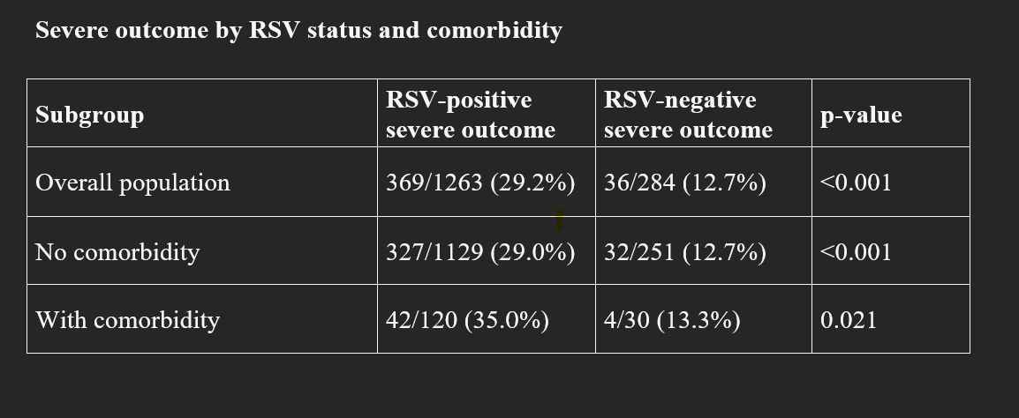
Table L . Outcome in RSV+ and RSV- groups
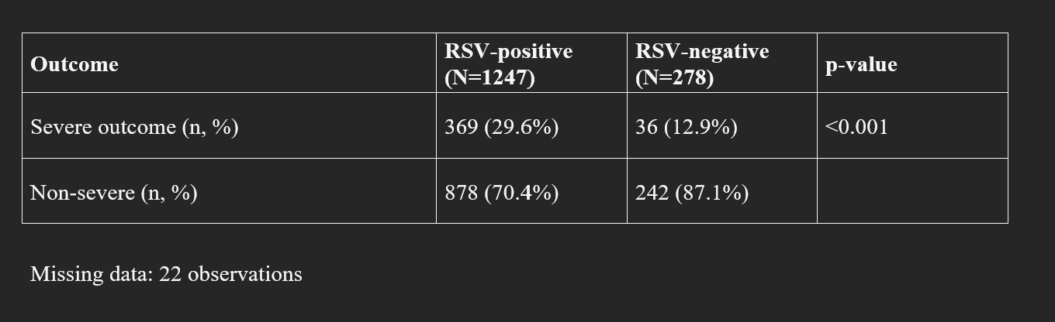

Figure 1. Bar chart - ICU patients by age group



