In group 1, patients diagnosed with BPD were evaluated at an average age of 63.9 ± 22 months. The age, gender, weight and height characteristics of the patients in the compared groups were similar. There was no significant difference between group 1 and group 2 in terms of gestational age. The gestational age of children with BPD (group-1) was significantly lower than the gestational ages of group 2 and group 3 patients. When children with BPD and the control group of premature children were compared, no significant difference was found in terms of delivery type, birth weight and antenatal steroids. RDS, surfactant, mechanical ventilation, postnatal steroid use and sepsis history of children with BPD were statistically significantly different from control premature children. The presence of RDS and surfactant use were found to be similarly high (91.6%) in cases with BPD. In our study, there was a significant difference between the duration of mechanical ventilation and total oxygen intake between group-1 and group-2. The average duration of mechanical ventilation in group-1 was 23.5 days and the total oxygen intake was 49 days, while the average duration of mechanical ventilation in group-2 was 4.3 days and the total oxygen intake was 23.5 days.
( table-1). Abi, bu veriler benim tezde yok,
Children who were included in the study had their blood pressure measured at three different times in appropriate conditions, and it was found that their systolic and diastolic pressures were within the appropriate percentiles for their ages. In the electrocardiographic examination of the cases, findings consistent with Wolf Parkinson White were detected in one case in group-1, which was confirmed by 24-hour Holter EKG monitoring, and medical treatment was initiated and follow-up was taken.
While chronic changes were detected in 31.25% (15 cases) of the lung x-rays of cases in group-1, no pathological features were found in the lung x-rays of cases in group-2, which was found to be statistically significantly high (p=0.013).

Cardiac measurements, systolic and diastolic functions of the patients participating in the study were evaluated by echocardiography. When LA, LVDd, LVDs, ESV, and EDV values in Group 1 were compared with the other two groups, it was found that they were statistically significantly smaller. Aortic and pulmonary artery measurements were similar in Group 1 and Group 2, but were significantly smaller when compared to Group 3. Antegrade flow pattern (PAaf) in the pulmonary artery in late diastole, an important parameter indicating right ventricular diastolic dysfunction, was significantly higher in Group 1 compared to Group 2 and Group 3 ( table-3). Table 2 de yer alıyor bu ölçümler

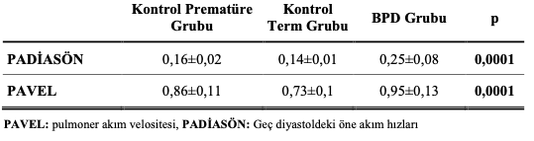
KAZIM ABİ, pulmoner arter ölçümlerini verdiğiniz gibi tablo 2 ye yerleştirdim, ancak burada tablo 3 yazıyor ?

Pa af : pavel mi padiasön olan mı abi ?

Systolic and diastolic functions of the right ventricle (RV), left ventricle (LV) and interventricular septum (IVS) were examined using tissue Doppler echocardiography. Systolic and diastolic functions of the right ventricle (RV), left ventricle (LV) and interventricular septum (IVS) were examined with tissue Doppler echocardiography.

When the right ventricular systolic and diastolic functions of patients with BPD in group-1 were compared with group-2 and group-3, statistically significant differences were detected in RV E, A, E/A, IVRT, decT, Tt, IVV, SV and St.

When LV functions were examined, statistically significant differences were detected in E/A and IVRT values ​​between group-1 and group-2 and group-3. No significant difference was observed in LV systolic parameters.

When IVS systolic and diastolic functions were evaluated, statistically significant differences were found in IVSDtı A, IVSDtı IVRT, IVSDtı Tt, IVSDtı St, IVSDtı Sv values ​​between group-1 and group-2 and group-3 (table-3).

There was no significant difference observed among groups in terms of total power, VLF, LF, HF, 24HSDNN, SDNNIN, SDANIN, RMSSD, PNN50, Mean Heart Rate (MHR), and LF/HF parameters when evaluating the 24-hour Holter ECG parameters (table-4).

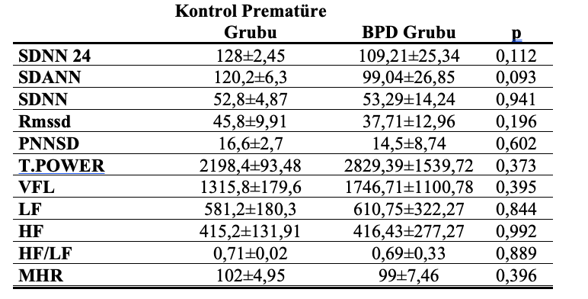

Standard deviations of all NN intervals (SDNN); mean of the standard deviations of all NN intervals for all 5-minute segments of the entire recording (SDNNI), the standard deviation of the averages of NN intervals in all 5-minute segments of the entire recording (SDANNI),

Abi materyal metotda bu şekilde yazmışız, SDNN24 olan açıklamada SDNNI olan mı ? tam bilemediğim için size sormam gerekti ?

