Appendix 1: Clinical Examples and Grading of Piezogenic Papules

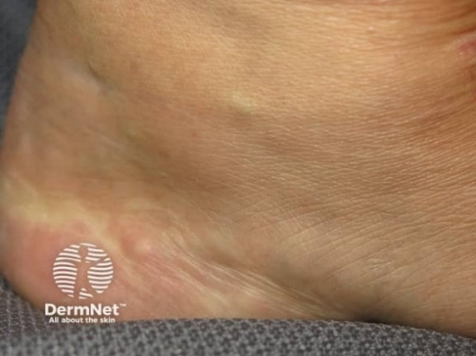
Mild:
single or few visible piezogenic papules

1:

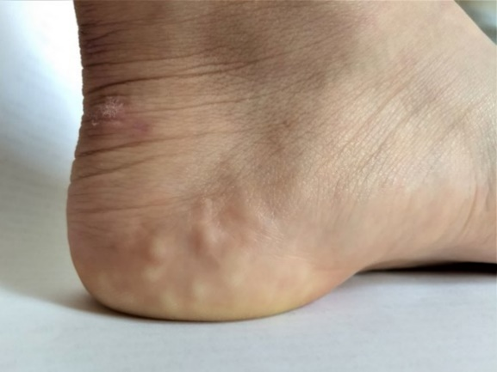
Moderate:
several piezogenic papules with clear visibility

2:

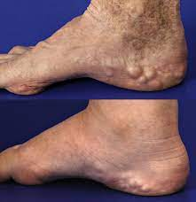

Severe:
multiple prominent, large piezogenic papules

3:

