Supplementary File
Supplementary Figure 1. Forest plot sensitivity analysis of pooled effects of vitamin D fortified food on vitamin D serum (a), height (b), PTH (c), ferritin (d), haemoglobin (e), and calcium (f).
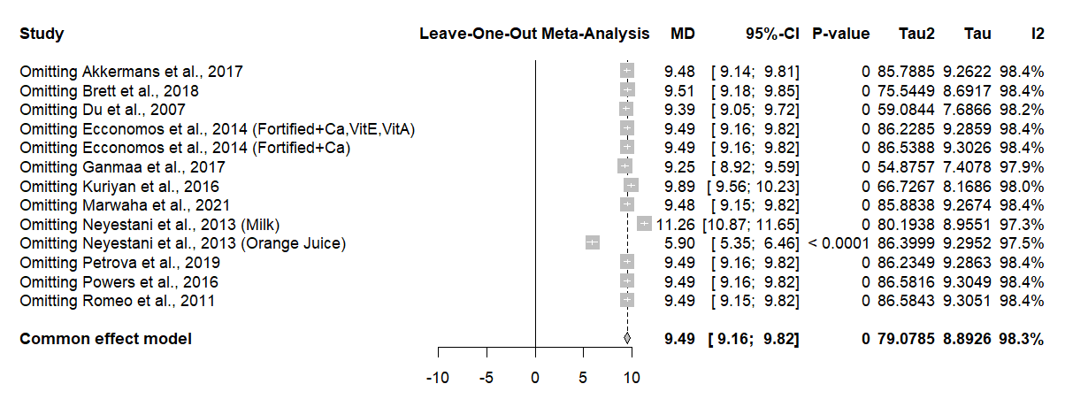
(a)
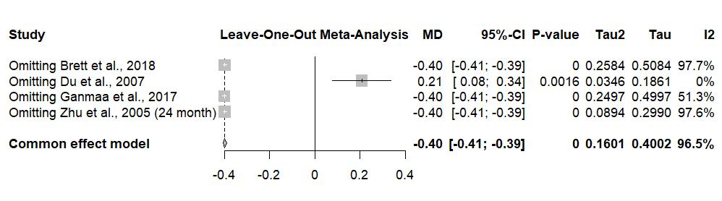
(b)
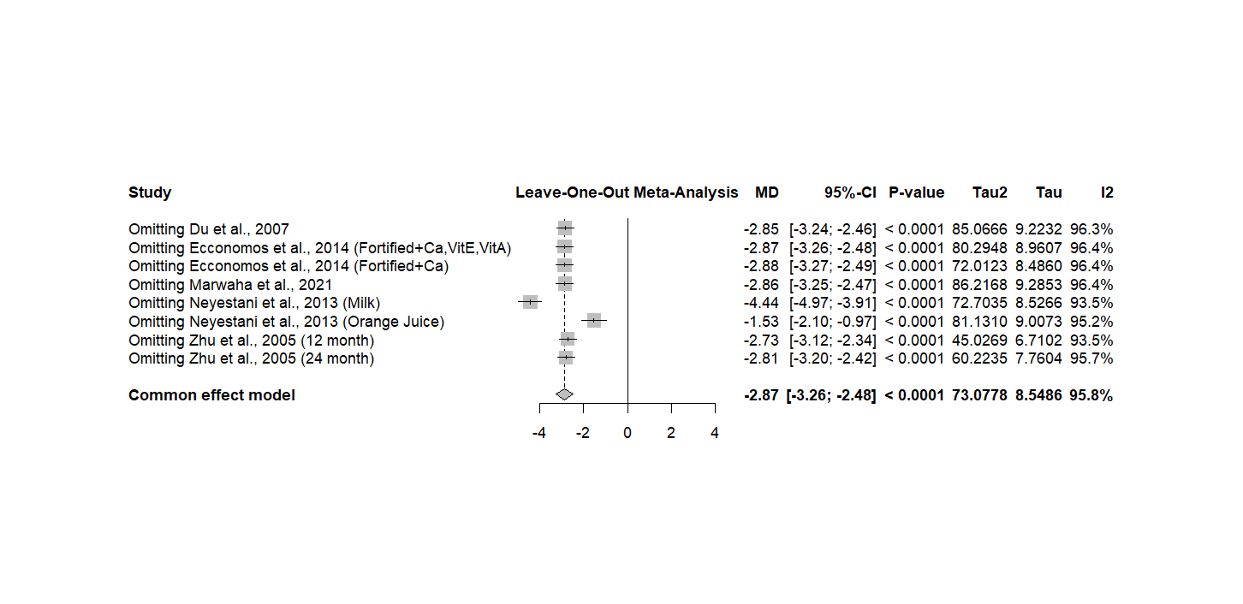
(c)
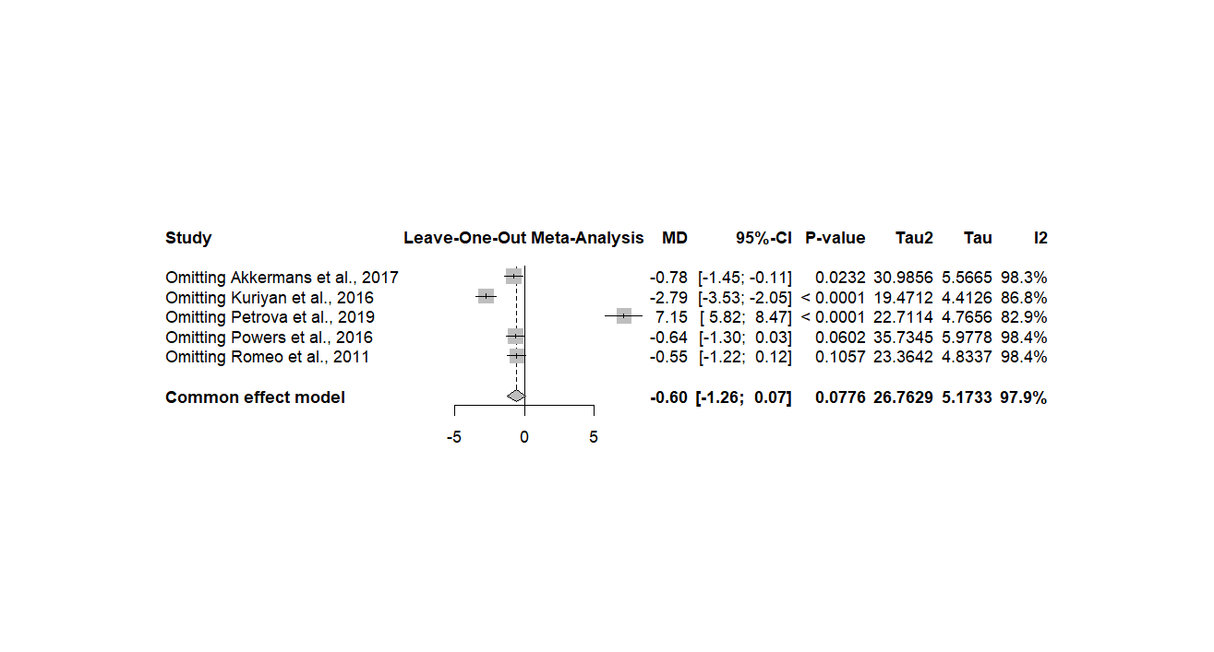
(d)

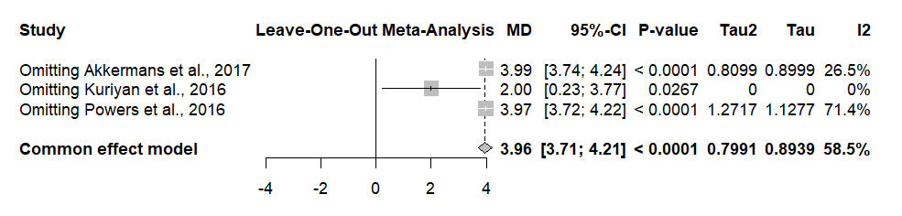
(e)
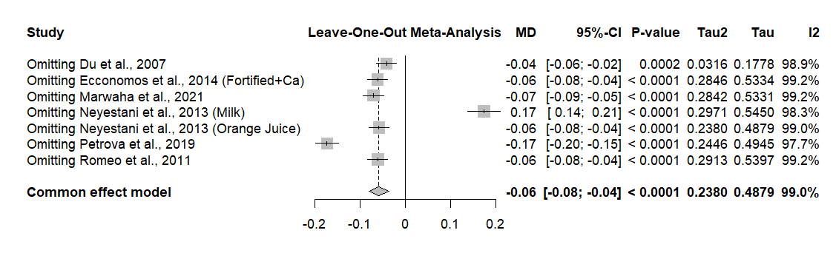
(f)

Supplementary Table 1. Searching Strategies using Boolean Operators
Database | Boolean Operator | Result
Pubmed | ("Vitamin D"[Title/Abstract] OR "cholecalciferol"[Title/Abstract] OR "ergocalciferol"[Title/Abstract] OR "25-hydroxyvitamin D"[Title/Abstract] OR "25 oh d"[Title/Abstract] OR "calcidiol"[Title/Abstract] OR "Vitamin D"[MeSH Terms] OR "cholecalciferol"[MeSH Terms] OR "ergocalciferols"[MeSH Terms] OR "calcifediol"[MeSH Terms]) AND ("food fortification"[Title/Abstract] OR "fortif*"[Title/Abstract] OR "fortified food*"[Title/Abstract] OR "fortified beverage*"[Title/Abstract]) AND ("child*"[Title/Abstract] OR "pediatric*"[Title/Abstract] OR "paediatric*"[Title/Abstract] OR "infant*"[Title/Abstract] OR "toddler*"[Title/Abstract] OR "school-age"[Title/Abstract] OR "under 18"[Title/Abstract] OR "child*"[MeSH Terms] OR "pediatric*"[MeSH Terms] OR "infant*"[MeSH Terms]) AND ("randomized controlled trial"[Title/Abstract] OR "RCT"[Title/Abstract] OR "randomised controlled trial"[Title/Abstract] OR "random*"[Title/Abstract] OR "random*"[MeSH Terms]) | 123
Scopus | TITLE-ABS-KEY ( "vitamin d" OR cholecalciferol OR ergocalciferol OR "25-hydroxyvitamin d" OR "25 oh d" OR calcidiol OR calcifediol ) AND TITLE-ABS-KEY ( "food fortification" OR fortif* OR "fortified food*" OR "fortified beverage*" ) AND TITLE-ABS-KEY ( child* OR pediatric* OR paediatric* OR infant* OR toddler* OR "school-age" OR "under 18" ) AND TITLE-ABS-KEY ( "randomized controlled trial" OR "randomised controlled trial" OR RCT OR random* ) | 350
Cochrane Library | ( ("vitamin d" OR cholecalciferol OR ergocalciferol OR "25-hydroxyvitamin d" OR "25 oh d" OR "25(OH)D" OR calcidiol OR calcifediol):ti,ab,kw OR [mh "Vitamin D"] OR [mh "Cholecalciferol"] OR [mh "Ergocalciferols"] OR [mh "Calcifediol"] ) AND ( ("food fortification" OR fortif* OR "fortified food*" OR "fortified beverage*" OR "fortified milk" OR "fortified cereal"):ti,ab,kw OR [mh "Food, Fortified"] ) AND ( (child* OR pediatric* OR paediatric* OR infant* OR toddler* OR adolescent* OR "school-age" OR "under 18"):ti,ab,kw OR [mh "Child"] OR [mh "Infant"] OR [mh "Adolescent"] ) AND ( ("randomized controlled trial" OR "randomised controlled trial" OR RCT OR random*):ti,ab,kw OR [mh "Randomized Controlled Trial"] ) | 277
Google Scholar | ("vitamin D" OR cholecalciferol OR ergocalciferol OR calcifediol OR "25-hydroxyvitamin D" OR "25(OH)D") AND ("food fortification" OR "fortified food" OR "fortified milk" OR "fortified cereal" OR "fortified beverage") AND (child OR children OR pediatric OR paediatric OR infant OR toddler OR adolescent) AND ("randomized controlled trial" OR "randomised controlled trial" OR RCT) | 1545

Supplementary Table 2. Characteristics of included randomized controlled trials
Author, year | Country | Study setting | Intervention | Population | M/F |  | Age |  | BMI (Mean ± SD) |  | Baseline 25(OH)D concentration (nmol/L) |  | Baseline vitamin D status
 |  |  |  |  | M | F | Mean | SD | Mean | SD | Mean | SD | Baseline vitamin D status
Akkermans et al,, 2017 | Western Europe | Mixed | Fortified | 158 | 89 | 69 | 20.8 | 7.3 | NA | NA | 69.4 | 27.0 | NA
Akkermans et al,, 2017 | Western Europe | Mixed | Unfortified | 160 | 91 | 69 | 20.5 | 7.72 | NA | NA | 70.2 | 26.7 | NA
Brett NR et al,, 2018 | Canada | Community | Fortified | 26 | 12 | 14 | 5.0 | 1.8 | NA | NA | 65.3 | 12.2 | 7.8% deficient & 92.2% sufficient
Brett NR et al,, 2018 | Canada | Community | Unfortified | 25 | 15 | 10 | 5.4 | 2.0 | NA | NA | 67.5 | 15.1 | 7.8% deficient & 92.2% sufficient
Du et al,, 2004 | China | School | Frotified + Ca 245 mg | 240 | 0 | 240 | 10.1 | 0.3 | 16.8 | 2.6 | 20.6 | 8.8 | NA
Du et al,, 2004 | China | School | Unfortified | 234 | 0 | 234 | 10.0 | 0.3 | 16.8 | 2.6 | 19.1 | 7.4 | NA
Economos et al,, 2014 | USA | school | Ca | 48 | 32 | 16 | 7.9 | 1.4 | 18.5 | 4.7 | 64.3 | 20.9 | 21.7% defficient & 78.3% sufficient
Economos et al,, 2014 | USA | school | CaD | 53 | 29 | 24 | 8.1 | 1.5 | 18.5 | 4.1 | 64.2 | 92.8 | 21.7% defficient & 78.3% sufficient
Economos et al,, 2014 | USA | school | CaDEA | 40 | 25 | 15 | 8.2 | 1.4 | 18.1 | 3.9 | 75.6 | 27.2 | 21.7% defficient & 78.3% sufficient
Ganmaa et al,, 2017 | Mongolia | School | Fortified | 138 | 73 | 65 | 10.0 | 0.8 | 16.4 | 1.9 | 19.25 | 10.0 | NA
Ganmaa et al,, 2017 | Mongolia | School | Unfortified | 97 | 46 | 51 | 9.7 | 0.9 | 16.3 | 1.8 | 18.0 | 9.5 | NA
Kuriyan et al,, 2016 | India | School | Fortified + multimicronutrient | 111 | 23 | 88 | 8.1 | 0.8 | NA | NA | 54.0 | 15.75 | 4.9% defficient & 95.1% sufficient
Kuriyan et al,, 2016 | India | School | Unfortified | 114 | 29 | 85 | 8.4 | 0.9 | NA | NA | 54.75 | 17.0 | 4.9% defficient & 95.1% sufficient
Marwaha et al,, 2021 | India | School | Fortified | 106 | 51 | 55 | 10.3 | 0.5 | 16.7 | 3.3 | 28.6 | 9.1 | 60% defficient & 40% sufficient
Marwaha et al,, 2021 | India | School | Unfortified | 104 | 49 | 55 | 10.4 | 0.8 | 16.8 | 3.2 | 29.9 | 9.5 | 60% defficient & 40% sufficient
Neyestani TR et al,, 2010 | Iran | Community | Fortified Juice | 83 | 44 | 39 | NA | NA | 18.0 | 0.3 | 24.9 | 1.3 | NA
Neyestani TR et al,, 2010 | Iran | Community | Unfortified Juice | 80 | 23 | 57 | NA | NA | 17.3 | 0.3 | 23.8 | 1.1 | NA
Neyestani TR et al,, 2010 | Iran | Community | Fortified Milk | 80 | 45 | 35 | NA | NA | 18.3 | 0..4 | 24.9 | 1.4 | NA
Neyestani TR et al,, 2010 | Iran | Community | Unfortified Milk | 53 | 22 | 31 | NA | NA | 18.3 | 0.4 | 27.4 | 1.9 | NA
Petrova et al,, 2019 | Spain | School | Fortified | 60 | 58 | 61 | NA | NA | 20.34 | 0.54 | 5.14 | 0.09 | NA
Petrova et al,, 2019 | Spain | School | Unfortified | 59 |  |  |  |  | 18.83 | 0.52 | 5.21 | 0.08 | NA
Powers et al,, 2016 | UK | School + College | Fortified | 37 | 0 | 37 | 18.84 | 0.96 | 22.69 | 3.09 | 41.56 | 28.66 | total 88.7% defficient & 11.3% sufficient
Powers et al,, 2016 | UK | School + College | Unfortified | 34 | 0 | 34 | 19.04 | 0.91 | 21.89 | 2.48 | 39.48 | 22.80 | total 88.7% defficient & 11.3% sufficient
Romeo et al,, 2011 | Spain | School | Fortified | 53 | 53 | 54 | NA | NA | 19.30 | 3.88 | 69.0 | 15.1 | NA
Romeo et al,, 2011 | Spain | School | Unfortified | 54 |  |  |  |  | 20.29 | 3.30 | 68.7 | 13.6 | NA
Zhu et al,, 2005 | China | School | Fortified + Ca 300 mL | 210 | 0 | 210 | 10.1 | 0.3 | 16.83 | 3.87 | NA | NA | NA
Zhu et al,, 2005 | China | School | Unfortified | 219 | 0 | 219 | 10.0 | 0.3 | 16.95 | 3.79 | NA | NA | NA

Supplementary Table 3. Meta Regression
Variable | k | Estimate | 95% CI | p-value | I²
25-hydroxyvitamin D Concentrations
Age | 9 | 0.4678 | -1.0927 to 2.0284 | 0.5568 | 96.32%
Proportion of boy | 12 | -15.9019 | -41.3851 to 9.5813 | 0.2213 | 98.15%
Sample size | 13 | 0.0463 | 0.0062 to 0.0863 | 0.0235* | 98.67%
Baseline vitamin D | 12 | -0.1876 | -0.4071 to 0.0320 | 0.0940 | 95.43%
Deficiency vitamin D | 7 | 16.3934 | -4.7233 to 37.5102 | 0.1281 | 91.89%
Dose | 13 | 0.0014 | -0.0537 to 0.0565 | 0.9611 | 99.25%
Summer  Winter  Winter-Spring  Winter-Summer | 1  8  1  1 | -15.4295  -2.2945  16.0705  -3.6295 | -34.1033 to 3.2442  -15.1115 to 10.5225  -2.7826 to 34.9235  -24.0294 to 16.7703 | 0.1053  0.7257  0.0948  0.7273 | 99.05%
Ca  Ca + Vit E + Vit A  Fe  Multivitamin + omega-3  Multivitamin +iron  Mutliple micronutrient  None | 4  1  1  1  1  1  4 | 15.0226  0.0774  0.7774  -4.2226  -1.9226  -16.0226  -1.3514 | 3.6453 to 26.3999  -27.1589 to 27.3138  -24.4454 to 26.0002  -29.9932 to 21.5480  -28.7577 to 24.9125  -40.4496 to 8.4044  -17.1356 to 14.4327 | 0.0097*  0.9956  0.9518  0.7481  0.8883  0.1986  0.8667 | 97.88%
Cereal  Dairy product  Juice  Milk  Yoghurt | 1  1  3  7  1 | 13.1000  -0.1000  -0.3765  1.2517  -11.3000 | -9.7854 to 35.9854  -31.3189 to 31.1189  -26.5913 to 25.8383  -22.9042 to 25.4076  -42.3147 to 19.7147 | 0.2619  0.9950  0.9775  0.9191  0.4752 | 98.23%
Follow-up > 3 months  Follow-up ≤ 3 months | 6  7 | 11.6143  2.3240 | 3.8331 to 19.3955  -8.3909 to 13.0388 | 0.0034*  0.6708
Low  Moderate | 6  7 | 11.7096  2.1588 | 3.9507 to 19.4684  -8.5632 to 12.8808 | 0.0031*  0.6931 | 99.18%

Supplementary Table 4. Subgroup Analysis
Variable | k | MD | 95% CI | p-value | I²
Calcium
Follow Up > 3 months | 3 | -0.24 | -1.07 to 0.58 | 0.564 | 99.15%
Follow Up ≤ 3 months | 4 | -0.01 | -0.21 to 0.20 | 0.936 | 96.50%
Dose <200 IU/day | 5 | -0.23 | -0.81 to 0.35 | 0.437 | 99.38%
Dose 200-399 IU/day | 2 | 0.1 | 0.03 to 0.17 | 0.00702* | 0%
Winter | 5 | -0.27 | -0.81 to 0.27 | 0.334 | 98.16%
Winter-Summer | 1 | 0.3 | 0.26 to 0.34 | <0.001* | -
Cofortification = Ca | 4 | -0.28 | -0.81 to 0.25 | 0.295 | 97.61%
Cofortification = Multivitamin + Omega-3 | 1 | 0.3 | 0.26 to 0.34 | <0.001* | -
Fortification Media = Milk | 4 | -0.22 | -0.81 to 0.38 | 0.475 | 99.40%
Fortification Media = Juice | 2 | - | - | 0.231 | -
Fortification Media = Dairy Product | 1 | 0.04 | -0.09 to 0.17 | 0.551 | -
Haemoglobin
Follow Up > 3 months | 2 | 3.28 | 1.40 to 5.16 | <0.001* | 71.37%
Follow Up ≤ 3 months | 1 | 2 | -1.35 to 5.35 | 0.242 | -
Dose <200 IU/day | 3 | 3.12 | 1.54 to 4.69 | <0.001* | 58.46%
Summer | 1 | 4 | 3.75 to 4.25 | <0.001* | -
Winter | 1 | 2 | -1.35 to 5.35 | 0.242 | -
Cofortification = Fe | 1 | 2 | -0.08 to 4.08 | 0.0598 | -
Cofortification = Multiple Micronutrient | 1 | 4 | 3.75 to 4.25 | <0.001* | -
Cofortification = Multivitamin + Iron | 1 | 2 | -1.35 to 5.35 | 0.242 | -
Fortification Media = Milk | 2 | 3.28 | 1.40 to 5.16 | <0.001* | 71.37%
Fortification Media = Cereal | 1 | 2 | -1.35 to 5.35 | 0.242 | -
Ferritin
Follow Up > 3 months | 4 | 1.86 | -4.33 to 8.04 | 0.557 | 97.91%
Follow Up ≤ 3 months | 1 | 3.7 | -3.06 to 10.46 | 0.283 | -
Dose <200 IU/day | 5 | 2.19 | -2.86 to 7.24 | 0.396 | 97.91%
Winter | 1 | 3.7 | -3.06 to 10.46 | 0.283 | -
Winter-Summer | 1 | -3.16 | -3.92 to -2.40 | <0.001* | -
Summer | 1 | 8.2 | 6.72 to 9.68 | <0.001* | -
Cofortification = Ca | 1 | -4.23 | -10.13 to 1.67 | 0.16 | -
Cofortification = Fe | 1 | 5.9 | 1.88 to 9.92 | 0.004* | -
Cofortification = Multiple Micronutrient | 1 | 8.2 | 6.72 to 9.68 | <0.001* | -
Cofortification = Multivitamin + Omega-3 | 1 | -3.16 | -3.92 to -2.40 | <0.001* | -
Cofortification = Multivitamin + Iron | 1 | 3.7 | -3.06 to 10.46 | 0.283 | -
Fortification Media = Milk | 3 | 3.55 | -3.44 to 10.54 | 0.319 | 98.94%
Fortification Media = Cereal | 1 | 3.7 | -3.06 to 10.46 | 0.283 | -
Fortification Media = Dairy Product | 1 | -423 | -10.13 to 1.67 | 0.16 | -
25OH
Follow Up > 3 months | 6 | 11.64 | 2.52 to 10.75 | 0.0123* | 97.14%
Follow Up ≤ 3 months | 7 | 13.94 | 7.12 to 20.76 | <0.001* | 98.70%
Dose <200 IU/day | 8 | 12.03 | 5.48 to 18.58 | <0.001* | 98.62%
Dose 200-399 IU/day | 4 | 17.54 | 7.24 to 27.84 | <0.001 | 96.47%
Dose ≥400 IU/day | 1 | 1.8 | -4.59 to 8.19 | 0.581 | -
Winter | 8 | 12.16 | 5.85 to 18.47 | <0.001* | 98.11%
Winter-Spring | 1 | 30.5 | 27.38 to 33.62 | <0.001* | -
Winter-Summer | 1 | 10.8 | 2.41 to 19.19 | 0.0117* | -
Summer | 1 | -1 | -2.73 to 0.73 | 0.257 | -
Cofortification = Ca | 4 | 15.03 | 3.93 to 26.12 | 0.00796* | 97.40%
Cofortification = Fe | 1 | 15.8 | 9.28 to 22.32 | <0.001* | -
Cofortification = Multiple Micronutrient | 1 | -1 | -2.73 to 0.73 | 0.257 | -
Cofortification = Multivitamin + Omega-3 | 1 | 10.8 | 2.41 to 19.19 | 0.0117* | -
Cofortification = Multivitamin + Iron | 1 | 13.1 | 1.86 to 24.34 | 0.0224* | -
Cofortification = Ca+Vit E+Vit A | 1 | 15.1 | 2.93 to 27.27 | 0.015* | -
Fortification Media = Milk | 7 | 14.37 | 5.38 to 23.37 | 0.00174* | 98.60%
Fortification Media = Yoghurt | 1 | 1.8 | -4.59 to 8.19 | 0.581 | -
Fortification Media = Juice | 3 | 11.5 | 11.09 to 11.92 | <0.001* | 0%
Fortification Media = Cereal | 1 | 13.1 | 1.86 to 24.34 | 0.0224* | -
Fortification Media = Dairy Product | 1 | 13 | 5.68 to 20.32 | <0.001* | -
PTH
Follow Up > 3 months | 3 | -19.52 | -26.18 to -12.87 | <0.001* | 65.04%
Follow Up ≤ 3 months | 5 | -2.64 | -4.76 to -0.52 | 0.0146* | 93.47%
Dose <200 IU/day | 5 | -11.99 | -21.01 to -2.97 | 0.0092* | 97.56%
Dose 200-399 IU/day | 3 | -2.73 | -6.45 to 0.99 | 0.15 | 5.92%
Winter | 6 | -3.25 | -5.63 to -0.88 | 0.00727* | 92.38%
Cofortification = Ca | 5 | -11.38 | -21.14 to -1.62 | 0.0223* | 96.72%
Cofortification = Ca+Vit E+Vit A | 1 | -3.4 | -9.12 to 2.32 | 0.244 | -
Fortification Media = Milk | 5 | -13.18 | -21.90 to -4.47 | 0.00304* | 96.77%
Fortification Media = Juice | 3 | -3.95 | -5.00 to -2.89 | <0.001* | 0%
BMI
Follow Up > 3 months | 3 | -0.02 | -1.17 to 1.13 | 0.972 | 89.26%
Follow Up ≤ 3 months | 3 | 0.32 | -0.03 to 0.67 | 0.0705 | 94.36%
Dose <200 IU/day | 5 | 0.2 | -0.34 to 0.74 | 0.472 | 98.47%
Dose 200-399 IU/day | 1 | 0.2 | -0.32 to 0.72 | 0.45 | -
Winter | 3 | 0.51 | 0.03 to 1.00 | 0.0361* | 94.76%
Winter-Spring | 1 | 0.2 | -0.32 to 0.72 | 0.45 | -
Winter-Summer | 1 | -0.17 | -0.20 to -0.14 | <0.001* | -
Cofortification = Ca | 3 | 0.09 | -1.03 to 1.21 | 0.873 | 84.71
Cofortification = Multivitamin + Omega-3 | 1 | -0.17 | -0.20 to -0.14 | <0.001* | -
Fortification Media = Milk | 4 | 0.22 | -0.23 to 0.68 | 0.333 | 90.46%
Fortification Media = Juice | 1 | 0.6 | 0.51 to 0.69 | <0.001 | -
Fortification Media = Dairy Product | 1 | 0.21 | -0.20 to 0.63 | 0.0752 | -
Weight
Follow Up > 3 months | 3 | 0.66 | -0.33 to 1.65 | 0.192 | 0%
Follow Up ≤ 3 months | 3 | 0.1 | -0.15 to 0.34 | 0.448 | 22.54%
Dose <200 IU/day | 4 | 0.13 | -0.29 to 0.55 | 0.541 | 41.71%
Dose 200-399 IU/day | 1 | 0.2 | -0.05 to 0.45 | 0.116 | -
Dose ≥400 IU/day | 1 | 0.7 | -4.44 to 5.84 | 0.79 | -
Winter | 4 | -0.01 | -0.34 to 0.32 | 0.971 | 0%
Winter-Spring | 1 | 0.2 | -0.05 to 0.45 | 0.116 | -
Cofortification = Ca | 3 | 0.32 | -0.12 to 0.76 | 0.15 | 15.26%
Fortification Media = Milk | 4 | 0.23 | 0.01 to 0.45 | 0.0376* | 0%
Fortification Media = Yoghurt | 1 | 0.7 | -4.44 to 5.84 | 0.79 | -
Fortification Media = Juice | 1 | -0.2 | -0.63 to 0.23 | 0.365 | -
Height
Follow Up > 3 months | 3 | 0.09 | -1.12 to 1.30 | 0.883 | 51.33%
Follow Up ≤ 3 months | 1 | 0.2 | 0.07 to 0.33 | 0.00254* | -
Dose <200 IU/day | 2 | 0.09 | -1.14 to 1.33 | 0.885 | 75.52%
Dose 200-399 IU/day | 1 | 0.2 | 0.07 to 0.33 | 0.00254* | -
Dose ≥400 IU/day | 1 | 0.5 | -10.73 to 11.73 | 0.93 | -
Winter | 2 | -0.4 | -0.41 to -0.39 | <0.001* | 0%
Winter-Spring | 1 | 0.2 | 0.07 to 0.33 | 0.00254* | -
Cofortification = Ca | 2 | 0.09 | -1.14 to 1.33 | 0.885 | 75.52%
Fortification Media = Milk | 3 | 0.04 | -0.55 to 0.64 | 0.884 | 97.67%
Fortification Media = Yoghurt | 1 | 0.5 | -10.73 to 11.73 | 0.93 | -

Supplementary Table 5. GRADE Assessment
Quality Assessment |  |  |  |  |  |  | Summary of Finding Table
 |  |  |  |  |  |  | No of patients |  | Effect |  | Certainty | Importance
No of studies | Study design | Risk of bias | Inconsistency | Indirectness | Imprecision | Other considerations | Experimental | Control | Relative | Absolute | Certainty | Importance
 |  |  |  |  |  |  |  |  | (95% CI) | (95% CI) | Certainty | Importance
Serum 25(OH)D concentration (follow-up: mean 26.69 weeks)
11 | randomised controlled trials | not serious | serious | not serious | not serious | large-effect | 1042 | 968 | - | MD 12.39 Points higher | ⨁⨁⨁⨁ | Strong
 |  |  |  |  |  |  |  |  |  | (7.65 higher to 18.02 higher) | High | Strong
PTH concentration (follow-up: mean 46 weeks)
5 | randomised controlled trials | not serious | serious | serious | not serious | large-effect | 895 | 893 | - | MD 9.02 Points lower | ⨁⨁⨁◯ | Strong
 |  |  |  |  |  |  |  |  |  | (15.31 lower to 2.73 lower) | Moderate | Strong
Haemoglobin level (follow-up: mean 28 weeks)
3 | randomised controlled trials | not serious | not serious | not serious | serious | large-effect | 292 | 291 | - | MD 3.22 Points higher | ⨁⨁⨁⨁ | Strong
 |  |  |  |  |  |  |  |  |  | (1.84 higher to 4.60 higher) | High | Strong
Height measurement (follow-up: mean 47.17 weeks)
4 | randomised controlled trials | not serious | serious | not serious | not serious | none | 614 | 574 | - | MD 0.02 Points higher | ⨁⨁⨁◯ | Weak/  Conditional
 |  |  |  |  |  |  |  |  |  | (0.50 lower to 0.54 higher) | Moderate | Weak/  Conditional
Weight measurement (follow-up: mean 42.14 weeks)
5 | randomised controlled trials | not serious | not serious | serious | not serious | none | 777 | 707 | - | MD 0.18 Points higher | ⨁⨁⨁◯ | Weak/  Conditional
 |  |  |  |  |  |  |  |  |  | (0.22 lower to 0.58 higher) | Moderate | Weak/  Conditional
CI: confidence interval; PTH: parathyroid hormone; MD: mean difference.

Supplementary Table 5. GRADE Assessment (Continue)
Quality Assessment |  |  |  |  |  |  | Summary of Finding Table
 |  |  |  |  |  |  | No of patients |  | Effect |  | Certainty | Importance
No of studies | Study design | Risk of bias | Inconsistency | Indirectness | Imprecision | Other considerations | Experimental | Control | Relative | Absolute | Certainty | Importance
 |  |  |  |  |  |  |  |  | (95% CI) | (95% CI) | Certainty | Importance
Ferritin concentrations (follow-up: mean 24.8 weeks)
5 | randomised controlled trials | not serious | serious | not serious | serious | none | 394 | 393 | - | MD 2.20 Points higher | ⨁⨁◯◯ | Weak/  Conditional
 |  |  |  |  |  |  |  |  |  | (2.71 lower to 7.10 higher) | Low | Weak/  Conditional
Serum calcium ion concentration (follow-up: mean 31.43 weeks)
6 | randomised controlled trials | not serious | serious | serious | serious | none | 40 | 40 | - | MD 0.12 Points lower | ⨁◯◯◯ | Weak/  Conditional
 |  |  |  |  |  |  |  |  |  | (0.51 lower to 0.27 higher) | Very Low | Weak/  Conditional
CI: confidence interval; PTH: parathyroid hormone; MD: mean difference.

