Contents

Search Strategies 2

Supplementary Table 1: GRADE Assessment of Evidence Quality for Efficacy Outcomes 3
Supplementary Table 2: Summary of pooled estimates by outcomes for IPC vs. FS
Supplementary Figure 1: Leave-One-Out Sensitivity Analysis for change in Hemoglobin levels After Removing Ozsureki 2019 Study 3
Supplementary Figure 2: Leave-One-Out Sensitivity Analysis for Total Adverse Effects (TAE) After Removing Amjad 2025 Study 3
Supplementary Figure 3: Forest plot comparing the risk of Constipation between IPC and FS. 4
Supplementary Figure 4: Forest plot comparing the risk of Abdominal Pain between IPC and FS. 4
Supplementary Figure 5: Forest plot comparing the risk of Diarrhea between IPC and FS. 4
Supplementary Figure 6: Leave-One-Out Sensitivity Analysis for Diarrhea after Removing Kavakli 2004 Study 4
Supplementary Figure 7: TSA graph showing the cumulative Z-curve for Ferritin, crossing significance threshold. 5
PRISMA CHECKLIST

Abbreviations
IPC = Iron Polymaltose Complex | FS = Ferrous Sulphate | MD = Mean Difference | RR = Risk Ratio
CI = Confidence Interval | SD = Standard Deviation | IV = Inverse-Variance method
I² = Higgins heterogeneity statistic | Tau² = Between-study variance | df = degrees of freedom
All pooled estimates use random-effects model (DerSimonian & Laird). Negative MD favours FS. Supplementary Figures: Figure S1 = Forest Plot, Haemoglobin (Hb, g/dL) | Figure S2 = Forest Plot, Ferritin (µg/L) | Figure S3 = Forest Plot, Adverse Events (Risk Ratio)

Search Strategies
PUBMED - 142
(("Infant*" OR "Child*" OR "Adolescen*" OR "Pediatric" OR "Paediatric") AND ("Iron Deficiency Anemia" OR "Iron Deficiency Anaemia" OR "IDA" OR "Iron Deficiency")) AND ("Iron Polymaltose Complex" OR "Iron Polymaltose" OR IPC OR "Polymaltose Iron") AND ("Ferrous Sulphate" OR "Ferrous Sulfate") AND ("Hemoglobin" OR "Haemoglobin" OR "Hb" OR "Serum Ferritin" OR "Ferritin" OR "Serum Iron" OR "MCV" OR "MCH" OR "Gastrointestinal" OR "Nausea" OR "Vomiting" OR "Diarrhea" OR "Constipation")
EMBASE - 59
('infant'/exp OR 'child'/exp OR 'adolescent'/exp OR pediatric OR paediatric) AND ('iron deficiency anemia'/exp OR 'iron deficiency anaemia'/exp OR IDA OR 'iron deficiency') AND ('iron polymaltose complex'/exp OR 'iron polymaltose' OR IPC OR 'polymaltose iron') AND ('ferrous sulphate'/exp OR 'ferrous sulfate') AND ('hemoglobin'/exp OR 'haemoglobin' OR 'hb' OR 'ferritin'/exp OR 'serum ferritin' OR 'serum iron'/exp OR 'mc?'/exp OR 'mcv' OR 'mch' OR 'gastrointestinal disorder'/exp OR nausea OR vomiting OR diarrhea OR constipation)
SCOPUS - 22
TITLE-ABS-KEY(("Infant*" OR "Child*" OR "Adolescen*" OR "Pediatric" OR "Paediatric") AND ("Iron Deficiency Anemia" OR "Iron Deficiency Anaemia" OR "IDA" OR "Iron Deficiency") AND ("Iron Polymaltose Complex" OR IPC OR "Iron Polymaltose") AND ("Ferrous Sulphate" OR "Ferrous Sulfate") AND ("Hemoglobin" OR "Haemoglobin" OR "Hb" OR "Serum Ferritin" OR "Ferritin" OR "Serum Iron" OR "MCV" OR "MCH" OR "Nausea" OR "Vomiting" OR "Diarrhea" OR "Constipation"))

Supplementary Table 1: GRADE Assessment of Evidence Quality for Efficacy Outcomes
Name of Outcome | No. of Studies | Study Design | Risk of Bias | Inconsistency | Imprecision | Indirectness | Effect estimate, 95% CI. | Certainty of Evidence
Change in Hemoglobin | 7 | Randomized Controlled Trials | Low | Not Serious (I² = 62%) | Not Serious | Not Serious | MD: -0.87 g/dL (95% CI -1.15, -0.59) | High
Change in Ferritin | 4 | Randomized Controlled Trials | Moderate | Serious (I² = 80%) | Not Serious | Not Serious | MD: -12.82 µg/L (95% CI -24.71, -0.93) | Moderate
Change in Serum Iron | 3 | Randomized Controlled Trials | Low | Not Serious (I² = 58%) | Serious | Not Serious | MD: -7.92 µg/dL (95% CI -24.81, 8.98) P= 0.36 | Low

Supplementary Table 2: Summary of Pooled Effect Estimates by Outcome for IPC vs. FS

Outcome | Studies | IPC vs FS (n) | Pooled Estimate | P-value | I² | 95% CI | Direction
Haemoglobin (all) | 7 | 283 vs 288 | −0.87 g/dL | <0.00001 | 62% | −1.15, −0.59 | Favours FS
Haemoglobin (Ozsurekci excl.) | 6 | 264 vs 267 | −0.73 g/dL | <0.00001 | 31% | −0.94, −0.51 | Favours FS
Ferritin (main) | 4 | 172 vs 169 | −12.82 µg/L | 0.03 | 80% | −24.71, −0.93 | Favours FS
Ferritin (1–3 mo) | 2 | 106 vs 107 | −4.36 µg/L | 0.33 | 74% | −13.21, 4.49 | None
Ferritin (4–6 mo) | 2 | 66 vs 62 | −32.25 µg/L | 0.02 | 66% | −58.99, −5.51 | Favours FS
Adverse Events (all) | 4 | 221 vs 220 | RR 0.54 | 0.48 | — | 0.10, 2.97 | None
Adverse Events (Amjad excl.) | 3 | 185 vs 184 | RR 0.43 | <0.0001 | 0% | 0.29, 0.63 | Favours IPC
Diarrhea | 3 | 143 vs 149 | RR 0.51 | 0.09 | 0% | 0.23, 1.11 | None
Constipation | 3 | 159 vs 164 | RR 0.66 | 0.43 | 38% | 0.24, 1.86 | None
Abdominal Pain | 3 | 159 vs 164 | RR 0.95 | 0.89 | 0% | 0.45, 2.00 | None
Green = favours FS; Blue = favours IPC; Yellow = NS.
All analyses used random-effects model (DerSimonian & Laird). MD = Mean Difference; RR = Risk Ratio.
Supplementary Figure 1: Leave-One-Out Sensitivity Analysis for change in Hemoglobin levels After Removing Ozsureki 2019 Study
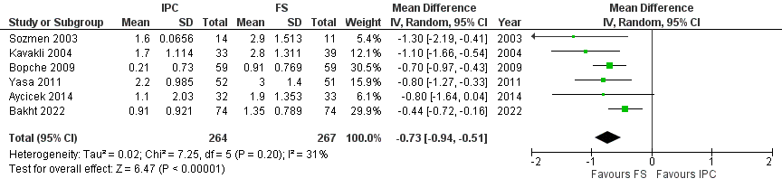
Supplementary Figure 2: Leave-One-Out Sensitivity Analysis for Total Adverse Effects (TAE) After Removing Amjad 2025 Study
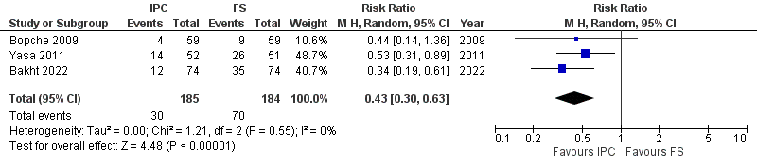
Supplementary Figure 3: Forest plot comparing the risk of Constipation between IPC and FS.
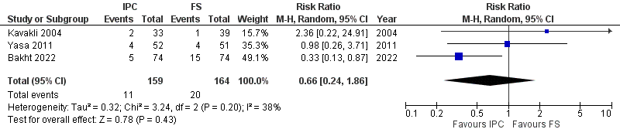
Supplementary Figure 4: Forest plot comparing the risk of Abdominal Pain between IPC and FS.
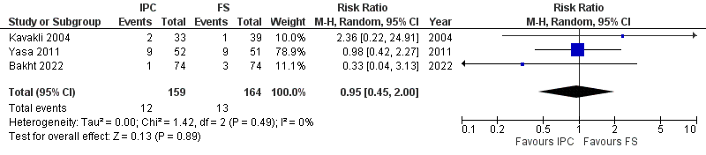
Supplementary Figure 5: Forest plot comparing the risk of Diarrhea between IPC and FS.
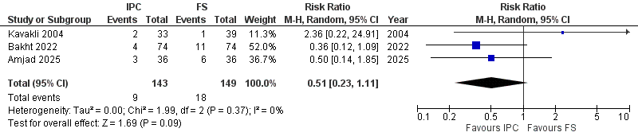
Supplementary Figure 6: TSA graph showing the cumulative Z-curve for Ferritin, not crossing significance threshold. 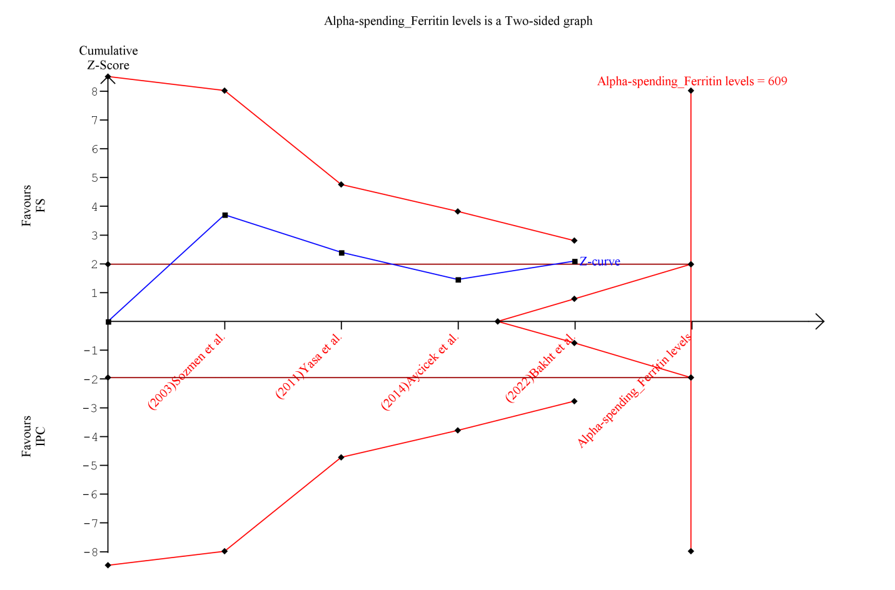

PRISMA CHECKLIST
Section/Topic | Item # | PRISMA 2020 Checklist Item | Location in Manuscript
TITLE
Title | 1 | Identify the report as a systematic review. | Title Page ("Comparative Efficacy and Safety of Oral Iron Polymaltose Complex vs Ferrous Sulphate in the Treatment of Pediatric Iron Deficiency Anemia: A Systematic Review, Meta-Analysis and Trial Sequential Analysis")
ABSTRACT
Abstract | 2 | See PRISMA 2020 for Abstracts checklist. | Abstract (Structured: Background, Methods, Results, Conclusion)
INTRODUCTION
Rationale | 3 | Describe the rationale for the review in the context of existing knowledge. | Section 1 (Background), Paragraphs 1–3
Objectives | 4 | Provide an explicit statement of the objective(s) or question(s) being addressed. | Section 1 (Background), Paragraph 4
METHODS
Eligibility criteria | 5 | Specify the study characteristics and report characteristics used as criteria for eligibility. | Section 2.3 (Inclusion Criteria) & Section 2.4 (Exclusion Criteria)
Information sources | 6 | Describe all information sources in the search and date last searched. | Section 2.2 (Search Strategy: PubMed, Embase, Scopus searched to 10 March 2026)
Search strategy | 7 | Present the full search strategies for all databases, including filters applied. | Section 2.2 (Search Strategy)
Selection process | 8 | State the process for selecting studies (screening, eligibility, duplicate handling). | Section 2.5 (Study Selection: Rayyan software, 2 independent reviewers, 3rd reviewer for consensus)
Data collection process | 9 | State the process for collecting data from reports. | Section 2.6 (Data Extraction: standardized Excel sheets, independent dual extraction)
Data items | 10a | List and define all outcomes for which data were sought. | Section 2.3 & Section 2.6 (Primary: mean change in Hb & Ferritin; Secondary: mean change in Serum Iron, adverse events)
Data items | 10b | List and define all other variables sought. | Section 2.6 & Table 1.1 (Study location, age range, treatment duration, dosage, baseline Hb/ferritin)
Study risk of bias assessment | 11 | Specify the tool(s) used to assess risk of bias in included studies. | Section 2.7 (Risk of Bias Assessment: Cochrane RoB 2.0 tool across 5 domains)
Effect measures | 12 | Specify for each outcome the effect measure(s) used. | Section 2.8 (Statistical Analysis: Mean Difference [MD] for continuous outcomes; Risk Ratio [RR] for dichotomous outcomes)
Synthesis methods | 13a | Describe the processes used to decide which studies were eligible for each synthesis. | Section 2.3, 2.5, & 2.8
Synthesis methods | 13b | Describe any methods used to prepare or process data for synthesis. | Section 2.6 (Standardized mean difference / mean difference calculations)
Synthesis methods | 13c | Describe any methods used to tabulate or visually display results. | Section 2.8 & 2.10 (Forest plots using DerSimonian–Laird random-effects model, TSA Z-curves)
Synthesis methods | 13d | Describe any methods used to synthesize results and assess statistical heterogeneity. | Section 2.8 (Chi-square test and I^2 statistic)
Synthesis methods | 13e | Describe any sensitivity analyses performed. | Section 2.8, 3.3.1, & 3.4.1 (Leave-one-out sensitivity analyses)
Synthesis methods | 13f | Describe any subgroup or meta-regression analyses performed. | Section 3.5.1 & 3.5.2 (Subgroups by dose: 5 vs. 6 mg/kg/day; duration: 1–3 vs. 4–6 months)
Reporting bias assessment | 14 | Describe any methods used to assess risk of bias due to missing results. | Section 2.8 (Funnel plots and Egger's test planned for >= 10 studies)
Certainty assessment | 15 | Describe any methods used to assess certainty in the body of evidence. | Section 2.9 (Certainty of Evidence: GRADE framework)
RESULTS
Study selection | 16a | Describe the results of the search and selection process. | Section 3.1 (Results: 223 records identified -> 8 RCTs included) & Figure 1 (PRISMA Flow Diagram)
Study selection | 16b | Cite studies that met inclusion criteria and excluded studies. | Section 3.1, Figure 1, & References [5, 22–28]
Study characteristics | 17 | Cite each included study and present its characteristics. | Section 3.1 & Table 1.1 (Baseline Characteristics and Intervention Details)
Risk of bias in studies | 18 | Present evaluations of risk of bias for each included study. | Section 3.2 & Figure 2 (Risk of Bias 2.0 Summary Domain Judgments)
Results of individual studies | 19 | For all outcomes, present summary statistics and effect estimates for each study. | Section 3.3 & 3.4, Figures 3–6 (Forest Plots)
Results of syntheses | 20a | For each synthesis, summarize the characteristics and risk of bias of contributing studies. | Section 3.2, 3.3, 3.4, & 3.6
Results of syntheses | 20b | Present statistical synthesis results including confidence intervals and heterogeneity. | Section 3.3, 3.4, 3.5, & 3.7
Results of syntheses | 20c | Present results of any sensitivity analyses. | Section 3.3.1 & 3.4.1 (Supplementary Figures 1 & 2)
Results of syntheses | 20d | Present results of any subgroup or meta-regression analyses. | Section 3.5.1 & 3.5.2 (Figures 5 & 6)
Reporting biases | 21 | Present assessments of risk of bias due to missing results. | Section 2.8 & 3.3 (Noted n < 10 trials threshold precluding formal funnel plot testing)
Certainty of evidence | 22 | Present assessments of certainty in the body of evidence. | Section 3.6 & Supplementary Table 1 (GRADE assessment)
DISCUSSION
Discussion | 23a | Provide a general interpretation of the results in the context of other evidence. | Section 4 (Discussion), Paragraphs 1–6
Discussion | 23b | Discuss any limitations of the evidence included in the review. | Section 4 (Discussion), Paragraph 7 (Limitations)
Discussion | 23c | Discuss any limitations of the review processes used. | Section 4 (Discussion), Paragraph 7
Discussion | 23d | Discuss implications of the results for practice, policy, and future research. | Section 4 (Discussion), Paragraphs 8–10 & Section 5 (Conclusion)
OTHER INFORMATION
Registration and protocol | 24a | Provide registration information (registry name and registration number). | Section 2.1 (PROSPERO CRD420261361633)
Registration and protocol | 24b | State where the review protocol can be accessed. | Section 2.1
Registration and protocol | 24c | Describe any amendments to information provided at registration. | Section 2.1 & 3.4.1 (Post-hoc sensitivity analyses noted)
Support | 25 | Describe sources of financial or other support for the review. | Declarations (Funding: "This research did not receive any specific grant...")
Competing interests | 26 | Declare any competing interests of review authors. | Declarations (Competing interests: "The authors declare that they have no competing interests.")
Availability of data | 27 | State availability of data, analytical code, and other materials. | Declarations (Availability of data and materials)

