Supplementary File S1.

English translated version of the original Chinese Home‑Management Self‑Efficacy Scale.

This questionnaire is specifically designed for primary caregivers of children with asthma aged 3–6 years to assess their confidence level in managing the child's asthma at home, and can be completed in just 5–8 minutes.
Based on your actual caregiving experience, select the option that best reflects your level of confidence for each description.
The scale uses a 5-point Likert scale: 1 = completely unsure, 2 = somewhat unsure, 3 = neutral, 4 = fairly confident, 5 = very confident.
All answers are optional. Please fill them in independently and truthfully. We will strictly protect your information.

Part A. Basic Information
- Child’s age: A. ＜1 year B. 1‑3 years C. 4‑6 years D. ＞6 years
- Child’s schooling status: A. Not in school B. Day‑care / Kindergarten C. Boarding nursery / kindergarten D. Already enrolled in school
- Duration of the child’s asthma: A. ≤1 year B. 1 year ＜ duration ≤3 years C. Duration ＞3 years
- Number of hospitalizations due to acute asthma exacerbations in the past one year (times): A. 1 time B. ≤3 times C. ＞3 times
- Severity of the child’s asthma:
A. No current symptoms, in remission stage
B. Mild: Mild symptoms with no obvious impact on quality of life (including sleep, daily activities and study)
C. Moderate: Noticeable symptoms with impacts on quality of life (including sleep, daily activities and study)
D. Severe: Severe symptoms with significant impairment of quality of life (including sleep, daily activities and study)
6. Your relationship with the child: A. Parent B. Grandparent / Great‑grandparent C. Other relative
7. Your gender: A. Male B. Female
8. Your age (years): A. ≤20 B. 21‑35 C. 36‑45 D. 46‑55 E. 56‑65 F. ＞65
9. Your educational level: A. Primary school or below B. Junior high school C. Senior high school / Technical secondary school D. Junior college E. Bachelor’s degree or above
10. Marital status: A. Married B. Widowed C. Divorced
11. Your occupation:
A. Civil servant B. Professional technical staff C. Office clerk D. Business / service worker
E. Factory worker F. Farmer G. Self‑employed H. Military personnel I. Retired
12. Medical payment method: A. Self‑pay B. Resident medical insurance C. Children’s hospitalization fund D. Commercial insurance
13. Daily care‑giving hours for the child: A. 3‑4 hours B. 6‑12 hours C. More than 12 hours
14. Have you received professional training on asthma care? A. Yes B. No

Part B. Home Management Confidence Scale
Dimensions | Items | 1 | 2 | 3 | 4 | 5
Confidence in Medication and Nebulization | Q15 Detect and simply handle adverse reactions after children take medicine timely
 | Q16 Complete the whole process of children’s nebulization operation in a standard way
 | Q17 Guide preschool children to cooperate with nebulization treatment
 | Q18 Keep children’s asthma drugs properly to avoid expiration and contamination
 | Q19Master the accurate dosage and time of children’s asthma medication
Confidence in Symptom Monitoring | Q20 Identify early symptoms of asthma attacks such as cough, wheezing and chest tightness
 | Q21 Find early warning signs of aggravated asthma in children timely
 | Q22 Record children’s daytime and nighttime asthma symptoms on time
 | Q23 Judge the severity of children’s asthma symptoms
 | Q24 Distinguish cough caused by common cold from cough caused by asthma attack
Confidence in Acute Emergency | Q25 Master emergency communication and medical treatment procedures during asthma attacks
 | Q26 Carry out initial home treatment calmly when children have acute asthma attacks
 | Q27 Judge whether children need immediate medical treatment for asthma attacks
 | Q28 Use reliever drugs correctly to control acute asthma symptoms rapidly
Confidence in Daily Environmental Care | Q29 Avoid asthma allergens of children such as dust mites, pollen and pet hair
 | Q30 Arrange daily activities and exercise scientifically to prevent asthma induction
 | Q31 Create a suitable home environment with proper temperature, humidity and ventilation
 | Q32Maintain a comfortable home environment with reasonable humidity and ventilation management
Confidence in Psychological Care and Emotional Management | Q33 Help children adapt to long-term asthma management and reduce resistance
 | Q34 Comfort children’s fear and crying during asthma attacks
 | Q35 Regulate negative emotions such as anxiety and pressure in the care process
Confidence in Doctor-patient Communication and Follow-up Management | Q36 Take the initiative to consult medical staff about problems in daily care
 | Q37 Describe children’s home asthma symptoms and care conditions clearly to doctors
 | Q38 Take children to complete regular asthma reexamination on time
 | Q39 Understand doctors’ treatment plans and home care suggestions accurately

患者权力距离量表
本量表采用Likert 5级评分法，1=完全不同意，2=不同意，3=不确定， 4=同意，5=同意，得分越高表示患者的权力距离越高，得分越低表示患者的权力距离越低，其中8-16题为反向计分
 | 题目 | 完全不同意 | 不同意 | 不确定 | 同意 | 完全同意
1. | 我认为医务人员在了解我的病情后可以直接做决策。 | 1 | 2 | 3 | 4 | 5
2. | 我认为如果医务人员让我参与医疗决策，这将可能影响他们的权威。 | 1 | 2 | 3 | 4 | 5
3 | 我认为医务人员不应该把重要的医疗决策授权给患者来决定。 | 1 | 2 | 3 | 4 | 5
4 | 我认为患者无需质疑医务人员所做的医疗决策。 | 1 | 2 | 3 | 4 | 5
5 | 我认为医院规定不能被打破，即使我认为改变有利于医院发展。 | 1 | 2 | 3 | 4 | 5
6 | 如果我说出了我所有的问题，医务人员会对我有负面的看法。 | 1 | 2 | 3 | 4 | 5
7 | 当我告诉医务人员真正困扰我的是什么时，我很紧张 | 1 | 2 | 3 | 4 | 5
8 | 我认为医务人员应该尊重我的隐私。 | 5 | 4 | 3 | 2 | 1
9 | 我认为当我诉说病情时，医务人员不应打断我。 | 5 | 4 | 3 | 2 | 1
10 | 我认为医务人员应尊重我提出的意见。 | 5 | 4 | 3 | 2 | 1
11 | 我认为医务人员应平等地对待我（不分贫富、地位）。 | 5 | 4 | 3 | 2 | 1
12 | 我认为医务人员应该被平等地对待（不分学历、职称、年资、岗位）。 | 5 | 4 | 3 | 2 | 1
13 | 我认为经由医务人员在疾病相关的医疗咨询，我可以参与制定医疗决策。 | 5 | 4 | 3 | 2 | 1
14 | 我认为我了解我所患的疾病相关知识，我可以与医生共同探讨病情。 | 5 | 4 | 3 | 2 | 1
15 | 根据我对我所患疾病的了解，我可以参与医疗决策。 | 5 | 4 | 3 | 2 | 1
16 | 与医务人员交流时，我敢于表达我的观点。 | 5 | 4 | 3 | 2 | 1

计分方法
- 条目计分：每个条目按所选选项直接计分，1-5分依次对应，无反向计分条目。
- 维度得分：各维度得分=该维度所有条目得分之和，维度得分越高，该方面信心越强。
- 总分：量表总分=25个条目得分之和，总分范围25-125分。
- 信心等级划分：
  - 25-50分：低信心水平，居家管理信心严重不足
  - 51-75分：中等信心水平，部分照护环节信心薄弱
  - 76-100分：较高信心水平，整体居家管理信心良好
  - 101-125分：高信心水平，居家管理信心充足

量表使用备注
- 本量表适用于学龄前期哮喘患儿主要照顾者的居家照护信心评估，可用于临床筛查、干预效果评价、科研调查。
- 评估后可针对性对信心薄弱维度开展照护培训、心理支持与指导，提升照顾者整体居家管理能力。

标准化结果
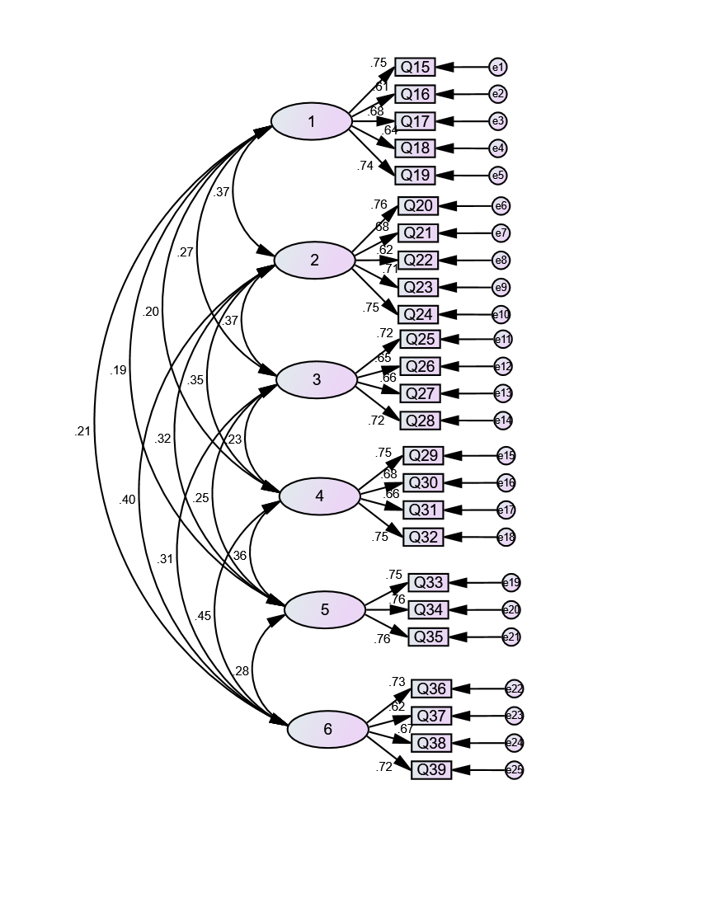

非标准化结果

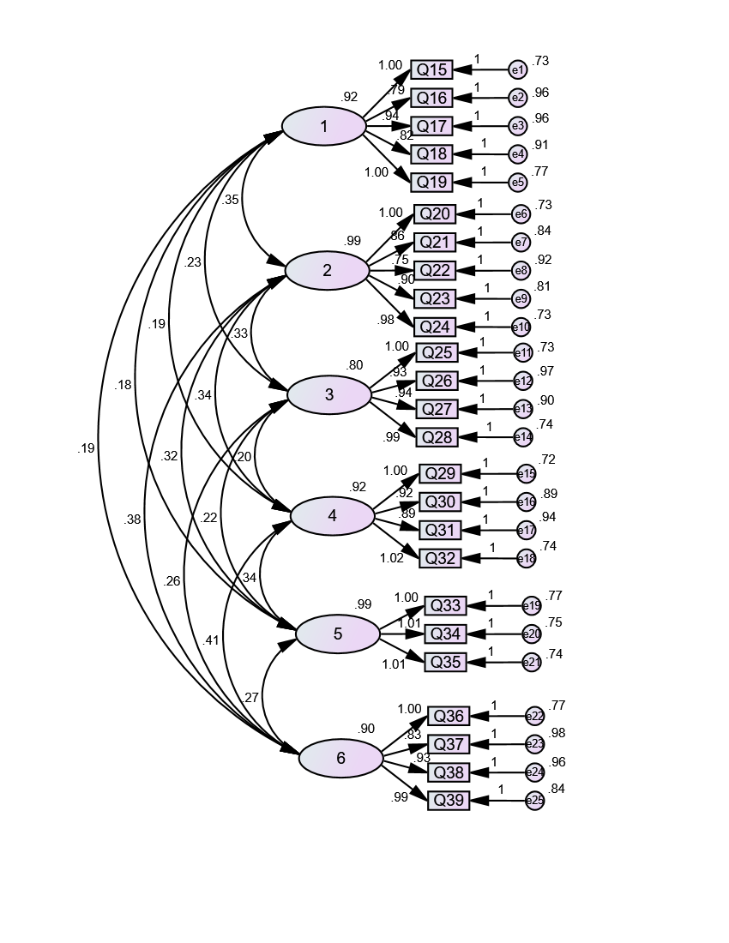

CMIN
Model | NPAR | CMIN | DF | P | CMIN/DF
Default model | 65 | 329.027 | 260 | .002 | 1.265
Saturated model | 325 | .000 | 0
Independence model | 25 | 3219.097 | 300 | .000 | 10.730

RMR, GFI
Model | RMR | GFI | AGFI | PGFI
Default model | .063 | .934 | .918 | .748
Saturated model | .000 | 1.000
Independence model | .374 | .428 | .380 | .395

Baseline Comparisons
Model | NFI  Delta1 | RFI  rho1 | IFI  Delta2 | TLI  rho2 | CFI
Default model | .898 | .882 | .977 | .973 | .976
Saturated model | 1.000 |  | 1.000 |  | 1.000
Independence model | .000 | .000 | .000 | .000 | .000

RMSEA
Model | RMSEA | LO 90 | HI 90 | PCLOSE
Default model | .027 | .017 | .036 | 1.000
Independence model | .165 | .160 | .170 | .000

KMO 和 Bartlett 的检验
取样足够度的 Kaiser-Meyer-Olkin 度量。 |  | .838
Bartlett 的球形度检验 | 近似卡方 | 3136.901
Bartlett 的球形度检验 | df | 300
Bartlett 的球形度检验 | Sig. | .000

解释的总方差
成份 | 初始特征值 |  |  | 提取平方和载入 |  |  | 旋转平方和载入
成份 | 合计 | 方差的 % | 累积 % | 合计 | 方差的 % | 累积 % | 合计 | 方差的 % | 累积 %
1 | 5.836 | 23.345 | 23.345 | 5.836 | 23.345 | 23.345 | 2.976 | 11.905 | 11.905
2 | 2.502 | 10.007 | 33.351 | 2.502 | 10.007 | 33.351 | 2.898 | 11.593 | 23.498
3 | 2.028 | 8.111 | 41.463 | 2.028 | 8.111 | 41.463 | 2.563 | 10.251 | 33.749
4 | 1.822 | 7.288 | 48.751 | 1.822 | 7.288 | 48.751 | 2.480 | 9.918 | 43.667
5 | 1.785 | 7.140 | 55.890 | 1.785 | 7.140 | 55.890 | 2.444 | 9.778 | 53.445
6 | 1.532 | 6.127 | 62.017 | 1.532 | 6.127 | 62.017 | 2.143 | 8.572 | 62.017
7 | .759 | 3.036 | 65.053
8 | .736 | 2.945 | 67.998
9 | .709 | 2.836 | 70.834
10 | .609 | 2.436 | 73.270
11 | .590 | 2.361 | 75.631
12 | .587 | 2.346 | 77.977
13 | .572 | 2.287 | 80.265
14 | .555 | 2.221 | 82.486
15 | .513 | 2.052 | 84.537
16 | .489 | 1.954 | 86.492
17 | .483 | 1.932 | 88.424
18 | .444 | 1.774 | 90.198
19 | .420 | 1.680 | 91.878
20 | .390 | 1.560 | 93.437
21 | .363 | 1.451 | 94.888
22 | .353 | 1.413 | 96.301
23 | .342 | 1.368 | 97.670
24 | .306 | 1.224 | 98.894
25 | .277 | 1.106 | 100.000
提取方法：主成份分析。

旋转成份矩阵ª
 | 成份
 | 1 | 2 | 3 | 4 | 5 | 6
能及时发现患儿用药后的不良反应并简单处理 | .805 | .139 | .073 | .028 | .036 | .124
能规范完成患儿雾化吸入的全程操作 | .762 | .135 | .060 | .153 | .134 | .062
能引导学龄前期患儿配合雾化吸入治疗 | .760 | .071 | .110 | .054 | .079 | .042
能妥善保管患儿哮喘药物，避免药物过期或污染 | .712 | .126 | .064 | .098 | .222 | .081
能准确掌握患儿哮喘用药剂量、用药时间 | .645 | .083 | .163 | .198 | .066 | .060
能准确识别患儿哮喘发作初期的症状（如咳嗽、喘息、胸闷） | .096 | .791 | .024 | .136 | -.034 | -.001
能及时发现患儿哮喘加重的预警信号 | .132 | .777 | .049 | .034 | .037 | .079
能按时记录患儿日间、夜间哮喘症状发作情况 | .065 | .728 | -.012 | .148 | .079 | .019
能判断患儿哮喘症状的严重程度 | .139 | .714 | -.014 | -.009 | .103 | .098
能区分患儿普通感冒咳嗽与哮喘发作咳嗽 | .076 | .694 | .203 | .022 | .043 | .000
能熟练掌握患儿哮喘发作时的应急沟通与就医流程 | .101 | .015 | .791 | .098 | .112 | .115
患儿哮喘急性发作时，能冷静开展居家初步处理 | .131 | .069 | .773 | .022 | .148 | .132
能准确判断患儿哮喘发作是否需要立即就医 | .068 | .007 | .747 | .018 | .134 | .098
能正确使用缓解类药物快速控制患儿急性发作症状 | .124 | .139 | .741 | .088 | .129 | .009
能有效规避患儿哮喘过敏原（如尘螨、花粉、宠物毛发） | .058 | .100 | .031 | .791 | .050 | .070
能科学安排患儿日常活动与运动，避免诱发哮喘 | .130 | .076 | .032 | .766 | .094 | .044
能为患儿营造适宜的居家环境（温湿度、通风管控） | .089 | .024 | .063 | .746 | .096 | .036
能为患儿营造适宜的居家环境（温湿度、通风管控） | .164 | .101 | .084 | .712 | .077 | .076
能主动向医护人员咨询照护中遇到的问题 | .153 | .075 | .151 | -.007 | .759 | .109
能清晰向医生描述患儿居家哮喘症状与照护情况 | .088 | .077 | .154 | .140 | .750 | .082
能按时带患儿完成哮喘定期复查 | .083 | .033 | .090 | .144 | .749 | .066
能准确理解医生的治疗方案与居家照护建议 | .132 | .035 | .125 | .057 | .721 | -.017
能引导患儿适应长期哮喘管理，减少抵触情绪 | .128 | .048 | .062 | .047 | .044 | .844
能安抚哮喘发作时患儿的恐惧、哭闹情绪 | .083 | .119 | .082 | .141 | .028 | .818
能自我调节照护过程中的焦虑、压力等负性情绪 | .100 | .008 | .206 | .038 | .158 | .798
提取方法 :主成份。
旋转法 :具有 Kaiser 标准化的正交旋转法。
a. 旋转在 6 次迭代后收敛。

