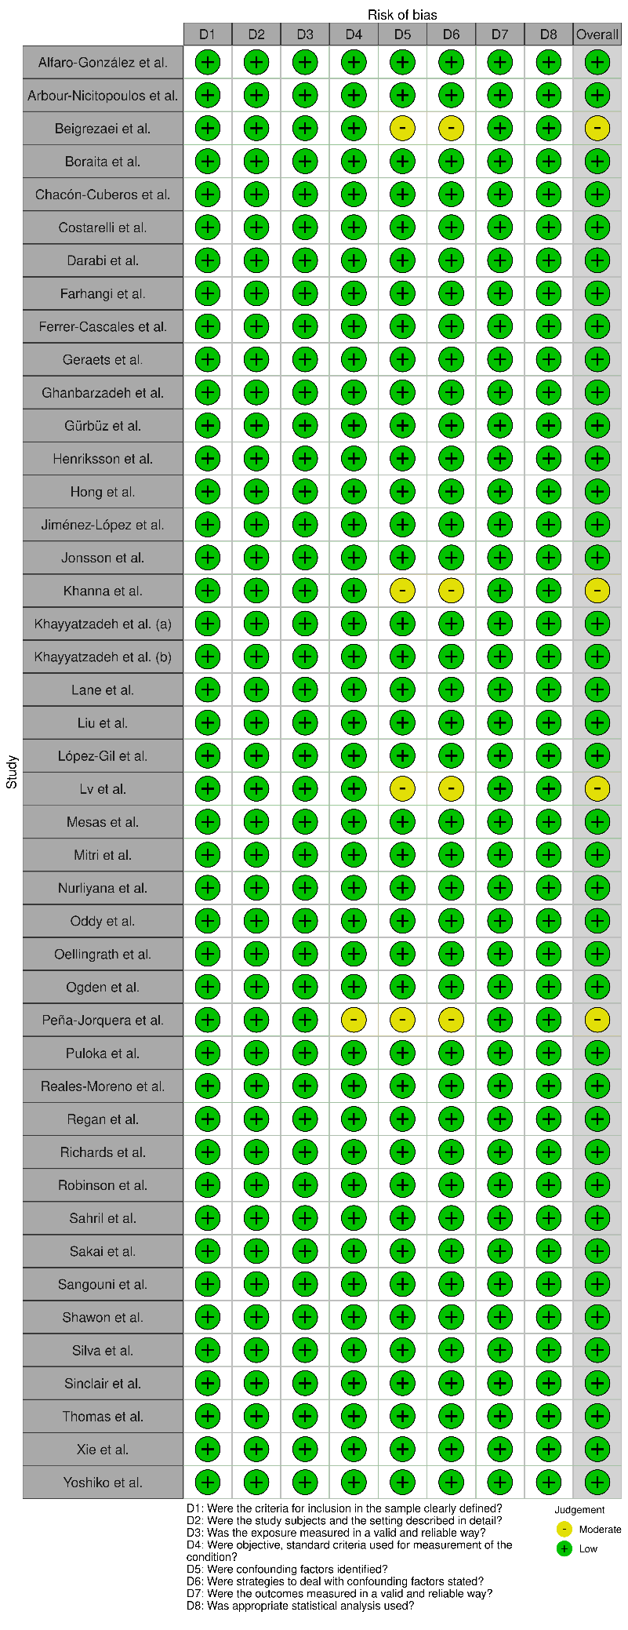
Figure 2: Risk of bias summary: “traffic light” plots of the domain-level judgements for each cross-sectional study result

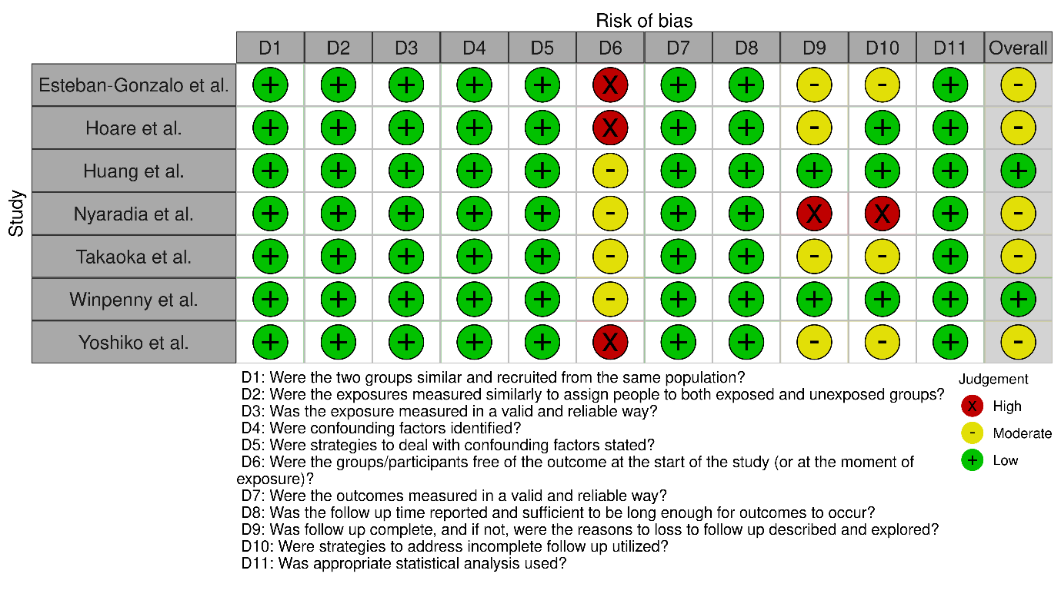
Figure 3: Risk of bias summary: “traffic light” plots of the domain-level judgements for longitudinal study result

