Qualitative Data Processing and Thematic Synthesis Audit Trail
1. Purpose and Overview
This supplementary file outlines the step-by-step workflow used in the qualitative component of the KLCRS QUALY study. It documents how raw interview data were processed and analysed, the role separation to ensure analytical neutrality, and how the final five descriptive themes were synthesised and conceptually mapped to four higher-order domains, following reviewer recommendations.
2. Role Separation and Research Integrity
Data collection, including fieldwork, participant consent, and conducting semi-structured interviews, was undertaken by the lead researcher, who also developed the interview guide. To maintain analytical neutrality and reduce potential bias:
- The coding and thematic synthesis were conducted by independent co-authors not involved in the interviews.
- Analysts had no prior relationship with participants.
- The team met regularly to resolve coding discrepancies and ensure inter-coder reliability.
This role separation aligns with best practices in qualitative research for enhancing reflexivity, confirmability, and trustworthiness.
3. Transcription Protocol
- All interviews were audio-recorded and transcribed verbatim using Otter.ai, an automated speech-to-text transcription tool.
- Transcripts were reviewed and cleaned for accuracy by a co-author.
- Anonymisation was applied to remove any identifiers.
4. Initial Framework Coding
- The verified transcripts were uploaded into Taguette (https://www.taguette.org), an open-source qualitative data annotation tool, for open coding. (1)
- A framework approach was used initially: responses were grouped into five main categories corresponding to the semi-structured interview guide (Q1–Q5).
- Coding was performed by multiple independent analysts, using an inductive approach, and cross-checked for consistency.
- Emerging codes were grouped into sub-themes related to service barriers, workflow realities, legal scope, and family contexts.
5. Visual Exploration with Orange3
- Coded transcripts were then exported to Orange3, an open-source visual analytics toolkit (https://orangedatamining.com). (2)
- Orange3 was used to generate preliminary word frequency plots, co-occurrence maps, and network graphs to visualise links between codes and participant types (public/private sector, profession).
- This supported the thematic synthesis, but final theme regrouping was done manually to capture contextual meaning.
6. Final Thematic Synthesis and Mapping
- Through iterative discussions, the coding team regrouped the original framework -coded segments into five final descriptive themes reflecting practical, regulatory, clinical, and systemic factors. (3)
- These final five themes were then conceptually mapped to four overarching domains (Environmental & Institutional Factors, Family & Socioeconomic Factors, Clinical & Case-Based Practices, Communication & Collaboration) as recommended by peer reviewers.
- A full crosswalk table showing the mapping from Q1–Q5 → final themes → reviewer domains is included below.
7. Crosswalk Table
Original Coded Block (Question) | Final Reported Theme | Reviewer Conceptual Domain(s) | Example Quotes
Q1 – Main Concerns | 1. Service Complexity & Time Burden | Environmental & Institutional | “The chair time is extremely long…” [P(G)]
Q2 – Different Ages | 2. Use of Cycloplegia Varies | Clinical & Case-Based | “Under 4s, I refer if I can’t be sure.” [P(A)]
Q1, Q4 | 3. Regulatory Ambiguity & Restricted Access | Environmental & Institutional | “We can’t keep the drugs on-site—it’s against the poison law…” [P(S)]
Q3 | 4. Perceived Redundancy or Non-Necessity | Clinical & Family/Socioeconomic | “I’m just an optician—I don’t do drugs.” [P(E)]
Q4, Q5 | 5. Systemic Barriers to Access & Continuity | Environmental, Family & Communication | “Parents have to visit multiple places…” [P(J)]

8. Visual Thematic Map
A simplified conceptual map illustrates how the original framework-coded categories (Q1–Q5) were synthesised into five final themes and mapped to the four broader reviewer domains.
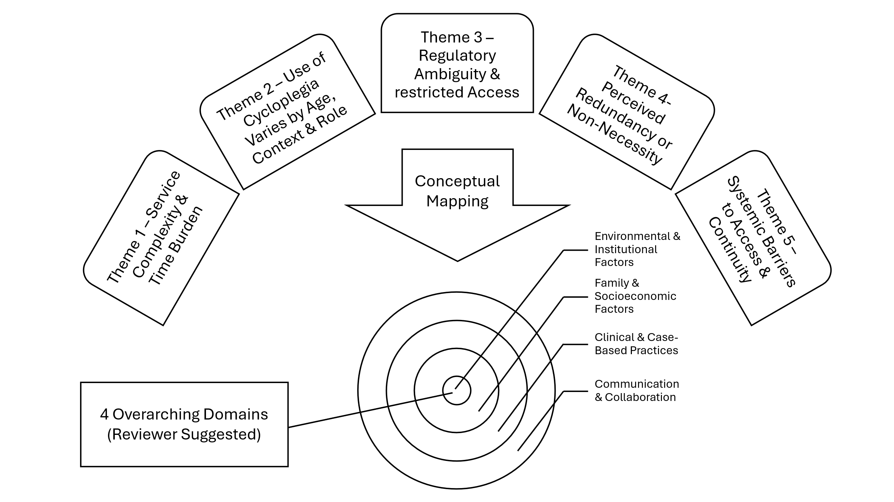
Figure 1: Thematic Synthesis Map
9. Reflexivity and Trustworthiness
- Analysts maintained reflective memos to track assumptions, emerging interpretations, and theme refinement.
- Regular team meetings and consensus-building ensured coding consistency and interpretive rigour.
- This approach aligns with Lincoln and Guba’s principles for qualitative credibility, confirmability, and dependability.
10. Documentation and Data Availability
- All coding decisions, theme definitions, and Orange3 workflows are documented as part of the study’s audit trail.
- These are available in the study’s GitHub repository or from the corresponding author upon reasonable request.
- Ethics Approvals: LSHTM MSc Ethics Ref: 14734; Malaysia MOH NMRR-18-986-41499.
REFERENCES
1. Rampin R, Rampin V. Taguette: open-source qualitative data analysis. Journal of open source software. 2021;6(68):3522.
2. Demšar J, Curk T, Erjavec A, Gorup Č, Hočevar T, Milutinovič M, et al. Orange: Data mining toolbox in python. Journal of machine learning research. 2013;14:2349-53.
3. Gale NK, Heath G, Cameron E, Rashid S, Redwood S. Using the framework method for the analysis of qualitative data in multi-disciplinary health research. BMC Medical Research Methodology. 2013;13(1):117.

