Association and diagnostic value of serum cardiometabolic biomarkers for metabolic-associated steatotic liver disease in children with obesity
Huanyu Wang ¹, Zongming Yang¹, Shimin Wu*, Ying Weng, Ling Hou, Wei Wu, Xiaoping Luo*(0000-0002-3748-4817)
¹ These authors contributed equally
*Corresponding: Xiaoping Luo, Department of Pediatrics, Tongji Hospital, Tongji Medical College, Huazhong University of Science and Technology, Wuhan 430030, China.
E-mail: xpluo@tjh.tjmu.edu.cn
Shimin Wu, Department of Pediatrics, Tongji Hospital, Tongji Medical College, Huazhong University of Science and Technology, Wuhan 430030, China.
E-mail address: wushimin123@tjh.tjmu.edu.cn

Figure S1 Correlation matrix of biomarkers employing Spearman correlation test
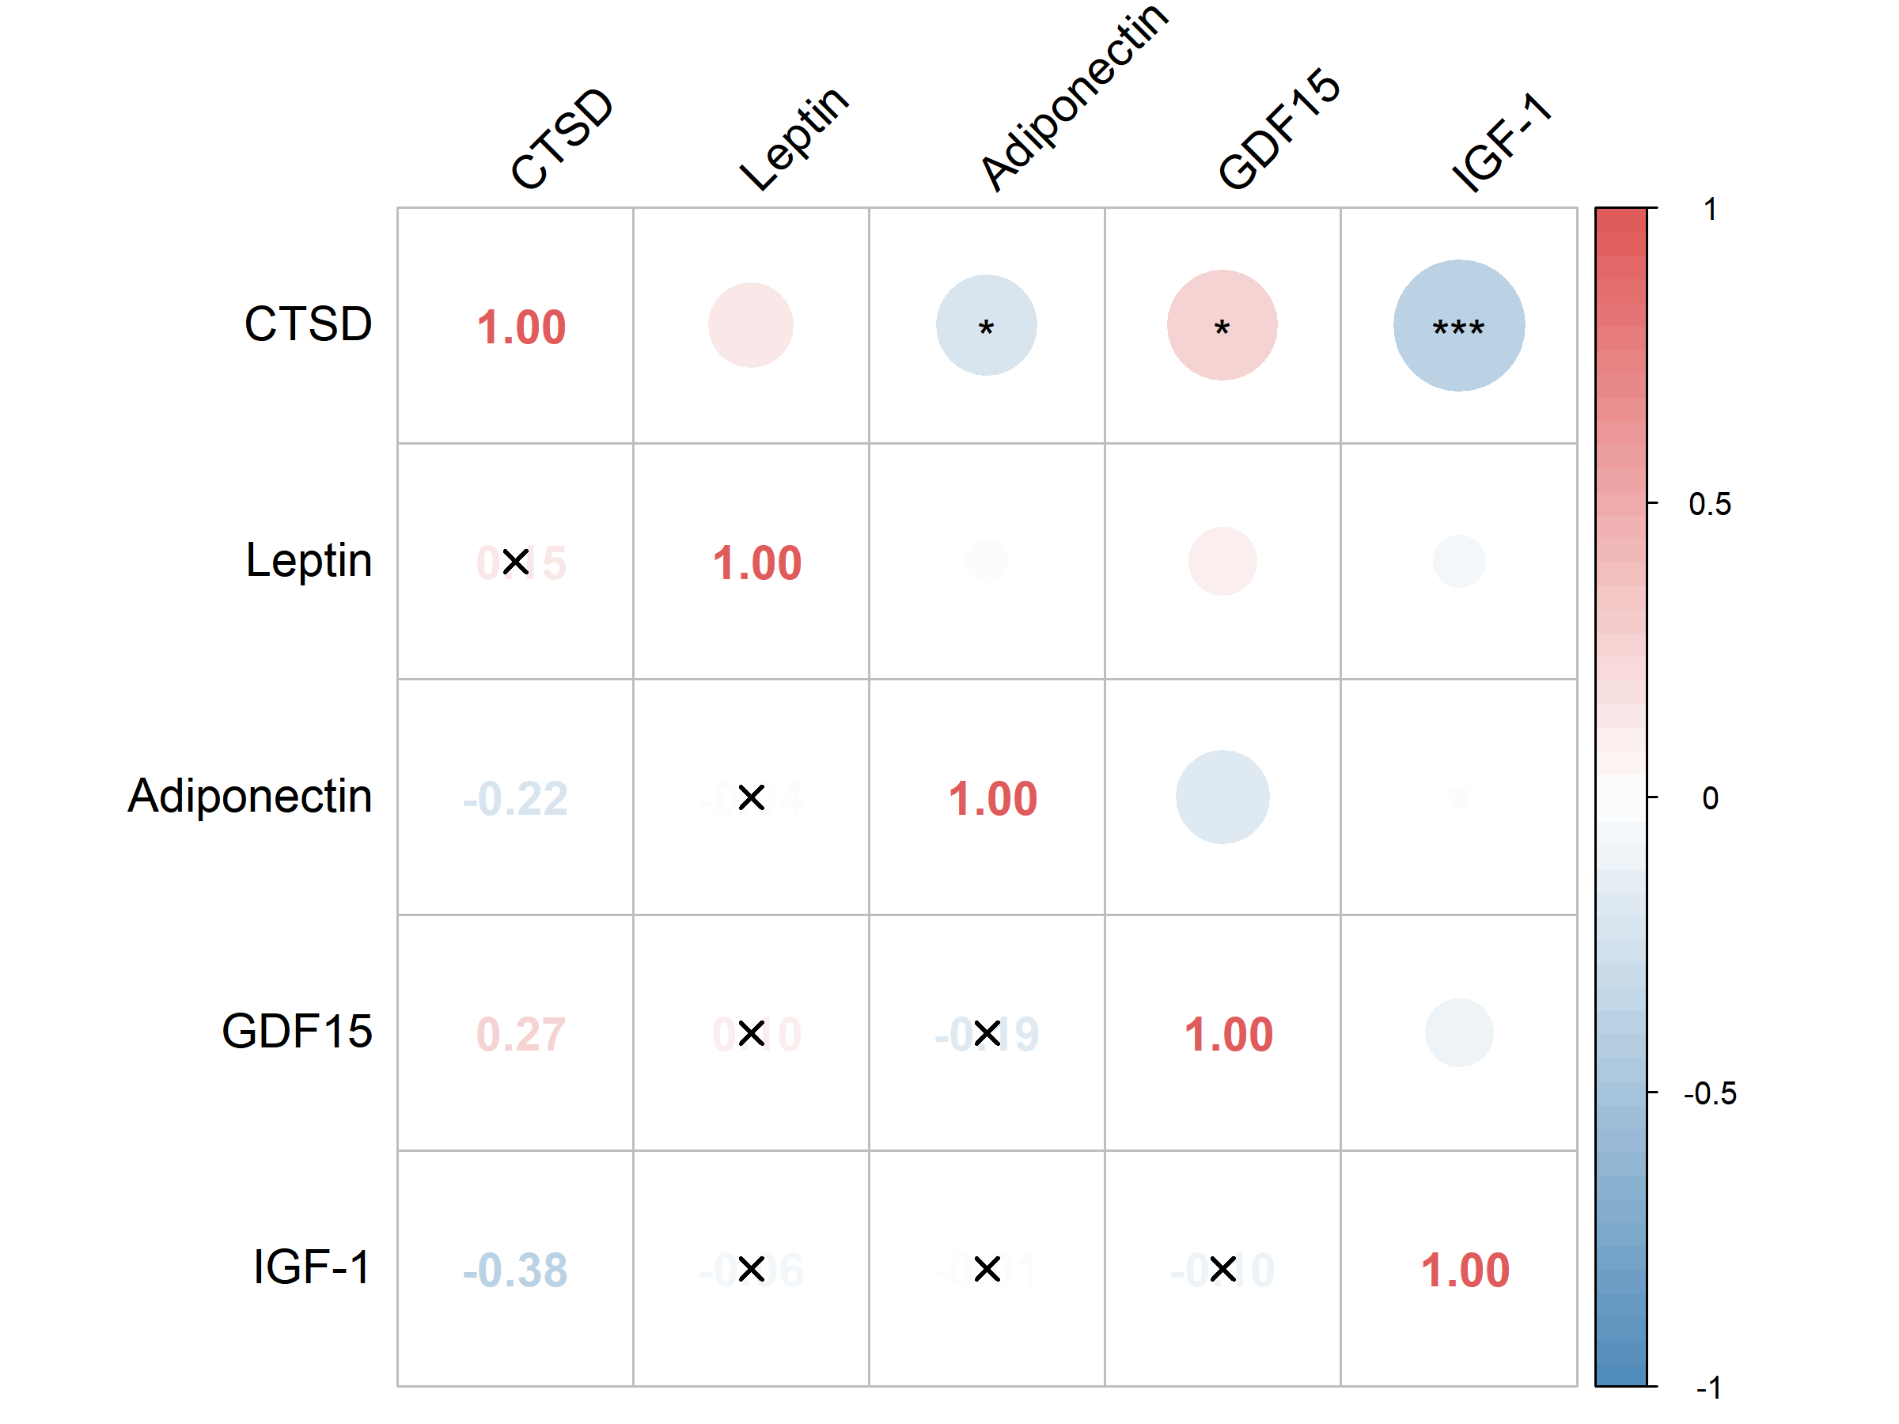
Abbreviations: CTSD=cathepsin D; GDF15=growth differentiation factor 15; IGF-1= insulin-like growth factor-1
Note：* p<0.05; *** p<0.001

Figure S2 Distribution of each biomarker before (left) and after (right) log_{e} transformation
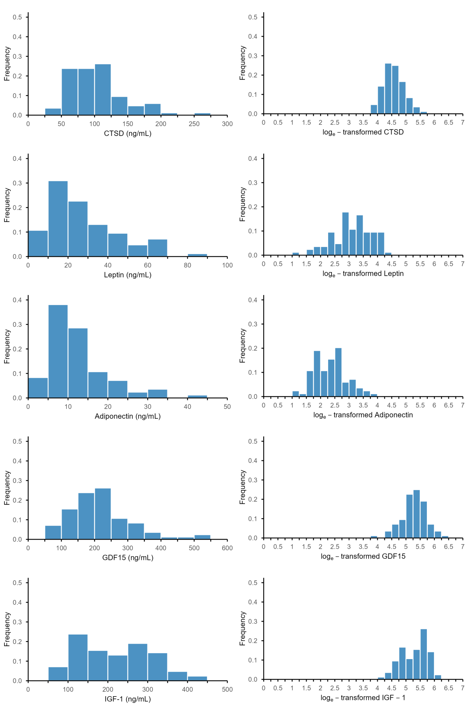
Abbreviations: CTSD=cathepsin D; GDF15=growth differentiation factor 15; IGF-1= insulin-like growth factor-1

Figure S3 ROC curve of each biomarker for diagnosing MASLD
Abbreviations: ROC=receiver operating characteristic curve; AUC=area under the curve; HOMA-IR=homeostatic model assessment for insulin resistance; apoA1=apolipoprotein A1; apoB=apolipoprotein B; ALT=alanine aminotransferase; AST=aspartate aminotransferase; LDL-C=low-density lipoprotein cholesterol; TyG=triglyceride-glucose index; VAI=visceral adiposity index; CTSD=cathepsin D; GDF15=growth differentiation factor-15; IGF-1=insulin-like growth factor-1
Figure S4 Calibration plots of base model and combined model
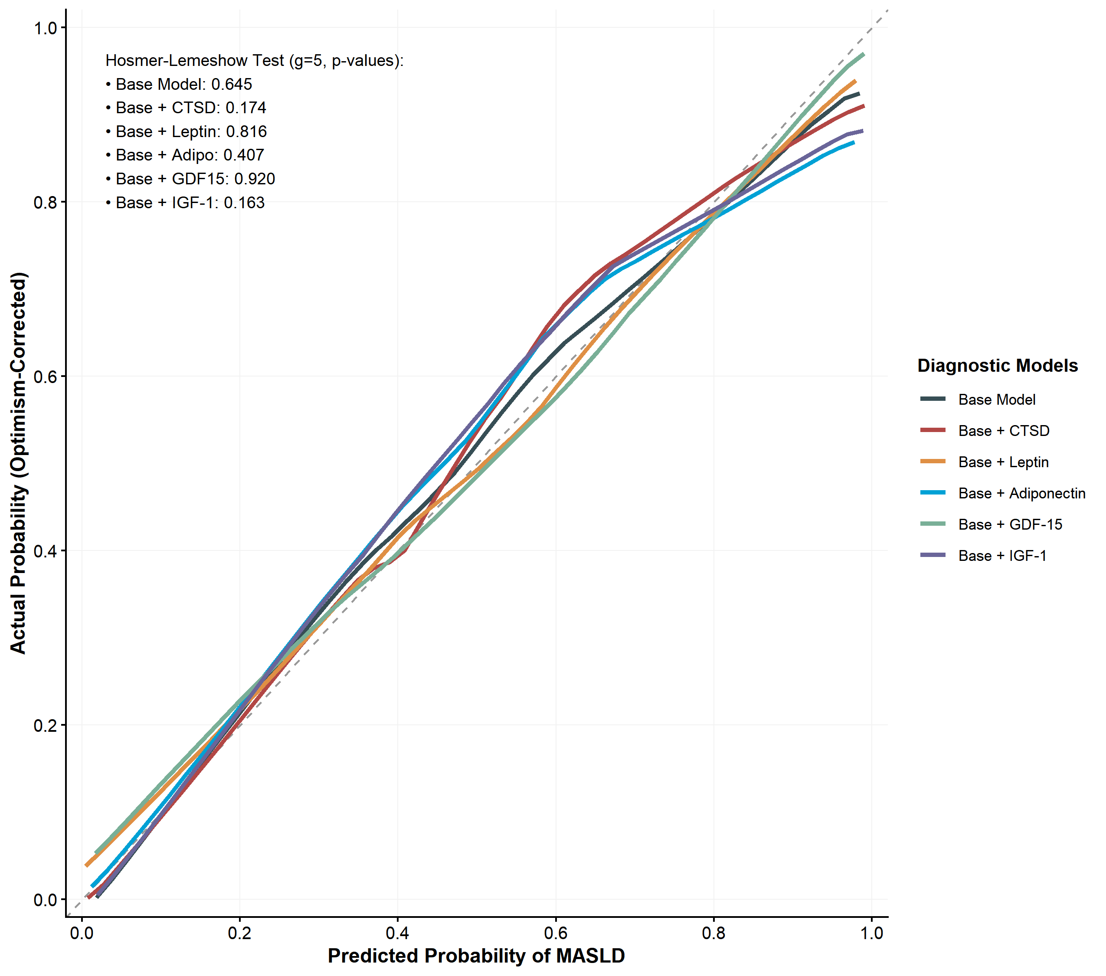
Abbreviations: CTSD=cathepsin D; GDF15=growth differentiation factor-15; IGF-1=insulin-like growth factor-1
Note: The Base model included age, sex, body mass index, and waist-to-height.
Table S1 Optimal cutoff value and diagnostic performance of each predictive model
Model types | Cutoff (Prob) (95%CI) | Sensitivity (95%CI) | Specificity (95%CI)
Base | 0.364 (0.272, 0.719) | 0.991 (0.684, 1.000) | 0.582 (0.657, 0.975)
+HOMA-IR | 0.586 (0.260, 0.724) | 0.780 (0.743, 1.000) | 0.848 (0.701, 0.976)
+apoA1 | 0.563 (0.265, 0.716) | 0.664 (0.690, 1.000) | 0.868 (0.651, 0.974)
+apoB | 0.427 (0.258, 0.701) | 0.878 (0.703, 1.000) | 0.623 (0.645, 0.972)
+ALT | 0.593 (0.288, 0.745) | 0.731 (0.753, 1.000) | 0.961 (0.744, 1.000)
+AST | 0.574 (0.272, 0.742) | 0.741 (0.724, 1.000) | 0.974 (0.710, 1.000)
+LDL-C | 0.610 (0.283, 0.696) | 0.645 (0.750, 0.980) | 0.979 (0.724, 0.977)
+TyG | 0.410 (0.202, 0.762) | 0.941 (0.736, 1.000) | 0.721 (0.674, 0.989)
+VAI | 0.568 (0.242, 0.741) | 0.782 (0.722, 1.000) | 0.839 (0.707, 1.000)
+CTSD | 0.539 (0.278, 0.732) | 0.886 (0.804, 1.000) | 0.922 (0.750, 1.000)
+Leptin | 0.573 (0.234, 0.739) | 0.810 (0.728, 1.000) | 0.839 (0.693, 0.976)
+Adiponectin | 0.452 (0.270, 0.678) | 0.860 (0.741, 1.000) | 0.746 (0.646, 0.953)
+GDF15 | 0.583 (0.295, 0.718) | 0.670 (0.698, 0.981) | 0.882 (0.685, 1.000)
+IGF-1 | 0.410 (0.256, 0.705) | 0.966 (0.734, 1.000) | 0.671 (0.667, 0.976)
Abbreviations: HOMA-IR=homeostatic model assessment for insulin resistance; apoA1=apolipoprotein A1; apoB=apolipoprotein B; ALT=alanine aminotransferase; AST=aspartate aminotransferase; LDL-C=low-density lipoprotein cholesterol; TyG=triglyceride-glucose index; VAI=visceral adiposity index; CTSD=cathepsin D; GDF15=growth differentiation factor-15; IGF-1=insulin-like growth factor-1;
Note: Base model included age, sex, body mass index z score, and waist-to-height ratio

