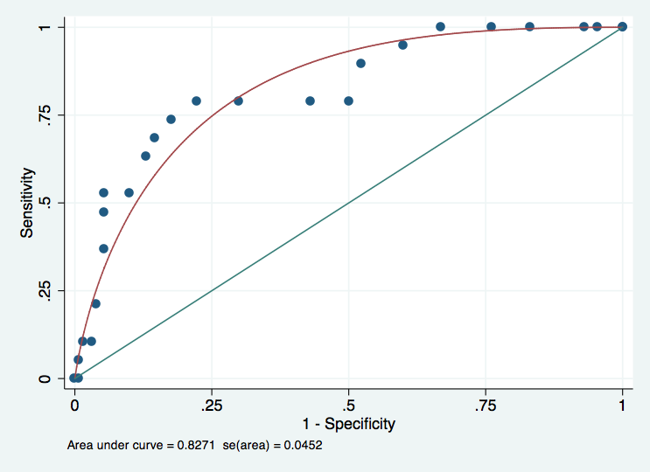
Fig.1 : ROC curve concerning the diagnostis of depression depending on EPDS score at D2

