SUPPLEMENTARY MATERIALS
Prospective multimodal functional and structural neuroimaging investigation of major depressive disorder following treatment with duloxetine. CHY Fu, SG Costafreda, A Sankar, TM Adams, MM Rasenick, P Liu, R Donati, LA Maglanoc, P Horton, LB Marangell.

Supplementary Results

Behavioral Responses

Sad faces task
In response latency, there was a main effect of intensity in which both groups showed a slower response to increasing intensity of expression (F (2,86)=14.96, p<0.001), while there were no significant main effects of time or group, nor any significant second or third order effects.

In accuracy, there were main effects of time in which more errors were made with the successive scans over time (F (3,129)=3.54, p=0.017) and of intensity in which the most errors were made for the highest intensity of expression (F (2,86)=3.744, p=0.028). There were no main effects of group, nor any significant second or third order effects.

Happy faces task
In response latency, there was a main effect of time (F (3,123)=3.30, p=0.023) as the response latencies decreased with successive scans over time. There were no significant effects of intensity or group, nor any significant second or third order effects.
In accuracy, there were no significant main effects of time, intensity, or group. There was a significant interaction effect of intensity by group (F (2,82)=3.85, p=0.025), as MDD participants showed the greatest errors for the medium intensity of expression while healthy participants had greater errors for the lowest intensity, as well as a significant interaction effect of intensity by time (F (6,246)=2.86, p=0.01) in which the most errors were made for the medium and highest intensities at the final (week 12) scan while there were few changes in accuracy for the lowest intensity with successive scans over time.

Emotional Stroop task
In response latency, there was a main effect of valence (F (1,40)=45.23, p<0.001), in which both groups were slower to respond to the negatively valenced words, and a main effect of group (F (1,40)=8.25, p=0.006) as major depressive disorder (MDD) participants were slower than healthy participants, but there was no main effect of time. Significant 2-way interaction effects were found for valence by group (F (1,39)=5.69, p=0.02), as MDD participants showed even greater response latencies for negative words relative to healthy participants, and valence by time (F (3,120)=4.01, p=0.009) in which there was increasing response latency for the neutral words with successive scans over time while the response latency for the negative words was greater at all time points with the slowest response at the baseline (week 0) scan followed by a faster response and subsequent slowing with successive scans.

In accuracy, there was a main effect of valence (F (1,39)=7.37, p=0.010) as both groups showed greater accuracy for neutral words, while there was no main effect of group and a trend towards a main effect of time (F (3,120)=2.46, p=0.066) with improved accuracy with time. There was also a significant valence by group interaction (F (1,39)=7.69, p=0.008), in which healthy participants showed no differences in errors between neutral and negatively valenced words while MDD participants showed greater errors for the negative words. There were no other significant second or third order effects.

Supplementary Table 1. Structural and Functional MRI responses at baseline and Intraclass Correlations for structural MRI regions in healthy participants
 | MDD Patients  N=32 | Healthy Participants  N=25 | p-value
sMRI volume
Anterior cingulate | 9333.5 (1348.2) | 9350.3 (1584.7) | 0.967
Left amygdala | 1535.6 (160.7) | 1502.1 (169.1) | 0.468
Right amygdala | 1698.8 (223.6) | 1732.2 (236.3) | 0.604
Left hippocampus | 4314.3 (426.5) | 4179.2 (336.4) | 0.216
Right hippocampus | 4310.6 (398.4) | 4210.9 (394.4) | 0.370
fMRI BOLD contrast responseto sad facial expressions
Anterior cingulate | -0.07 (0.49) | -0.15 (0.51) | 0.565
Left amygdala | 0.42 (0.60) | 0.62 (0.67) | 0.239
Right amygdala | 0.19 (0.52) | 0.42 (0.58) | 0.129
Left hippocampus | 0.23 (0.37) | 0.35 (0.47) | 0.324
Right hippocampus | 0.19 (0.41) | 0.29 (0.46) | 0.392
Intraclass Correlations
Anterior cingulate | n/a | 0.954
Left amygdala | n/a | 0.911
Right amygdala | n/a | 0.936
Left hippocampus | n/a | 0.961
Right hippocampus | n/a | 0.976
Mean values and standard deviations in parentheses are presented. Units of measure for sMRI volumes are cm³ and for fMRI BOLD response are in %. Abbreviations: BOLD, blood oxygenation level-dependent; fMRI, functional magnetic resonance imaging; MDD, major depressive disorder; N, number of participants; n/a, not applicable; sMRI, structural magnetic resonance imaging.

Supplementary Table 2. Pearson correlation between change in neuroimaging and clinical measures (last-observation-carried-forward analysis) in MDD patients (N=28)
Region | Study Interval | Endpoint Measure | r | p-value
fMRI BOLD anterior cingulate | Baseline | HAMA total score | -0.403 | 0.034
 | Baseline to week 8 |  | 0.427 | 0.024
 | Baseline to week 12 |  | 0.456 | 0.015
fMRI BOLD anterior cingulate | Baseline to week 8 | CGI-S | 0.405 | 0.032
 | Baseline to week 12 |  | 0.359 | 0.61
fMRI BOLD anterior cingulate | Baseline | PGI-I | -0.458 | 0.014
 | Baseline to week 1 |  | 0.450 | 0.016
 | Baseline to week 8 |  | 0.343 | 0.074
 | Baseline to week 12 |  | 0.436 | 0.020
sMRI volume left hippocampus | Baseline to week 1 | HRSD-17 total score | -0.339 | 0.077
 | Baseline to week 12 |  | -0.300 | 0.120
Abbreviations: BOLD, blood oxygenation level-dependent [contrast]; CGI-S, Clinical Global Impression of Severity scale; fMRI, functional magnetic resonance imaging; HRSD-17, 17-item Hamilton Rating Scale for Depression; LOCF, last observation carried forward; MDD, major depressive disorder; N, number of participants; PGI-I, Patient Global Impression of Improvement scale; sMRI, structural magnetic resonance imaging

Supplementary Table 3. Prognosis classifier and week 12 clinical remissionin MDD patients (N=28) (last-observation-carried-forward analysis)

Neuroimaging Measure | Study Interval | Odds Ratioª (95% CI) | p-value
sMRI volume left hippocampus | Baseline to week 1 | 1.01 (1.00, 1.02) | 0.031
 | Baseline to week 12 | 1.01 (1.00, 1.02) | 0.042
ªOdds ratio corresponding to a 10 mm³ increase in volume
Abbreviations: CI, confidence interval; LOCF, last observation carried forward; MDD, major depressive disorder; N, number of participants; sMRI, structural magnetic resonance imaging

Supplementary Figure 1. Study Design

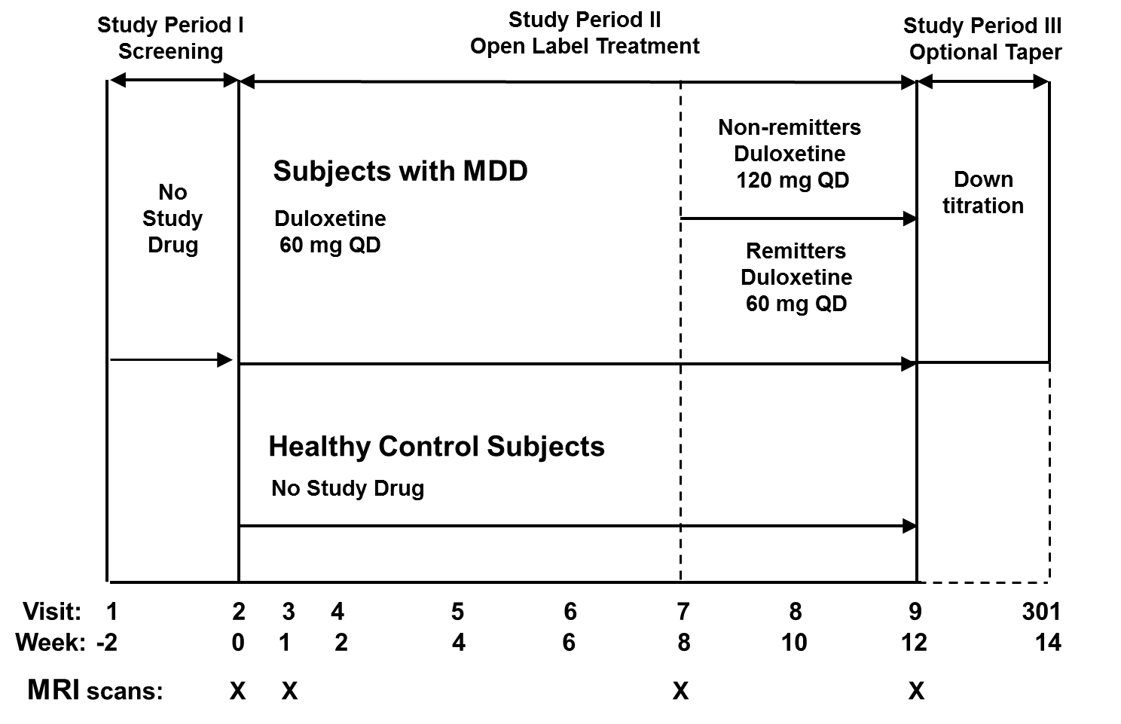
Abbreviations: MDD, major depressive disorder; MRI, magnetic resonance imaging; QD, once daily

Supplementary Figure 2. Independent component analysis of resting-state fMRI revealed five component networks representing core areas of the default mode network.

