Figure S1. Percentage (95% CI) of 3C Subjects with any IADL impairmentª at each assessment
by Depressive Symptom Change over 1 Year.
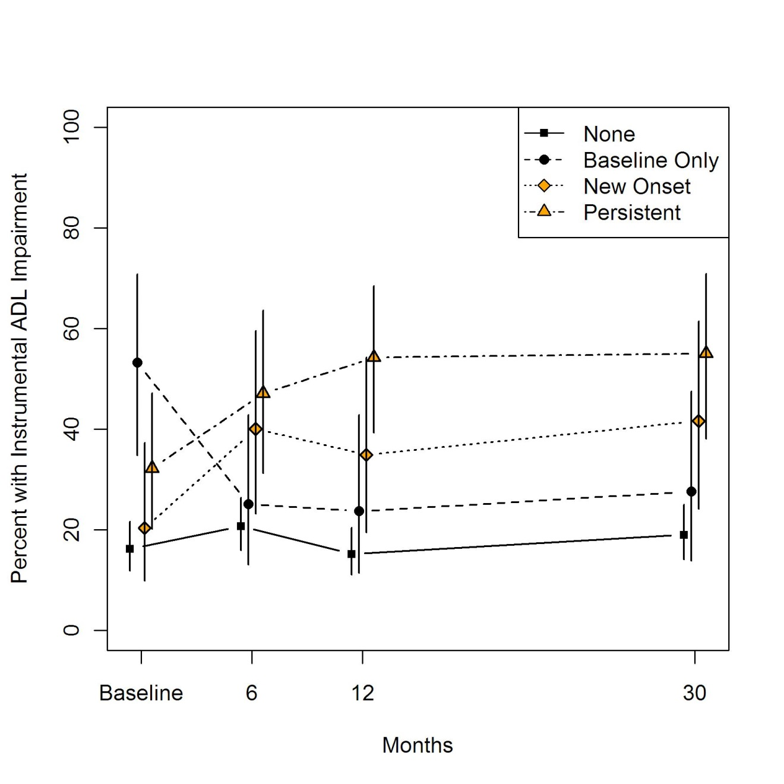
ªadjusted for age, sex and baseline MMSE

 | Baseline | 6 | 12 | 30
None | 16.21 | 20.69 | 15.20 | 19.00
Baseline Only | 53.21 | 25.14 | 23.70 | 27.63
New Onset | 20.37 | 40.05 | 34.91 | 41.61
Persistent | 32.23 | 47.12 | 54.24 | 55.02
Adjusted Percentage of Patients with any IADL over time by Depression Category

Figure S2. Percentage (95% CI) of 3C Subjects with any BADL impairmentª at each assessment
by Depressive Symptom Change over 1 Year.
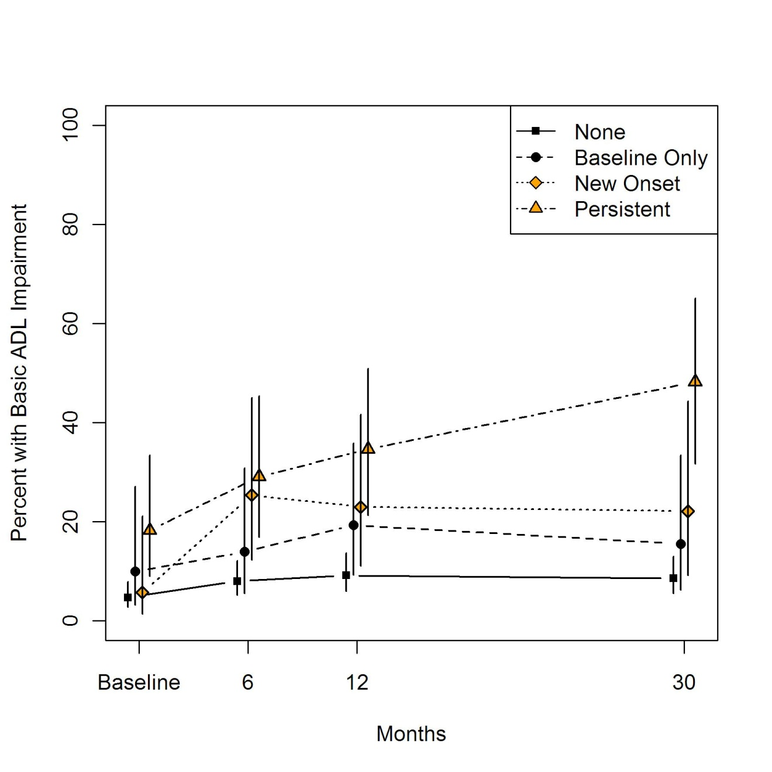
ªadjusted for age, sex and baseline MMSE

 | Baseline | 6 | 12 | 30
None | 4.70 | 8.02 | 9.16 | 8.55
Baseline Only | 9.97 | 13.92 | 19.33 | 15.50
New Onset | 5.76 | 25.35 | 22.99 | 22.13
Persistent | 18.24 | 29.10 | 34.64 | 48.23
Adjusted Percentage of Patients with any BADL over time by Depression Category

