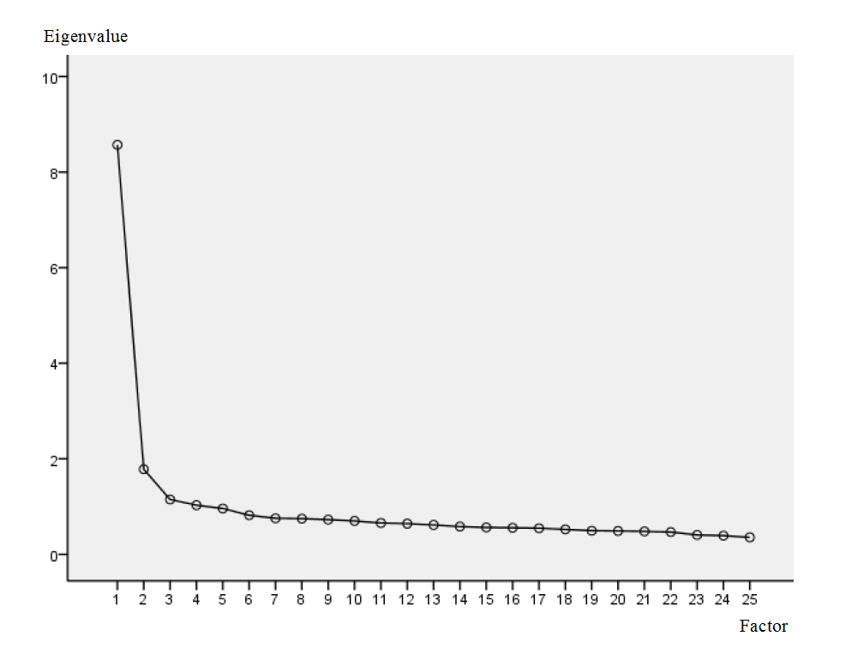
Supplementary Figure 1 Scree plot of the present 4-factor structure

