Online appendix material

Figure A1. Plotted test of eigenvalues across countries from full youth samples

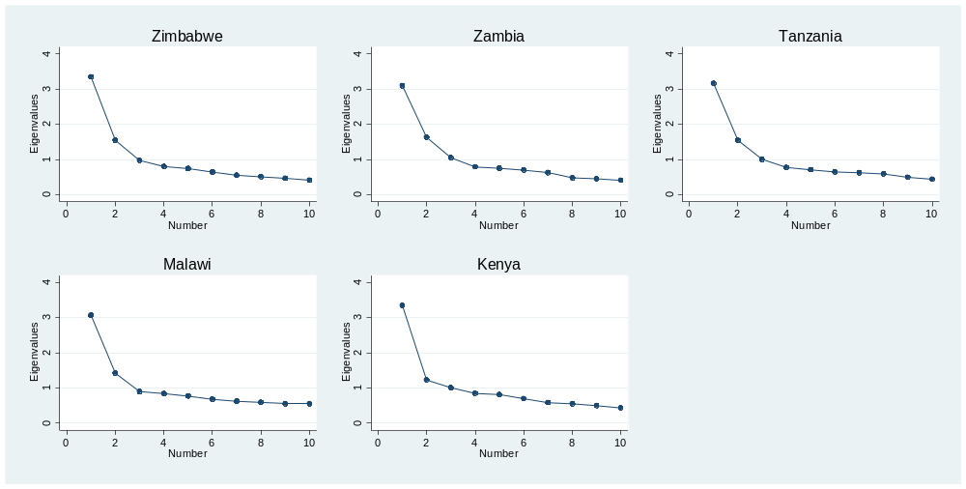

Notes: Plots based on “Scree test” suggested in Atkins (2014)

Figure A2. Kernel density graphs of CES-D 10 scores for 18 years and under samples by individual country

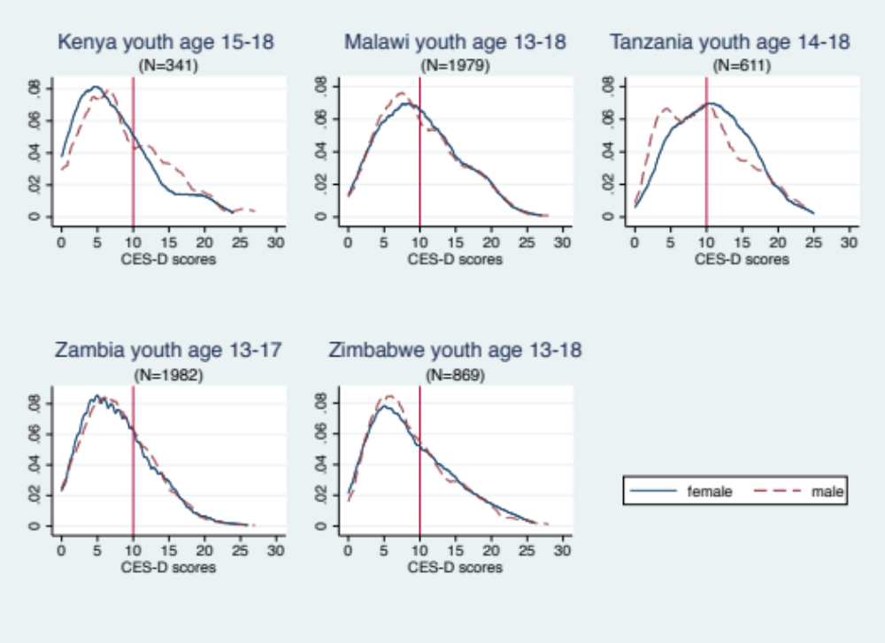
Table A1. Studies in sub-Saharan Africa using the CES-D among or including youth populations (alphabetical by author)
Reference | Aim of study | Sample | Location | Depression | Correlates of depressive symptoms | Internal  Reliability  (Cronbach’s Alpha)
Asante & Andoh-Arthur [2015] | Cross-sectional study to assess prevalence and determinants of depressive symptoms. | 270 university students [average age 22 years] from the Department of Psychology were conveniently sampled. | Accra, Ghana | 39.2% scored above a cut-off point at 10 using the 10-item CES-D. | Lack of support, heaving episodic drinking, forced sex, physical and sexual assault as a child, and having been beaten by a sexual partner were associated with depressive symptoms. | 0.72
Baron et al. [2017] | Cross-sectional study to establish the reliability and validity of the CES-D-10 among the general adult Zulu, Xhosa and Afrikaans speaking populations in South Africa. | Stratified random samples of Xhosa, Afrikaans and Zulu-speaking participants aged 15 years or older (N = 944)  (Very few adolescents were recruited to the study and almost none reported depression so results are for the full sample). | Cape Town Metro and Ethekwini districts, South Africa | 6.6% of Zulu, 18.0% of Afrikaans and 6.9% of Zulu samples were diagnosed with depression  using MINI diagnosis. The most appropriate CES-D 10 cut-offs were found to be 12, 11 and 13, respectively. | Socio-demographic measures associated with depression included female gender, older age, being divorced or widowed and retired were associated with depression. | 0.69-0.89
Brown et. al. [2009] | Quasi-experimental study to test a mentorship program for youth-headed households and the effect on psychosocial outcomes among the youth. | 692 youth heads of households in intervention and control villages were interviewed [12-24 years] at baseline. At follow-up, 593 individuals [14-27 years] were included. | South-western Rwanda | Average CES-D score, 23.3 [control group] using the 20-item CES-D. | Mentorship program participation was associated with lower levels of depressive symptoms. Being female, a higher education, not living alone, having a parent killed in the genocide, poor health, having fewer assets and eating only one meal per day were associated with more depressive symptoms. | 0.86
Kilburn et. al [2015] | Randomized controlled trial to study the impact of a cash transfer program on mental health outcomes among youth. | 1960 young people [15-24 years] were interviewed 4 years after the start of the program. | Kenya | 32% in the intervention group and 37% in the control group scored above a cut-off point of 10 using the 10-item CES-D. | The cash transfer reduced the odds of showing depressive symptoms. In addition, higher age and living in Nairobi were associated with higher odds of depression and no illness/injury in the past 4 weeks were associated with lower odds. | Not reported in text
Mukabutera et. al [2013] | Cross-sectional study with the aim to investigate psychosocial outcomes [including depression] and socio-economic status and quality of mentoring relationships. | 201 youth heads of households [11-24 years] and participating in an adult mentoring program were sampled. | Bugasera, Rwanda | The 20-item CES-D was used. | Being female, location of the household and water from river, rain or stream as main water source were associated with depression. | 0.87
Nduna et. al. [2013] | Cross-sectional study with the aim to explore determinants of depressive symptoms in South African youth. | 1415 women and 1368 men [15–26 years] enrolled in an evaluation study of an HIV intervention were sampled based on their willingness to participate. | Eastern Cape Province, South Africa | Prevalence of depressive symptoms was 20.5% in women and 13.5% in men using a cut-off at 16 using the 20-item CES-D. | Factors associated with higher levels of depressive symptoms: Being female, childhood adversity, sexual violence and substance misuse. Among women only: intimate partner violence and lower perceptions of community cohesion. Among men only: a mother’s death and relationship conflict. | 0.90 for women;  0.91 for men
Neese et al. [2013] | Cross-sectional study with the aim to explore links between stress, coping strategies, depression and somatic complaints. | 299 adolescents [11-19 years] were recruited from a boarding secondary school. | Zambia | 37% scored above a cut-off of 28 using the 20-item CES-D. | Higher levels of perceived stress, and more coping were associated with increased depressive symptoms. | Not reported in text
Othieno et. al. [2015] | Cross-sectional study with the aim to describe links between risky sexual behaviour, depressive symptoms and socio-demographic characteristics | 923 [525 males and 365 females] undergraduate students with a mean age of 23 years were sampled. | Nairobi, Kenya | 41.33% scored above a cut-off point of 10 using the 10-item CES-D. | Tobacco use, positive history of HIV or other Sexual Transmitted Infection (STI), experience of traumatic event, such as abuse, as a child were associated with depression. | Not reported in text
Otwombe et. al. [2015] | Cross-sectional study with the aim to describe socio-demographic characteristics and health seeking behaviours. | 830 adolescents [14-19 years] were included in the study. | Soweto, South Africa | 48.1% scored above a cut-off point of 24 using the 20-item CES-D. | Not reported | 0.81
Peltzer et al. [2013] | Cross-sectional study with the aim to explore links between mental health, childhood abuse and HIV sexual risk behaviour | 824 university students [50% men and 50% women] with a mean age of 23.7 years. | Abidjan, Ivory Coast | 17.6% scored above a cut-off point of 10 using the 10-item CES-D. | HIV risk behaviour was found to be associated with depression. | 0.72
Pengpid et al. [2013] | Cross-sectional study to explore assocaitons between mental health, substance use and HIV sexual risk behaviour | 722 undergraduate university students [mean age = 21.7] were recruited from University of Limpopo Medical University of Southern Africa | Limpopo, South Africa | 39.5% showed depressive symptoms above a cut-off point of 10 using the 10-item CES-D. | Among men: intimate partner violence, forced sex and physical abuse as a child. Among women: sexual partner violence. | 0.72
Pretorius [1991] | Cross-sectional study to determine the validity and reliability of the CES-D scale among black South African students. | 450 undergraduate students in psychology [19-53 years, mean age=24] from the University of the Western Cape. | Cape Town, South Africa | Average CES-D score 15.0 among men and 17.1 among women using the 20-item CES-D. | Being female, coming from a rural area and being a part-time student. | 0.90

Table A2. Summary of cash transfer program and evaluation characteristics
Country | Program | Targeting | Data collection | Ethical (IRB) Approval
Kenya | Cash Transfer for Orphans and Vulnerable Children  (CT-OVC) | Ultra-poor households with at least one orphan or vulnerable child (OVC) under the age of 18 residing in the household | Baseline data were collected in 2007 across seven districts (Homa Bay, Garissa, Kisumu, Kwale, Migori, Nairobi and Suba), however the youth module with the CES-D scale was an addition to the 2011 endline survey. Out of the 2,759 households that were interviewed at baseline; 2,255 were interviewed again at endline. | The University of North Carolina at Chapel Hill IRB and the Kenya Medical Research Institute Ethics Review Committee
Malawi | Social Cash Transfer Program (SCTP) | Ultra-poor, labor-constrained households (those with a dependency ratio higher than three) | Baseline data were collected in 2014 and include a total of 3,531 households in Salima and Mangochi districts. | The University of North Carolina at Chapel Hill IRB, Malawi’s National Commission for Science and Technology (NCST), and National Committee for Research in Social Sciences and Humanities
Tanzania | Productive Social Safety Net (PSSN) | Poor households living below the food poverty line, as determined by community-based targeting, and verified by a proxy means test | Baseline data were collected in 2015 in 84 communities within eight districts of mainland Tanzania (Misungwi, Kahama, Kilola, Kisarawe, Handeni, Mbogwe, Itilima, Uyui). The sample includes a total of 801 households, all of which include resident youth aged 14 to 28 years. | Tanzania’s Commission for Science and Technology (COSTECH)
Zambia | Multiple Category Targeted Grant (MCTG) | Households with a disabled member, or other vulnerable households such as those with a female or elderly head keeping orphans | Baseline data were collected in 2011 in 92 communities from the Luwingu and Serenje districts. The baseline sample includes 3,078 households. | American Institute for Research IRB and the University of Zambia’s Research Ethics Committee
Zimbabwe | Harmonized Social Cash Transfer (HSCT) | Food-poor and labor-constrained households (no able bodied prime-age member or dependency ratio of three or above, or special cases) | Baseline data were collected in 2013 six districts (Binga, Chiredzi, Hwange, Mudzi, Mwenzi and Uzumba-Maramba-Pfungwe (UMP)), within 90 wards, for a total of 3,063 households. | American Institute for Research IRB and the Medical Research Council of Zimbabwe

Table A3. Questionnaire translations for CES-D 10 in local languages
 | English | Bemba [Zambia] | Chichewa [Malawi] | Shona [Zimbabwe] | Swahili [Kenya/Tanzania]
 | Reference period is previous 7 days [one week] |  | Pa masiku 7 apitawa ndi masiku angati amene | Wakarara zvakanaka here? | Kipindi husika ni siku saba zilizopita [ wiki moja]
(1) | How often did you sleep well? | Munshiku 7 ishapita Kunuma, ninshiku shinga isho mwalelepo bwino? | Unagona bwino? | Wakaraa zvankanaka here? | Kwa siku saba zilizopita ni mara ngapi ulilala vizuri
(2) | How often were you happy? | Munshiku 7 ishapita kunuma, ninshiku shinga isho mwalipo abansansa? | Unali osangalala? | Wanga uchifara here? | Mara ngapi ulikuwa na furaha?
(3) | How often did you have trouble concentrating? | Munshiku 7 ishapita kunuma, ninshiku shinga isho mwakwetepo ubwafya bwa kutontontonkaya pachintu chimo? | Unali ndimavuto kutsatila zinthu mwachidwi? | Waive nedambudziko here rekuti pfungwa dzive pamwechete? | Mara ngapi umekuwa unashughuliki na matatizo?
(4) | How often do you feel hopeful about the future? | Munshiku 7 ishapita kunuma, ninshiku shinga isho tamwali abakusakamana pafintu ifyakuntanshi mumweo wenu? | Unali ndi chiyembekezo chabwino cha tsogolo? | Wanga une tariro yakanaka here mune remangwana? | Mara ngapi umekuwa na matumaini kuhusu wakati ujao?
(5) | How often did you feel that everything you did was an effort? | Munshiku 7 ishapita kunuma, ninshiku shinga isho mwaumfwile ati fyonse ifyo mwachitile fyali fyakutulukusha? | Kuti chilichonse umapanga unavutikila? | Wanga uchinzwa here kuti zvese zvawanga uchiita ndezvekushingaira? | Mara ngapi umejisikia kwamba kila kitu ulichofanya ni bidii?
(6) | How often did you feel lonely? | Munshiku 7 ishapita Kunuma, ninshiku shinga isho mwaumfwile abankumba bulili? | Unali osungulumwa? | Wanga uchisurukirwa here? | Mara ngapi unajisikia mpweke?
(7) | How often did you feel depressed? | Munshiku 7 ishapita Kunuma, ninshiku shinga isho mwaumfwile abatitikishiwa? | Unali okhumudwa? | Wanga uchinzwa kutambudzika mumoyo nemupfungwa here? | Mara ngapi unajisikia msongo wa mawazo?
(8) | How often did you feel that you ould not ‘get going’? | Munshiku 7 ishapita Kunuma, ninshiku shinga isho mwaumfwile ati teti mukwanishe ukutwalilila? | Unaona kuti zinthu sizikuyenda? | Wanga uchinzwa here kuti zvinhu hazvisi kufamba? | Mara ngapi unajisikia kuwa huwezi kujihamasisha mwenyewe kufanya kile kitu unachotaka kukifanya?
(9) | How often were you bothered by things that don’t usually bother you? | Munshiku 7 ishapita Kunuma, ninshiku shinga isho mwali abakusakamikwa nefintu ifishimisakamika? | Unasautsidwa ndi zinthu zimene sizimakusautsa nthawi zonse? | Wanga uchishungurudzika here nezvinhu zvisingawanzo kushungurudza? | Mara ngapi unasumbuliwa na vitu ambavyo kwa kawaida huwa havikusumbui?
(10) | How often did you feel fearful? | Munshiku 7 ishapita Kunuma, ninshiku shinga elyo mwali aba mwenso? | Unali ndi mantha? | Wanga uchinzwa kutya here? | Mara ngapi unajisikia woga?

Table A4 Summary of criteria for reliability and validity assessment of CES-D scale among the full sample
Criterion |  | Zimbabwe | Zambia | Tanzania | Malawi | Kenya
(1a) | Each factor with eigenvalue ≥1 should be rotated (number of qualifying factors) | 2 factors | 3 factors | 3 factors | 2 factors | 3 factors
(2) | Each item should load ≥0.40 on the primary factor | All items meet criteria, except effort | All items meet criteria | All items meet criteria, except effort and sleep | All items meet criteria | All items meet criteria except concentrate and effort
(3) | No cross-loading (a difference of at least 0.20 on item loading between factors) | All items meet criteria | All items meet criteria | All items meet criteria | All items meet criteria | All items meet criteria
(4) | No trivial factors (all factors have at least 3 or more items loading at 0.30 or higher) | Achieved | Achieved | Achieved | Achieved | Achieved
(5) | Factors with coefficient alpha > 0.70 | Not achieved | Not achieved | Not achieved | Not achieved | Not achieved
Notes: Criteria based on Atkins (2014). For “Scree test” of visual representation of eigenvalue plots, see Appendix Figure A1.

