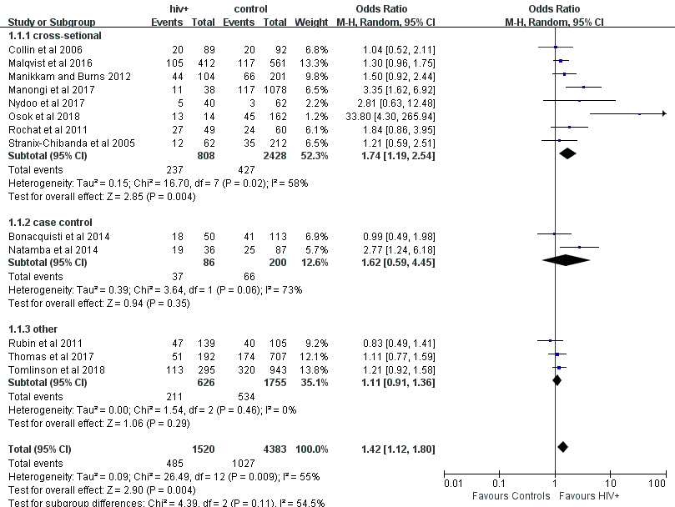
Fig. S1. Sub-group analysis of different study designs of antenatal depression in HIV-infected women compare with controls
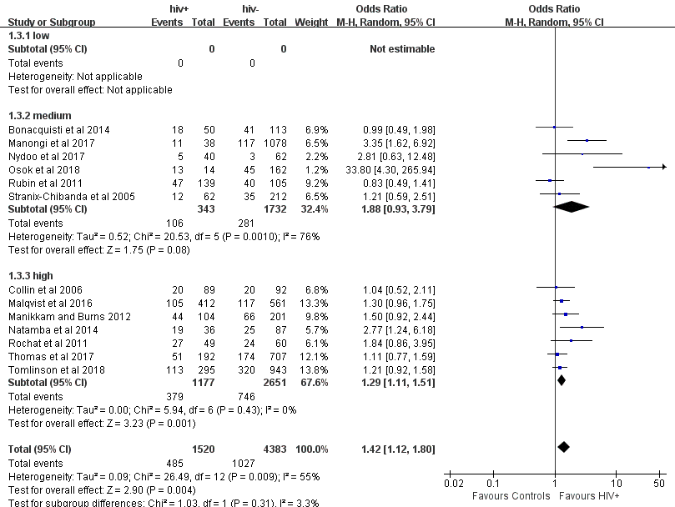
Fig. S2. Sub-group analysis of different study quality of antenatal depression in HIV-infected women compare with controls
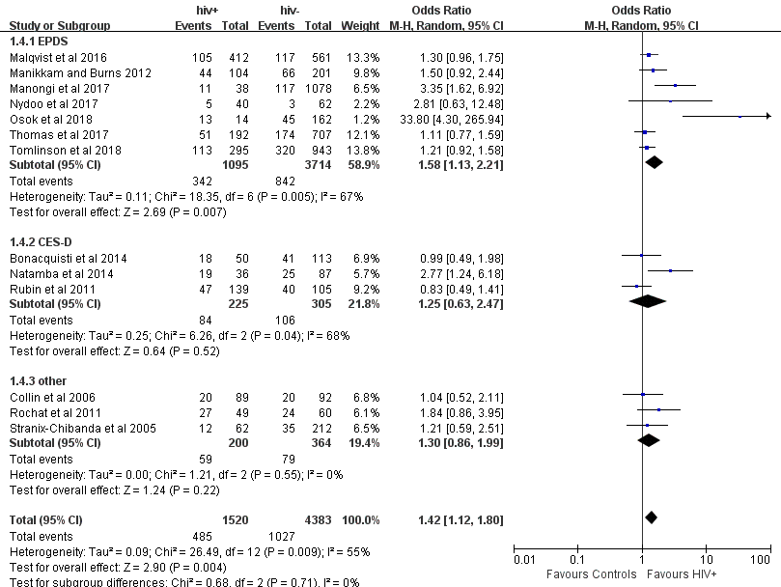

Fig. S3. Sub-group analysis of different screening tools of antenatal depression in HIV-infected women compare with controls
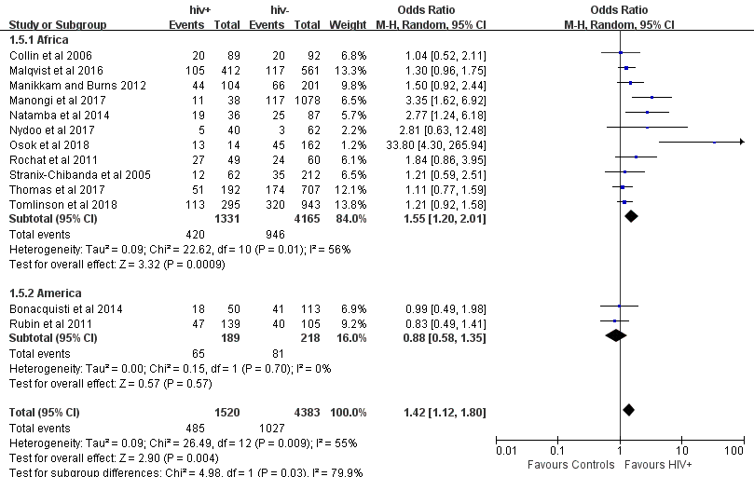

Fig. S4. Sub-group analysis of different geographical locations of antenatal depression in HIV-infected women compare with controls
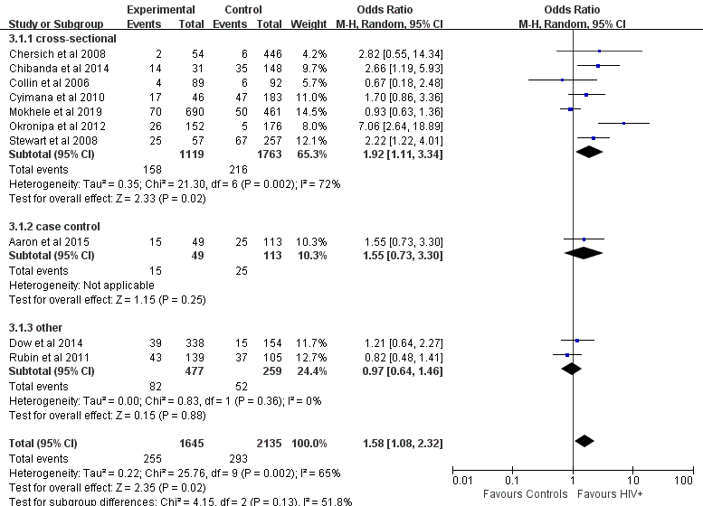
Fig. S5. Sub-group analysis of different study designs of postnatal depression in HIV-infected women compare with controls
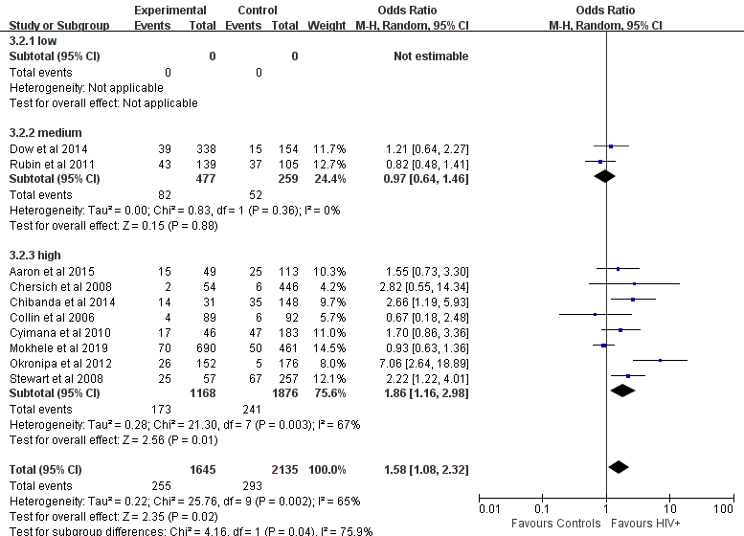
Fig. S6. Sub-group analysis of different study quality of postnatal depression in HIV-infected women compare with controls
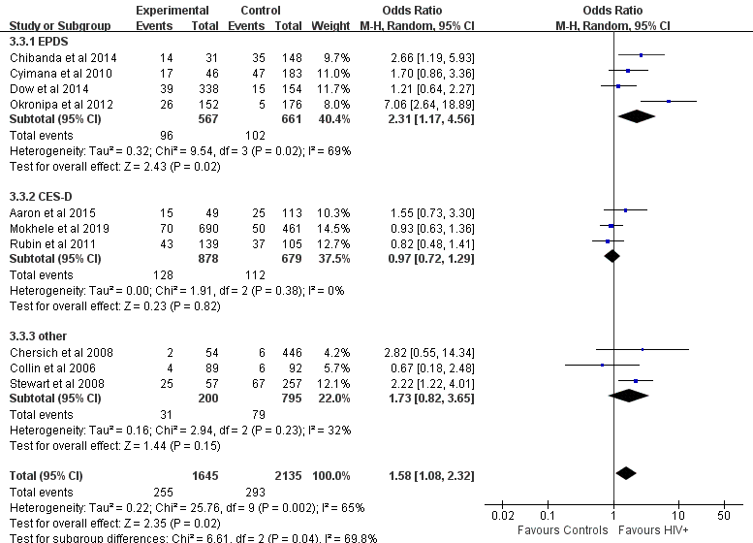
Fig. S7. Sub-group analysis of different screening tools of postnatal depression in HIV-infected women compare with controls
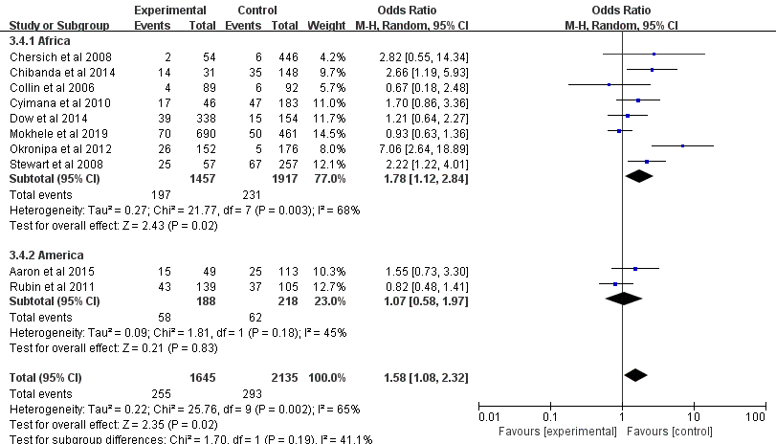
Fig. S8. Sub-group analysis of different geographical locations of postnatal depression in HIV-infected women compare with controls

