Additional files
Kroll et al. “NON-CONTACT MONITORING OF AGITATION AND USE OF A SHELTERING DEVICE IN PATIENTS WITH DEMENTIA IN EMERGENCY DEPARTMENTS: A FEASIBILITY STUDY”
Additional file 1:
Figure S1
A
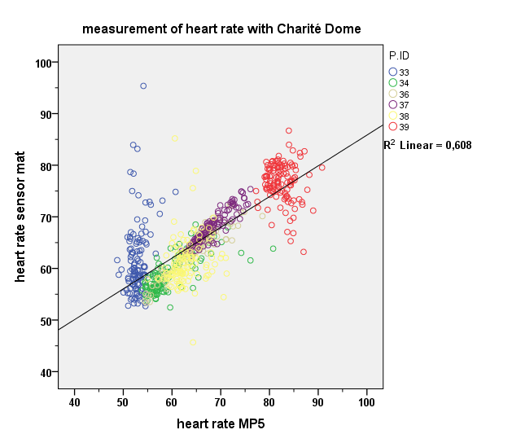
0.608
B
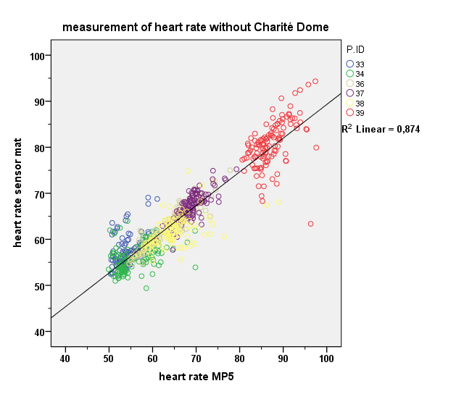
0.874
C
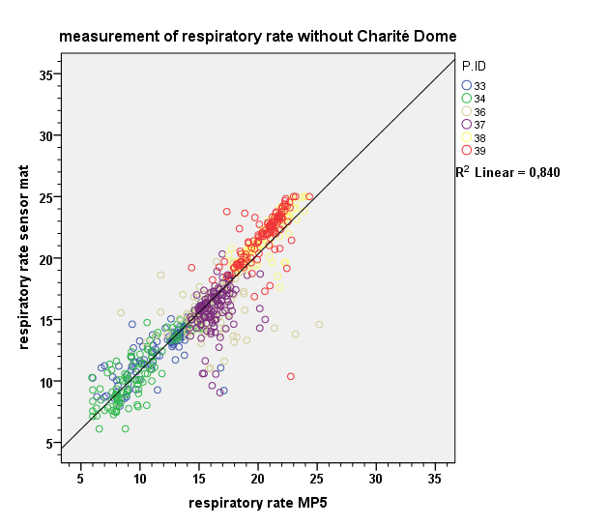
0.840
D
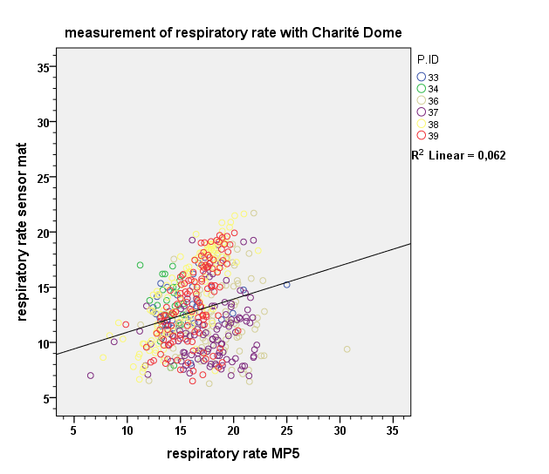
0.062
Figure S1: Validity of non-contact monitoring of heart and respiratory rate, sound, and movement in healthy test-persons. Linear correlation (A) for the first (correlation of R²=0.874) and (B) the second hour (R²=0.608) of HR monitoring between the reference monitor and the SM in all six healthy test persons. Correlation for the measurement of RR (C) in the first (R²=0.840) and (D) in the second hour (R²=0.062).

Additional file 2:
Figure S2
A Heart rate (BPM)
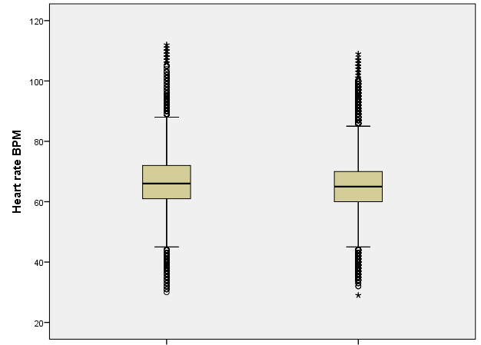
P>.05
With ChD
Without ChD

B Respirationrate (per minute)
P>.05
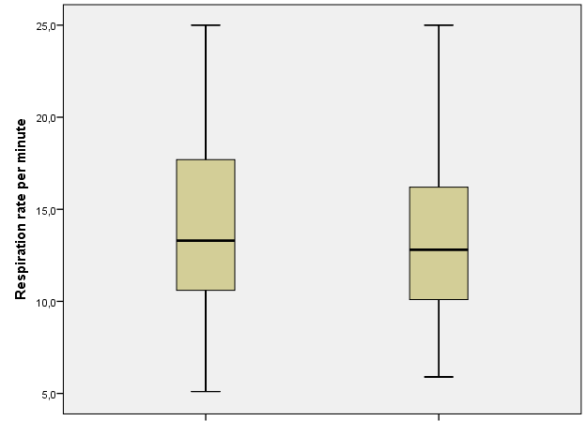
Without ChD
With ChD

C Activity value
P>.05
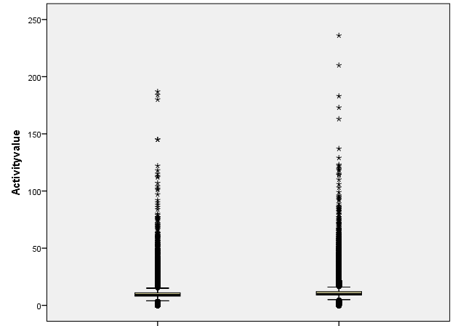
With ChD
Without ChD

D Number of motions
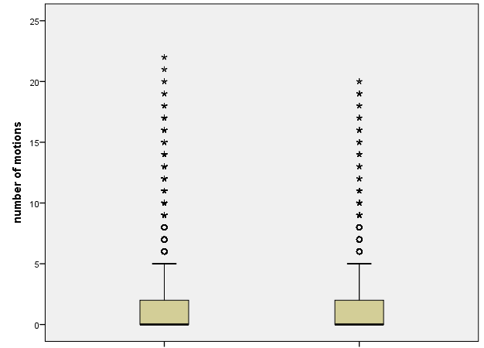
P>.05

With ChD
Without ChD

Figure S2: Effects of the ChD on vital parameters of patients. Vital parameters of patients lying in bed were measured for one hour without the ChD followed for one hour with the ChD. Differences for the (A) heart rate, (B) the respiratory rate, (C) the activity values and (D) the number of recorded motions were analyzed by multiple t-tests using the Holm-Sidak method, with alpha=5.000%.

Additional file 3:
Table S1: Evaluation interface based on parameters of OERS and DMPT
Dementia Patients:
Pat-ID | Situation | Emotion (1-5): happy, sad, anxious, angry | General alertness | Wellbeing/  Stress | Trend | Additional comments of observing staff
50/2001 | Before ChD | joy (4) | 3 | 3
 | After ChD | joy (1) | 3 | 2 | Deterioriation | Pt. generally agitated
51/2002 | Before ChD | n.s. | 3 | 1
 | After ChD | n.s. | 3 | 0 | Deterioriation | Pt. often calls, screams and complains in general; tries to look past the ChD
52/2003 | Before ChD | n.s. | 4 | 4
 | After ChD | n.s. | 3 | 3 | Amelioration | Pt. likes the ChD
53/2004 | Before ChD | joy (3) | 4 | 3
 | After ChD | joy (3) | 4 | 4 | Amelioration | Pt. much calmer after the ChD is mounted. Cuddling to the side canvas of the ChD  Permanent nurse judges ChD for that pat. beneficial, observing his cuddling inside it
54/2005 | Before ChD | n.s. | 3 | 4
 | After ChD | n.s. | 4 | 4 | Deterioriation | Pt. does not like the ChD
55/2006 | Before ChD | joy (1) | 4 | 4
 | After ChD | joy (2) | 4 | 5 | Amelioration | Pt. is more relaxed and likes the ChD
56/2007 | Before ChD | joy (1) | 3 | 4
 | After ChD | joy (1) | 3 | 3 | Deterioriation | Pt. agitated and does not like the ChD
58/2009 | Before ChD | joy (1) | 3 | 3
 | After ChD | joy (1) | 5 | 5 | Amelioration | Pt. calmer under the ChD
59/2010 | Before ChD | fear (1) | 4 | 3
 | After ChD | fear (1) | 5 | 5 | Amelioration | Agitated pt.
60/2011 | Before ChD | sadness (1) | 4 | 5
 | After ChD | n.s. | 3 | 3 | No change | Pt. very cooperative
45/1005 | Before ChD | joy (5) | n.s. | n.s.
 | After ChD | joy (5) | n.s. | n.s. | No change
47/1006 | Before ChD | n.s. | 2 | 2
 | After ChD | n.s. | 4 | 3 | Amelioration
48/1007 | Before ChD | n.s. | 1 | 3
 | After ChD | joy (3) | 5 | 4 | Amelioration | Wife talks very positively about ChD
Non-Dementia Patients:
Pat-ID | Situation | Emotion (1-5): happy, sad, anxious, angry | General alertness | Wellbeing/  Stress | Trend | Additional comments of observing staff
 | After ChD | joy (1) | 3 | 3 | Amelioration | Pt. feels more relaxed
41/1002 | Before ChD | joy (5) | 3 | 3
 | After ChD | joy (5) | 4 | 1 | Deterioration | Pt. is afraid of getting too warm in the summertime
42/1003 | Before CD | n.s. | 4 | 3
 | After CD | joy (1) | 4 | 3 | Amelioration | Pt. is relieved and likes the lighting conditions
43/1004 | Before CD | joy (3) | 4 | 3
 | After CD | joy (4) | 4 | 4 | Amelioration | Pt. likes better privacy protection and better lighting conditions
49/1008 | Before CD | joy (3) | 3 | 3
 | After CD | joy (4) | 5 | 4 | Amelioration | Pt. calls the ChD cozy and comfortable
Abbreviations: ChD, Charité Dome; Pt., patient; OERS, Observed Emotion Rating Scale; DMPT, Dementia Mood Picture Test

