Additional file 1
Bootstrapped difference test for edge weights and node expected influences

- Figure S1. Bootstrapped difference test for edge weights
- Figure S2. Bootstrapped difference test for node expected influences

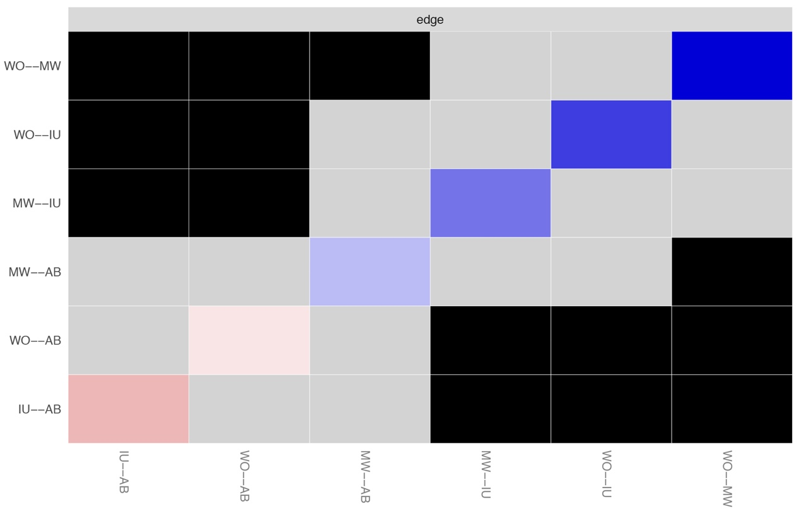
Fig. S1. Bootstrapped difference test for edge weights.
Note: Gray boxes indicate edge weights that do not differ significantly from one another, while black boxes indicate edge weights that do differ significantly. Blue and red boxes on the diagonal correspond to edge weights with positive and negative correlations, respectively.

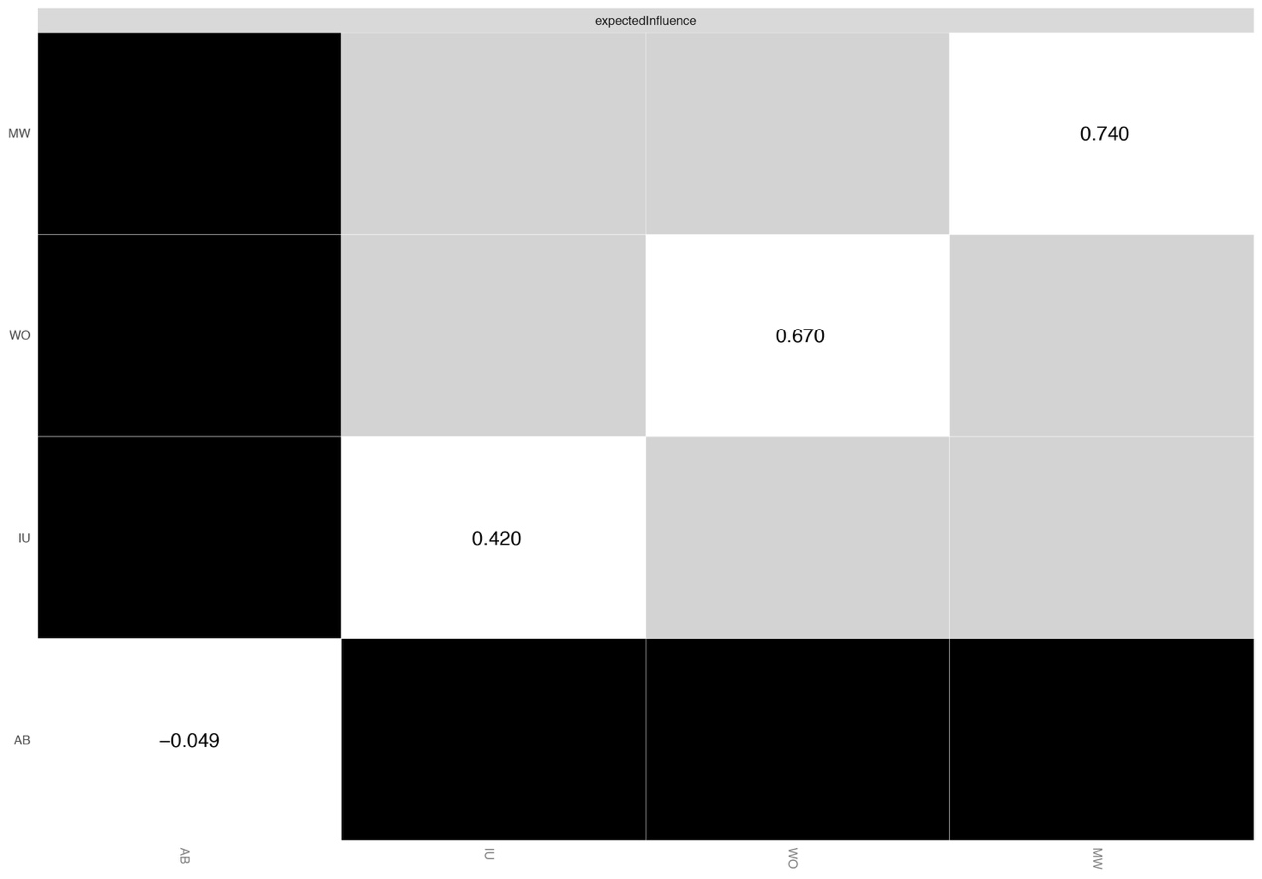
Fig. S2. Bootstrapped difference test for node expected influences.
Note: Gray boxes indicate node expected influences that do not differ significantly from one another, while black boxes indicate node expected influences that do differ significantly. The number in the white boxes (i.e., diagonal line) represent the value of node expected influences.

