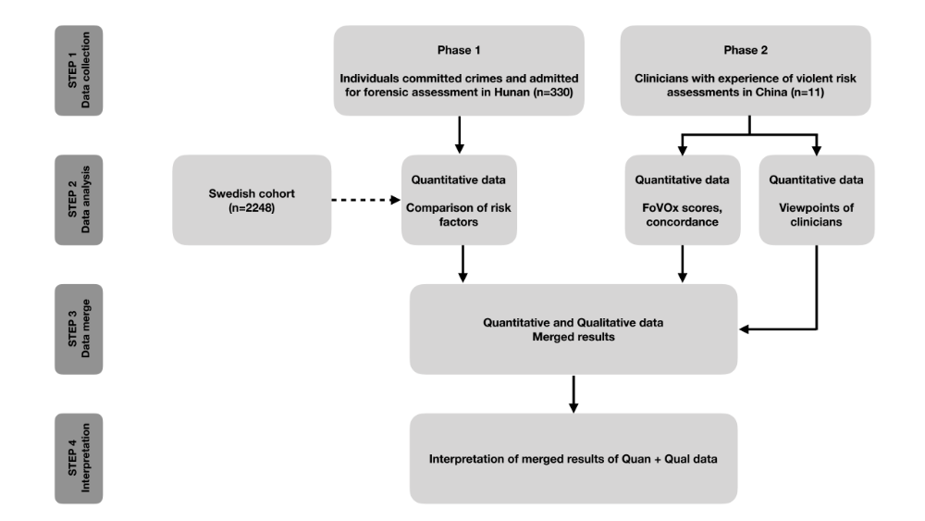
Supplemental materials:

Figure 1. Flow-diagram of the study design

