Appendix 2
Subgroup analysis: Forest plot of intervention theory, time, adherence, and whether or not to communicate with the therapist
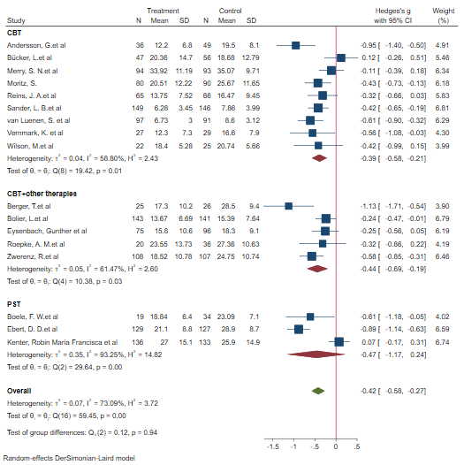
Figure S1-A
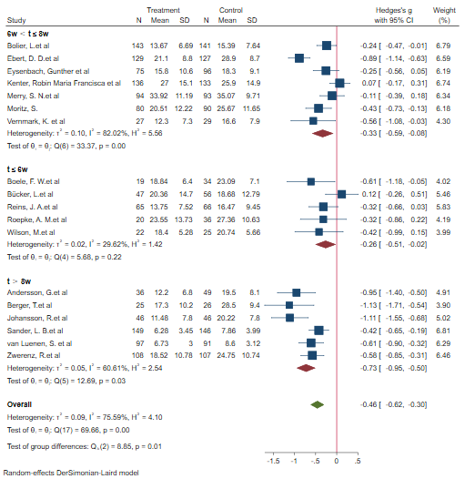
Figure S1-B
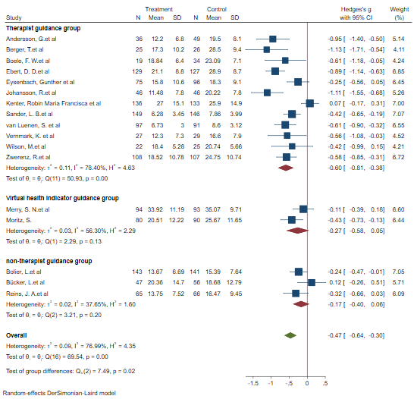
Figure S1-C

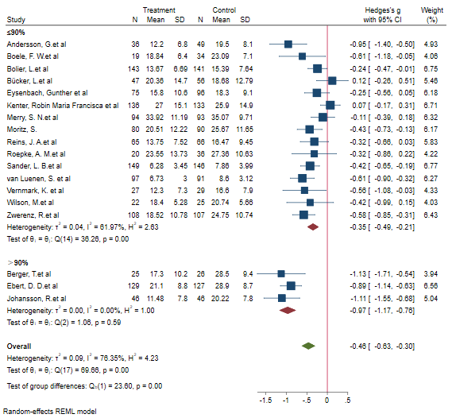
Figure S1-D

