Additional file 3 Sensitivity and sub-group meta-analyses
Figure 5: Sensitivity analysis excluding Dincer et al., 2021; and Gharaati Sotoudeh et al., 2020: Comparative effectiveness of psychological interventions on measures of depression
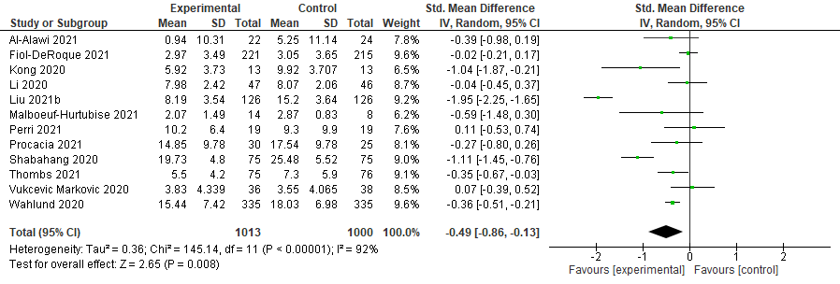
Figure 6: Sensitivity analysis excluding Dincer et al., 2021; and Gharaati Sotoudeh et al., 2020: Comparative effectiveness of psychological interventions on measures of anxiety
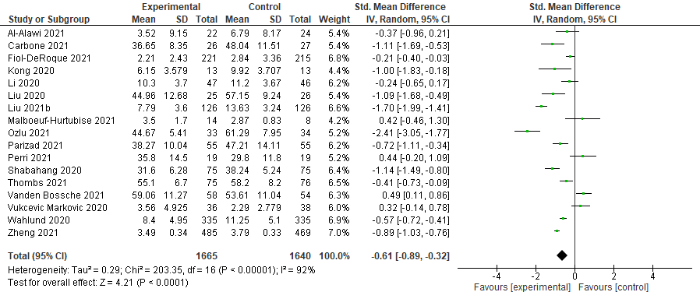
Figure 7: Sensitivity analysis excluding Dincer et al., 2021; and Gharaati Sotoudeh et al., 2020: Comparative effectiveness of psychological interventions on measures of stress
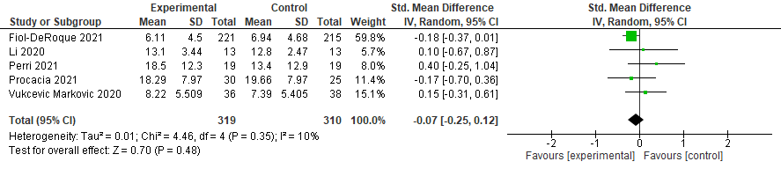

Figure 8: Comparative effectiveness of psychological interventions on measures of depression by study risk of bias
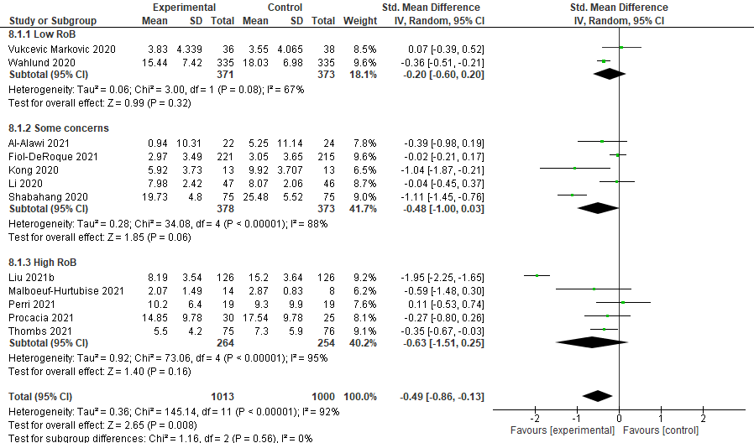
Figure 9: Comparative effectiveness of psychological interventions on measures of anxiety by study risk of bias
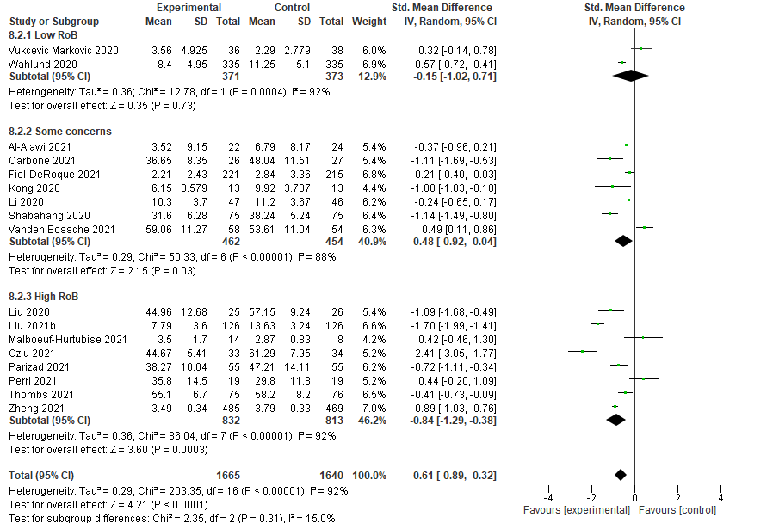

Figure 10: Comparative effectiveness of psychological interventions on measures of stress by study risk of bias
