Supplementary figure 1: Effectiveness of screening programmes in perinatal depression
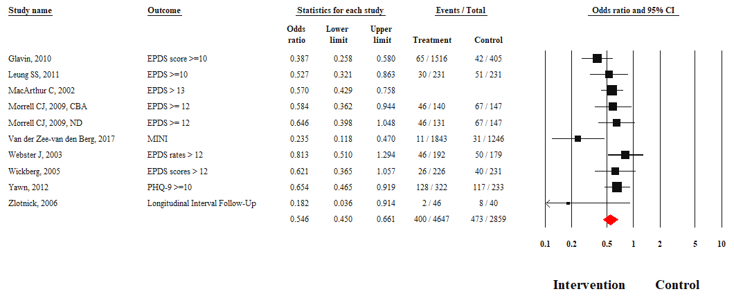

Supplementary figure 2: Effectiveness of screening programmes in perinatal state anxiety
Supplementary figure 3: Effectiveness of screening programmes in perinatal psychological quality of life
Supplementary figure 4: Effectiveness of screening programmes in perinatal physical quality of life

Supplementary figure 5: Effectiveness of screening programmes in improving treatment seeking behaviours

Supplementary figure 6: Funnel plot visualizing publication bias in reporting of depression outcome

Supplementary figure 7: Summary of risk of bias across studies
