Supplementary Table
PDSS-SR cut-point | Sensitivity | Specificity | Youden index | Positive predictive Value | Negative predictive Value
0 | 1.00 | 0.00 | 0.000 | 0.41 | 1.00
1 | 1.00 | 0.18 | 0.178 | 0.45 | 1.00
2 | 0.99 | 0.26 | 0.254 | 0.48 | 0.98
3 | 0.98 | 0.34 | 0.316 | 0.5 | 0.96
4 | 0.94 | 0.38 | 0.324 | 0.51 | 0.91
5 | 0.91 | 0.43 | 0.348 | 0.52 | 0.88
6 | 0.88 | 0.48 | 0.355 | 0.54 | 0.85
7 | 0.86 | 0.57 | 0.422 | 0.57 | 0.85
8 | 0.81 | 0.65 | 0.459 | 0.61 | 0.83
9 | 0.79 | 0.70 | 0.492 | 0.65 | 0.83
10 | 0.74 | 0.75 | 0.490 | 0.67 | 0.81
11 | 0.65 | 0.81 | 0.463 | 0.7 | 0.77
12 | 0.61 | 0.86 | 0.468 | 0.75 | 0.76
13 | 0.54 | 0.91 | 0.446 | 0.8 | 0.74
14 | 0.51 | 0.93 | 0.444 | 0.84 | 0.74
15 | 0.40 | 0.95 | 0.351 | 0.84 | 0.70
16 | 0.31 | 0.96 | 0.268 | 0.84 | 0.67
17 | 0.25 | 0.97 | 0.224 | 0.87 | 0.65
18 | 0.21 | 0.98 | 0.192 | 0.88 | 0.65
19 | 0.14 | 0.99 | 0.138 | 0.94 | 0.63
20 | 0.09 | 0.99 | 0.080 | 0.9 | 0.61
21 | 0.08 | 0.99 | 0.070 | 0.89 | 0.61
22 | 0.06 | 0.99 | 0.051 | 0.86 | 0.61
23 | 0.04 | 0.99 | 0.032 | 0.8 | 0.60
24 | 0.03 | 0.99 | 0.022 | 0.75 | 0.60
25 | 0.02 | 0.99 | 0.013 | 0.67 | 0.60
26 | 0.00 | 0.99 | -0.007 | 0.00 | 0.59
27 | 0.00 | 1.00 | 0.000 | 0.00 | 0.59

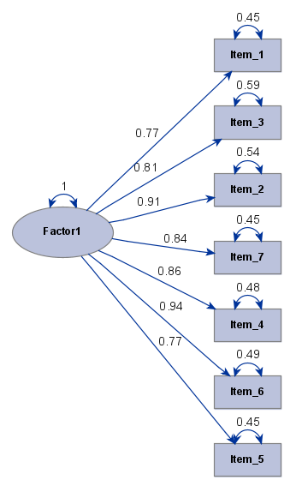
Supplementary Figure. Path diagram from confirmatory factor analysis

