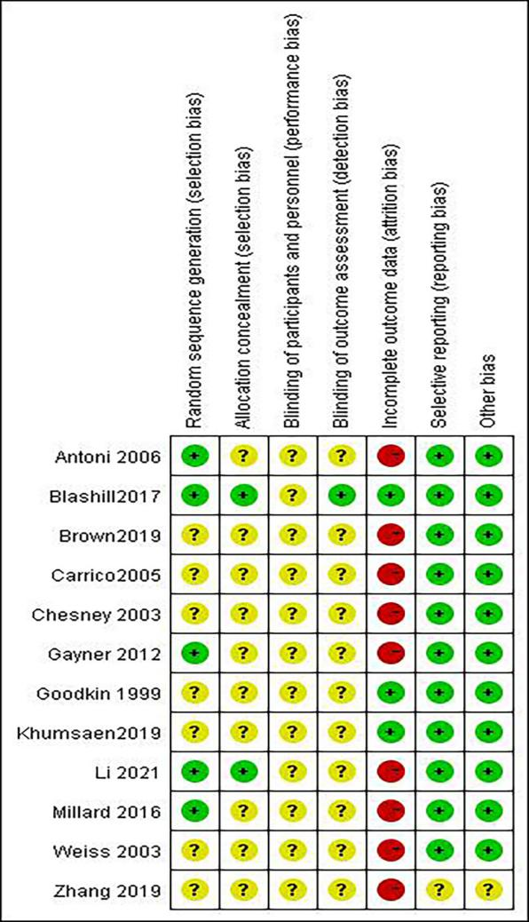
Additional file 4. Quality of included studies

eFigure 1. Risk of bias’ summary
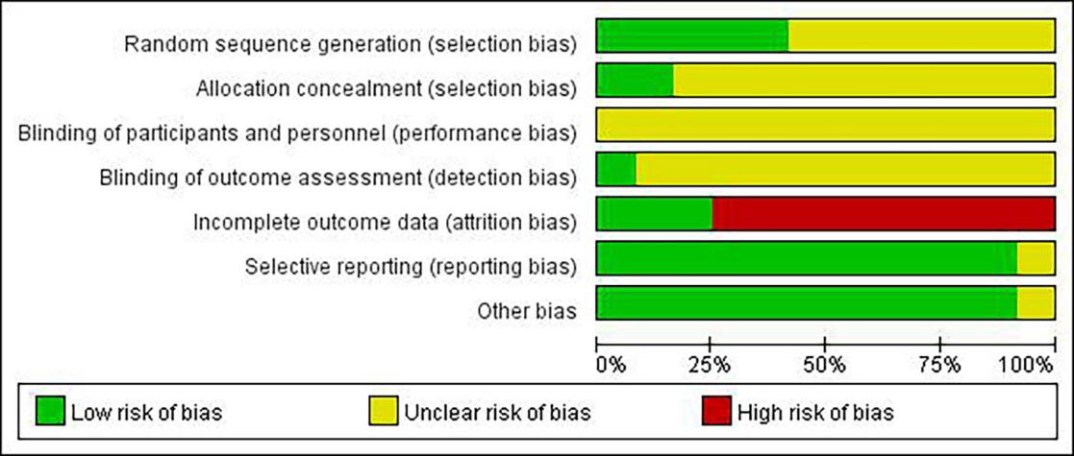

eFigure 2. Risk of bias graph

