Additional file 5. Forest plot of effect sizes for anxiety, stress and social support
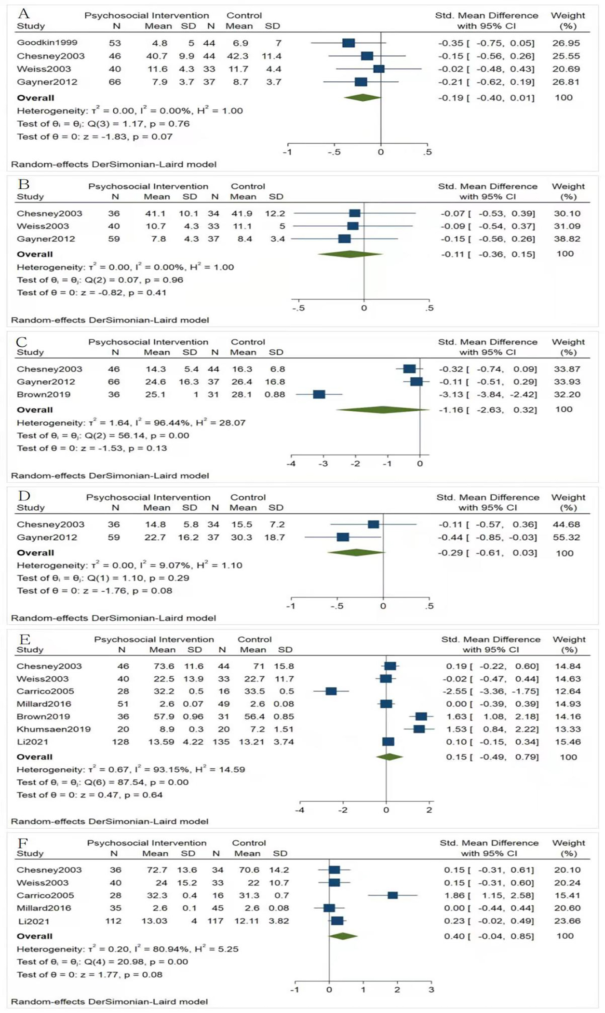
Forest plot of effect sizes for anxiety, stress and social support
A: Forest plot of effect sizes for anxiety measure at post intervention (n = 4);
B: Forest plot of effect sizes for anxiety measure at follow-up (n = 3);
C: Forest plot of effect sizes for stress measure at post intervention (n = 3);
D: Forest plot of effect sizes for stress measure at follow-up (n = 2);
E: Forest plot of effect sizes for social support measure at post intervention (n = 7);
F: Forest plot of effect sizes for social support measure at follow-up (n = 5);

