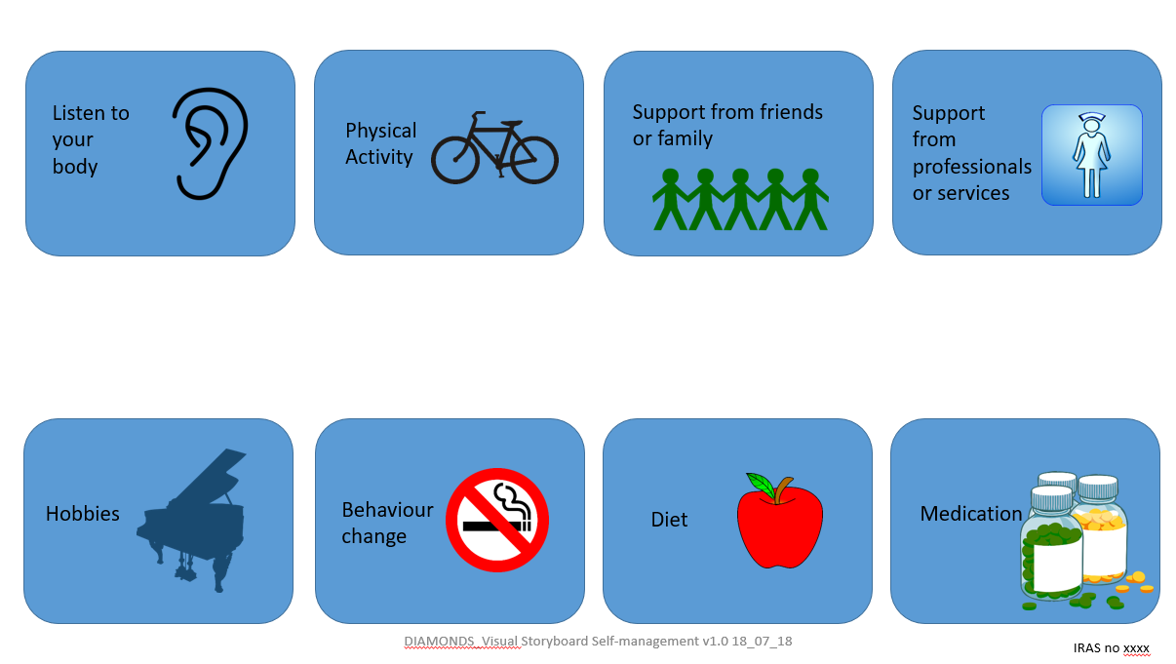
Appendix B. Visual storyboard

