Supplemental information
Supplemental tables
Table. S1: Primary antibodies used in western blot.
ANTIBODIES | PRODUCERS | RRID
Rabbit anti-IDO1 | Proteintech, Rosemont, IL, USA | AB_2123444
Rabbit anti-BDNF | Proteintech | AB_2818984
Rabbit anti-TrkB | Proteintech | AB_2155156
Rabbit anti-NGF | Abcam, Cambridge, MA, USA | AB_881254
Rabbit anti-TLR4 | Abcam | AB_300457
Mouse anti-β-actin | Zsgb-Bio, Beijing, P R China | AB_2636897
Mouse anti-GAPDH | Zsgb-Bio | AB_2747414
Table. S2: Assay kits used in ELISA.
ANTIBODIES | PRODUCERS | IDENTIFIER
Mouse IL-1β ELISA kit | Enzyme-linked Biotech, Shanghai, P R China | ml001814
Mouse IL-6 ELISA kit | Enzyme-linked Biotech | ml002293
Mouse TNF-α ELISA kit | Sangon Biotech, Shanghai, P R China | D721026
Mouse 5-HT ELISA kit | Enzyme-linked Biotech | ml001891
Mouse ACTH ELISA kit | Enzyme-linked Biotech | ml001895
Mouse CORT ELISA kit | Enzyme-linked Biotech | ml037564
Table. S3: Statistical data.
FIGURE |  | DOF | P VALUE
Fig. 1B |  | F _{(4, 35)} = 11.62 | < 0.001
Fig. 1C |  | F _{(4, 35)} = 1.225 | 0.318
Fig. 1D |  | F _{(4, 35)} = 10.61 | < 0.001
Fig. 1F |  | F _{(4, 35)} = 12.1 | < 0.001
Fig. 1G |  | F _{(4, 35)} = 15.25 | < 0.001
Fig. 1H |  | F _{(4, 35)} = 29.5 | < 0.001
Fig. 2A |  | F _{(4, 35)} = 21.01 | < 0.001
Fig. 2B |  | F _{(4, 35)} = 20.37 | < 0.001
Fig. 2C |  | F _{(4, 35)} = 25.27 | < 0.001
Fig. 3A |  | F _{(4, 35)} = 5.384 | 0.0017
Fig. 3B |  | F _{(4, 35)} = 6.726 | < 0.001
Fig. 4A |  | F _{(4, 35)} = 10.09 | < 0.001
Fig. 4B |  | F _{(4, 35)} = 7.969 | < 0.001
Fig. 4E | ERK1/2 | F _{(4, 35)} = 8.304 | < 0.001
Fig. 4E | BDNF | F _{(4, 35)} = 17.77 | < 0.001
Fig. 4E | NGF | F _{(4, 35)} = 8.831 | < 0.001
Fig. 4F | ERK1/2 | F _{(4, 35)} = 8.345 | < 0.001
Fig. 4F | BDNF | F _{(4, 35)} = 7.106 | < 0.001
Fig. 4F | NGF | F _{(4, 35)} = 5.808 | 0.0011
Fig. 5B | Hippocampus | F _{(4, 35)} = 33.69 | < 0.001
Fig. 5B | PFC | F _{(4, 35)} = 11.65 | < 0.001
Fig. 5C | Hippocampus | F _{(4, 35)} = 22.04 | < 0.001
Fig. 5C | PFC | F _{(4, 35)} = 18.96 | < 0.001
Fig. 5D | Hippocampus | F _{(4, 35)} = 16.38 | < 0.001
Fig. 5D | PFC | F _{(4, 35)} = 23.07 | < 0.001
Fig. 5E | Hippocampus | F _{(4, 35)} = 20.85 | < 0.001
Fig. 5E | PFC | F _{(4, 35)} = 13.96 | < 0.001
Fig. 5F | Hippocampus | F _{(4, 35)} = 29.86 | < 0.001
Fig. 5F | PFC | F _{(4, 35)} = 30.2 | < 0.001
Fig. 7B |  | F _{(4, 35)} = 41.56 | < 0.001
Supplemental figures
Figure. S1: Standard curve of 5-HT concentration.
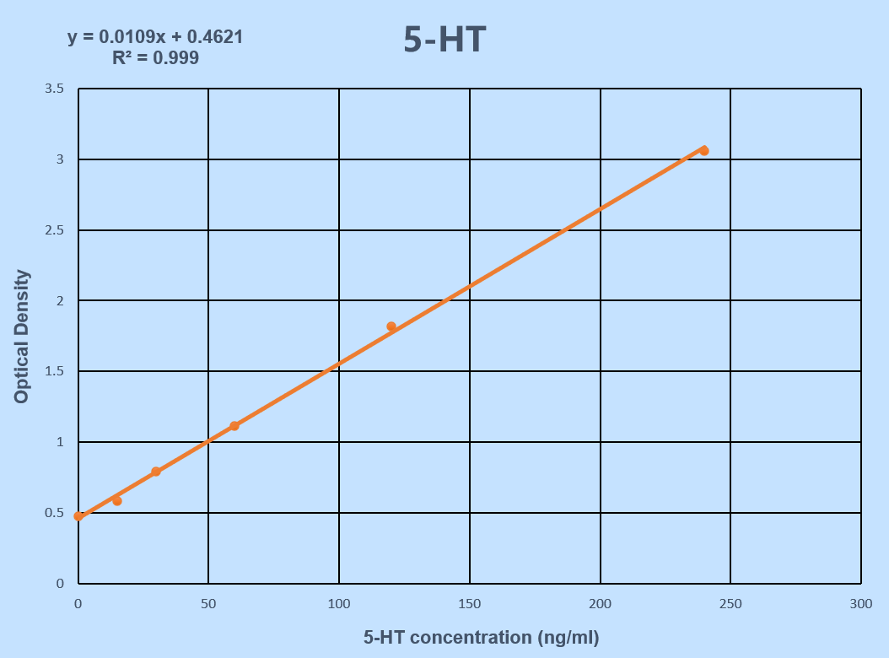
Figure. S2: Standard curve of IL-1β concentration.
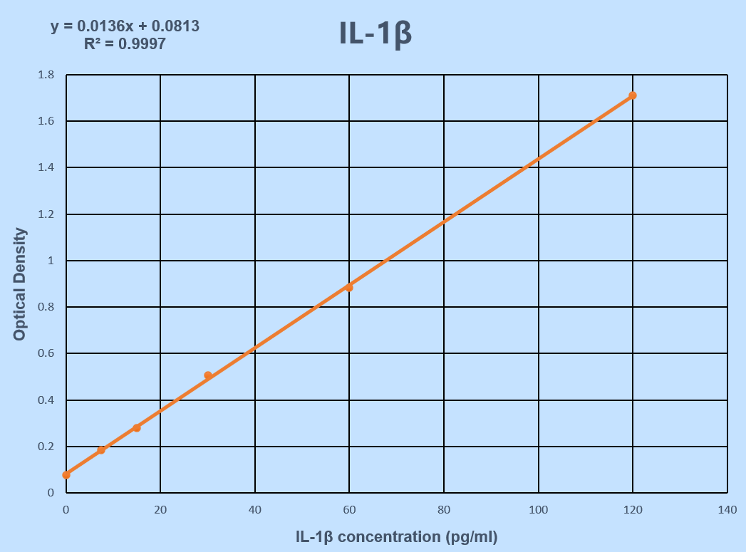
Figure. S3: Standard curve of IL-6 concentration.
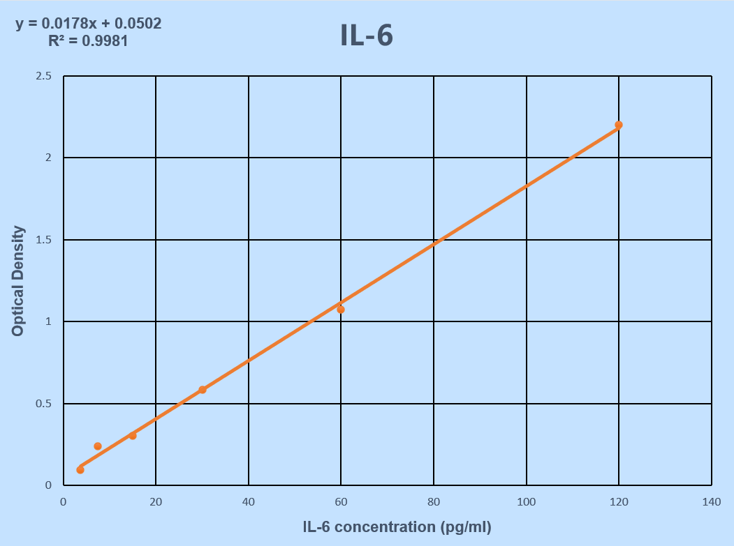
Figure. S4: Standard curve of TNF-α concentration.
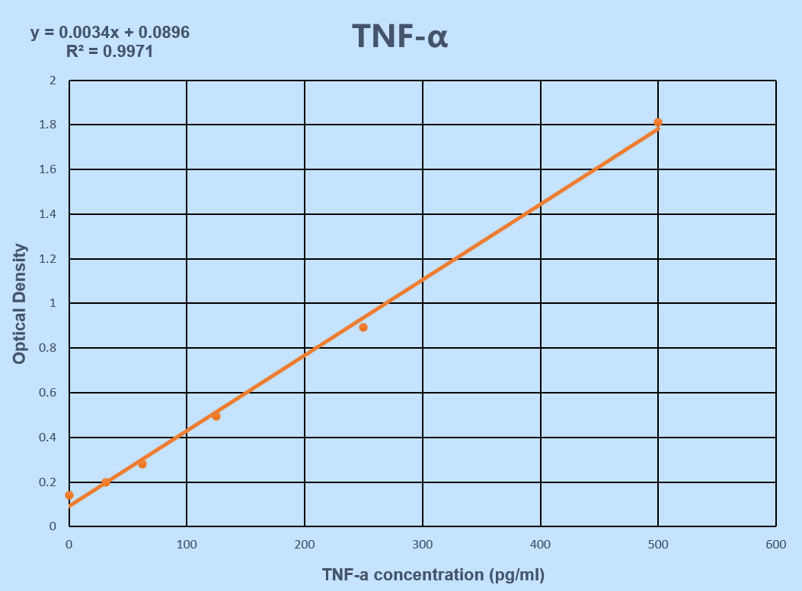
Figure. S5: Standard curve of ACTH concentration.
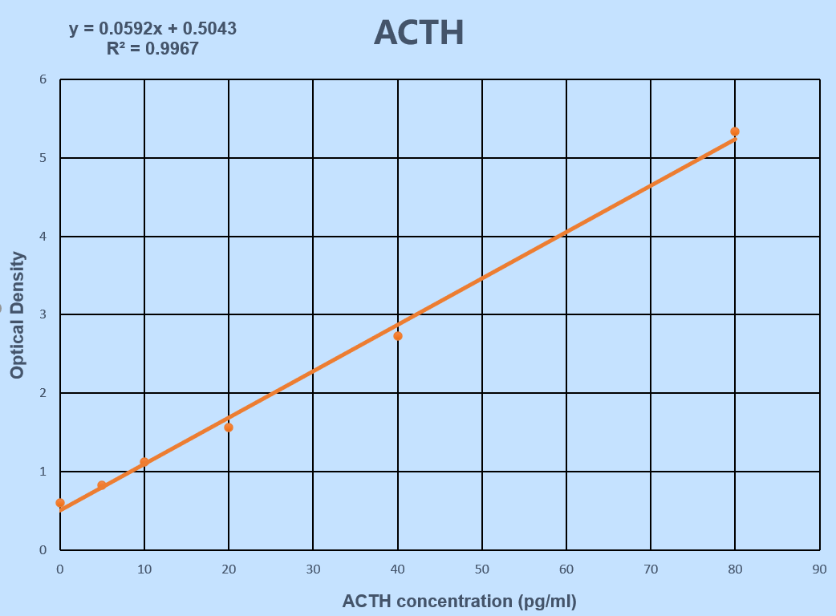
Figure. S6: Standard curve of CORT concentration.
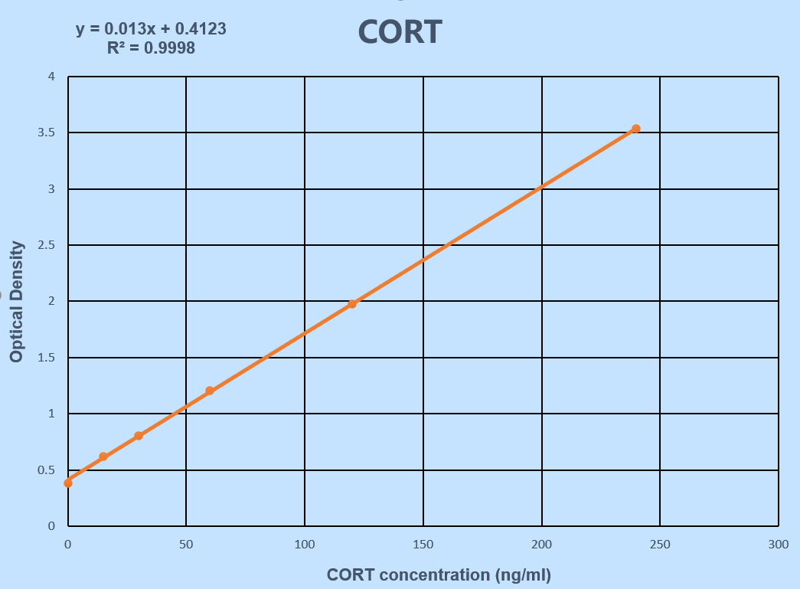
Figure. S7: Raw images of western blots from all Figures (Protein Ladder 26616 produced by ThermoFisher Scientific).

