Additional file 1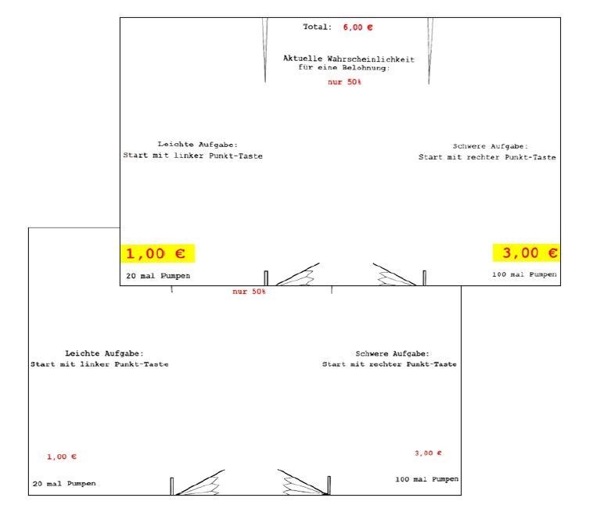
Decision phase in the Balloon Effort Task in salient and normal trials.

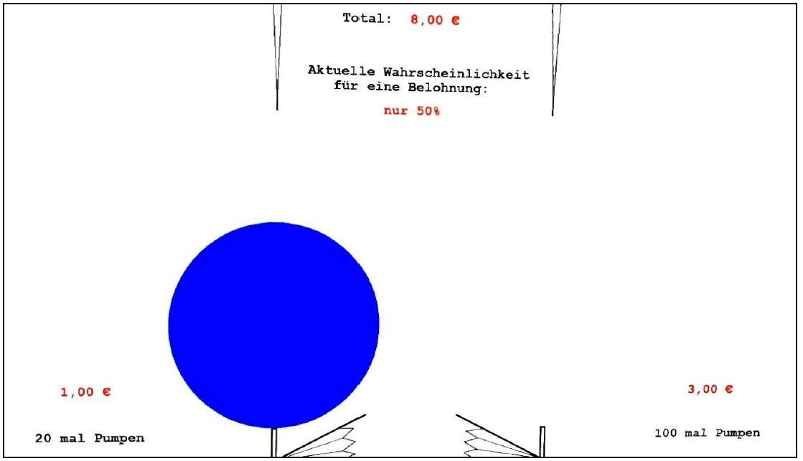
Balloon pumping phase.

