Additional file 1
Supplementary Table 1
Names of all 38 medical colleges (government and private) across all regions of Saudi Arabia and the number of students who participated in the study from each university (N = 7,116)
Regions | N | %
Central Region:
-1 Imam Muhammad Bin Saud Islamic University College of Medicine - Riyadh | 170 | 2.4
-2 Almaarefa Medical College - Riyadh | 167 | 2.3
-3 Almajmaah University College of Medicine - Al Majma'ah | 132 | 1.9
-4 Alfaisal University College of Medicine - Riyadh | 333 | 4.7
-5 College of Medicine of Alfarabi Private Colleges - Riyadh | 165 | 2.3
-6 Dar Al Uloom University College of Medicine - Riyadh | 241 | 3.4
-7 King Saud University, College of Medicine - Riyadh | 204 | 2.9
-8 King Saud bin Abdulaziz University for Health Sciences College of Medicine - Riyadh | 275 | 3.9
9- Prince Sattam bin Abdulaziz University College of Medicine - Al Kharj | 87 | 1.2
10- Princess Nourah Bint Abdulrahman University College of Medicine – Riyadh | 124 | 1.7
11- Shaqra College of Medicine - Shaqra | 57 | .8
12- Shaqra College of Medicine in Dawadmi - Al- Dawadmi | 90 | 1.3
13- Sulaiman Alrajhi College of Medicine - Al Bukairyah | 133 | 1.9
14- Qassim University College of Medicine - Burayda | 198 | 2.8
15- Unaizah College of Medicine and Medical Sciences, Qassim University - Unaizah | 179 | 2.5
Eastern Region:
16- Imam Abdulrahman Bin Faisal University College of Medicine - Dammam | 197 | 2.8
17- King Faisal University, College of Medicine - Al-Ahsa | 264 | 3.7
Western Region:
18- Al Rayan Medical College - Madinah al munawarah | 178 | 2.5
19- Batterjee Medical College for Sciences and Technology - Jeddah | 159 | 2.2
20- King Saud bin Abdulaziz University for Health Sciences College of Medicine - Jeddah | 266 | 3.7
21- King Abdulaziz University - College of Medicine in Jeddah | 170 | 2.4
22- Umm Al-Qura University - College of Medicine in Mecca - Mecca | 282 | 4.0
23- University of Jeddah Faculty of Medicine - Jeddah | 174 | 2.4
24- Fakeeh College for Medical Sciences - Jeddah | 61 | .9
25- College of Medicine in Al-Qunfudah - Umm Al-Qura University - Al-Qunfudah | 281 | 3.9
26- Ibn Sina National College for Medical Studies Faculty of Medicine - Jeddah | 261 | 3.7
27- King Abdulaziz University - College of Medicine in Rabigh (Rabigh Branch) | 203 | 2.9
28- Taibah University College of Medicine - Madinah al munawarah | 236 | 3.3
29- Taif University College of Medicine - Taif | 185 | 2.6
Southern Region:
30- Al Baha University School of Medicine - Al Baha | 239 | 3.4
31- Jazan University Faculty of Medicine - Jazan | 194 | 2.7
32- King Khalid University College of Medicine and Health Sciences - Abha | 174 | 2.4
33- University of Bisha College of Medicine - Bisha | 91 | 1.3
34- Najran University College of Medicine - Najran | 211 | 3.0
Northern Region:
35- Al Jouf University College of Medicine - Al Jouf | 246 | 3.4
36- Northern Borders University College of Medicine - Arar | 103 | 1.4
37- University of Tabuk Faculty of Medicine - Tabuk | 185 | 2.6
38- University of Hail College of Medicine - Hail | 201 | 2.8
Total: | 7116 | 100

Supplementary Figure 1
The effects of online learning on medication usage reported by 868 medical students across the Kingdom of Saudi Arabia
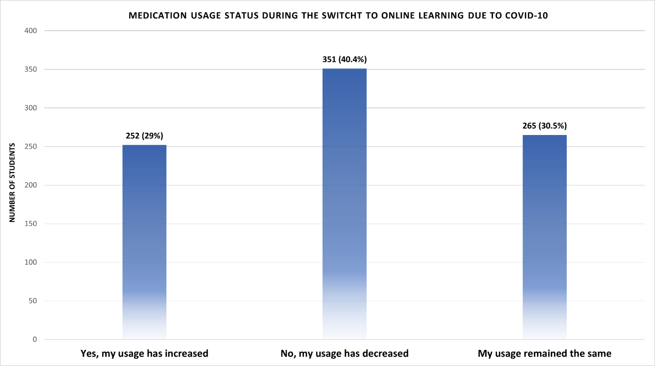

Supplementary Table 2
Baseline characteristics and patterns of medication usage among 868 medical students across the Kingdom of Saudi Arabia
Item |  | Number | Percentage (%)
When do you use any of anti-anxiety medications the most?ª
Before oral exams (OSCE) |  | 308 | 35.5
Before poster or oral presentations |  | 263 | 30.3
During final exams |  | 311 | 35.8
During mid-term exams period |  | 195 | 22.5
What are the reasons to use any of these anti-anxiety medications?ª
For medical reasons |  | 382 | 44.0
To relief anxiety |  | 499 | 57.5
Peer pressure |  | 154 | 17.7
Who prescribed any of these anti-anxiety medications for you?
Yourself |  | 234 | 27.0
Your colleague |  | 163 | 18.8
Your physician |  | 455 | 52.4
What is your usual dose of any of these anti-anxiety medications?
I use less than the recommended dose |  | 192 | 22.1
I use the recommended dose |  | 434 | 50.0
I use more than the recommended dose |  | 173 | 19.9
I don't know |  | 69 | 7.9
What activity requires you to use higher than your usual dose? ª
Before oral exams (OSCE) |  | 138 | 15.9
Before poster or oral presentations |  | 123 | 14.2
During final exams |  | 168 | 19.4
During mid-term exams |  | 129 | 14.9
I do not increase my dose |  | 445 | 51.3
Have you noticed that you need to increase the dose over time?
No |  | 395 | 45.5
Yes |  | 473 | 54.5
ª Respondents could select more than one answer

