Appendix A
Table A1
Means and standard deviations of depression outcomes at study assessment timepoints.
 | MADRS |  |  | PHQ-9
Timepoint | n | M | SD | n | M | SD
Preprogram | 95 | 26.96 | 8.42 | 96 | 17.07 | 4.89
Surf | 48 | 25.92 | 8.23 | 48 | 15.96 | 4.78
Hike | 47 | 28.02 | 8.56 | 48 | 18.19 | 4.78
Postprogram | 88 | 19.94 | 11.41 | 88 | 12.08 | 6.90
Surf | 47 | 18.62 | 11.35 | 47 | 10.72 | 6.61
Hike | 41 | 21.46 | 11.43 | 41 | 13.63 | 6.98
3-month follow-up | 75 | 17.55 | 12.63 | 74 | 10.24 | 6.74
Surf | 43 | 15.63 | 11.79 | 43 | 8.88 | 6.22
Hike | 32 | 20.13 | 13.45 | 31 | 12.13 | 7.08
Note. MADRS = Montgomery-Åsberg Depression Rating Scale; PHQ-9 = 9-item Patient Health Questionnaire.
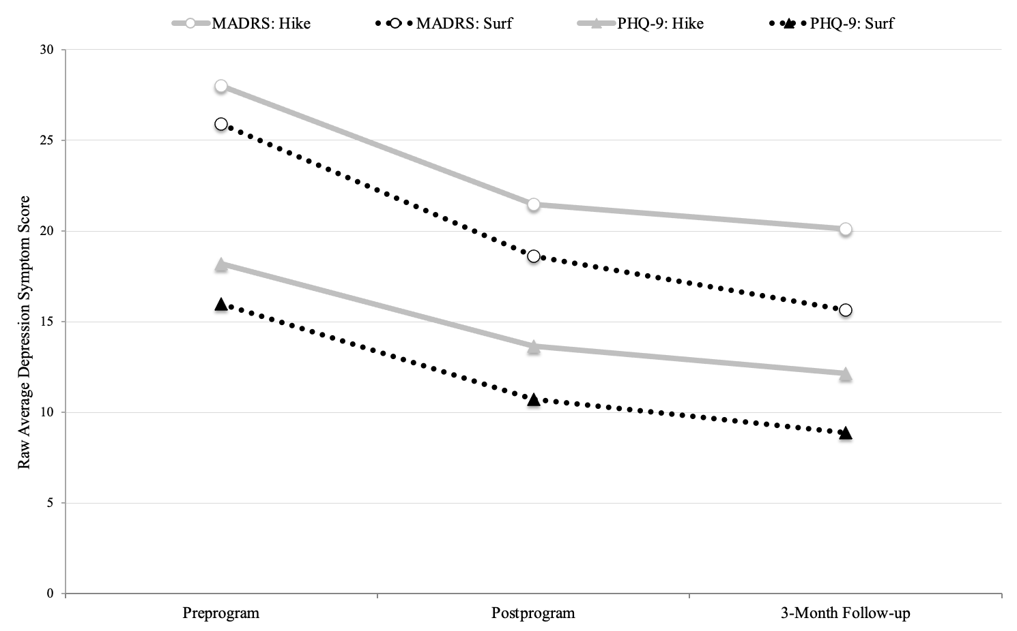
Fig. A1. Raw average depression symptom scores at study assessment timepoints. MADRS = Montgomery-Åsberg Depression Rating Scale; PHQ-9 = 9-item Patient Health Questionnaire.
Table A2
Means and standard deviations of depression/anxiety symptoms at session assessment timepoints.
 |  | PHQ-4
 |  | Total sample |  |  | Surf |  |  | Hike
Timepoint |  | n | M | SD | N | M | SD | n | M | SD
Session 1 | Presession 1 | 87 | 6.31 | 2.74 | 44 | 5.55 | 2.56 | 43 | 7.09 | 2.72
Session 1 | Postsession 1 | 85 | 3.15 | 2.47 | 44 | 2.50 | 2.24 | 41 | 3.85 | 2.55
Session 2 | Presession 2 | 82 | 6.11 | 2.78 | 44 | 6.11 | 2.94 | 38 | 6.11 | 2.62
Session 2 | Postsession 2 | 81 | 2.84 | 2.71 | 43 | 2.51 | 2.59 | 38 | 3.21 | 2.84
Session 3 | Presession 3 | 78 | 5.72 | 3.06 | 42 | 5.43 | 3.22 | 36 | 6.06 | 2.87
Session 3 | Postsession 3 | 76 | 2.46 | 2.51 | 40 | 1.88 | 2.14 | 36 | 3.11 | 2.76
Session 4 | Presession 4 | 71 | 5.62 | 2.81 | 40 | 5.55 | 2.81 | 31 | 5.71 | 2.85
Session 4 | Postsession 4 | 70 | 3.27 | 2.80 | 39 | 3.05 | 2.87 | 31 | 3.55 | 2.74
Session 5 | Presession 5 | 52 | 5.15 | 3.20 | 27 | 4.81 | 3.08 | 25 | 5.52 | 3.36
Session 5 | Postsession 5 | 50 | 2.62 | 2.70 | 26 | 2.62 | 2.94 | 24 | 2.63 | 2.46
Session 6 | Presession 6 | 25 | 4.36 | 3.24 | 14 | 3.36 | 3.34 | 11 | 5.64 | 2.73
Session 6 | Postsession 6 | 23 | 2.13 | 2.51 | 12 | 1.58 | 2.54 | 11 | 2.73 | 2.45
Note. PHQ-4 = 4-item Patient Health Questionnaire.

