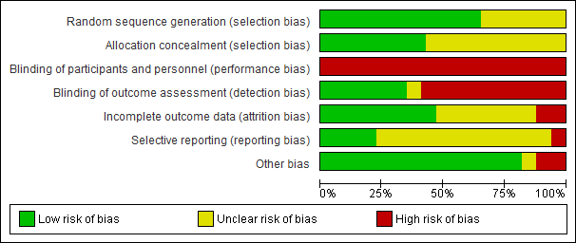
Figure S1: Risk of bias graph: review authors' judgements about each risk of bias item presented as percentages across all included studies.

