Supplementary Figure 1. Flow-chart of sampling

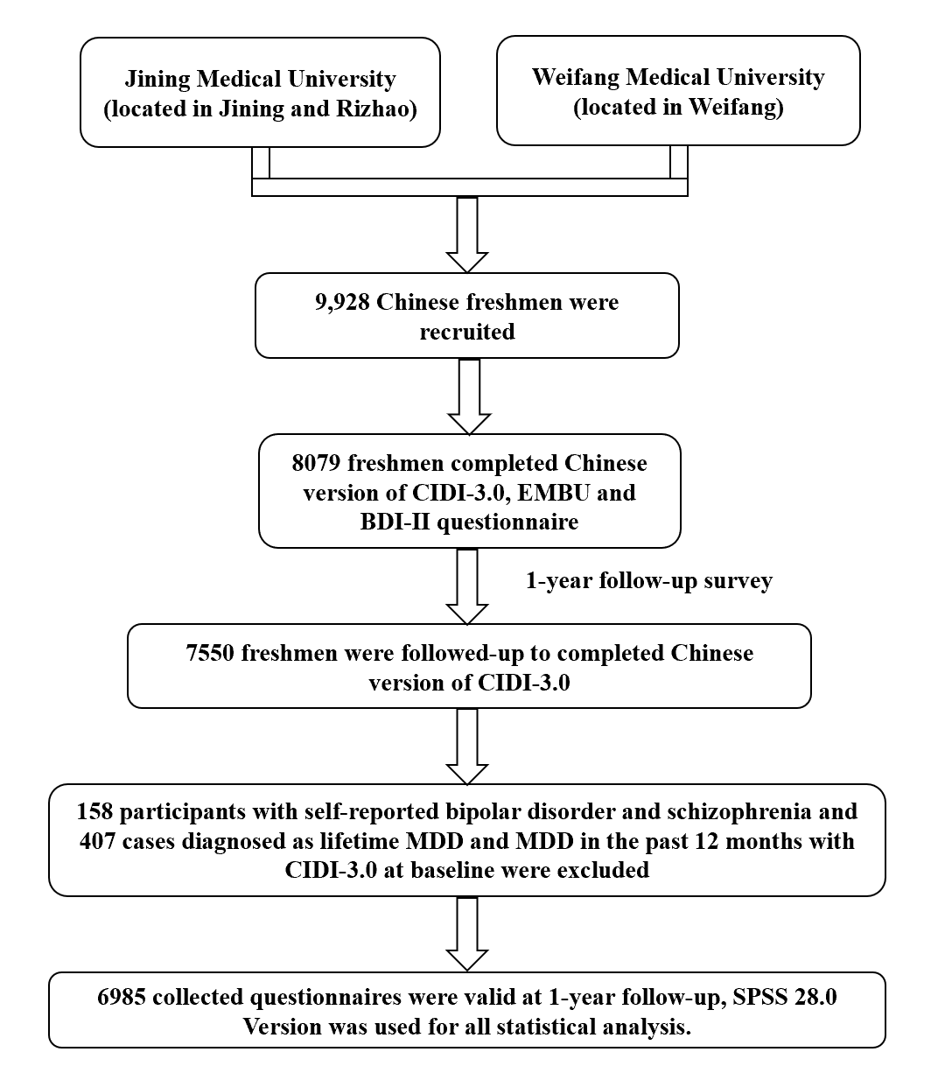

Supplementary Table 1
Spearman correlation coefficients between socio-demographic characteristics and perceived parenting styles
Variables | 1 | 2 | 3 | 4 | 5 | 6 | 7 | 8 | 9
1 | 1
2 | 0.07* | 1
3 | -0.27* | -0.45* | 1
4 | -0.05* | -0.07* | 0.05* | 1
5 | 0.01 | -0.01 | -0.01 | -0.02# | 1
6 | -0.05 | 0.01 | 0.00 | 0.01 | -0.57* | 1
7 | 0.01 | -0.05* | 0.06* | 0.01 | 0.20* | -0.25* | 1
8 | -0.01 | -0.02 | 0.01 | -0.01 | 0.15* | -0.11* | 0.05* | 1
9 | -0.08* | 0.01 | 0.01 | 0.03* | -0.55* | 0.67* | -0.20* | -0.12* | 1
PE | 0.04* | -0.09* | 0.10* | 0.04* | -0.39* | 0.35* | -0.11* | -0.15* | 0.40*
PP | -0.18* | -0.01 | 0.02 | -0.02 | 0.24* | -0.17* | 0.00 | 0.17* | -0.22*
PC | -0.15* | -0.06* | 0.07* | 0.00 | 0.12* | -0.07* | -0.03* | 0.12* | -0.11*
PF | -0.01 | -0.10* | 0.16* | 0.06* | -0.02 | 0.00 | -0.01 | 0.04* | 0.00
PR | -0.16* | -0.01 | 0.03* | -0.02 | 0.24* | -0.19* | 0.01 | 0.17* | -0.25*
PO | -0.11* | 0.00 | 0.02# | 0.00 | 0.06* | -0.05* | -0.04* | 0.13* | -0.06*
ME | 0.05* | -0.12* | 0.13* | 0.04* | -0.33* | 0.27* | -0.07* | -0.14* | 0.34*
MO | -0.13* | -0.08* | 0.10* | 0.02 | 0.15* | -0.13* | -0.00 | 0.16* | -0.16*
MR | -0.11* | -0.01 | 0.01 | -0.02 | 0.25* | -0.21* | 0.02* | 0.18* | -0.26*
MP | -0.14* | -0.02# | 0.02 | -0.03* | 0.25* | -0.20* | 0.04* | 0.18* | -0.24*
MF | -0.02 | -0.12* | 0.17* | 0.06* | 0.01 | -0.03# | 0.02# | 0.05* | -0.02#
a #, p<0.05 (double tail), the correlation is significant; *, p<0.01 (double tail), the correlation is significant;
b 1:Gender; 2:Residence; 3:Only-child; 4:Major; 5:Overall feeling about family atmosphere; 6:Parents’ relationship; 7:The marital status of parents; 8:Baseline depressive symptoms; 9:Parents’ marriage satisfaction level (scores); PE: Paternal Emotional warmth; PP: Paternal Punishment; PC: Paternal Control attempt; PF: Paternal Favoring; PR: Paternal Rejection; PO: Paternal Overprotection; ME: Maternal Emotional warmth; MO: Maternal Overprotection; MR: Maternal Rejection; MP: Maternal Punishment; MF: Maternal Favoring.

Supplementary Table 2
Pearson correlation coefficients between perceived parenting styles
Variables | PE | PP | PC | PF | PR | PO | ME | MO | MR | MP | MF
PE | 1
PP | -0.37* | 1
PC | -0.17* | 0.61* | 1
PF | 0.23* | 0.14* | 0.14* | 1
PR | -0.34* | 0.78* | 0.60* | 0.15* | 1
PO | 0.07 | 0.47* | 0.60* | 0.23* | 0.51* | 1
ME | 0.88* | -0.32* | -0.17* | 0.21* | -0.31* | -0.05 | 1
MO | -0.14* | 0.50* | 0.73* | 0.21* | 0.55* | 0.66* | -0.08* | 1
MR | -0.34* | 0.70* | 0.53* | 0.16* | 0.82* | 0.50* | -0.33* | 0.63* | 1
MP | -0.36* | 0.83* | 0.49* | 0.14* | 0.69* | 0.39* | -0.37* | 0.54* | 0.77* | 1
MF | 0.16* | 0.16* | 0.13* | 0.94* | 0.16* | 0.21* | 0.23* | 0.23* | 0.16* | 0.15* | 1
a *, p<0.01 (double tail), the correlation is significant;
b significant correlations with r > 0.70 are in bold
c PE: Paternal Emotional warmth; PP: Paternal Punishment; PC: Paternal Control attempt; PF: Paternal Favoring; PR: Paternal Rejection; PO: Paternal Overprotection; ME: Maternal Emotional warmth; MO: Maternal Overprotection; MR: Maternal Rejection; MP: Maternal Punishment; MF: Maternal Favoring.

