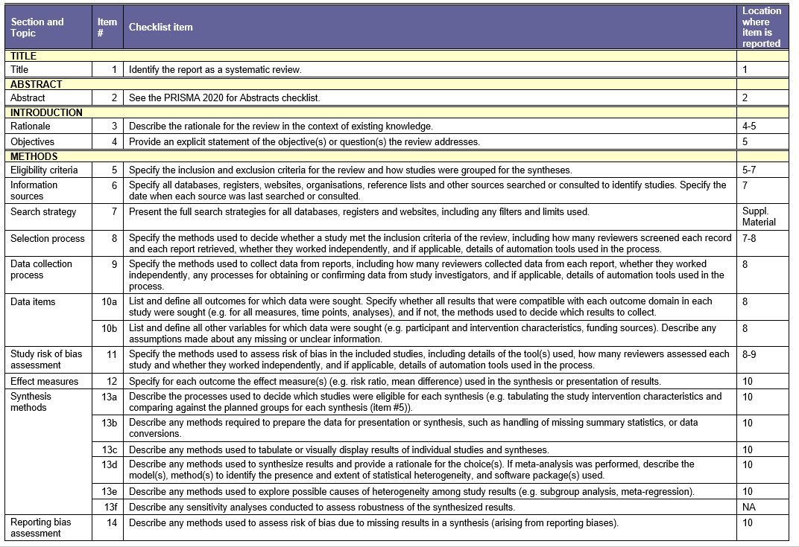
Supplementary Appendix 1: The PRISMA checklist for systematic reviews
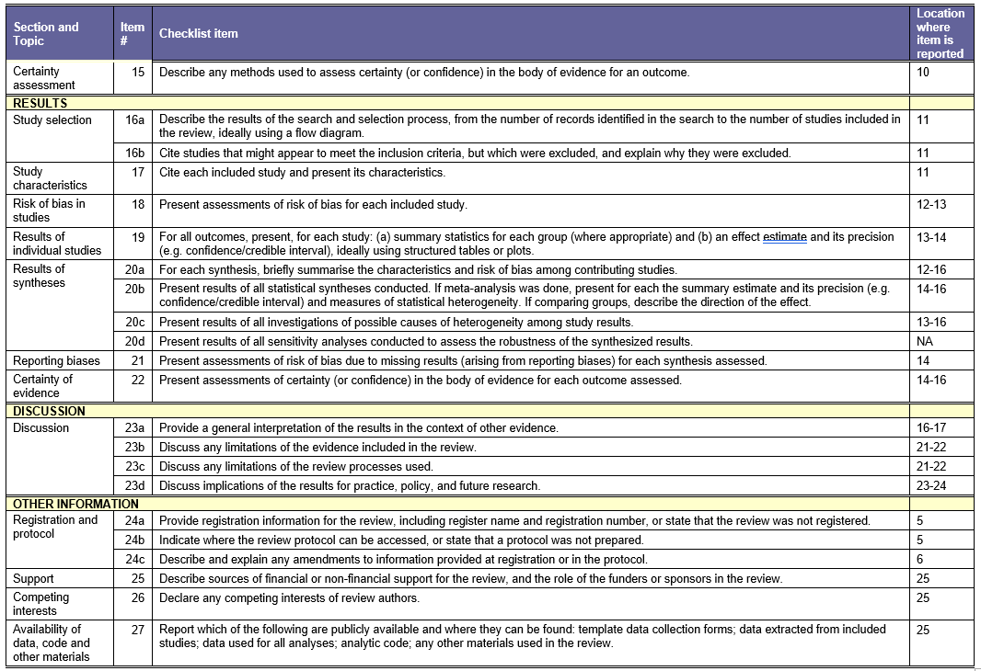
From: Page MJ, McKenzie JE, Bossuyt PM, Boutron I, Hoffmann TC, Mulrow CD, et al. The PRISMA 2020 statement: an updated guideline for reporting systematic reviews. BMJ 2021;372:n71. doi: 10.1136/bmj.n71
Supplementary Appendix 2A: Search strategy for EMBASE (1947-present)
1. | posttraumatic stress disorder/
2. | ((Posttraumatic or post traumatic) adj stress).mp.
3. | Ptsd.mp.
4. | 1 or 2 or 3
5. | mortality/ or all cause mortality/ or cardiovascular mortality/ or hospital mortality/ or mortality rate/ or premature mortality/ or accidental death/ or cause of death/ or heart death/ or sudden death/
6. | Death*.mp.
7. | Mortalit*.mp.
8. | 5 or 6 or 7
9. | 4 and 8

Supplementary Appendix 2B: Search strategy for MEDLINE (1946-present)
1. | stress disorders, traumatic/ or stress disorders, post-traumatic/
2. | ((posttraumatic or post traumatic) adj stress).mp.
3. | ptsd.mp.
4. | 1 or 2 or 3
5. | mortality/ or cause of death/ or hospital mortality/ or mortality, premature/ or death, sudden/
6. | death*.mp.
7. | mortalit*.mp.
8. | 5 or 6 or 7
9. | 4 and 8

Supplementary Appendix 2C: Search strategy for PsycINFO (1806-present)

1. | exp Posttraumatic Stress Disorder/
2. | ((Posttraumatic or post traumatic) adj stress).mp.
3. | Ptsd.mp.
4. | 1 or 2 or 3
5. | Death*.mp.
6. | Mortalit*.mp.
7. | 5 or 6
8. | 4 and 7

Study | Groups from the same population | Exposure measured similarly for all | Valid measure of exposure | Confounding factors identified (age, gender, depression) | Strategies to deal with confounding | Free of outcome at start of study | Valid measure of outcome | Sufficient follow-up time | Complete follow up | Appropriate statistics | Total /10
Bohnert, 2012 | Yes | No | Yes | No | No | Yes | Yes | Yes | Yes | Yes | 7
Boscarino, 2006 | Yes | Yes | Yes | No | No | Yes | Yes | Yes | Yes | Yes | 8
Bramsen, 2007 | Yes | Yes | Yes | No | No | Yes | Yes | Yes | Yes | Yes | 8
Bullman, 1994 | Yes | No | Yes | No | No | Yes | Yes | Unclear | Yes | Yes | 6
Cho, 2016 | Yes | No | Yes | Unclear | Unclear | Yes | Yes | Yes | Unclear | Yes | 6
Chwastiak, 2010 | Yes | No | Yes | Yes | Yes | Yes | Yes | Yes | Unclear | Yes | 8
Clark, 2022 | Yes | No | Yes | Yes | Yes | Yes | Yes | Yes | Unclear | Yes | 8
Flood, 2010 | No | No | Yes | No | No | Yes | Yes | Yes | Unclear | Yes | 5
Giesinger, 2020 | Yes | Yes | Yes | Yes | Yes | Yes | Yes | Yes | Yes | Yes | 10
Gradus, 2015 | Yes | No | Yes | No | No | Yes | Yes | Yes | Unclear | Yes | 6
Kilbourne, 2009 | Yes | Unclear | Unclear | No | No | Yes | Yes | Unclear | Unclear | No | 3
Kim, 2022 | Yes | No | Yes | Yes | Yes | Yes | Yes | Yes | Yes | Yes | 9
Kimbrell, 2011 | Yes | No | Yes | No | No | Yes | No | Yes | Yes | Yes | 6
Kinder, 2008 | Yes | No | Yes | Yes | Yes | Yes | Yes | Yes | Unclear | Yes | 8
Li, 2019 | Yes | Yes | Yes | Yes | Yes | Yes | Yes | Yes | Yes | Yes | 10
Meier, 2016 | Yes | No | Yes | Yes | Yes | Yes | Yes | Yes | Yes | Yes | 9
Mollica, 2001 | Unclear | Yes | Yes | No | No | Yes | No | Yes | Yes | Yes | 6
Roberts, 2020 | Yes | Yes | Yes | Yes | Yes | Yes | Yes | Yes | Yes | Yes | 10
Schlenger, 2015 | Yes | No | No | No | No | Yes | Yes | Yes | Unclear | Yes | 5
Solomon, 2019 | Yes | Yes | Yes | No | No | Yes | Yes | Yes | Yes | Yes | 8
Song, 2020 | Yes | No | Yes | Yes | Yes | Yes | Yes | Yes | Yes | Yes | 9
Szymanski, 2021 | Yes | No | Yes | No | No | Yes | Yes | Yes | Yes | Yes | 7
Tian, 2022a | Yes | No | Yes | Yes | Yes | Yes | Yes | Yes | Yes | Yes | 9
Tian, 2022b | Yes | No | Yes | Yes | No | Yes | Yes | Yes | Yes | Yes | 8
Trivedi, 2015 | Yes | No | Yes | No | No | Yes | Yes | Yes | Unclear | Yes | 6
Valliant, 2018 | Yes | Yes | No | No | No | Yes | Unclear | Yes | Yes | Yes | 6
Welch, 2018 | Yes | Yes | Yes | No | No | Yes | Yes | Yes | Yes | Yes | 8
Wolf, 2018 | Unclear | Yes | Yes | No | No | Yes | No | Yes | Unclear | Yes | 5
Zohar, 2013 | Yes | Unclear | Yes | No | No | Yes | Yes | Yes | Yes | Yes | 7

Supplementary Appendix 3A. Critical Appraisal of Cohort Studies Included in the Review, using relevant criteria from the JBI Critical Appraisal Checklist.

Supplementary Appendix 3B. Critical Appraisal of Case-Control Studies Included in the Review, using relevant criteria from the JBI Critical Appraisal Checklist.
Study | Groups were comparable | Cases and controls matched appropriately | Same criteria to identify cases and controls | Valid measure of exposure | Exposure measured the same for cases and controls | Confounding factors identified (age, gender, depression) | Strategies to deal with confounding | Valid measure of outcome | Sufficient exposure period | Appropriate statistics | Total/10
Lewandowski-Romps, 2018 | Yes | No | Yes | Yes | Yes | Yes | Yes | Yes | Yes | Yes | 9

Supplementary Appendix 4. Grading of Recommendations, Assessment, Development and Evaluation (GRADE) assessment.
Odds Ratio/ Risk Ratio
No. studies  Design | Risk of bias | Inconsistency | Indirectness | Imprecision | Publication bias | Effect |  | Quality of evidence
6 studies  Observational | Not serious | Seriousª | Not serious | Not serious | Not serious | 1.47 (1.06-2.04) |  | Very low
Hazard Ratio
No. studies  Design | Risk of bias | Inconsistency | Indirectness | Imprecision | Publication bias | Effect | Quality of evidence
18 studies  Observational | Not serious | Seriousª | Not serious | Not serious | Not serious | 1.32 (1.10-1.59) |  | Very low

ªThe score was downgraded due to substantial heterogeneity between studies which could not be fully explained

Supplementary Appendix 5A. Funnel plot of PTSD and mortality in studies reporting Odds Ratios (OR) and Risk Ratios (RR)
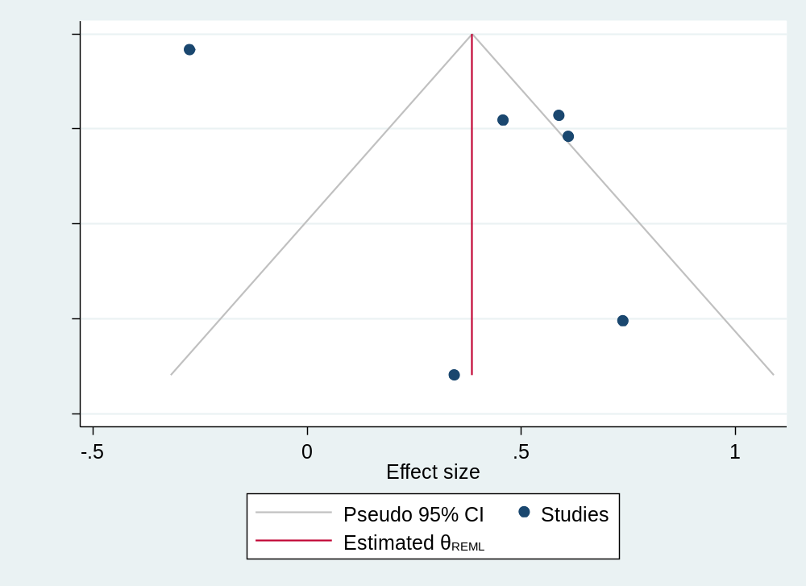

Supplementary Appendix 5B. Funnel plot of PTSD and mortality in studies reporting Hazard Ratios (HR)

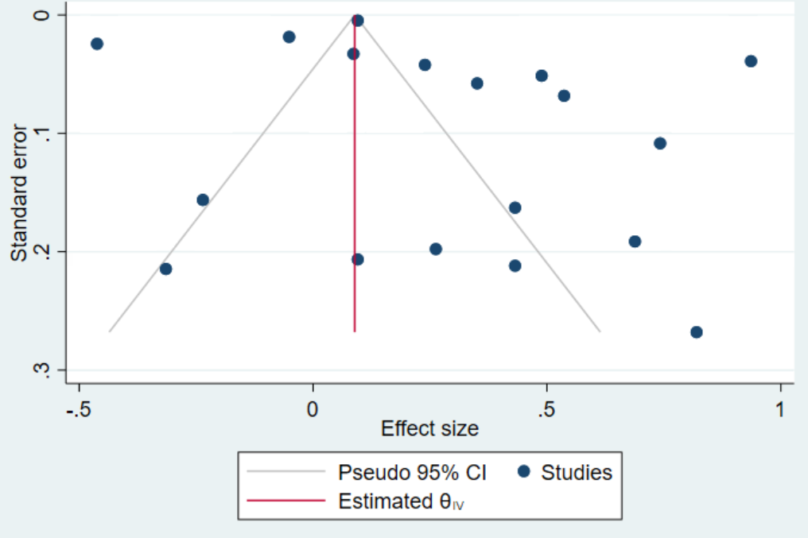

Supplementary Appendix 6A. Results from subgroup analyses by veteran status, in studies reporting Odds Ratios (OR) and Risk Ratios (RR)*
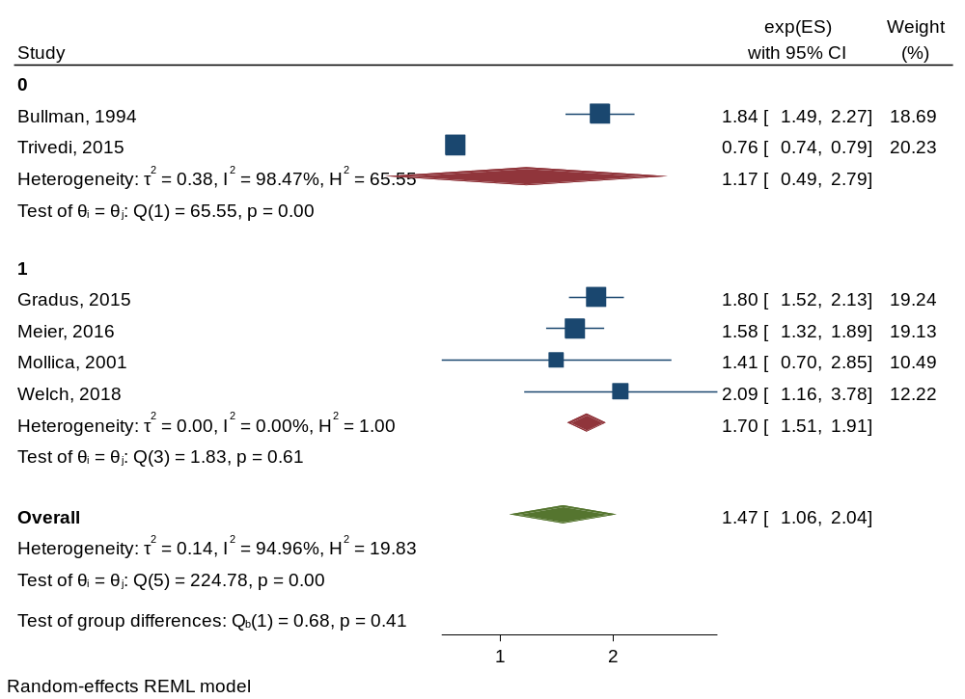
Veterans

Civilians

*Effect sizes shown may vary by 0.1 to what is reported in the studies, due to logarithmic transformation during analyses
Supplementary Appendix 6B. Results from subgroup analyses by veteran status, in studies reporting Hazard Ratios (HR)*
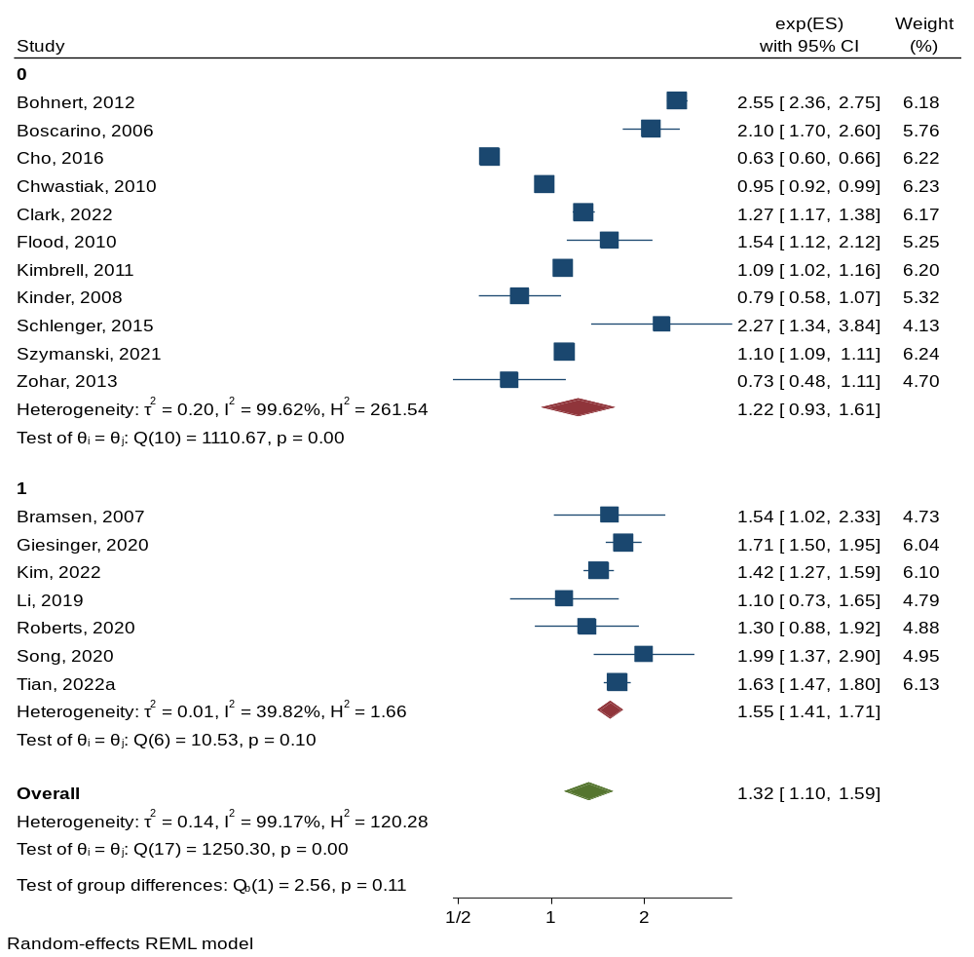
Veterans

Civilians

*Effect sizes shown may vary by 0.1 to what is reported in the studies, due to logarithmic transformation during analyses
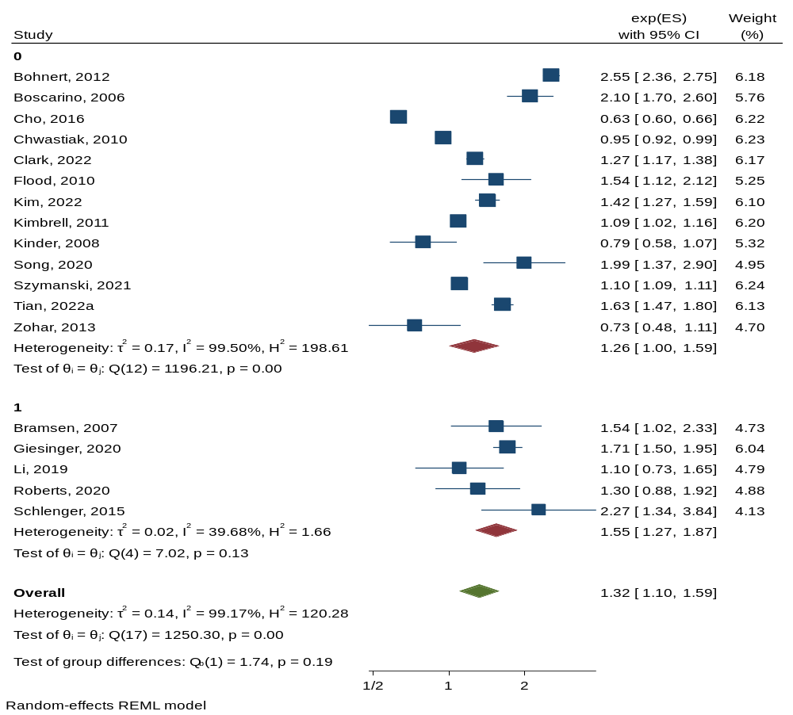
Supplementary Appendix 7. Results from subgroup analyses by PTSD diagnosis, in studies reporting Hazard Ratios (HR)*
Diagnosis

Probable diagnosis

*Effect sizes shown may vary by 0.1 to what is reported in the studies, due to logarithmic transformation during analyses
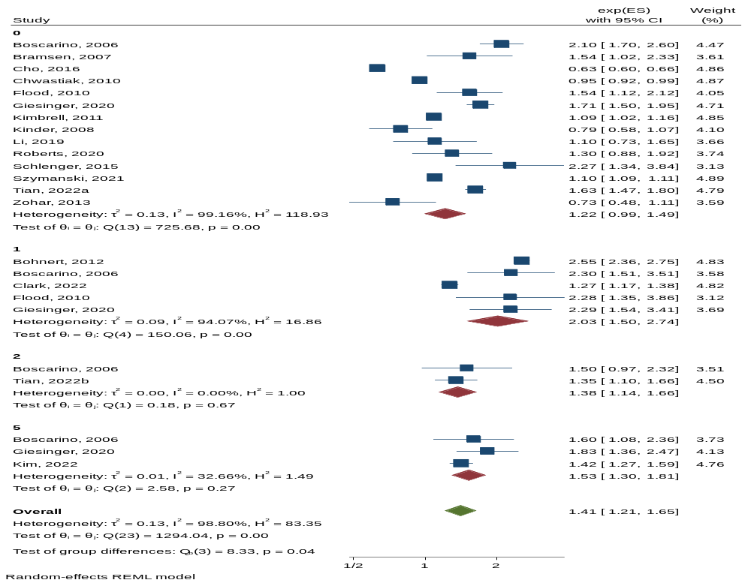
Supplementary Appendix 8A. Results from subgroup analyses by cause of death, in studies reporting Hazard Ratios (HR)*
All-cause
External
Cancer
All-cause

External

Cancer

Cardiovascular

*Effect sizes shown may vary by 0.1 to what is reported in the studies, due to logarithmic transformation during analyses
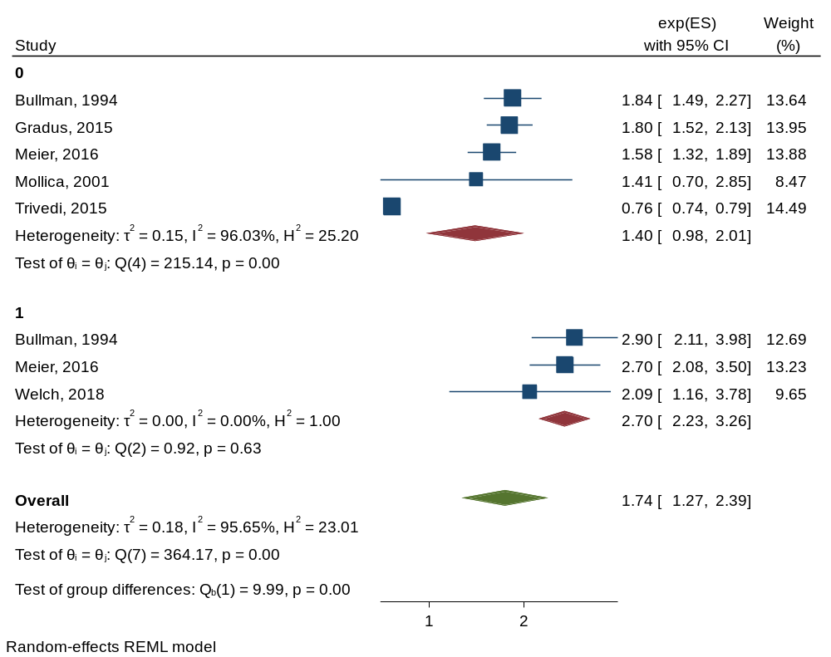
Supplementary Appendix 8B. Results from subgroup analyses by cause of death, in studies reporting Odds Ratios (OR) and Risk Ratios (RR)*

All-cause

External

*Effect sizes shown may vary by 0.1 to what is reported in the studies, due to logarithmic transformation during analyses
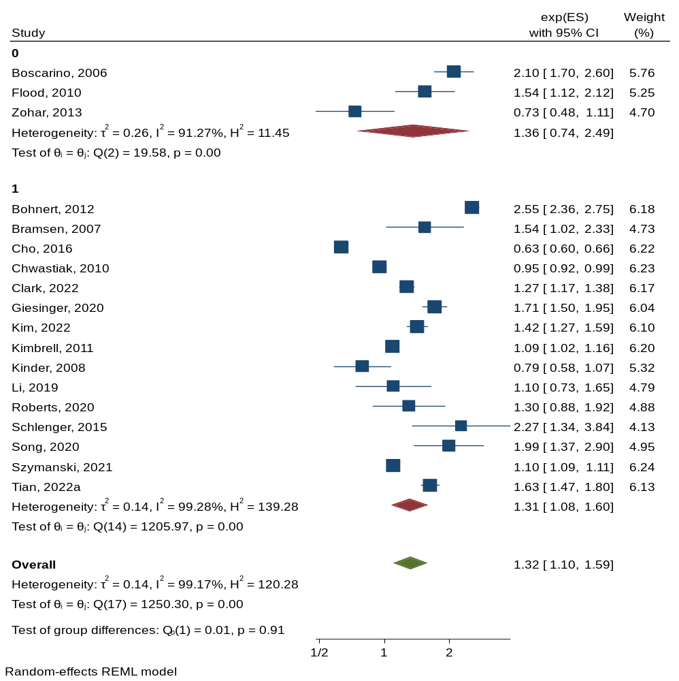
Supplementary Appendix 9. Results from subgroup analyses by sex, in studies reporting Hazard Ratios (HR)*
Both
Men

*Effect sizes shown may vary by 0.1 to what is reported in the studies, due to logarithmic transformation during analyses
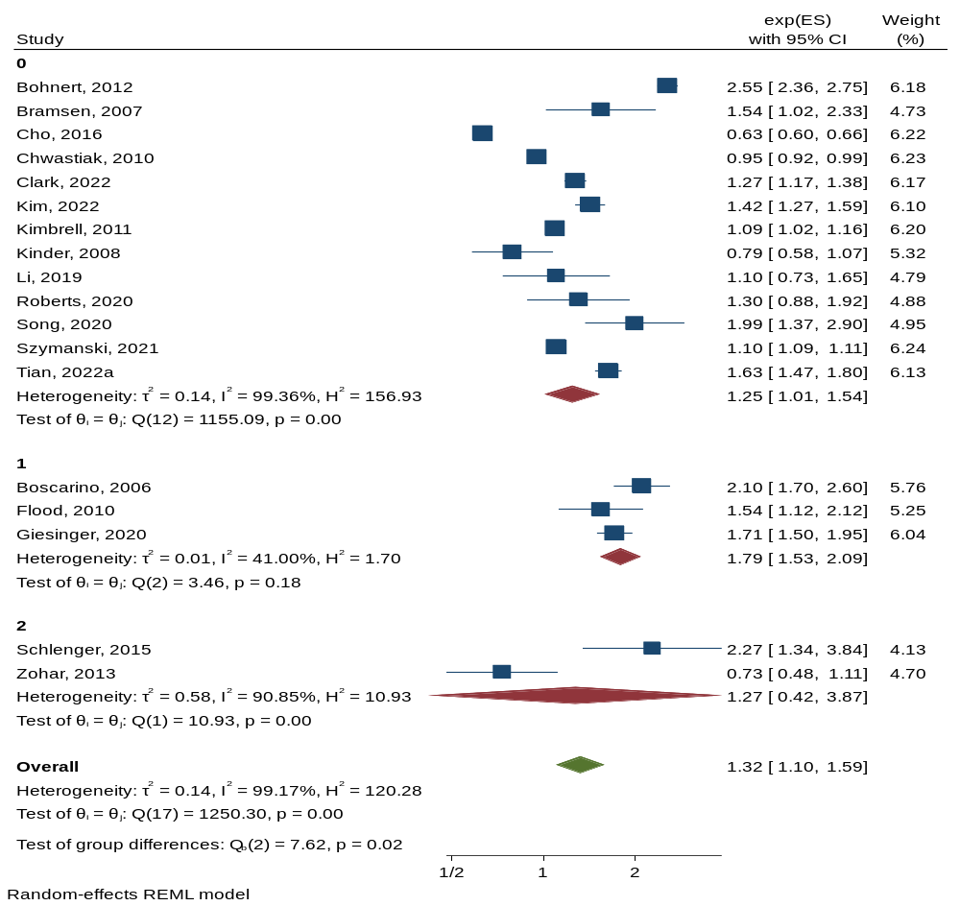
Supplementary Appendix 10. Results from subgroup analyses by follow-up period, in studies reporting Hazard Ratios (HR)*
≤ 10 years

10-20 years

≥ 20 years

*Effect sizes shown may vary by 0.1 to what is reported in the studies, due to logarithmic transformation during analyses
Supplementary Appendix 11A. Results from subgroup analyses by methodological quality, in studies reporting Odds Ratios (OR) and Risk Ratios (RR)*
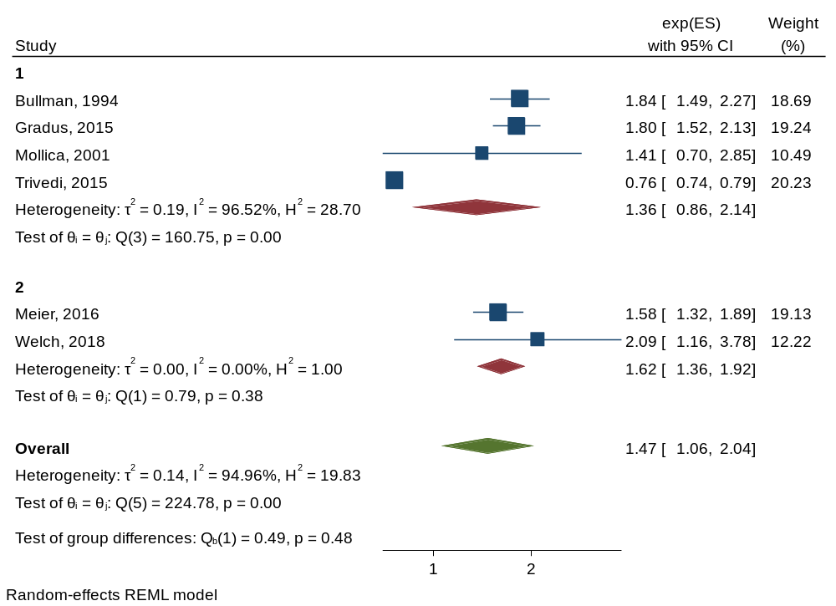
Fair

Good

*Effect sizes shown may vary by 0.1 to what is reported in the studies, due to logarithmic transformation during analyses
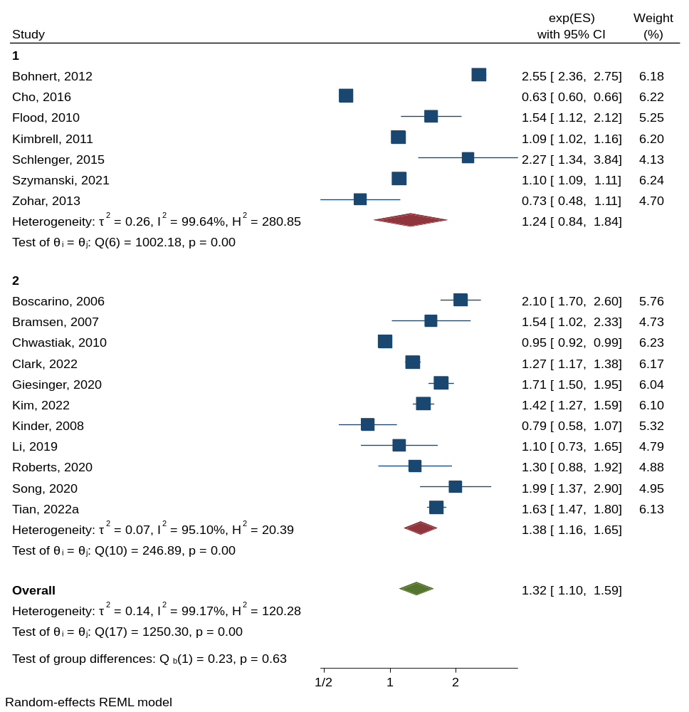
Supplementary Appendix 11B. Results from subgroup analyses by methodological quality, in studies reporting Hazard Ratios (HR)*
Fair

Good

*Effect sizes shown may vary by 0.1 to what is reported in the studies, due to logarithmic transformation during analyses

