mental health literacy:
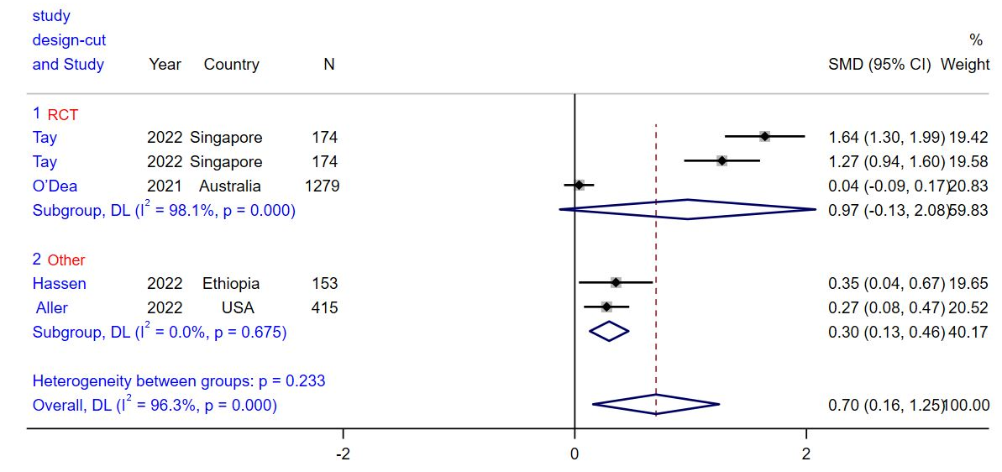
Figure 1: Subgroup analysis for the effect of Web-Based Educational Interventions on mental health literacy, expressed as the mean differences between the intervention and the control groups. The area of each square is proportional to the inverse of the variance of the SMD. Horizontal lines represent 95% CIs. Diamonds represent pooled estimates from random-effects analysis
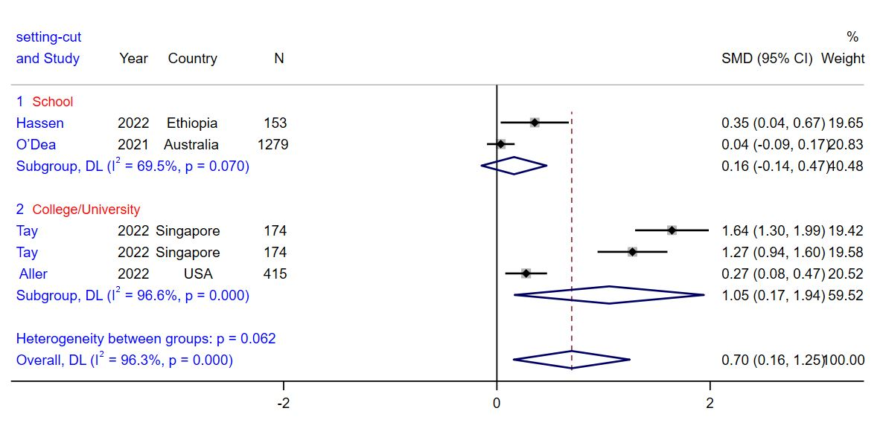Figure 2: Subgroup analysis for the effect of Web-Based Educational Interventions on mental health literacy, expressed as the mean differences between the intervention and the control groups. The area of each square is proportional to the inverse of the variance of the SMD. Horizontal lines represent 95% CIs. Diamonds represent pooled estimates from random-effects analysis

Help-seeking intentions/attitudes:

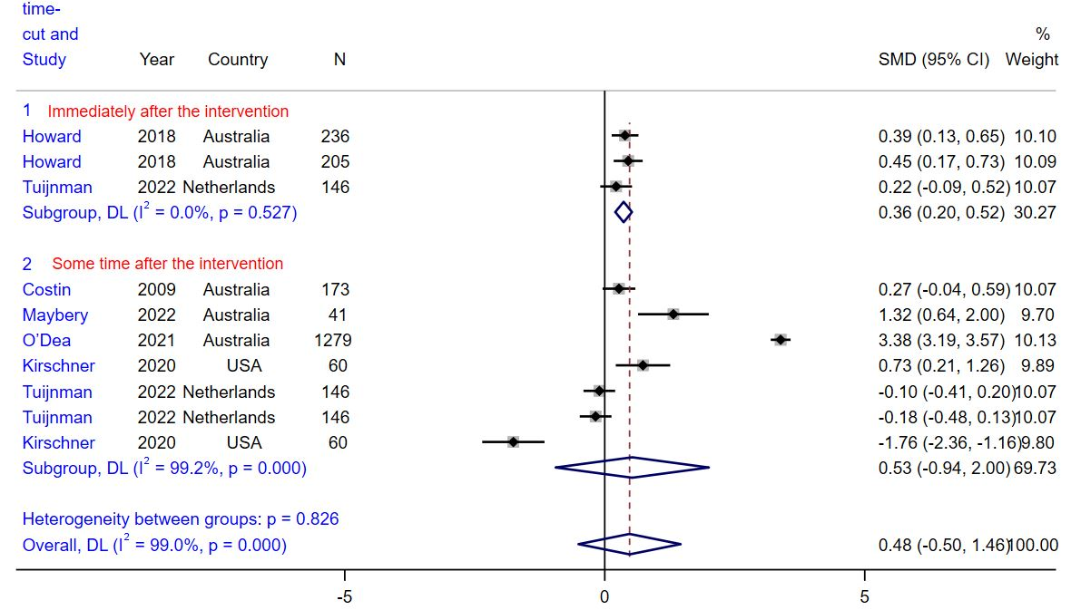
Figure 3: Subgroup analysis for the effect of Web-Based Educational Interventions on Help-seeking intentions/attitudes, expressed as the mean differences between the intervention and the control groups. The area of each square is proportional to the inverse of the variance of the SMD. Horizontal lines represent 95% CIs. Diamonds represent pooled estimates from random-effects analysis.
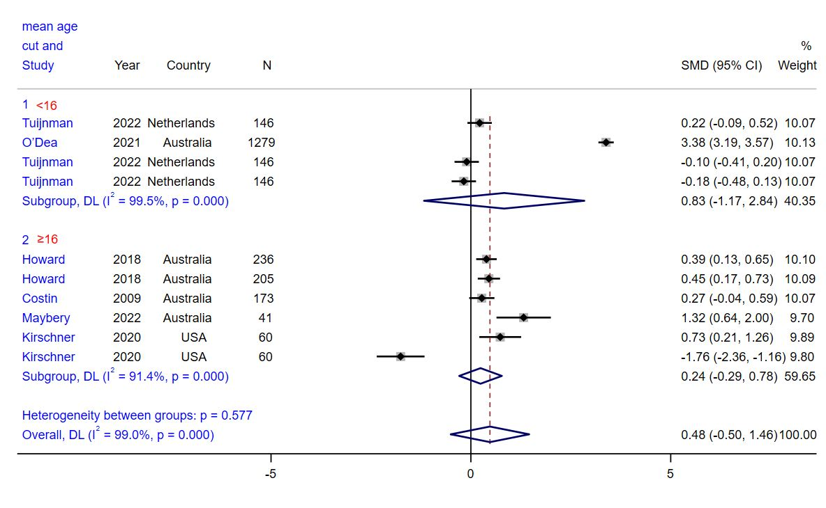Figure 4: Subgroup analysis for the effect of Web-Based Educational Interventions on Help-seeking intentions/attitudes, expressed as the mean differences between the intervention and the control groups. The area of each square is proportional to the inverse of the variance of the SMD. Horizontal lines represent 95% CIs. Diamonds represent pooled estimates from random-effects analysis

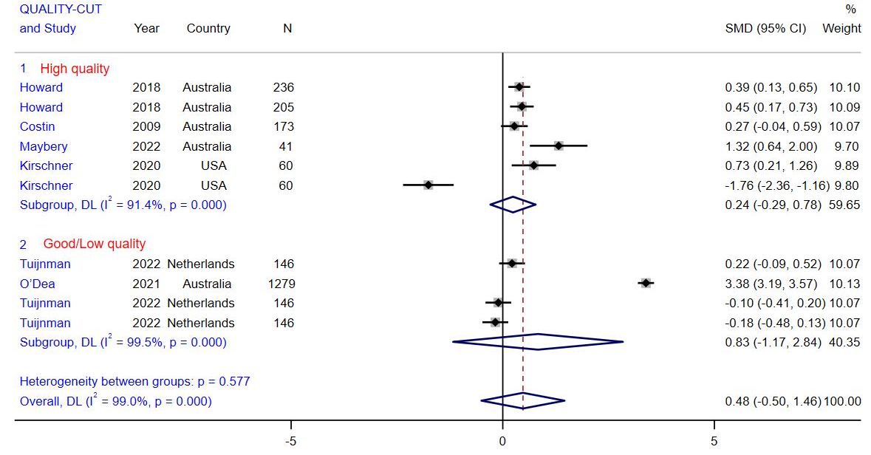Figure 5: Subgroup analysis for the effect of Web-Based Educational Interventions on Help-seeking intentions/attitudes, expressed as the mean differences between the intervention and the control groups. The area of each square is proportional to the inverse of the variance of the SMD. Horizontal lines represent 95% CIs. Diamonds represent pooled estimates from random-effects analysis

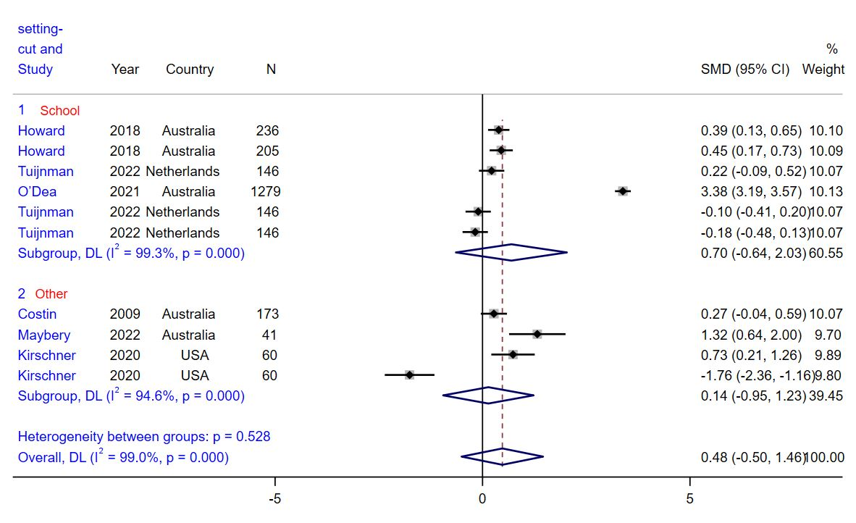Figure 6: Subgroup analysis for the effect of Web-Based Educational Interventions on Help-seeking intentions/attitudes, expressed as the mean differences between the intervention and the control groups. The area of each square is proportional to the inverse of the variance of the SMD. Horizontal lines represent 95% CIs. Diamonds represent pooled estimates from random-effects analysis
Stigma:
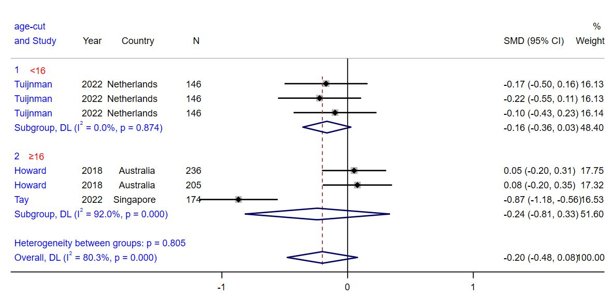Figure 7: Subgroup analysis for the effect of Web-Based Educational Interventions on Stigma, expressed as the mean differences between the intervention and the control groups. The area of each square is proportional to the inverse of the variance of the SMD. Horizontal lines represent 95% CIs. Diamonds represent pooled estimates from random-effects analysis

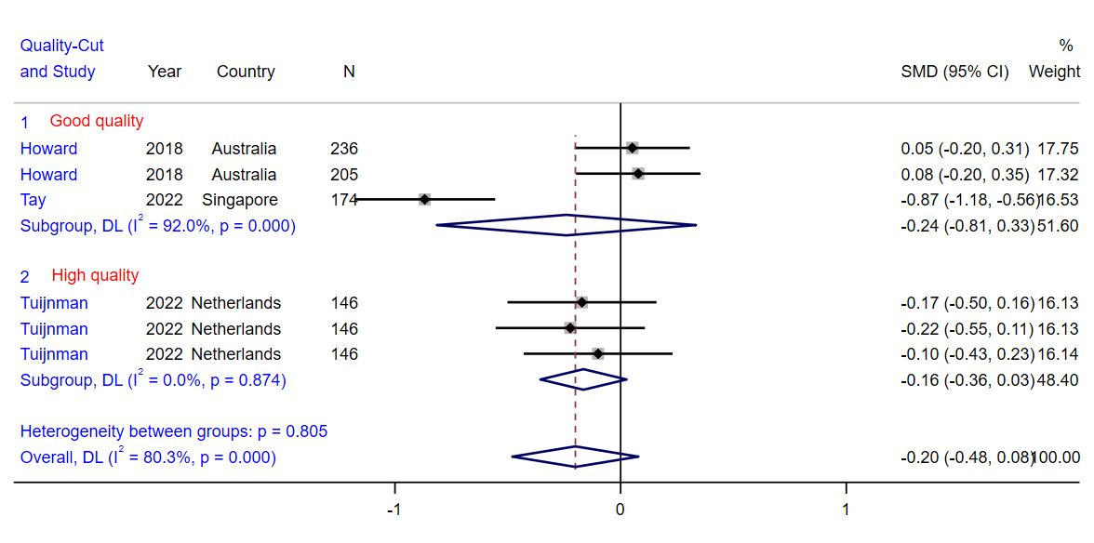Figure 8: Subgroup analysis for the effect of Web-Based Educational Interventions on Stigma, expressed as the mean differences between the intervention and the control groups. The area of each square is proportional to the inverse of the variance of the SMD. Horizontal lines represent 95% CIs. Diamonds represent pooled estimates from random-effects analysis

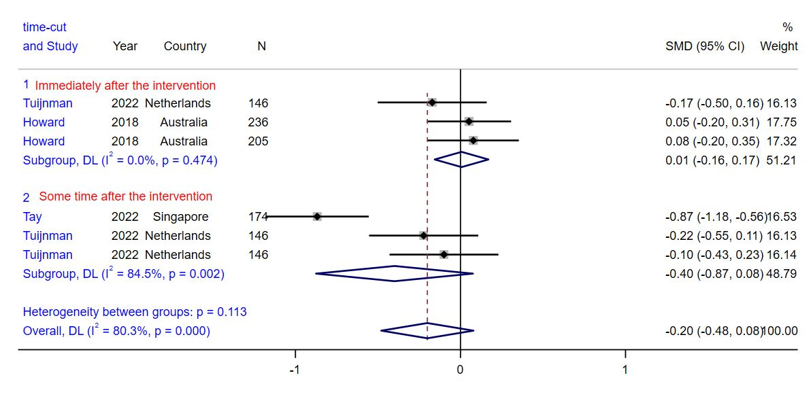Figure 9: Subgroup analysis for the effect of Web-Based Educational Interventions on Stigma, expressed as the mean differences between the intervention and the control groups. The area of each square is proportional to the inverse of the variance of the SMD. Horizontal lines represent 95% CIs. Diamonds represent pooled estimates from random-effects analysis

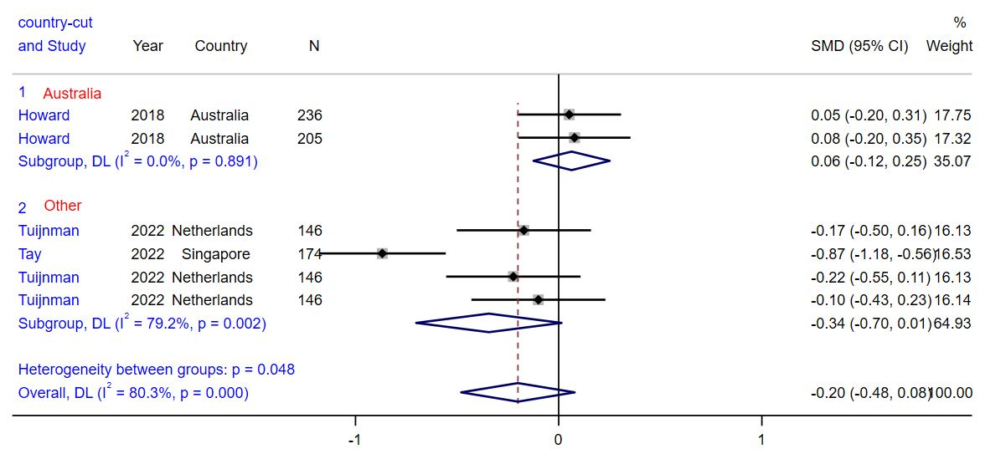Figure 10: Subgroup analysis for the effect of Web-Based Educational Interventions on Stigma, expressed as the mean differences between the intervention and the control groups. The area of each square is proportional to the inverse of the variance of the SMD. Horizontal lines represent 95% CIs. Diamonds represent pooled estimates from random-effects analysis

