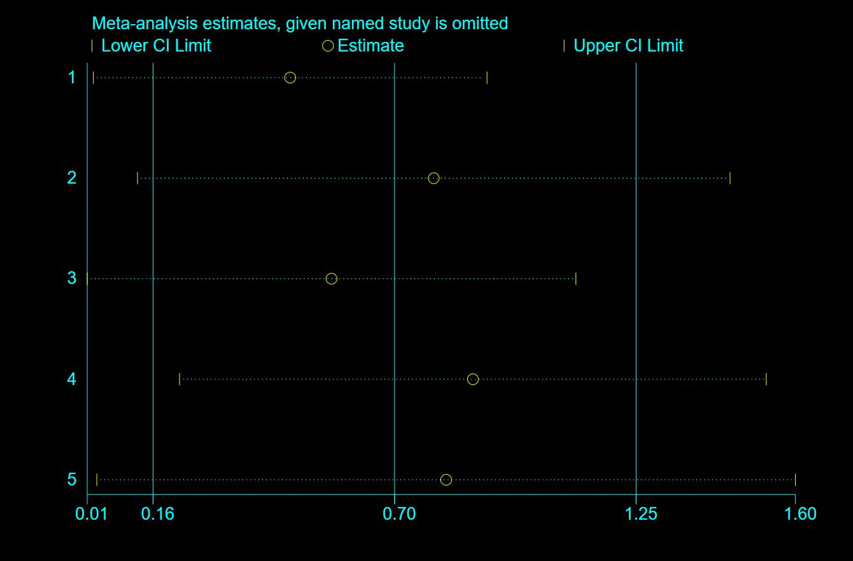
Figure 1: Sensitivity analysis of mental health literacy studies

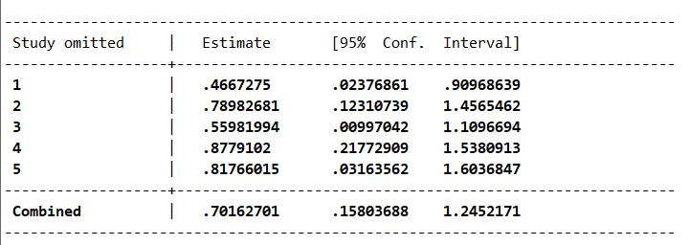
Figure 2: Sensitivity analysis of mental health literacy studies

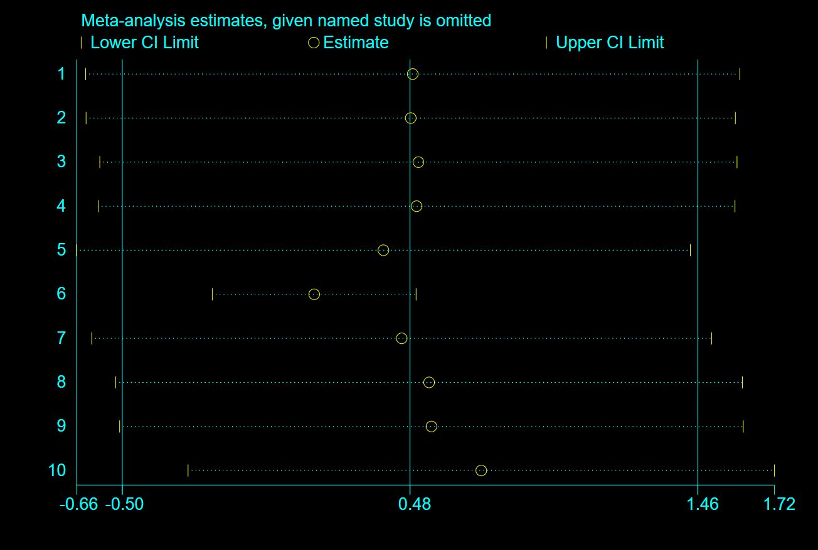
Figure 3: Sensitivity analysis of Help-seeking intentions/attitudes studies

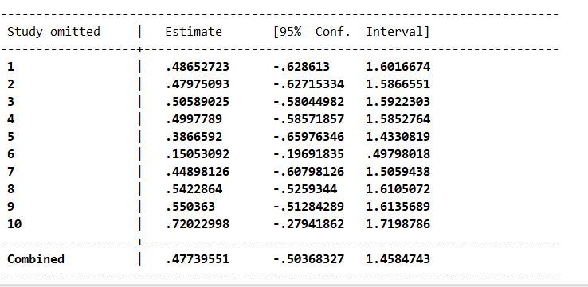
Figure 4: Sensitivity analysis of Help-seeking intentions/attitudes studies

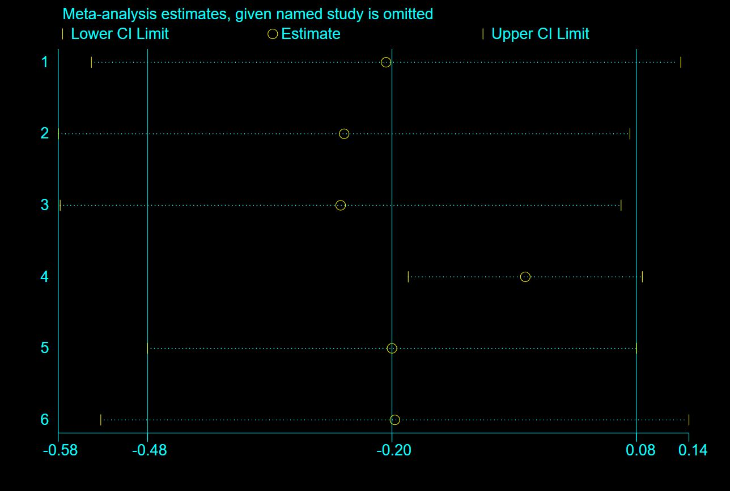
Figure 5: Sensitivity analysis of stigma studies

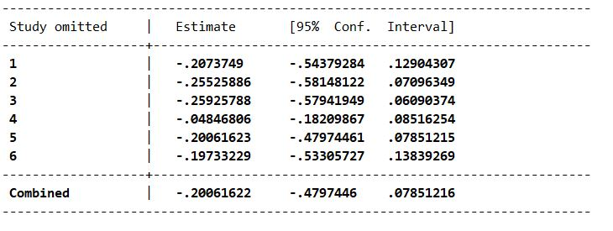Figure 6: Sensitivity analysis of stigma studies

