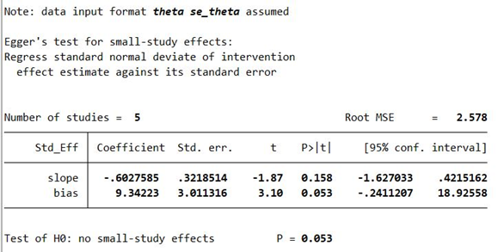
Figure 1: Publication bias results for mental health literacy studies
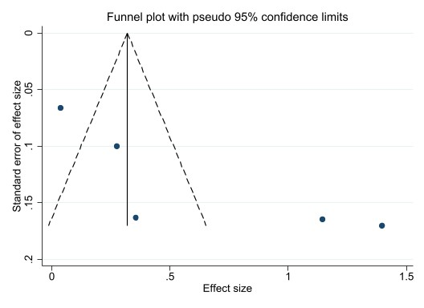
Figure 2: Publication bias results for mental health literacy studies

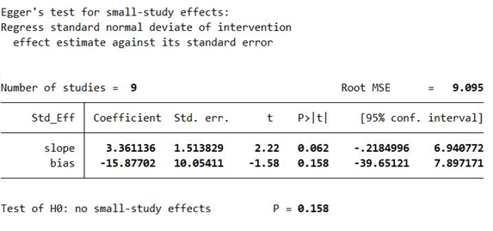
Figure 3: Publication bias results for seeking help studies
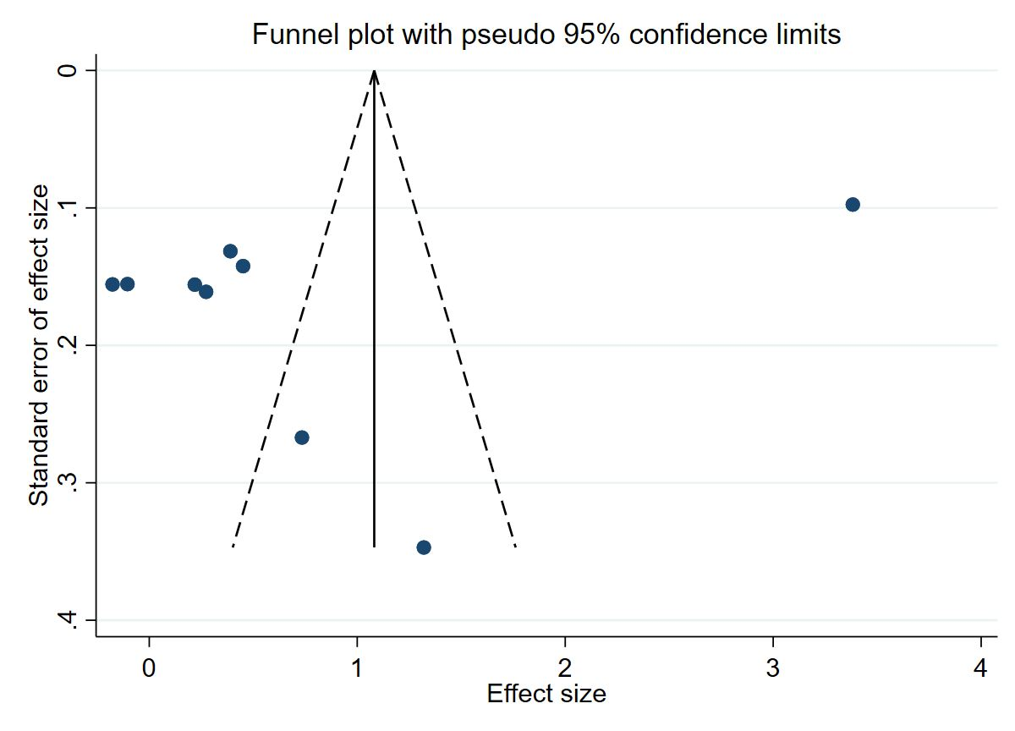
Figure 4: Publication bias results for seeking help studies

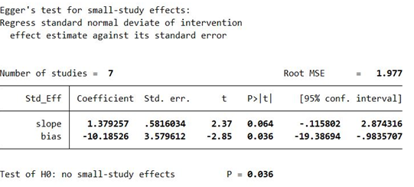
Figure 5: Publication bias results for Stigma related to mental illnesses studies
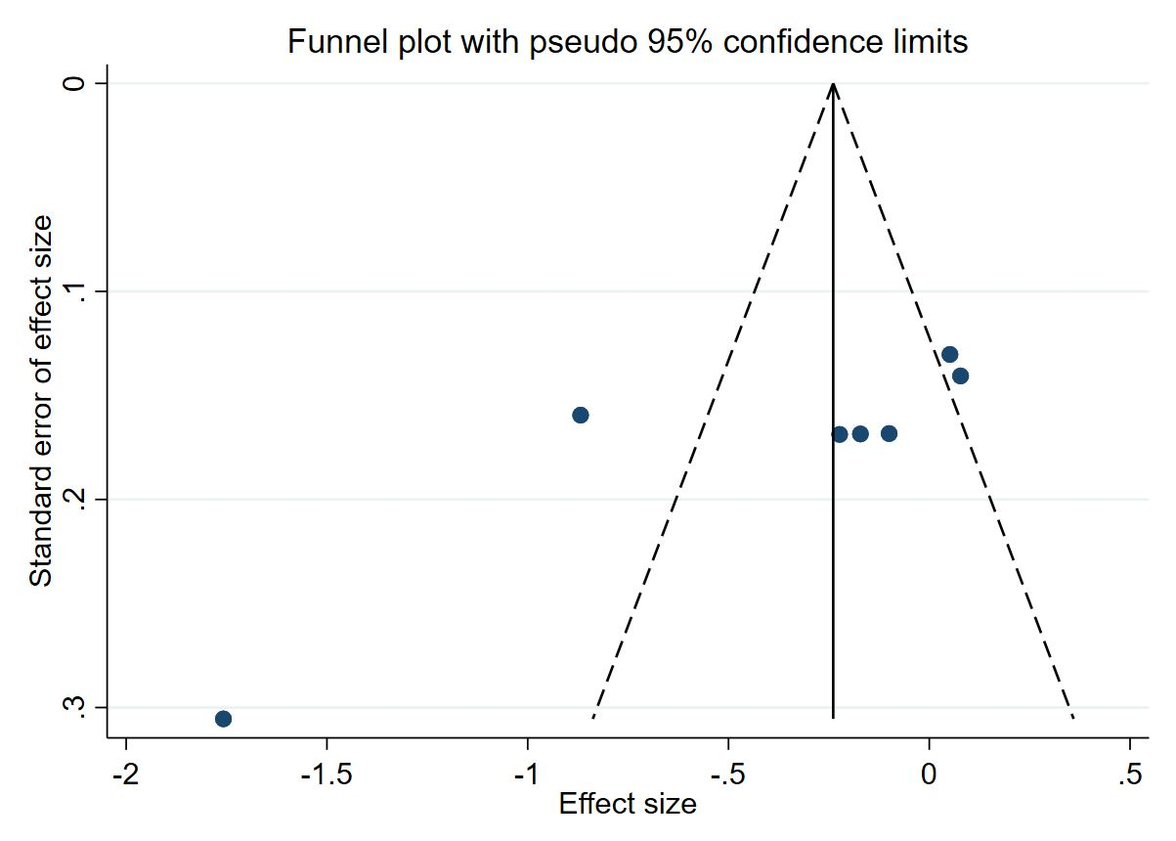
Figure 6: Publication bias results for Stigma related to mental illnesses studies

