Table1 Cerebral FC differences (DS vs. NC) using cerebellar regions as Seed ROIs
Anatomical description | AAL3 label | Peak t-value of cluster | MNI coordinates of peak t-value |  |  | Cluster size（voxels）
Anatomical description | AAL3 label | Peak t-value of cluster | X | Y | Z | Cluster size（voxels）
ROI：Left Crus I of cerebellar ( AAL3 Label: 95 )
Right Cuneus (CUN) | 50 | 4.16 | 12 | -90 | 18 | 1126
Left Inferior parietal gyrus, excluding supramarginal and angular gyri (IPG) | 65 | -5.31 | -60 | -42 | 45 | 479
Left Superior frontal gyrus,  dorsolateral (SFG) | 3 | -3.88 | -15 | 36 | 33 | 353
Left Middle temporal gyrus (MTG) | 89 | -5.03 | -66 | -51 | -12 | 247
Right Lobule IX of cerebellar  hemisphere (CER9) | 110 | -4.48 | 6 | -45 | -45 | 200
ROI：Right Crus I of cerebellar (AAL3 Label: 96 )
Right Supplementary motor area (SMA) | 16 | -4.36 | 6 | -21 | 51 | 139
ROI：Left Crus Ⅱ of cerebellar (AAL3 Label: 97 )
Left Lingual gyrus (LING) | 51 | 4.17 | -21 | -99 | -15 | 604
Left Inferior parietal gyrus,  excluding supramarginal and  angular gyri (IPG) | 65 | -4.65 | -45 | -54 | 54 | 399
ROI：Right Crus Ⅱ of cerebellar (AAL3 Label: 98 )
Right Middle temporal gyrus (MTG) | 90 | 4.78 | 54 | -75 | 0 | 340
Left Lobule VIIB of cerebellar  hemisphere (CER7b) | 105 | -4.57 | -39 | -63 | -48 | 262
ROI：Left Lobule III of cerebellar (AAL3 Label: 99 )
- | - | - | - | - | - | -
ROI：Right Lobule III of cerebellar (AAL3 Label: 100 )
Right Middle temporal gyrus (MTG) | 90 | 5.73 | 57 | -69 | -3 | 264
ROI：Left Lobule IV, V of cerebellar (AAL3 Label: 101 )
Left Lingual gyrus (LING) | 51 | 7.86 | -33 | -93 | -15 | 410
ROI：Right Lobule IV, V of cerebellar (AAL3 Label: 102 )
- | - | - | - | - | - | -
ROI：Left Lobule VI of cerebellar (AAL3 Label: 103 )
Left Lingual gyrus (LING) | 51 | 4.48 | -27 | -90 | -18 | 188
Left Inferior frontal gyrus,  opercular part (IFGoperc) | 7 | -3.94 | -36 | 3 | 21 | 165
Left Inferior parietal gyrus,  excluding supramarginal and  angular gyri (IPG) | 65 | -3.28 | -42 | -51 | 48 | 146
ROI：Right Lobule VI of cerebellar (AAL3 Label: 104 )
- | - | - | - | - | - | -
ROI：Left Lobule VIIB of cerebellar (AAL3 Label: 105 )
Left Middle occipital gyrus (MOG) | 55 | 5.58 | -42 | -81 | 0 | 498
ROI：Right Lobule VIIB of cerebellar (AAL3 Label: 106 )
Right Calcarine fissure and  surrounding cortex (CAL) | 48 | 4.95 | 21 | -99 | 0 | 441
Left Superior temporal gyrus (STG) | 85 | 6.09 | -48 | -42 | 12 | 170
ROI：Left Lobule VIII of cerebellar (AAL3 Label: 107 )
Left Middle occipital gyrus (MOG) | 55 | 6.25 | -39 | -84 | -3 | 545
ROI：Right Lobule VIII of cerebellar (AAL3 Label: 108 )
Left Olfactory_L (OLF) | 17 | 5.07 | -6 | 18 | -15 | 166
ROI：Left Lobule IX of cerebellar (AAL3 Label: 109 )
Right Inferior occipital gyrus (IOG) | 58 | 4.17 | 36 | -90 | -6 | 175
ROI：Right Lobule IX of cerebellar (AAL3 Label: 110 )
Left Fusiform gyrus (FFG) | 59 | -3.90 | -30 | -54 | -18 | 441
Right Lingual gyrus (LING) | 52 | 4.12 | 27 | -99 | -18 | 276
ROI：Left Lobule X of cerebellar (AAL3 Label: 111 )
Left Cuneus (CUN) | 49 | -4.62 | -12 | -75 | 18 | 247
ROI：Right Lobule X of cerebellar (AAL3 Label: 112 )
- | - | - | - | - | - | -
ROI：Lobule I, II of vermis (AAL3 Label: 113 )
- | - | - | - | - | - | -
ROI：Lobule III of vermis (AAL3 Label: 114 )
Left Middle temporal gyrus (MTG) | 89 | -3.78 | -60 | -18 | 0 | 136
ROI：Lobule IV, V of vermis (AAL3 Label: 115 )
Left Superior occipital gyrus (SOG) | 53 | 4.32 | -6 | -84 | 45 | 451
Left Lingual_L (LING) | 51 | 5.94 | -30 | -90 | -15 | 260
Left SupraMarginal gyrus (SMG) | 67 | -4.54 | -48 | -42 | 24 | 166
Left Inferior temporal gyrus (ITG) | 93 | -3.75 | -51 | -24 | -18 | 165
ROI：Lobule VI of vermis (AAL3 Label: 116 )
Left Lingual gyrus (LING) | 51 | 4.42 | -24 | -90 | -15 | 227
ROI：Lobule VII of vermis (AAL3 Label: 117 )
Left Lingual gyrus (LING) | 51 | 4.57 | -27 | -93 | -15 | 174
ROI：Lobule VIII of vermis (AAL3 Label: 118 )
Left Lingual gyrus (LING) | 51 | 5.89 | -27 | -93 | -15 | 212
Right Lingual gyrus (LING) | 52 | 4.49 | 18 | -96 | -9 | 207
ROI：Lobule IX of vermis (AAL3 Label: 119 )
Right Precentral gyrus (PreCG) | 2 | -5.06 | 54 | 3 | 18 | 332
Right Inferior occipital gyrus (IOG) | 58 | 4.47 | 36 | -90 | -6 | 216
ROI：Lobule X of vermis (AAL3 Label: 120 )
Right Precentral gyrus (PreCG) | 2 | -5.20 | 57 | 3 | 21 | 349

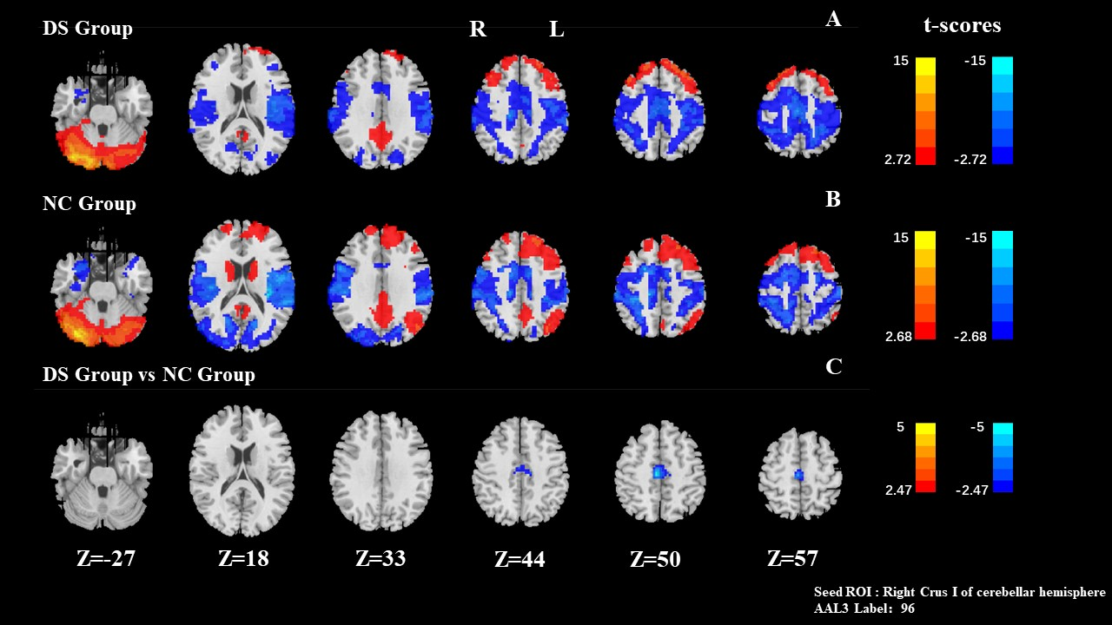
Figure 1. FC results of seed ROI: Right Crus I of cerebellar (AAL3 Label: 96 )

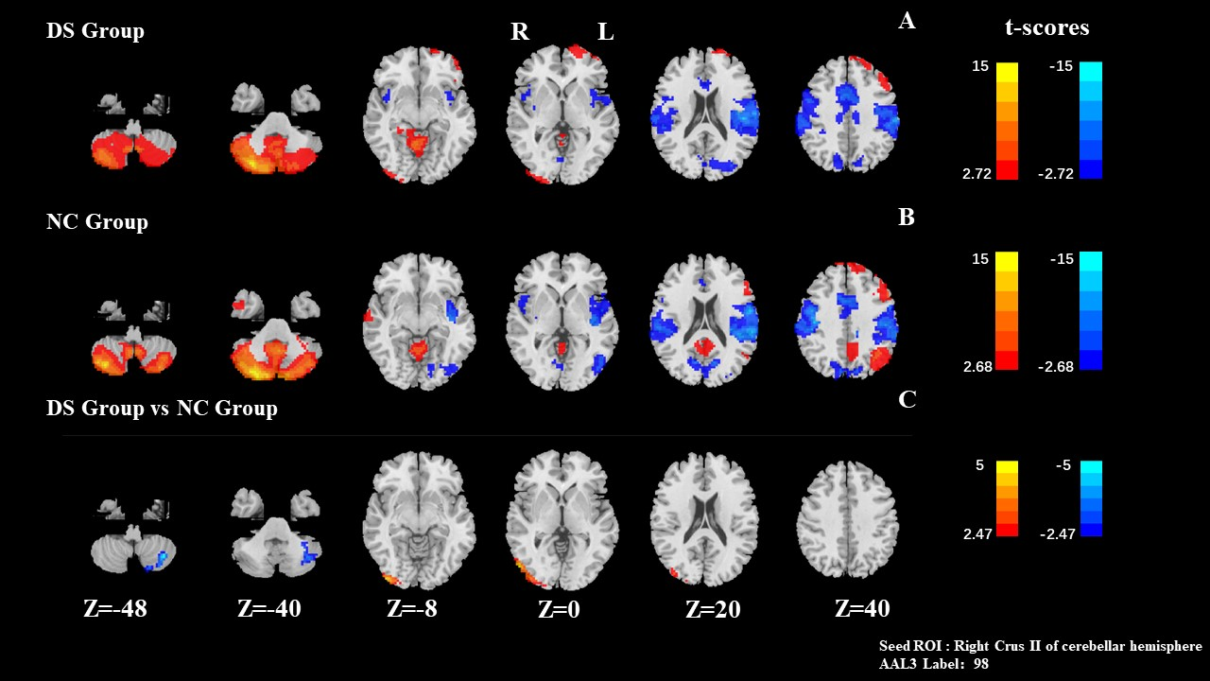
Figure 2. FC results of seed ROI: Right Crus Ⅱ of cerebellar (AAL3 Label: 98 )

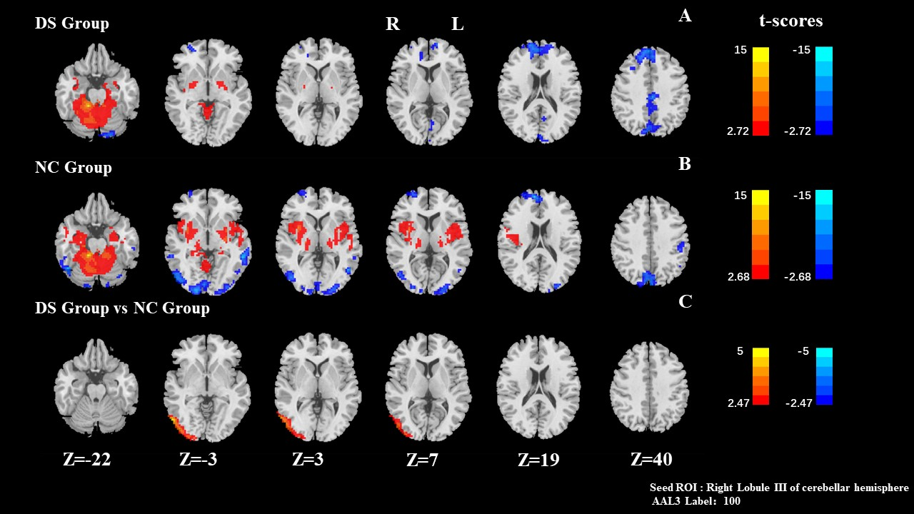
Figure 3. FC results of seed ROI: Right Lobule III of cerebellar (AAL3 Label: 100 )
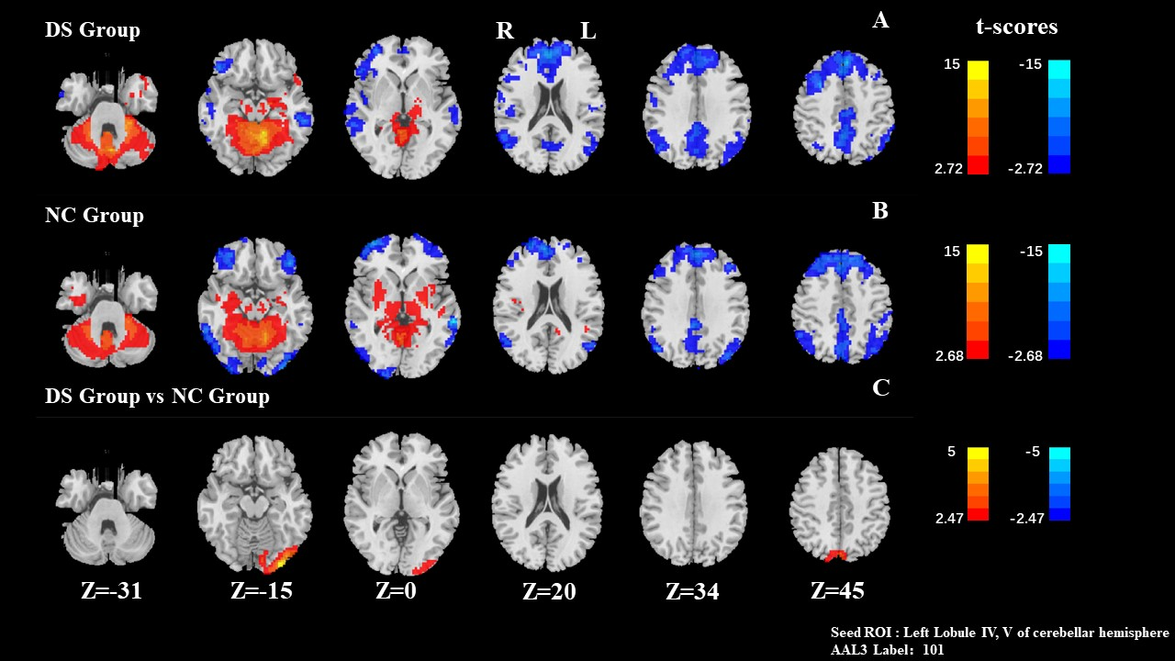
Figure 4. FC results of seed ROI: Left Lobule IV, V of cerebellar (AAL3 Label: 101 )

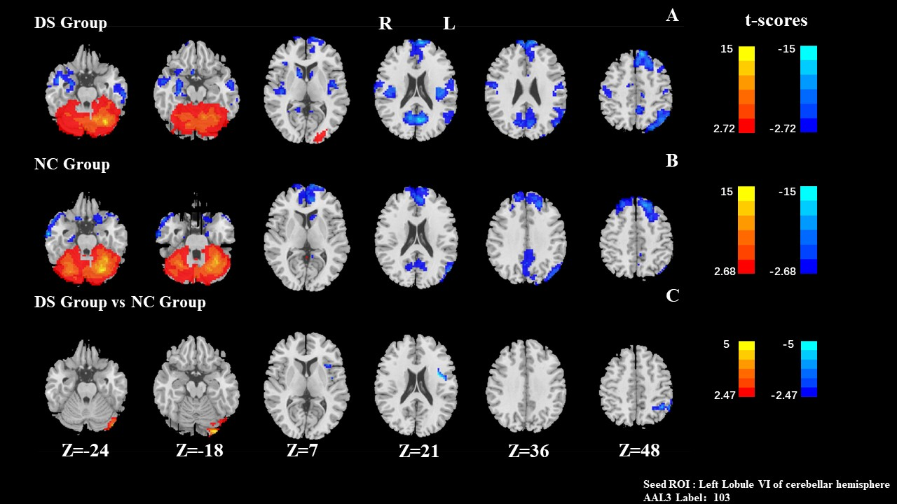
Figure 5. FC results of seed ROI: Left Lobule VI of cerebellar (AAL3 Label: 103 )

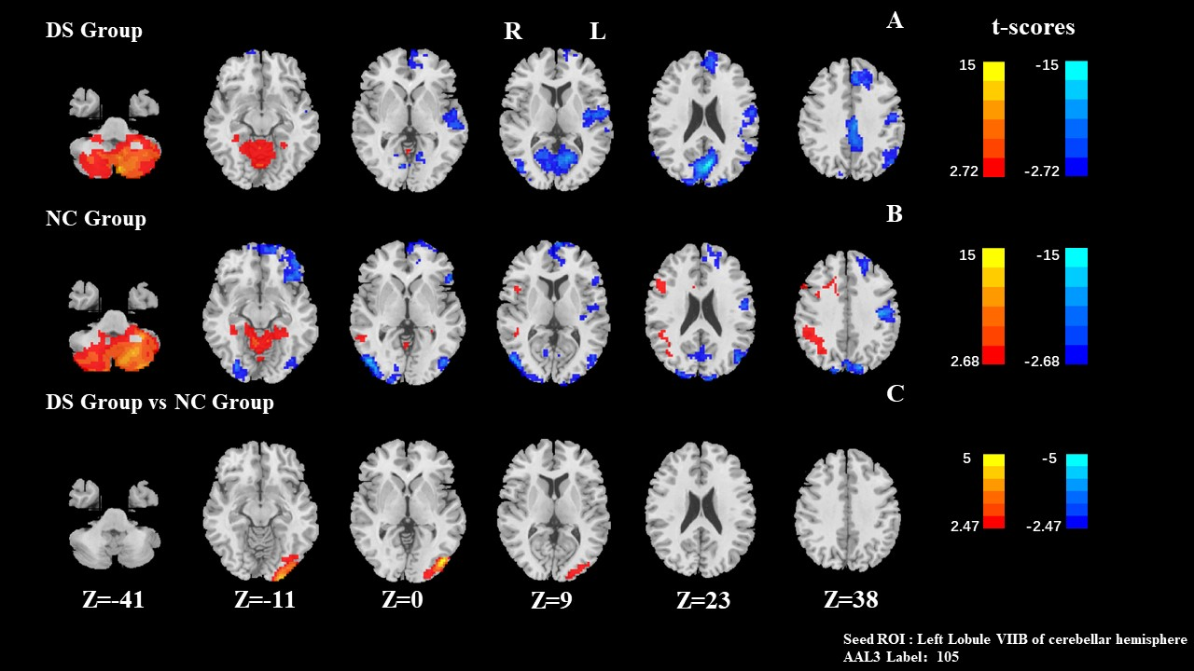
Figure 6. FC results of seed ROI: Left Lobule VIIB of cerebellar (AAL3 Label: 105 )

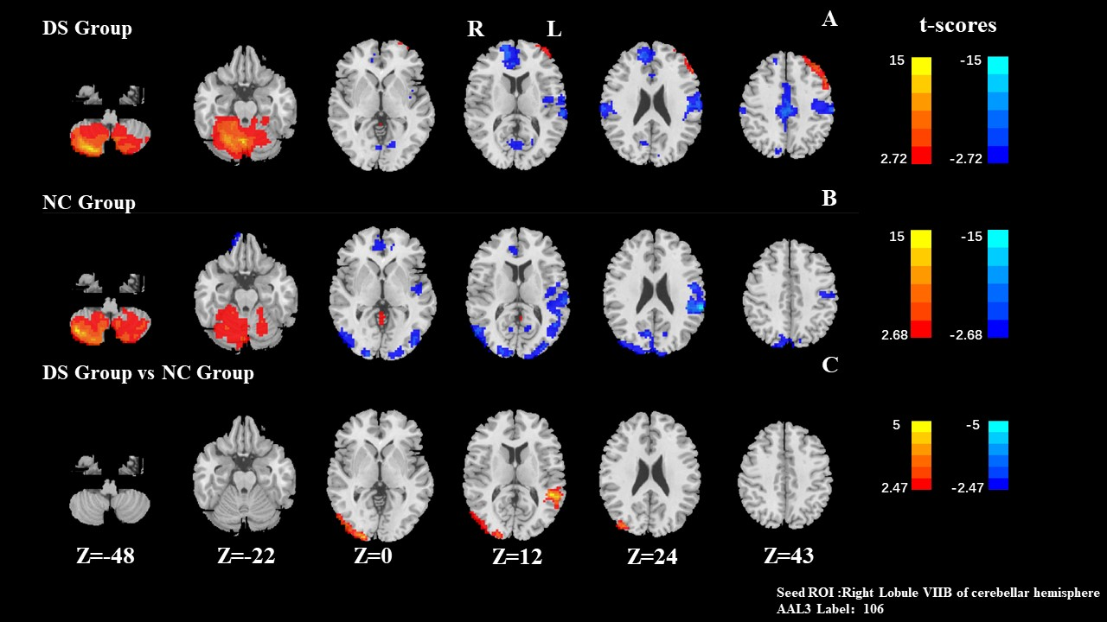
Figure 7. FC results of seed ROI: Right Lobule VIIB of cerebellar (AAL3 Label: 106 )

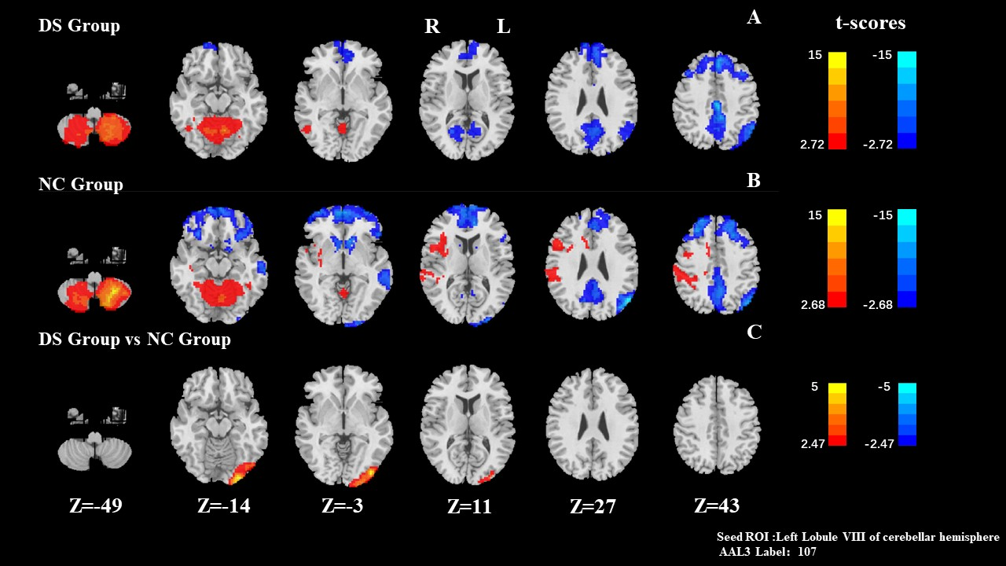
Figure 8. FC results of seed ROI: Left Lobule VIII of cerebellar (AAL3 Label: 107 )

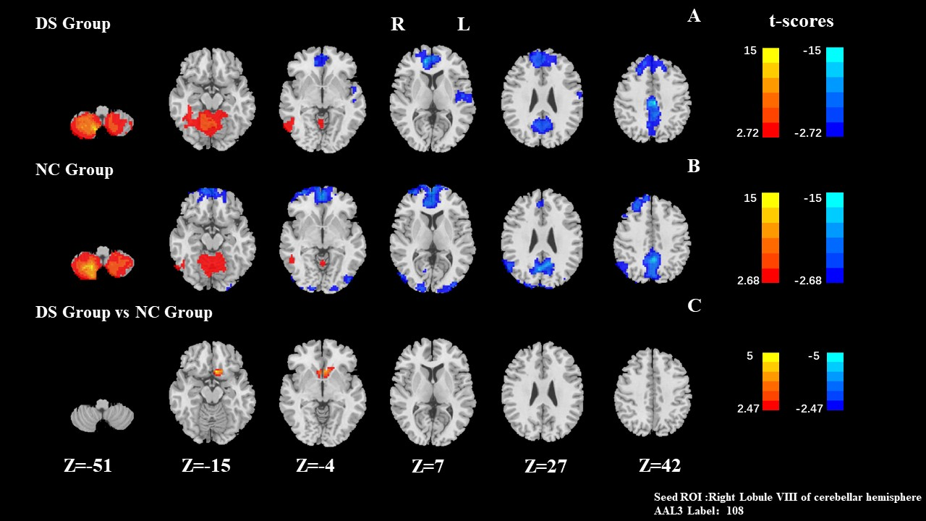
Figure 9. FC results of seed ROI: Right Lobule VIII of cerebellar (AAL3 Label: 108 )

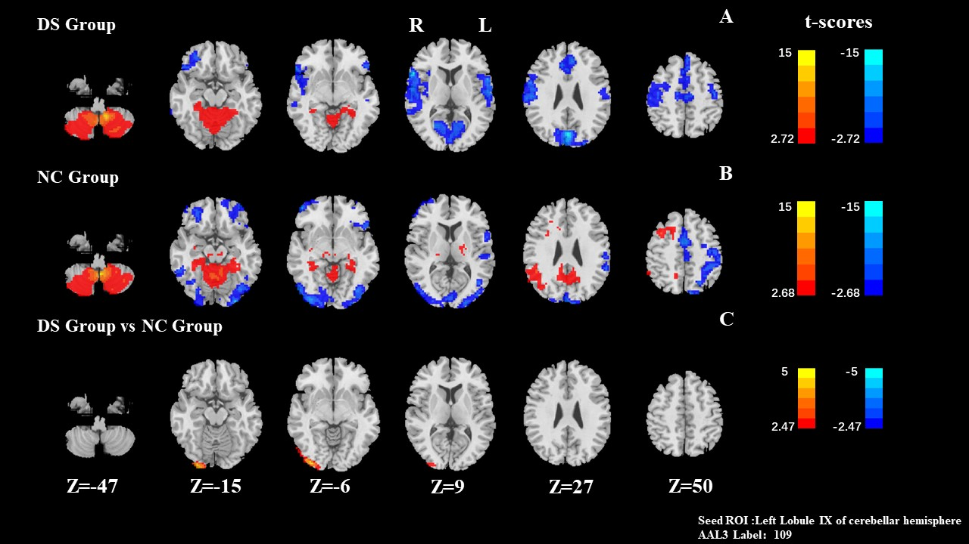
Figure 10. FC results of seed ROI: Left Lobule IX of cerebellar (AAL3 Label: 109 )

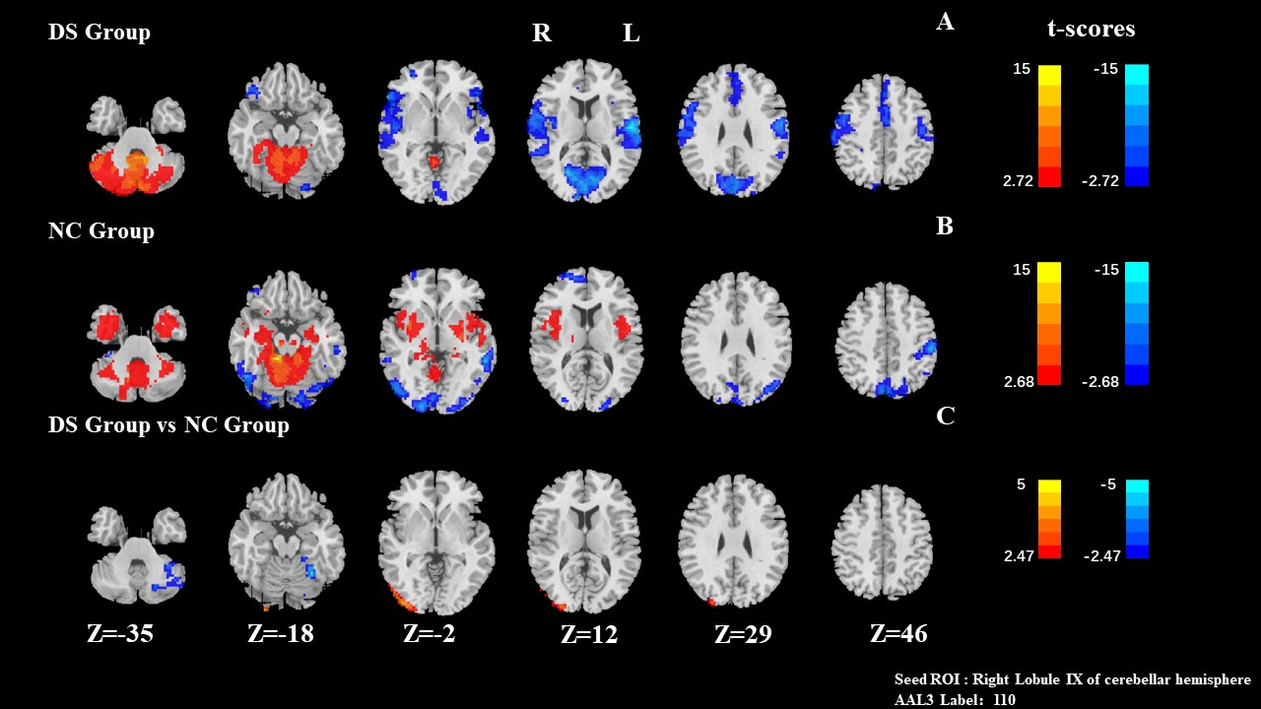
Figure 11. FC results of seed ROI: Right Lobule IX of cerebellar (AAL3 Label: 110 )

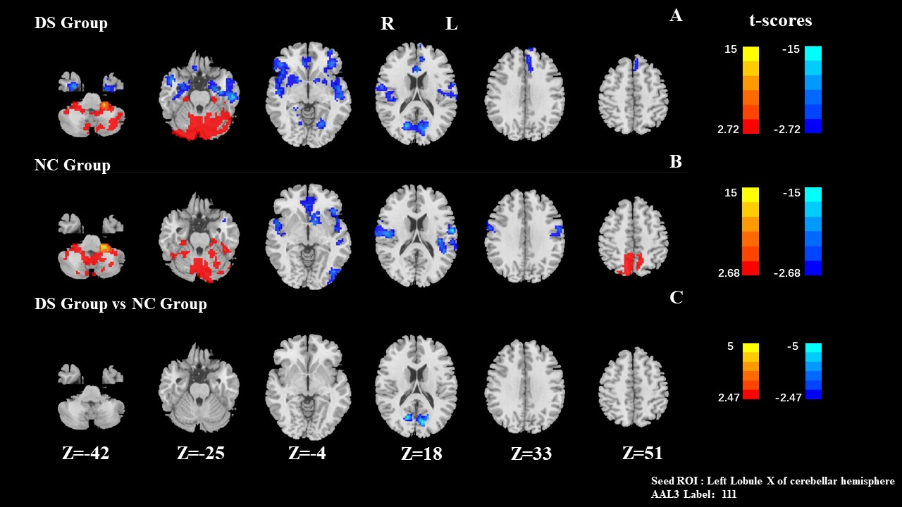
Figure 12. FC results of seed ROI: Left Lobule X of cerebellar (AAL3 Label: 111 )

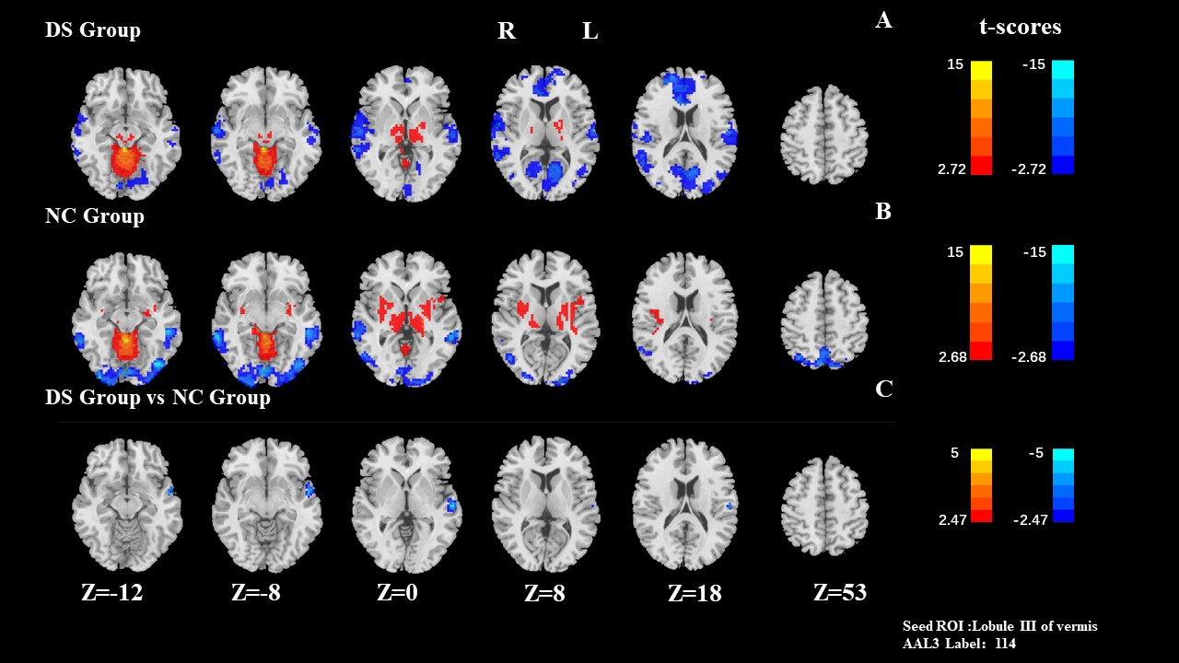
Figure 13. FC results of seed ROI: Lobule III of vermis (AAL3 Label: 114 )

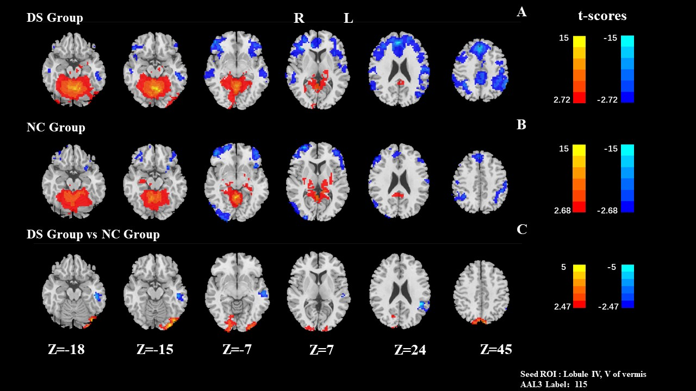
Figure 14. FC results of seed ROI: Lobule IV, V of vermis (AAL3 Label: 115 )

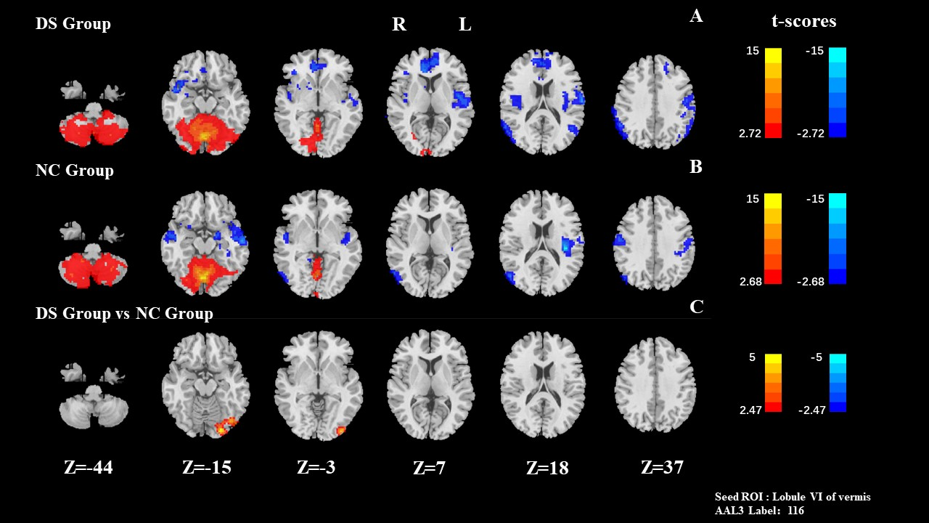
Figure 15. FC results of seed ROI: Lobule VI of vermis (AAL3 Label: 116 )

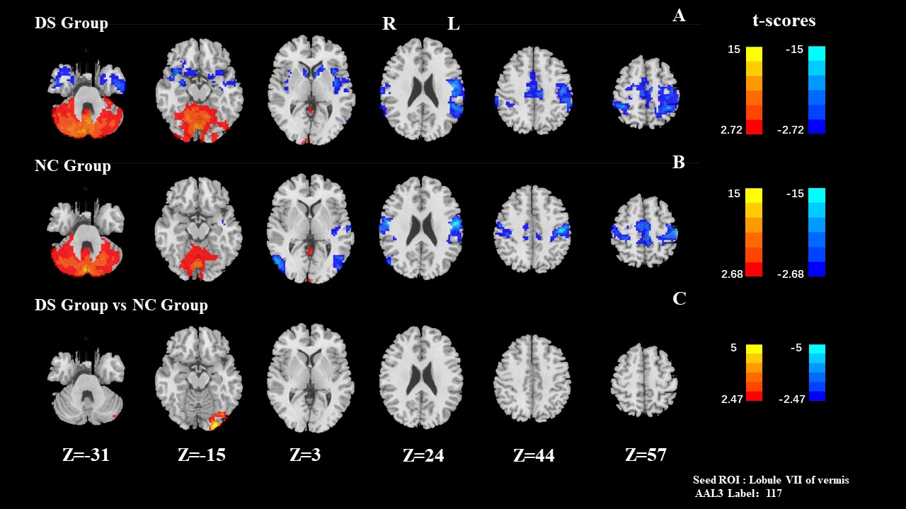
Figure 16. FC results of seed ROI: Lobule VII of vermis (AAL3 Label: 117 )

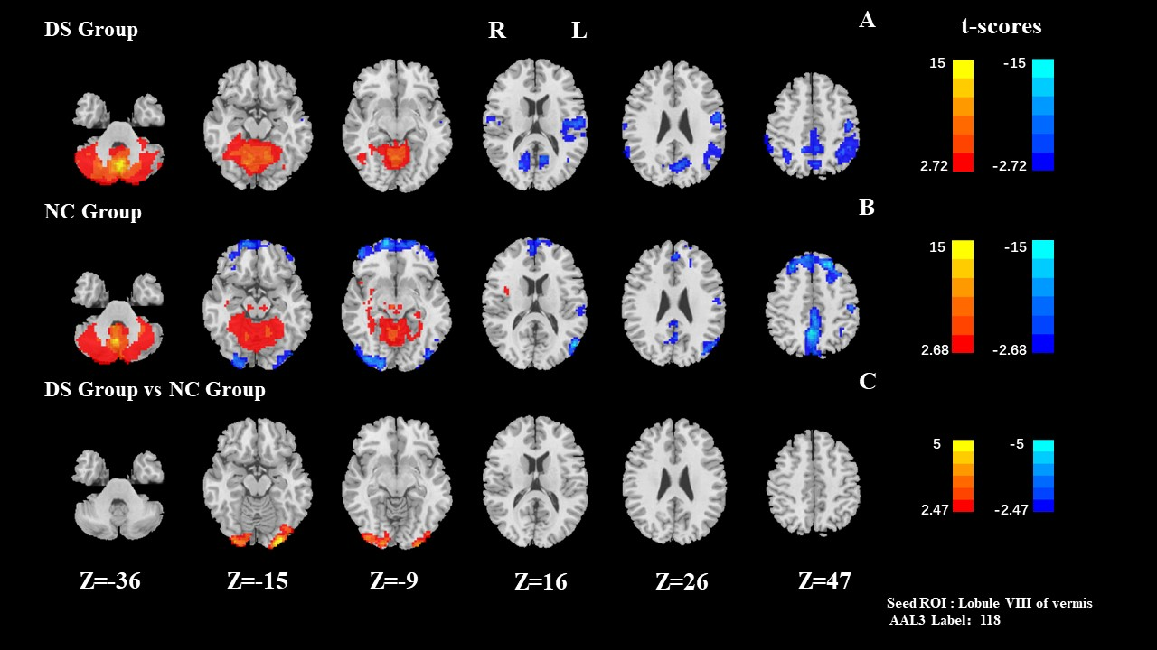
Figure 17. FC results of seed ROI: Lobule VIII of vermis (AAL3 Label: 118 )

