Supplementary Appendix

Table S1. Edge weights (1 – stable outpatients; 2 – patients during the acute phase of psychosis).
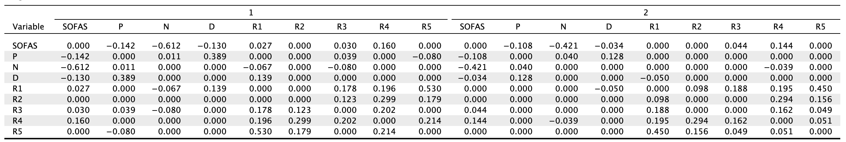
Abbreviations: D, depressive symptoms; N, negative symptoms; P, positive symptoms; R1, immediate memory; R2, visuospatial/constructional abilities; R3, language; R4, attention; R5, delayed memory; SOFAS, the Social and Occupational Functioning Assessment Scale.

Table S2. Strength centrality measures (1 – stable outpatients; 2 – patients during the acute phase of psychosis).
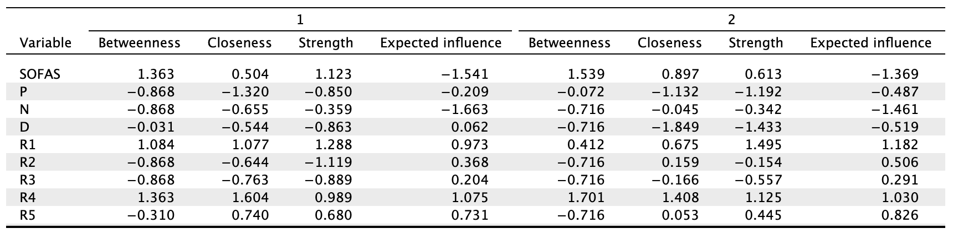
Abbreviations: D, depressive symptoms; N, negative symptoms; P, positive symptoms; R1, immediate memory; R2, visuospatial/constructional abilities; R3, language; R4, attention; R5, delayed memory; SOFAS, the Social and Occupational Functioning Assessment Scale.

Table S3. The comparison of strength and expected influence between both networks (p-values after the Benjamini-Hochberg correction are shown).
Node | Strength | Expected influence
P | 0.276 | 0.653
N | 0.354 | 0.342
D | 0.270 | 0.342
R1 | 0.435 | 0.508
R2 | 0.813 | 0.813
R3 | 0.355 | 0.813
R4 | 0.454 | 0.342
R5 | 0.342 | 0.610
SOFAS | 0.276 | 0.342
Abbreviations: D, depressive symptoms; N, negative symptoms; P, positive symptoms; R1, immediate memory; R2, visuospatial/constructional abilities; R3, language; R4, attention; R5, delayed memory; SOFAS, the Social and Occupational Functioning Assessment Scale.

Table S4. The comparison of edge weights between both samples.
Edges | p-value*
P – N | 1.000
P – D | 0.221
N – D | 1.000
P – R1 | 1.000
N – R1 | 0.221
D – R1 | < 0.001
P – R2 | 1.000
N – R2 | 1.000
D – R2 | 1.000
R1 – R2 | 0.724
P – R3 | 0.881
N – R3 | 0.060
D – R3 | 1.000
R1 – R3 | 1.000
R2 – R3 | 0.432
P – R4 | 1.000
N – R4 | 0.221
D – R4 | 1.000
R1 – R4 | 1.000
R2 – R4 | 1.000
R3 – R4 | 1.000
P – R5 | 0.054
N – R5 | 1.000
D – R5 | 1.000
R1 – R5 | 1.000
R2 – R5 | 1.000
R3 – R5 | 0.789
R4 – R5 | 0.785
P – SOFAS | 1.000
N – SOFAS | 0.221
D – SOFAS | 1.000
R1 – SOFAS | 0.616
R2 – SOFAS | 1.000
R3 – SOFAS | 1.000
R4 – SOFAS | 1.000
R5 – SOFAS | 1.000
*p-values after the Benjamini-Hochberg correction
Abbreviations: D, depressive symptoms; N, negative symptoms; P, positive symptoms; R1, immediate memory; R2, visuospatial/constructional abilities; R3, language; R4, attention; R5, delayed memory; SOFAS, the Social and Occupational Functioning Assessment Scale.

Figure S1. Stability of centrality metrics. Average correlations with original sample is ploted against the percentage of sampled cases. The maximum percentage of cases that can be dropped from the data to retain, with 95% probability, a correlation of at least 0.7 between statistics from the original network and statistics computed with a lower number of cases should be at least 0.25 (the CS-C value).
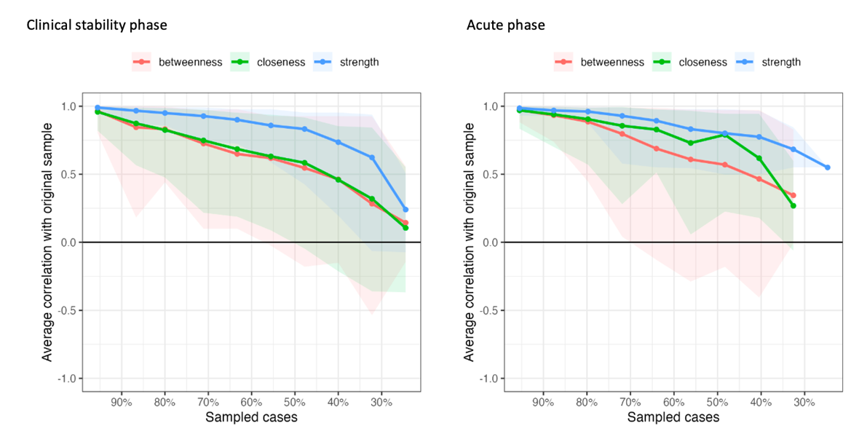
Figure S2. Stability of edge weights. The maximum percentage of cases that can be dropped from the data to retain, with 95% probability, a correlation of at least 0.7 between statistics from the original network and statistics computed with a lower number of cases should be at least 0.25 (the CS-C value).
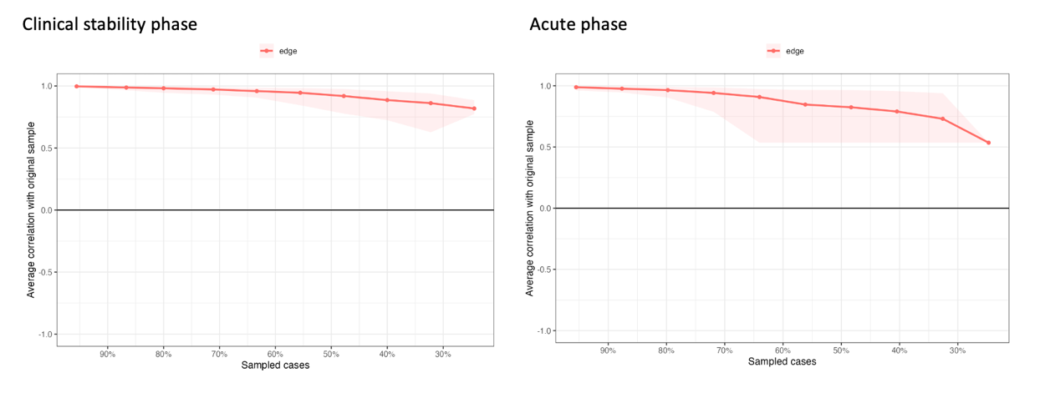

Figure S3. Bootstrapped 95% confidence intervals of estimated edge weights. The grey area shows bootstrapped 95% confidence intervals. Red points refer to edge weights in the sample, whole black points depict bootstrapped edge weights.
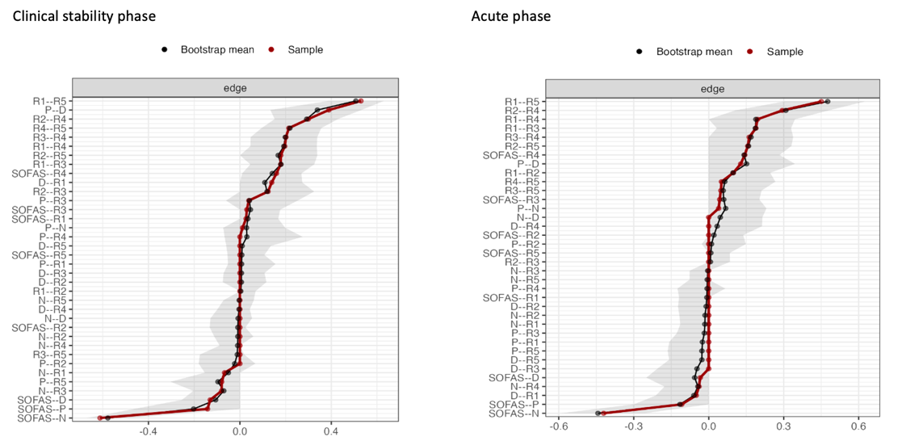
Abbreviations: D, depressive symptoms; N, negative symptoms; P, positive symptoms; R1, immediate memory; R2, visuospatial/constructional abilities; R3, language; R4, attention; R5, delayed memory; SOFAS, the Social and Occupational Functioning Assessment Scale.

