Supplementary Material
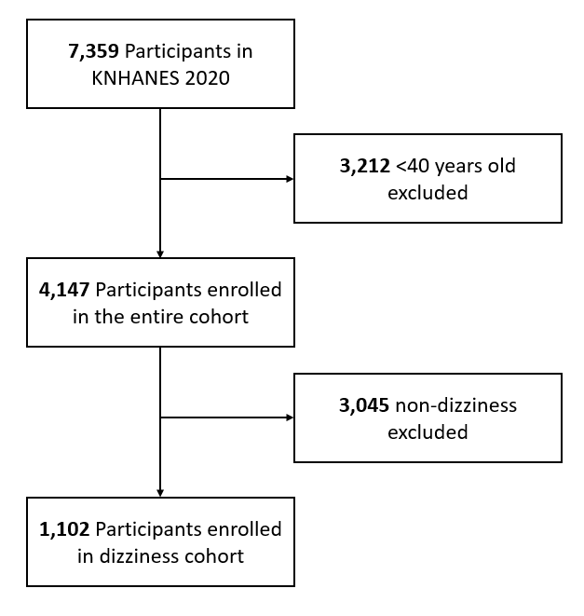
Supplementary Fig. S1. Study population: a flow chart of exclusions

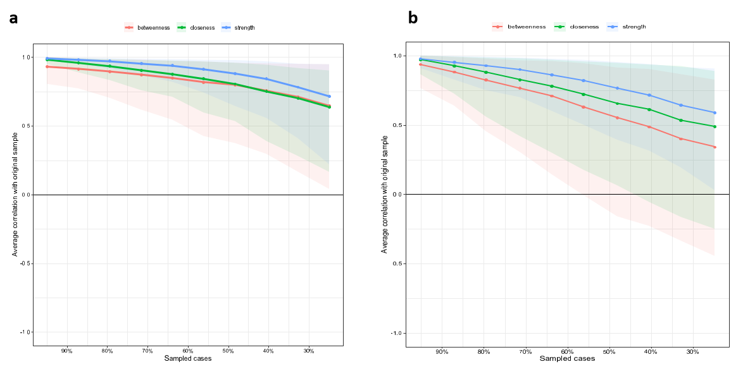
Supplementary Fig. S2. Stability of all centrality indices of depression dimension by the case-dropping subset bootstrap in (a) episodic dizziness and (b) chronic dizziness

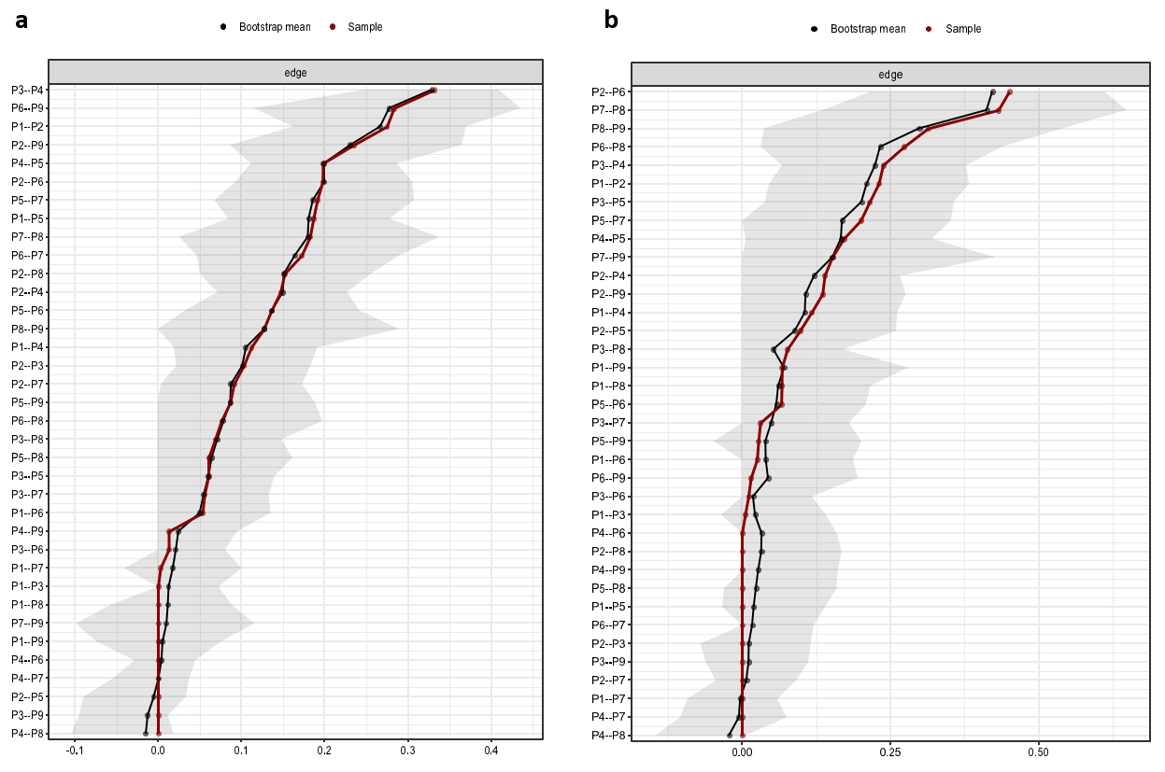
Supplementary Fig. S3. Bootstrapped confidence intervals for all edges of depression dimension with (a) episodic dizziness and (b) chronic dizziness

