Supplement Table 1. Linear Regression for SAMS and SAMS sub-scales using the BDI (A) and Covariates (B) 2
Supplement Table 2. Linear Regression after Elastic Net Regularization for SAMS sub-scales using BDI items as predictors 3
Supplement Figure 1. Spearman Correlations for SAMS Forgetting and BDI Items 4
Supplement Figure 2. Spearman Correlations for SAMS Missing Knowledge and BDI Items 5
Supplement Figure 3. Spearman Correlations for SAMS Modification and BDI Items 6
Supplement Figure 4. Network for SAMS Forgetting and BDI Items 7
Supplement Figure 5. Network for SAMS Missing Knowledge and BDI Items 8
Supplement Figure 6. Network for SAMS Modification and BDI Items 9

Supplement Table 1. Linear Regression for SAMS and SAMS sub-scales using the BDI (A) and Covariates (B)
Predictors | Est. | CI | p | Est. | CI | p | Est. | CI | p | Est. | CI | p
A Model with BDI Only | Model 1A: SAMS |  |  | Model 2A: Forgetting |  |  | Model 3A: Missing Knowledge |  |  | Model 4A: Modification
Intercept | 3.63 | 2.76 – 4.50 | <0.001 | 0.28 | 0.21 – 0.34 | <0.001 | 0.31 | 0.22-0.40 | <0.001 | 0.08 | 0.01-0.14 | 0.014
BDI | 0.26 | 0.19 – 0.33 | <0.001 | 0.01 | 0.01 – 0.02 | <0.001 | 0.01 | 0-01-0.02 | <0.001 | 0.01 | 0.01-0.02 | <0.001
Model Fit | N = 731, R²/R² adjusted = 0.067 / 0.066, F(1, 729) = 52.23, p < .001 |  |  | N = 731, R²/R² adjusted 0.037 / 0.035, F(1, 729) = 27.87, p < .001 |  |  | N= 731, R²/R² adjusted = 0.018 / 0.016, F(1, 729) = 13.12, p < .001 |  |  | N = 731, R²/R² adjusted = 0.045 / 0.043, F(1, 729) = 34.12, p < .001
B Model with Covariates | Model 1B: SAMS |  |  | Model 2B: Forgetting |  |  | Model 3B: Missing Knowledge |  |  | Model 4B: Modification
 | Est. | CI | p | Est. | CI | p | Est. | CI | p | Est. | CI | p
Intercept | 9.31 | -0.43 – 19.04 | 0.061 | -0.05 | -0.86 – 0.76 | 0.906 | 0.45 | -0.58 – 1.48 | 0.388 | 0.61 | -0.14 – 1.35 | 0.111
BDI | 0.36 | 0.26 – 0.45 | <0.001 | 0.01 | 0.00 – 0.02 | 0.009 | 0.02 | 0.01 – 0.03 | <0.001 | 0.03 | 0.02 – 0.03 | <0.001
Age | 0.01 | -0.06 – 0.09 | 0.776 | 0.00 | -0.01 – 0.01 | 0.842 | 0.01 | 0.00 – 0.02 | 0.028 | -0.00 | -0.01 – 0.00 | 0.291
Gender [male] | 1.85 | 0.65 – 3.05 | 0.003 | 0.13 | 0.03 – 0.23 | 0.013 | 0.15 | 0.02 – 0.28 | 0.021 | 0.07 | -0.03 – 0.16 | 0.159
Education [medium] | -0.88 | -2.38 – 0.63 | 0.253 | 0.12 | -0.00 – 0.25 | 0.056 | -0.18 | -0.34 – -0.02 | 0.028 | -0.05 | -0.17 – 0.06 | 0.385
Education [high] | -0.14 | -1.64 – 1.35 | 0.851 | 0.12 | 0.00 – 0.25 | 0.049 | -0.13 | -0.29 – 0.03 | 0.108 | 0.01 | -0.10 – 0.12 | 0.860
Marital [married] | 1.55 | -0.48 – 3.58 | 0.134 | 0.14 | -0.03 – 0.31 | 0.098 | -0.05 | -0.27 – 0.16 | 0.625 | 0.16 | 0.00 – 0.31 | 0.046
Living [not alone] | -0.41 | -2.62 – 1.80 | 0.715 | -0.03 | -0.21 – 0.16 | 0.762 | 0.08 | -0.16 – 0.31 | 0.521 | -0.10 | -0.27 – 0.07 | 0.247
MoCA | -0.11 | -0.35 – 0.12 | 0.337 | 0.01 | -0.01 – 0.03 | 0.218 | -0.04 | -0.07 – -0.02 | 0.001 | 0.00 | -0.02 – 0.02 | 0.833
TuG Seconds | 0.12 | -0.01 – 0.26 | 0.076 | 0.00 | -0.01 – 0.01 | 0.698 | 0.01 | -0.00 – 0.03 | 0.092 | 0.01 | -0.00 – 0.02 | 0.067
BFI [Openness] | 1.67 | -0.63 – 3.97 | 0.153 | 0.06 | -0.13 – 0.25 | 0.521 | 0.02 | -0.22 – 0.26 | 0.862 | 0.12 | -0.05 – 0.30 | 0.171
BFI [Agreeableness] | 1.45 | -1.30 – 4.20 | 0.299 | 0.09 | -0.14 – 0.32 | 0.438 | -0.06 | -0.35 – 0.23 | 0.696 | 0.11 | -0.10 – 0.33 | 0.284
BFI [Conscientiousness] | 1.32 | -0.66 – 3.31 | 0.191 | 0.03 | -0.14 – 0.19 | 0.759 | -0.01 | -0.22 – 0.20 | 0.947 | 0.12 | -0.03 – 0.27 | 0.119
BFI [Extraversion] | 0.28 | -1.99 – 2.54 | 0.812 | -0.03 | -0.21 – 0.16 | 0.787 | -0.02 | -0.26 – 0.21 | 0.839 | 0.03 | -0.14 – 0.20 | 0.738
HCCQ | -0.74 | -1.28 – -0.20 | 0.007 | -0.06 | -0.10 – -0.01 | 0.014 | -0.03 | -0.08 – 0.03 | 0.354 | -0.02 | -0.06 – 0.02 | 0.283
Number of Drugs | 0.07 | -0.10 – 0.23 | 0.430 | 0.01 | -0.01 – 0.02 | 0.315 | 0.04 | 0.02 – 0.06 | <0.001 | -0.01 | -0.03 – -0.00 | 0.023
Diagnosis [Cerebrovasc.] | -0.87 | -2.54 – 0.80 | 0.308 | -0.07 | -0.21 – 0.07 | 0.314 | -0.01 | -0.19 – 0.16 | 0.881 | -0.02 | -0.15 – 0.11 | 0.792
Diagnosis [Neuromusc.] | -0.55 | -2.16 – 1.06 | 0.505 | -0.13 | -0.27 – -0.00 | 0.050 | -0.08 | -0.25 – 0.09 | 0.334 | 0.09 | -0.03 – 0.21 | 0.145
Diagnosis [Epilepsy] | -0.55 | -3.54 – 2.45 | 0.720 | -0.09 | -0.34 – 0.16 | 0.498 | 0.11 | -0.21 – 0.43 | 0.492 | -0.12 | -0.35 – 0.11 | 0.319
Diagnosis [Misc.] | -0.67 | -2.37 – 1.03 | 0.438 | -0.08 | -0.22 – 0.06 | 0.243 | -0.02 | -0.20 – 0.16 | 0.791 | 0.03 | -0.10 – 0.16 | 0.631
SRH [1 - Excellent] | -15.68 | -23.28 – -8.09 | <0.001 | 0.22 | -0.42 – 0.85 | 0.504 | -0.24 | -1.04 – 0.56 | 0.556 | -1.73 | -2.31 – -1.15 | <0.001
SRH [2 - Very good] | 9.65 | 3.26 – 16.03 | 0.003 | -0.19 | -0.72 – 0.34 | 0.484 | -0.00 | -0.68 – 0.67 | 0.998 | 1.27 | 0.78 – 1.75 | <0.001
SRH [3 - Good] | -5.88 | -10.32 – -1.45 | 0.009 | 0.11 | -0.25 – 0.48 | 0.544 | -0.10 | -0.57 – 0.37 | 0.681 | -0.76 | -1.10 – -0.42 | <0.001
SRH [4 - Poor] | 1.00 | -1.39 – 3.38 | 0.412 | -0.07 | -0.27 – 0.13 | 0.502 | 0.04 | -0.22 – 0.29 | 0.778 | 0.19 | 0.01 – 0.38 | 0.038
Model Fit | N = 410, R²/R² adjusted = 0.251 / 0.206, F(23, 386) = 5.624, p < .001 |  |  | N = 410, R²/R² adjusted 0.121 / 0.068, F(23, 386) = 2.30, p < .001 |  |  | N = 410, R²/R² adjusted 0.223 / 0.177, F(23, 386) = 4.815, p < .001 |  |  | N = 410, R²/R² adjusted = 0.237 / 0.191, F(23,386) = 5. 202, p < .001
Note: BDI = Beck Depression Inventory II, BFI = Big Five Inventory, MoCA = Montreal Cognitive Assessment, HCCQ = Healthcare Climate, Questionnaire, SAMS = Stendal Adherence to Medication Score, SRH = Self-Rated Health according to SF-36 Item 1, TuG = Timed Up and Go

Supplement Table 2. Linear Regression after Elastic Net Regularization for SAMS sub-scales using BDI items as predictors
Variable | Est. | CI | p | Est. | CI | p | Est. | CI | p
Outcome | Model 1: SAMS: Forgetting |  |  | Model 2: SAMS: Missing Knowledge |  |  | Model 3: SAMS: Modification
Intercept | 0.28 | 0.21 – 0.34 | <0.001 | 0.38 | 0.28 – 0.49 | <0.001 | 0.06 | -0.00 – 0.13 | 0.063
BDI 1 |  |  |  |  |  |  | 0.03 | -0.05 – 0.10 | 0.465
BDI 3 | 0.04 | -0.05 – 0.13 | 0.357 | 0.09 | -0.03 – 0.21 | 0.127
BDI 4 |  |  |  | -0.08 | -0.18 – 0.02 | 0.101 | 0.07 | -0.03 – 0.17 | 0.144
BDI 5
BDI 9 | 0.07 | -0.05 – 0.18 | 0.263
BDI 10 |  |  |  | 0.04 | -0.05 – 0.13 | 0.353
BDI 11 | 0.02 | -0.05 – 0.08 | 0.640 |  |  |  | 0.03 | -0.03 – 0.09 | 0.305
BDI 12 | 0.09 | 0.01 – 0.17 | 0.029 | 0.14 | 0.03 – 0.25 | 0.013 | 0.07 | -0.00 – 0.14 | 0.056
BDI 14 | 0.04 | -0.05 – 0.13 | 0.417 | 0.07 | -0.06 – 0.20 | 0.283
BDI 15 |  |  |  | -0.13 | -0.23 – -0.02 | 0.018
BDI 16 |  |  |  |  |  |  | 0.03 | -0.01 – 0.07 | 0.158
BDI 17 | 0.02 | -0.07 – 0.10 | 0.699 |  |  |  | 0.04 | -0.04 – 0.12 | 0.302
BDI 18 |  |  |  | 0.04 | -0.04 – 0.13 | 0.330
BDI 19 | 0.03 | -0.04 – 0.10 | 0.375 | 0.16 | 0.06 – 0.25 | 0.001 | 0.02 | -0.04 – 0.08 | 0.561
BDI 20 | 0.06 | -0.01 – 0.13 | 0.093 |  |  |  | 0.05 | -0.02 – 0.11 | 0.144
Model Fit | N = 730, R² / R² adjusted = 0.058 / 0.047  F(8, 721) = 5.509, p < .001 |  |  | N = 730, R² / R² adjusted = 0.058 / 0.047  F(8, 721) = 5.54, p < .001 |  |  | N = 730, R² / R² adjusted = 0.058 / 0.047  F(8, 721) = 5.52, p < .001
Note: BDI = Beck Depression Inventory II; CI = Confidence Interval; SAMS = Stendal Adherence to Medication Score. Grey fields indicate that the variable was excluded from the model during elastic net regularization

Supplement Figure 1. Spearman Correlations for SAMS Forgetting and BDI Items

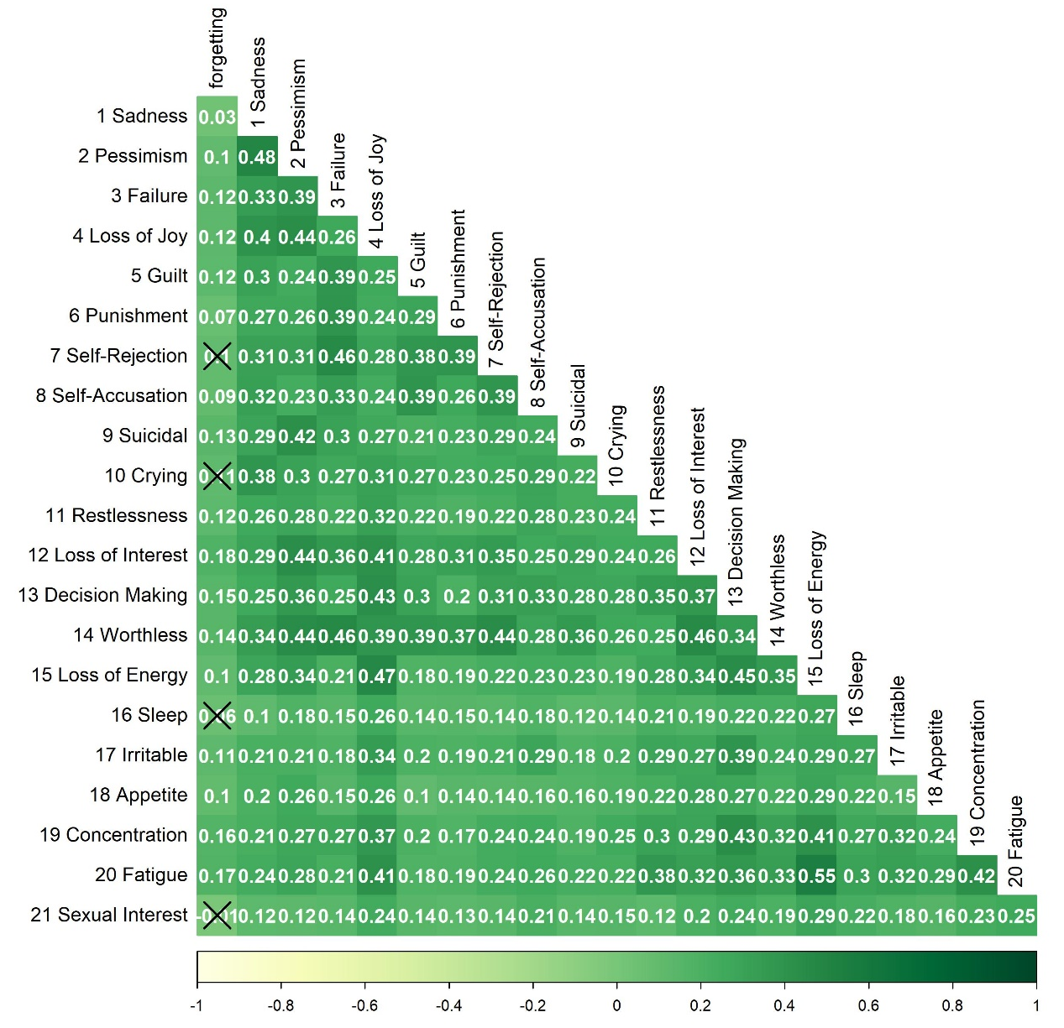
Note: BDI = Beck Depression Inventory II; SAMS = Stendal Adherence to Medication Score

Supplement Figure 2. Spearman Correlations for SAMS Missing Knowledge and BDI Items

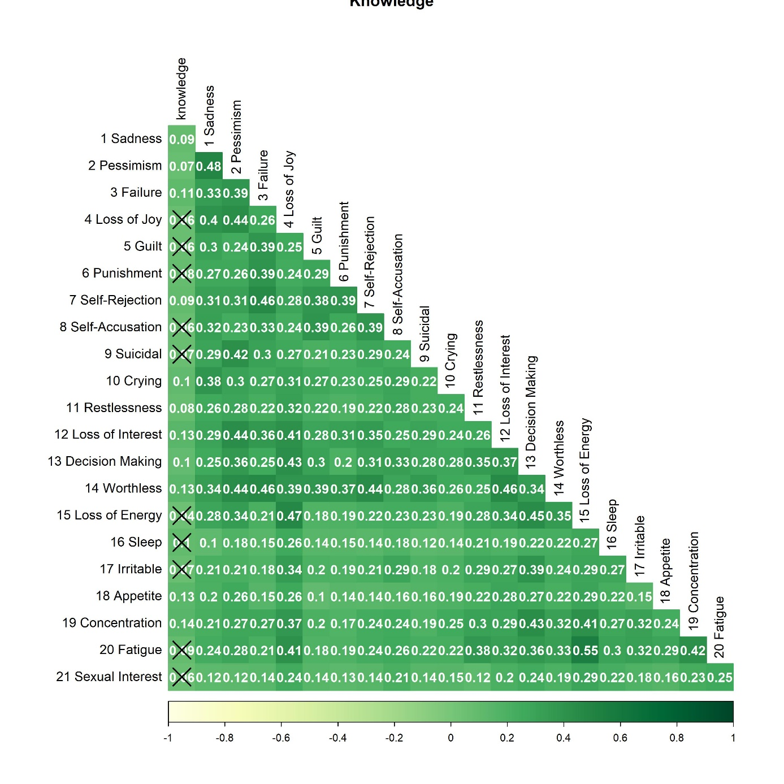
Note: BDI = Beck Depression Inventory II; SAMS = Stendal Adherence to Medication Score

Supplement Figure 3. Spearman Correlations for SAMS Modification and BDI Items

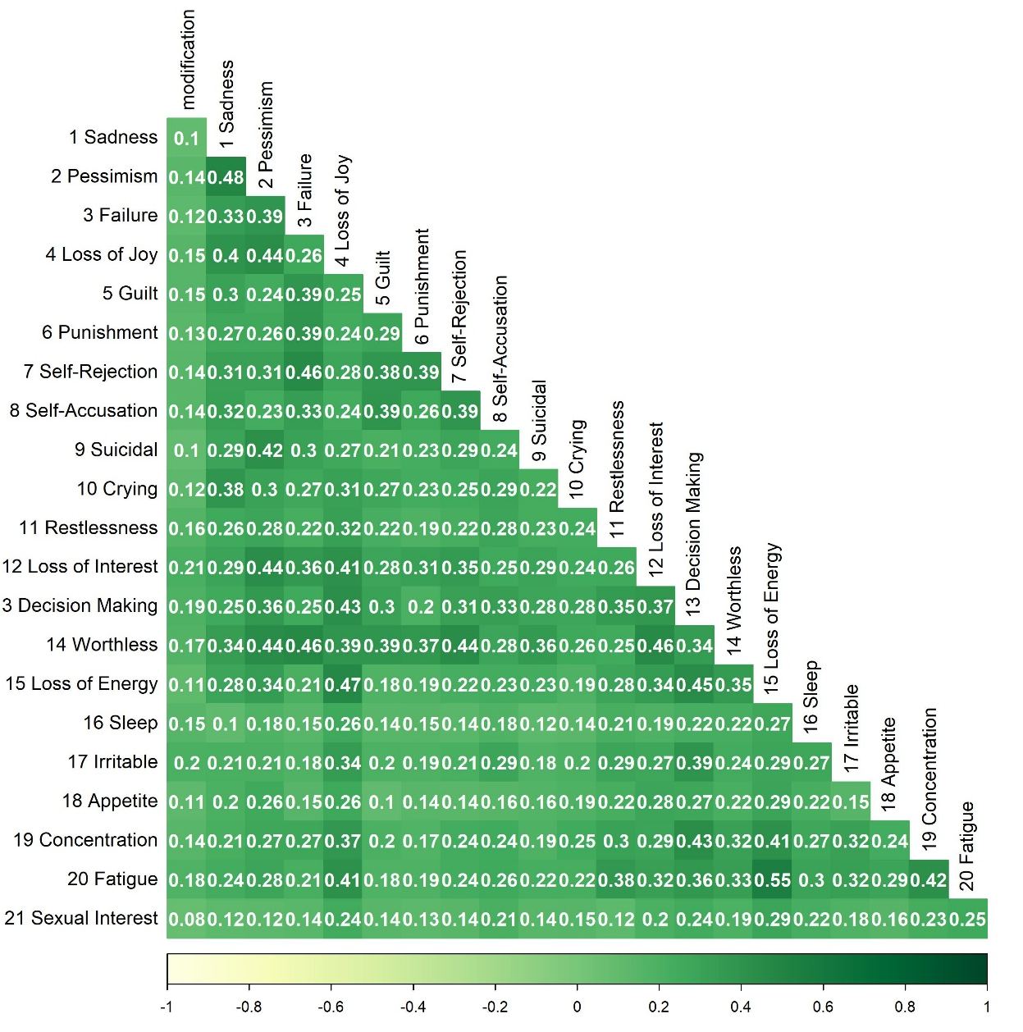
Note: BDI = Beck Depression Inventory II; SAMS = Stendal Adherence to Medication Score

Supplement Figure 4. Network for SAMS Forgetting and BDI Items
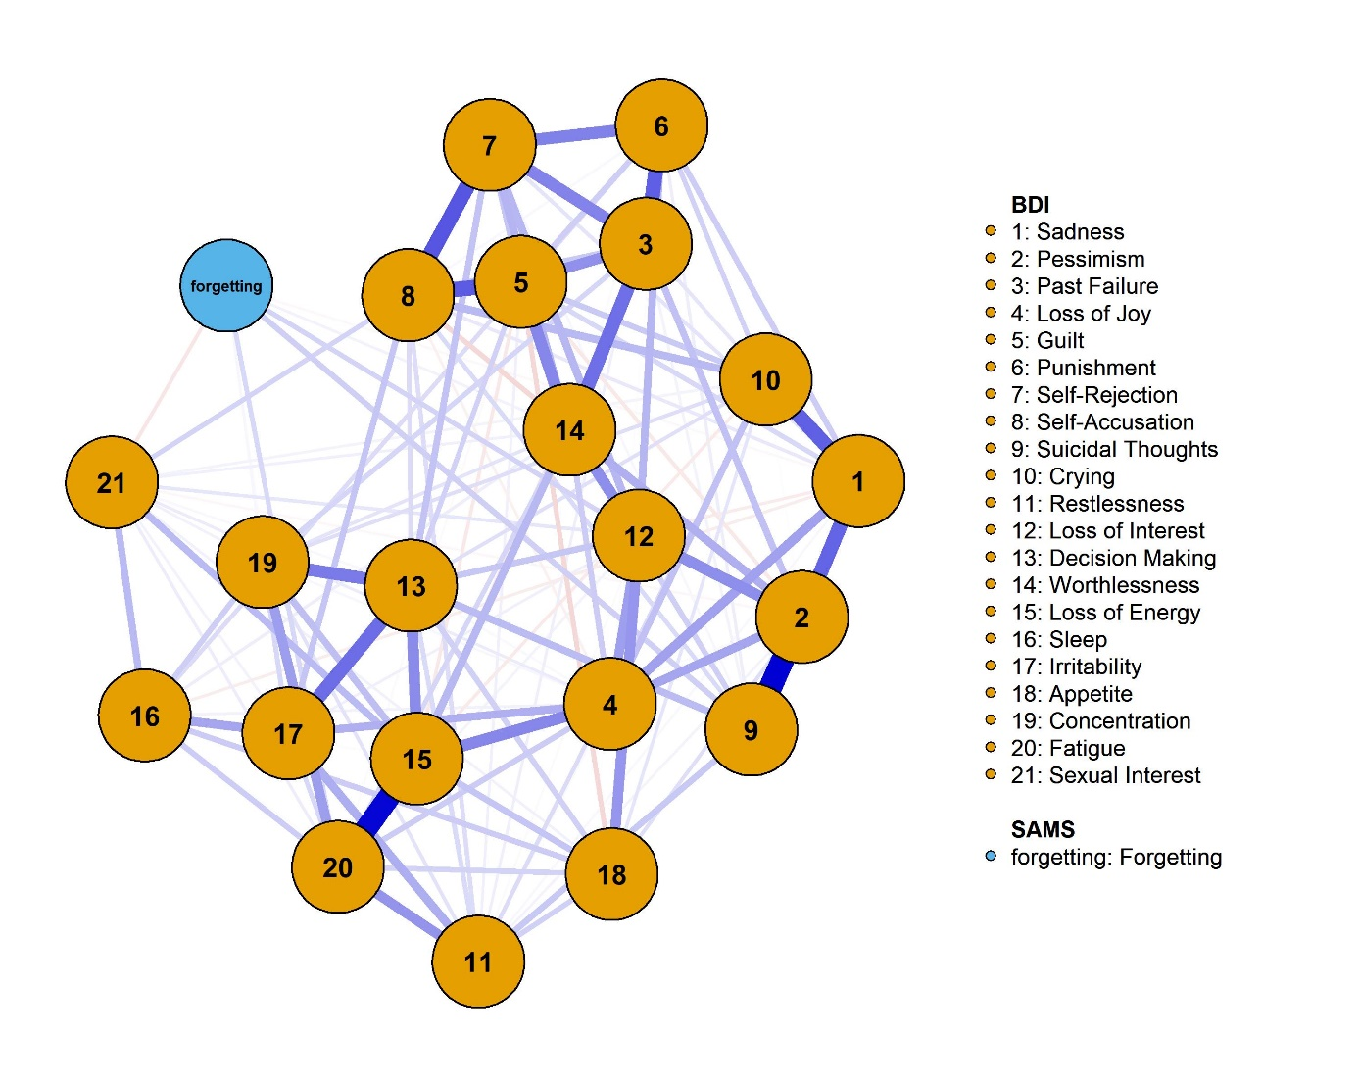

Note: CS-C = .595., displaying 133/231 edges. BDI = Beck Depression Inventory II; SAMS = Stendal Adherence to Medication Score

Supplement Figure 5. Network for SAMS Missing Knowledge and BDI Items
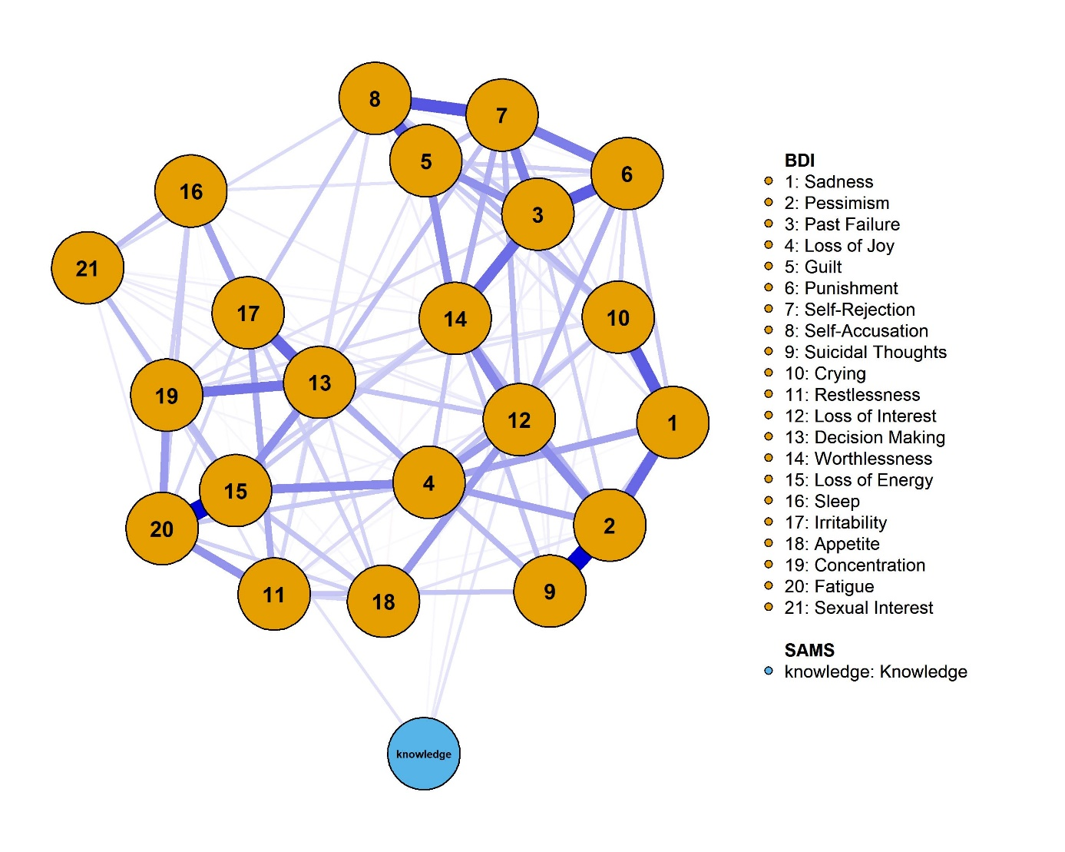
Note: CS-C = .595., displaying 116/231 edges. BDI = Beck Depression Inventory II; SAMS = Stendal Adherence to Medication Score

Supplement Figure 6. Network for SAMS Modification and BDI Items
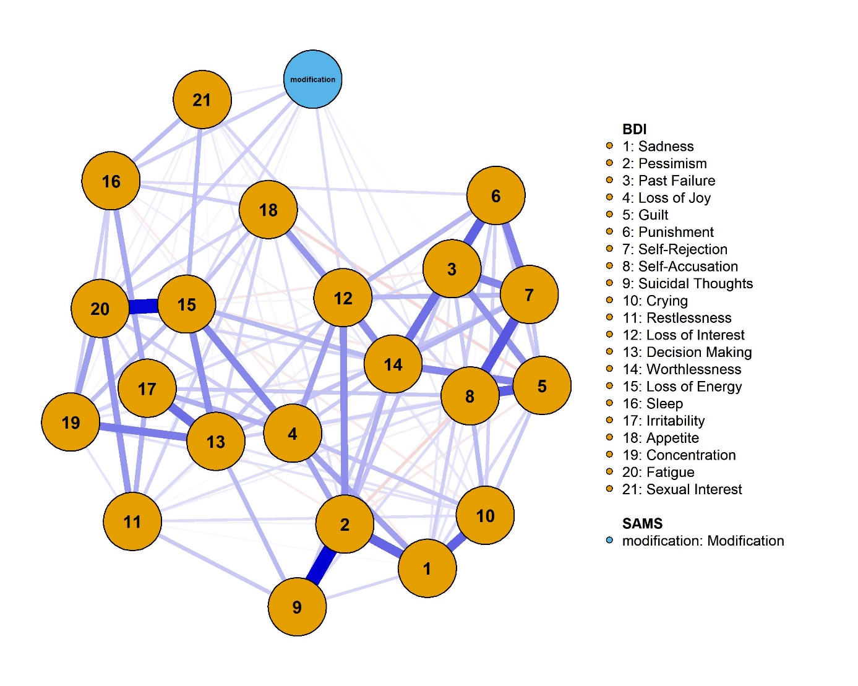
Note: CS-C = .516., displaying 136/231 edges. BDI = Beck Depression Inventory II; SAMS = Stendal Adherence to Medication Score

