Data Import and plotting for Fitbit data
This Notebook provides functions and code for explorative analysis of Fitbit data. The Data is asumed to exist in a folder with the following structure:
- A CSV file containing start and stop dates, Patient ID and important clincal covariates.
- Daily sleep summary files named following ‘Patient_ID_dailySteps_…’ pattern
- Daily activity summary files named following ‘Patient_ID_sleepStagesDay_’.
- High temporal Resolution sleep data named following ‘Patient_ID_30secondSleepStages’ .
- High temporal Resultion activity data named following the ’Patient_ID__hourlySteps’ pattern.
It is asumed that there is only one such file per patientht and that multiple Files stemming from separate exports are merged.
Time and date are handled with the lubridate package which is localisation and language setting sensitive.I.e.: “Monday, Tuesday” or “Montag, Dienstag”.
The aim of this analysis is to establish the data quality and characteristics which can be expected from Activity tracking in a clincal setting.

Data Summary
All but one Patient consented to wear the Activity tracker. Leaving 17 Patients in the Control treatment group (TAU) and 15 in the combinded CR+IR treatment group.
One additional Patient had no reported data in file P510020
CR IR TAU 7 7 17

Initialisation
We first read the overview file which contains PatientIDs, Quaracteristics and study dates.
require(ggplot2)
## Loading required package: ggplot2
## Warning: package 'ggplot2' was built under R version 4.0.4
require(lubridate)
## Loading required package: lubridate
## Warning: package 'lubridate' was built under R version 4.0.5
##
## Attaching package: 'lubridate'
## The following objects are masked from 'package:base':
##
## date, intersect, setdiff, union
Uebersicht<-read.csv("Daten_JK/Uebersicht2.csv")
Uebersicht$Intervention<- rep("TAU",nrow(Uebersicht))
Uebersicht$Intervention[Uebersicht$IV..TAU.!="TAU"]<-"INT"
Uebersicht$HAMD17_DIFF<- Uebersicht$Prä.HAMD17- Uebersicht$Post.HAMD17
head(Uebersicht)
## neue.Einw. Trackergerät Trackerpw Trackeraccount
## 1 x 27 doktorarbeit123 p5studieka+0273@gmail.com
## 2 x 22 doktorarbeit p5studieka+0223@gmail.com
## 3 x 29 doktorarbeit123 p5studieka+0293@gmail.com
## 4 x 22 doktorarbeit123 p5studieka+0226@gmail.com
## 5 Mitte Juni 24 doktorarbeit123 p5studieka+0244@gmail.com
## 6 x 26 doktorarbeit123 p5studieka+0261@gmail.com
## Probandennummer Einschlussdatum IV..TAU. X X1..EG Prä.BDI Prä.HAMD.21
## 1 P510022 19.08.2020 CR NA 19.08.2020 20 25
## 2 P510023 19.08.2020 CR NA 19.08.2020 20 21
## 3 P510024 19.08.2020 CR NA 19.08.2020 38 33
## 4 P510032 04.11.2020 CR NA 04.11.2020 36 35
## 5 P510033 16.11.2020 CR NA 16.11.2020 30 34
## 6 P510036 02.12.2020 CR NA 02.12.2020 21 33
## Post.BDI Post.HAMD.21 X2..EG X3.EG X4.EG..Ende TAU CR IR Prä.HAMD17
## 1 7 3 27.08.2020 03.09.2020 09.09.2020 NA 1 NA 19
## 2 6 4 26.08.2020 02.09.2020 04.09.2020 NA 1 NA 20
## 3 34 22 28.08.2020 03.09.2020 09.09.2020 NA 1 NA 29
## 4 16 11 11.11.2020 18.11.2020 25.11.2020 NA 1 NA 31
## 5 40 16 23.11.2020 04.12.2020 10.12.2020 NA 1 NA 31
## 6 17 9 09.12.2020 16.12.2020 23.12.2020 NA 1 NA 29
## Post.HAMD17 leichte.Depr Schwere.Dep Intervention HAMD17_DIFF
## 1 3 1 NA INT 16
## 2 4 1 NA INT 16
## 3 18 NA NA INT 11
## 4 8 1 NA INT 23
## 5 13 NA NA INT 18
## 6 8 1 NA INT 21
Treat<-Uebersicht$Intervention
names(Treat)<-Uebersicht$Probandennummer
Hamd17Group<-rep("M",nrow(Uebersicht))
names(Hamd17Group)<- Uebersicht$Probandennummer
Hamd17Group[Uebersicht$Post.HAMD17>=21]<-"S"
Hamd17Group[Uebersicht$Post.HAMD17<=11]<-"L"

First look
Treatment as usual (TAU) and Intervention group have similar starting HAMD17 scores.
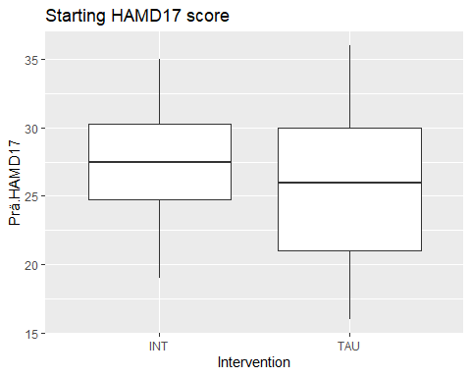
End of Intervention HAMD17 scores improved for the treatment group.
g<-ggplot(Uebersicht,aes(y=Post.HAMD17,x=Intervention))+geom_boxplot()+labs(title="End HAMD17 score")
print(g)
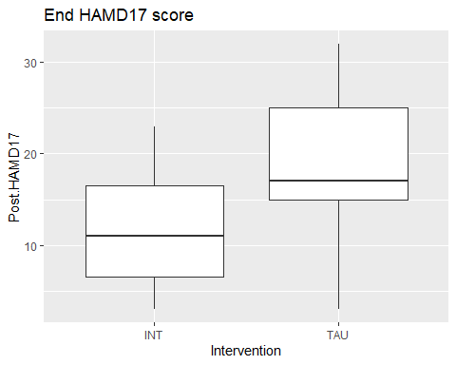
g<-ggplot(Uebersicht,aes(y=HAMD17_DIFF,x=Intervention))+geom_boxplot()+labs(title="Improvement in HAMD17 scores")
print(g)
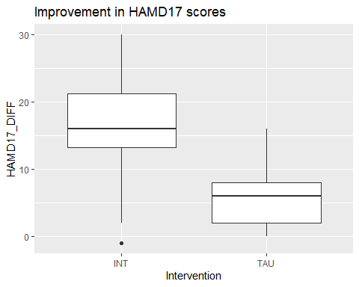

Steps
Individual data sets are read through accessory functions which take patientID, start and a stop dates.
readDailySteps<-function(Patient,start,stop){
f<-list.files("./Daten_JK/",pattern = paste(Patient,"_dailySteps_",sep="",collapse = ""),full.names = T)
#dmy("20.08.2020")
#print(f)
print(f)
StepsCSV<-read.csv(f[1])
TimePoints<-parse_date_time(StepsCSV[,1],'%m/%d/%Y')
StepsCSV["TimePoints"]<-TimePoints
StepsCSV[,"Weekdays"] <- weekdays(TimePoints)
selTime<- TimePoints >=dmy(start) & TimePoints<=dmy(stop)
StepsCSV$fromStart<-as.numeric(date(TimePoints)-dmy(start))
StepsCSV$toEnd<-as.numeric(date(TimePoints)-dmy(stop))
StepsCSV$PatientID<-Patient
StepsCSV[selTime,]
}
For instance we can access and store the daily steps the patient “P510033” who started “16.11.2020” and ended “16.11.2020” by running:
i=5 # "P510033
P= Uebersicht[i,"Probandennummer"] # "P510033"
S<- Uebersicht[i,"X1..EG"] #"16.11.2020"
E<-Uebersicht[i,"X4.EG..Ende"] #"16.11.2020"
DF<-readDailySteps(P,S ,E)
## [1] "./Daten_JK/P510033_dailySteps_20191020_20210526.csv"
head(DF)
## ActivityDay StepTotal TimePoints Weekdays fromStart toEnd PatientID
## 1 11/16/2020 3802 2020-11-16 Montag 0 -24 P510033
## 2 11/17/2020 9331 2020-11-17 Dienstag 1 -23 P510033
## 3 11/18/2020 8756 2020-11-18 Mittwoch 2 -22 P510033
## 4 11/19/2020 6556 2020-11-19 Donnerstag 3 -21 P510033
## 5 11/20/2020 11435 2020-11-20 Freitag 4 -20 P510033
## 6 11/21/2020 5124 2020-11-21 Samstag 5 -19 P510033

Concatenate
for(i in 1:33){
P<- Uebersicht[i,"Probandennummer"]
if(P=="P510040") next
S<- Uebersicht[i,"X1..EG"]
E<-Uebersicht[i,"X4.EG..Ende"]
DF<-readDailySteps(P,S,E)
if(nrow(DF)==0) next
DF$Intervention<- Uebersicht$Intervention[i]
DF$Post.HAMD<-Uebersicht$Post.HAMD17[i]
DF$Prä.HAMD<-Uebersicht$Prä.HAMD17[i]
DF$Post.BDI<-Uebersicht$Post.BDI[i]
DF$Prä.BDI<-Uebersicht$Prä.BDI[i]
DF$Post.HAMD.GROUP<-"M"
if (Uebersicht$Post.HAMD17[i]<= 11) DF$Post.HAMD.GROUP<-"L"
if (Uebersicht$Post.HAMD17[i]>= 21) DF$Post.HAMD.GROUP<-"S"
DF$Prä.HAMD.GROUP<-"M"
if (Uebersicht$Prä.HAMD17[i]<= 11) DF$Prä.HAMD.GROUP<-"L"
if (Uebersicht$Prä.HAMD17[i]>= 21) DF$Prä.HAMD.GROUP<-"S"
if(i ==1) DFALL<-DF else DFALL<-rbind(DFALL,DF)
}
## [1] "./Daten_JK/P510022_dailySteps_20191020_20210526.csv"
## [1] "./Daten_JK/P510023_dailySteps_20191020_20210526.csv"
## [1] "./Daten_JK/P510024_dailySteps_20191020_20210526.csv"
## [1] "./Daten_JK/P510032_dailySteps_20191020_20210526.csv"
## [1] "./Daten_JK/P510033_dailySteps_20191020_20210526.csv"
## [1] "./Daten_JK/P510036_dailySteps_20191020_20210526.csv"
## [1] "./Daten_JK/P510042_dailySteps_20191020_20210526.csv"
## [1] "./Daten_JK/P510001_dailySteps_20191020_20210526.csv"
## [1] "./Daten_JK/P510002_dailySteps_20191020_20210526.csv"
## [1] "./Daten_JK/P510007_dailySteps_20191020_20210526.csv"
## [1] "./Daten_JK/P510011_dailySteps_20191020_20210526.csv"
## [1] "./Daten_JK/P510014_dailySteps_20191020_20210526.csv"
## [1] "./Daten_JK/P510017_dailySteps_20191020_20210526.csv"
## [1] "./Daten_JK/P510018_dailySteps_20191020_20210526.csv"
## [1] "./Daten_JK/P510021_dailySteps_20191020_20210526.csv"
## [1] "./Daten_JK/P510025_dailySteps_20191020_20210526.csv"
## [1] "./Daten_JK/P510026_dailySteps_20191020_20210526.csv"
## [1] "./Daten_JK/P510030_dailySteps_20191020_20210526.csv"
## [1] "./Daten_JK/P510041_dailySteps_20191020_20210526.csv"
## [1] "./Daten_JK/P510043_dailySteps_20191020_20210526.csv"
## [1] "./Daten_JK/P510044_dailySteps_20191020_20210526.csv"
## [1] "./Daten_JK/P510045_dailySteps_20191020_20210526.csv"
## [1] "./Daten_JK/P510046_dailySteps_20191020_20210526.csv"
## [1] "./Daten_JK/P510047_dailySteps_20191020_20210526.csv"
## [1] "./Daten_JK/P510005_dailySteps_20191020_20210526.csv"
## [1] "./Daten_JK/P510006_dailySteps_20191020_20210526.csv"
## [1] "./Daten_JK/P510008_dailySteps_20191020_20210526.csv"
## [1] "./Daten_JK/P510009_dailySteps_20191020_20210526.csv"
## [1] "./Daten_JK/P510020_dailySteps_20191020_20210526.csv"
## [1] "./Daten_JK/P510037_dailySteps_20191020_20210526.csv"
## [1] "./Daten_JK/P510038_dailySteps_20191020_20210526.csv"
## [1] "./Daten_JK/P510039_dailySteps_20191020_20210526.csv"

Compare Steps
Early data does not show difference between intervention and TAU.
sel1<- DFALL$fromStart<10 & DFALL$Weekdays%in%c("Montag","Dienstag","Mittwoch","Donnerstag","Freitag")
tt<-tapply(DFALL$StepTotal[sel1],DFALL$PatientID[sel1],mean)
DF1<-data.frame(MeanStepsDay=tt,Treatment=Treat[names(tt)])
g1<-ggplot(DF1,aes(y=MeanStepsDay,x=Treatment) )+geom_boxplot() +labs(title="mean daily steps days 0-9")
print(g1)
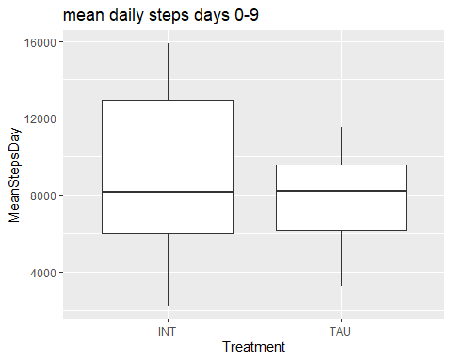
wilcox.test(tt[Treat[names(tt)]=="TAU"],tt[Treat[names(tt)]!="TAU"] )
##
## Wilcoxon rank sum exact test
##
## data: tt[Treat[names(tt)] == "TAU"] and tt[Treat[names(tt)] != "TAU"]
## W = 107, p-value = 0.6526
## alternative hypothesis: true location shift is not equal to 0
table(Treat[names(tt)]=="TAU")
##
## FALSE TRUE
## 14 17
median(tt[Treat[names(tt)]=="TAU"])
## [1] 8199.875
median(tt[Treat[names(tt)]!="TAU"])
## [1] 8168.845
IQR(tt[Treat[names(tt)]=="TAU"])
## [1] 3426.667
IQR(tt[Treat[names(tt)]!="TAU"])
## [1] 6958.201
sel1<- DFALL$fromStart>=10 & DFALL$fromStart<= 21& DFALL$Weekdays%in%c("Montag","Dienstag","Mittwoch","Donnerstag","Freitag")
tt<-tapply(DFALL$StepTotal[sel1],DFALL$PatientID[sel1],mean)
DF1<-data.frame(MeanStepsDay=tt,Treatment=Treat[names(tt)])
g1<-ggplot(DF1,aes(y=MeanStepsDay,x=Treatment) )+geom_boxplot() +labs(title="mean daily steps days 10-21")
print(g1)
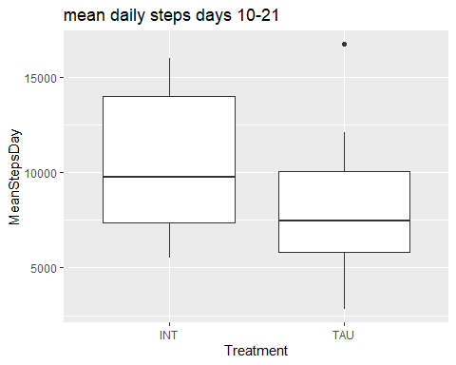
wilcox.test(tt[Treat[names(tt)]=="TAU"],tt[Treat[names(tt)]!="TAU"] )
##
## Wilcoxon rank sum exact test
##
## data: tt[Treat[names(tt)] == "TAU"] and tt[Treat[names(tt)] != "TAU"]
## W = 78, p-value = 0.1087
## alternative hypothesis: true location shift is not equal to 0
table(Treat[names(tt)]=="TAU")
##
## FALSE TRUE
## 14 17
median(tt[Treat[names(tt)]=="TAU"])
## [1] 7483.125
median(tt[Treat[names(tt)]!="TAU"])
## [1] 9760.375
IQR(tt[Treat[names(tt)]=="TAU"])
## [1] 4274.111
IQR(tt[Treat[names(tt)]!="TAU"])
## [1] 6612.833

Split by Post Intervention Hamd17 evaluation
sel1<- DFALL$fromStart>=10 & DFALL$fromStart<=21 & DFALL$Weekdays%in%c("Montag","Dienstag","Mittwoch","Donnerstag","Freitag")
tt<-tapply(DFALL$StepTotal[sel1],DFALL$PatientID[sel1],mean)
DF1<-data.frame(MeanStepsDay=tt,Hamd17Group=Hamd17Group[names(tt)])
g1<-ggplot(DF1,aes(y=MeanStepsDay,x=Hamd17Group) )+geom_boxplot() +labs(title="mean daily steps days 10-21")
print(g1)
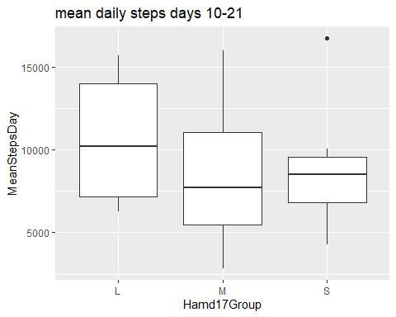
wilcox.test(tt[Hamd17Group[names(tt)]=="L"],tt[Hamd17Group[names(tt)]=="S"] )
##
## Wilcoxon rank sum exact test
##
## data: tt[Hamd17Group[names(tt)] == "L"] and tt[Hamd17Group[names(tt)] == "S"]
## W = 58, p-value = 0.3154
## alternative hypothesis: true location shift is not equal to 0
table(Hamd17Group[names(tt)])
##
## L M S
## 10 12 9
median(tt[Hamd17Group[names(tt)]=="L"]) #"Light"
## [1] 10201.06
median(tt[Hamd17Group[names(tt)]!="M"])
## [1] 9233.875
median(tt[Hamd17Group[names(tt)]!="S"]) #"heavy depressed"
## [1] 8636.812

Hourly data
Function to read hour resolved step data:
readHSteps<-function(Patient,start,stop,restrict=TRUE){
f<-list.files("./Daten_JK/",paste(Patient,"_hourlySteps",sep="",collapse = ""),full.names = T)
StepsCSV<-read.csv(f[1])
TimePoints<-parse_date_time(StepsCSV[,1],'%m/%d/%Y %I:%M:%S %p')
Weeks<-week(TimePoints)
Weeks<-Weeks-min(Weeks)
WD<-weekdays(TimePoints)
DF<-data.frame(ActivityHour=TimePoints,Weekdays=WD,week=Weeks,StepTotal=StepsCSV[,2],LastWeek=(TimePoints> dmy(E)-days(10)) )
DF$toEnd<- -(dmy(stop)-date(TimePoints))
DF$fromStart <- as.numeric(date(TimePoints)- dmy(start))
DF$PatientID<-Patient
if(restrict){
selTime<- date(TimePoints) >=dmy(S) & date(TimePoints)<=dmy(E)
DF[selTime,]
}else DF[,]
}
Concatenate
for(i in 1:33){
P<- Uebersicht[i,"Probandennummer"]
if(P=="P510040") next
S<- Uebersicht[i,"X1..EG"]
E<-Uebersicht[i,"X4.EG..Ende"]
DF<-readHSteps(P,S,E,T)
if(nrow(DF)==0) next
DF$Intervention<- Uebersicht$Intervention[i]
#DF$PatientID<-P
DF$Post.HAMD<-Uebersicht$Post.HAMD17[i]
DF$Prä.HAMD<-Uebersicht$Prä.HAMD17[i]
DF$Post.BDI<-Uebersicht$Post.BDI[i]
DF$Prä.BDI<-Uebersicht$Prä.BDI[i]
DF$Post.HAMD.GROUP<-"M"
if (Uebersicht$Post.HAMD17[i]<= 11) DF$Post.HAMD.GROUP<-"L"
if (Uebersicht$Post.HAMD17[i]>= 21) DF$Post.HAMD.GROUP<-"S"
DF$Prä.HAMD.GROUP<-"M"
if (Uebersicht$Prä.HAMD17[i]<= 11) DF$Prä.HAMD.GROUP<-"L"
if (Uebersicht$Prä.HAMD17[i]>= 21) DF$Prä.HAMD.GROUP<-"S"
if(i ==1) DFALL<-DF else DFALL<-rbind(DFALL,DF)
}
DFAll_H_Steps<-DFALL

Plot
sel<-DFAll_H_Steps$Weekdays%in%c("Montag","Dienstag","Mittwoch","Donnerstag","Freitag")&hour(DFAll_H_Steps$ActivityHour)%in%c(7:21)& DFAll_H_Steps$StepTotal>0 & DFAll_H_Steps$fromStart<=21
DFAll_H_Steps1<-subset(DFAll_H_Steps,sel)
patient_day<-paste(DFAll_H_Steps1$PatientID,DFAll_H_Steps1$toEnd,sep="_")
DF_H_week_day<-data.frame(MedSteps=tapply(DFAll_H_Steps1$StepTotal,patient_day,median),
toEnd=tapply(DFAll_H_Steps1$toEnd,patient_day,function(v)v[1]),
PatientID= tapply(DFAll_H_Steps1$PatientID,patient_day,function(v)v[1])
)
#DF_H_week_afternoon<-data.frame(MedSteps=tapply(DFAll_H_Steps1$StepTotal,patient_day,mean),toEnd=tapply(DFAll_H_Steps1$toEnd,patient_day,function(v)v[1]), PatientID= tapply(DFAll_H_Steps1$PatientID,patient_day,function(v)v[1]) )
DF_H_week_day$Post.HAMD.GROUP<- tapply(DFAll_H_Steps1$Post.HAMD.GROUP,patient_day,function(v)v[1])
DF_H_week_day$fromStart<- tapply(DFAll_H_Steps1$fromStart,patient_day,function(v)v[1])
#gg1<- ggplot(DF_H_week_afternoon,aes(fromStart,MedSteps ,color=Post.HAMD.GROUP))+geom_line(aes(group=PatientID,colour=Post.HAMD.GROUP ))+geom_smooth(method="loess",aes(group=Post.HAMD.GROUP,color=Post.HAMD.GROUP))
gg1<- ggplot(DF_H_week_day,aes(fromStart,MedSteps ,color=Post.HAMD.GROUP))+geom_smooth(method="loess",aes(group=Post.HAMD.GROUP,color=Post.HAMD.GROUP))
print(gg1)
## `geom_smooth()` using formula 'y ~ x'
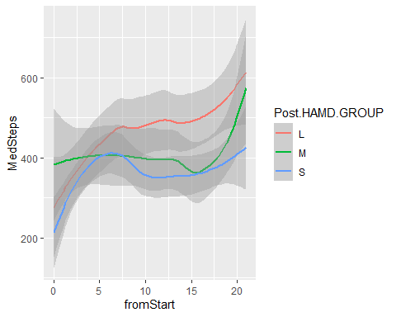 # by Treatment
sel<-DFAll_H_Steps$Weekdays%in%c("Montag","Dienstag","Mittwoch","Donnerstag","Freitag")&hour(DFAll_H_Steps$ActivityHour)%in%c(7:21)& DFAll_H_Steps$StepTotal>0 & DFAll_H_Steps$fromStart<=21
DFAll_H_Steps1<-subset(DFAll_H_Steps,sel)
patient_day<-paste(DFAll_H_Steps1$PatientID,DFAll_H_Steps1$toEnd,sep="_")
DF_H_week_day<-data.frame(MedSteps=tapply(DFAll_H_Steps1$StepTotal,patient_day,median),
toEnd=tapply(DFAll_H_Steps1$toEnd,patient_day,function(v)v[1]),
PatientID= tapply(DFAll_H_Steps1$PatientID,patient_day,function(v)v[1])
)
DF_H_week_day$fromStart<- tapply(DFAll_H_Steps1$fromStart,patient_day,function(v)v[1])
DF_H_week_day$Intervention<- Treat[DF_H_week_day$PatientID]
gg1<- ggplot(DF_H_week_day,aes(fromStart,MedSteps ,color=Intervention))+geom_smooth(method="loess",aes(group=Intervention,color=Intervention))
print(gg1)
## `geom_smooth()` using formula 'y ~ x'
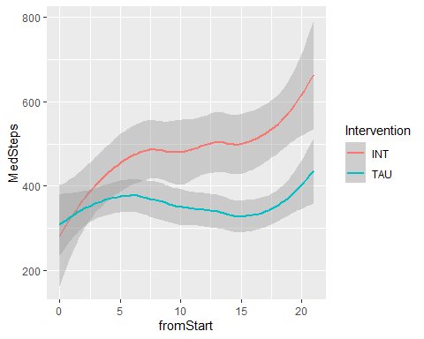
(table(DF_H_week_day$PatientID)) # Two patients missing
##
## P510001 P510002 P510005 P510006 P510007 P510008 P510009 P510011 P510014 P510017
## 7 15 11 16 15 14 14 15 14 14
## P510018 P510021 P510022 P510023 P510024 P510025 P510026 P510030 P510032 P510033
## 15 16 16 11 12 16 15 15 16 16
## P510036 P510037 P510038 P510039 P510041 P510042 P510043 P510044 P510045 P510046
## 16 15 13 15 16 16 14 14 14 12
## P510047
## 16

Summaries
sel<-DFAll_H_Steps$Weekdays%in%c("Montag","Dienstag","Mittwoch","Donnerstag","Freitag")&hour(DFAll_H_Steps$ActivityHour)%in%c(7:21)& DFAll_H_Steps$StepTotal>=0 & DFAll_H_Steps$fromStart<=21 & DFAll_H_Steps$fromStart>=10
DFAll_H_Steps1<-subset(DFAll_H_Steps,sel)
tt<-tapply(DFAll_H_Steps1$StepTotal,DFAll_H_Steps1$PatientID,median)
DF_box<-data.frame(H_steps_median=tt,PatientID=names(tt),Intervention=Treat[names(tt)] )
gg1<-ggplot(DF_box,aes(y=H_steps_median,x=Intervention))+geom_boxplot()+labs(title =" TAU vs INT median steps day 10-21")
print(gg1)
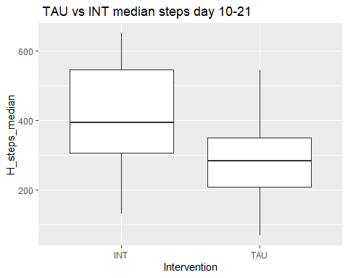
wilcox.test(DF_box$H_steps_median[DF_box$Intervention=="TAU"],DF_box$H_steps_median[DF_box$Intervention!="TAU"] )
##
## Wilcoxon rank sum exact test
##
## data: DF_box$H_steps_median[DF_box$Intervention == "TAU"] and DF_box$H_steps_median[DF_box$Intervention != "TAU"]
## W = 56, p-value = 0.01157
## alternative hypothesis: true location shift is not equal to 0
#t.test(DF_box$H_steps_median[DF_box$Intervention=="TAU"],DF_box$H_steps_median[DF_box$Intervention!="TAU"] )
print(paste("global median(IQR): ",median(DF_box$H_steps_median[]),"(",IQR(DF_box$H_steps_median[]),")"))
## [1] "global median(IQR): 316 ( 203.25 )"
print(paste("TAU median(IQR):", median(DF_box$H_steps_median[DF_box$Intervention=="TAU"]),"(",IQR(DF_box$H_steps_median[DF_box$Intervention=="TAU"]),")"))
## [1] "TAU median(IQR): 283 ( 141 )"
print(paste("Intervention median(IQR)",median(DF_box$H_steps_median[DF_box$Intervention!="TAU"]),"(",IQR(DF_box$H_steps_median[DF_box$Intervention!="TAU"]),")"))
## [1] "Intervention median(IQR) 394.5 ( 239.125 )"
table(DF_box$Intervention=="TAU")
##
## FALSE TRUE
## 14 17
by Post-treatment Hamd17
sel<-DFAll_H_Steps$Weekdays%in%c("Montag","Dienstag","Mittwoch","Donnerstag","Freitag")&hour(DFAll_H_Steps$ActivityHour)%in%c(7:21)& DFAll_H_Steps$StepTotal>=0 & DFAll_H_Steps$fromStart<=21 & DFAll_H_Steps$fromStart>=10
DFAll_H_Steps1<-subset(DFAll_H_Steps,sel)
tt<-tapply(DFAll_H_Steps1$StepTotal,DFAll_H_Steps1$PatientID,median)
DF_box<-data.frame(H_steps_median=tt,PatientID=names(tt),Post.HAMD.GROUP=Hamd17Group[names(tt)] )
gg1<-ggplot(DF_box,aes(y=H_steps_median,x=Post.HAMD.GROUP))+geom_boxplot()+labs(title =" TAU vs INT median steps day 10-21")
print(gg1)
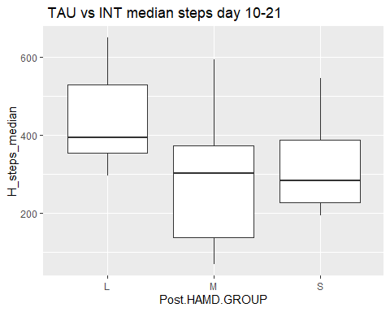
wilcox.test(DF_box$H_steps_median[DF_box$Post.HAMD.GROUP=="L"],DF_box$H_steps_median[DF_box$Post.HAMD.GROUP=="S"] )
##
## Wilcoxon rank sum exact test
##
## data: DF_box$H_steps_median[DF_box$Post.HAMD.GROUP == "L"] and DF_box$H_steps_median[DF_box$Post.HAMD.GROUP == "S"]
## W = 70, p-value = 0.04347
## alternative hypothesis: true location shift is not equal to 0
median(DF_box$H_steps_median[DF_box$Post.HAMD.GROUP=="L"])
## [1] 394.5
median(DF_box$H_steps_median[DF_box$Post.HAMD.GROUP=="S"])
## [1] 283
IQR(DF_box$H_steps_median[DF_box$Post.HAMD.GROUP=="L"])
## [1] 174.375
IQR(DF_box$H_steps_median[DF_box$Post.HAMD.GROUP=="S"])
## [1] 160

SLEEP

Individual daily summary data Sleep
readDaylySleep<-function(Patient,start,stop){
f<-list.files("./Daten_JK/",pattern = paste(Patient,"_sleepStagesDay_",sep="",collapse = ""),full.names = T)
#dmy("20.08.2020")
#print(f)
print(f)
StepsCSV<-read.csv(f[1])
TimePoints<-parse_date_time(StepsCSV[,1],'%m/%d/%Y %I:%M:%S %p')
StepsCSV["TimePoints"]<-TimePoints
StepsCSV[,"Weekdays"] <- weekdays(TimePoints)
selTime<- TimePoints >=dmy(start) & TimePoints<=dmy(stop)
StepsCSV$fromStart<-as.numeric(date(TimePoints)-dmy(start))
StepsCSV$toEnd<-as.numeric(date(TimePoints)-dmy(stop))
StepsCSV$PatientID<-Patient
StepsCSV[selTime,]
}
We create a long Data-frame containing all patient data by concatenating all individual files. For reasons of interpretation only days with one single sleep record are retained.
for(i in 1:33){
P<- Uebersicht[i,"Probandennummer"]
if(P=="P510040") next
S<- Uebersicht[i,"X1..EG"]
E<-Uebersicht[i,"X4.EG..Ende"]
DF<-readDaylySleep(P,S,E)
if(nrow(DF)==0) next
DF$Intervention<- Uebersicht$Intervention[i]
DF$Post.HAMD<-Uebersicht$Post.HAMD17[i]
DF$Prä.HAMD<-Uebersicht$Prä.HAMD17[i]
DF$Post.BDI<-Uebersicht$Post.BDI[i]
DF$Prä.BDI<-Uebersicht$Prä.BDI[i]
DF$Post.HAMD.GROUP<-"M"
if (Uebersicht$Post.HAMD17[i]<= 11) DF$Post.HAMD.GROUP<-"L"
if (Uebersicht$Post.HAMD17[i]>= 21) DF$Post.HAMD.GROUP<-"S"
DF$Prä.HAMD.GROUP<-"M"
if (Uebersicht$Prä.HAMD17[i]<= 11) DF$Prä.HAMD.GROUP<-"L"
if (Uebersicht$Prä.HAMD17[i]>= 21) DF$Prä.HAMD.GROUP<-"S"
if(i ==1) DFALL<-DF else DFALL<-rbind(DFALL,DF)
}
## [1] "./Daten_JK/P510022_sleepStagesDay_20191020_20210526.csv"
## [1] "./Daten_JK/P510023_sleepStagesDay_20191020_20210526.csv"
## [1] "./Daten_JK/P510024_sleepStagesDay_20191020_20210526.csv"
## [1] "./Daten_JK/P510032_sleepStagesDay_20191020_20210526.csv"
## [1] "./Daten_JK/P510033_sleepStagesDay_20191020_20210526.csv"
## [1] "./Daten_JK/P510036_sleepStagesDay_20191020_20210526.csv"
## [1] "./Daten_JK/P510042_sleepStagesDay_20191020_20210526.csv"
## [1] "./Daten_JK/P510001_sleepStagesDay_20191020_20210526.csv"
## [1] "./Daten_JK/P510002_sleepStagesDay_20191020_20210526.csv"
## [1] "./Daten_JK/P510007_sleepStagesDay_20191020_20210526.csv"
## [1] "./Daten_JK/P510011_sleepStagesDay_20191020_20210526.csv"
## [1] "./Daten_JK/P510014_sleepStagesDay_20191020_20210526.csv"
## [1] "./Daten_JK/P510017_sleepStagesDay_20191020_20210526.csv"
## [1] "./Daten_JK/P510018_sleepStagesDay_20191020_20210526.csv"
## [1] "./Daten_JK/P510021_sleepStagesDay_20191020_20210526.csv"
## [1] "./Daten_JK/P510025_sleepStagesDay_20191020_20210526.csv"
## [1] "./Daten_JK/P510026_sleepStagesDay_20191020_20210526.csv"
## [1] "./Daten_JK/P510030_sleepStagesDay_20191020_20210526.csv"
## [1] "./Daten_JK/P510041_sleepStagesDay_20191020_20210526.csv"
## [1] "./Daten_JK/P510043_sleepStagesDay_20191020_20210526.csv"
## [1] "./Daten_JK/P510044_sleepStagesDay_20191020_20210526.csv"
## [1] "./Daten_JK/P510045_sleepStagesDay_20191020_20210526.csv"
## [1] "./Daten_JK/P510046_sleepStagesDay_20191020_20210526.csv"
## [1] "./Daten_JK/P510047_sleepStagesDay_20191020_20210526.csv"
## [1] "./Daten_JK/P510005_sleepStagesDay_20191020_20210526.csv"
## [1] "./Daten_JK/P510006_sleepStagesDay_20191020_20210526.csv"
## [1] "./Daten_JK/P510008_sleepStagesDay_20191020_20210526.csv"
## [1] "./Daten_JK/P510009_sleepStagesDay_20191020_20210526.csv"
## [1] "./Daten_JK/P510020_sleepStagesDay_20191020_20210526.csv"
## [1] "./Daten_JK/P510037_sleepStagesDay_20191020_20210526.csv"
## [1] "./Daten_JK/P510038_sleepStagesDay_20191020_20210526.csv"
## [1] "./Daten_JK/P510039_sleepStagesDay_20191020_20210526.csv"
#
DFALLSleep<-DFALL
DFALLSleep<- DFALLSleep[DFALLSleep$TotalSleepRecords==1,]
hist(table(DFALLSleep$PatientID))
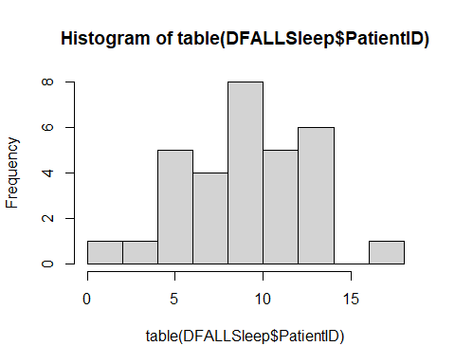
median(table(DFALLSleep$PatientID))
## [1] 10
The median number of usable sleep records is <10 indicting problematic data. Plots dont show usable trends. #
gg1<-ggplot(DFALLSleep,aes(fromStart,TotalMinutesAsleep,color=Intervention))+geom_line(aes(group=PatientID,colour=Intervention ))+geom_smooth(method="loess",aes(group=Intervention,color=Intervention))
print(gg1)
## `geom_smooth()` using formula 'y ~ x'
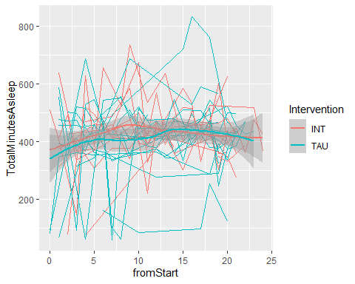

Individual high resolution data: Sleep
Individual data sets are read through accessory functions which take patientID, start and a stop dates.
read30sSleep<-function(patient,S,E){
f<-list.files("./Daten_JK/",paste(patient,"_30secondSleepStages",sep="",collapse = ""),full.names = T)
SleepCSV<-read.csv(f[1])
TimePoints<-parse_date_time(SleepCSV[,2],'%m/%d/%Y %I:%M:%S %p')
Weeks<-isoweek(TimePoints)
Weeks<-Weeks-min(Weeks)
WD<-weekdays(TimePoints)
DF<-data.frame(LogId=SleepCSV$LogId,LogIdN=as.numeric(factor(SleepCSV$LogId)),Time=TimePoints,Weekdays=WD,week=Weeks,SleepLevel=(factor(SleepCSV$Level)),LastWeek=(TimePoints> dmy(E)-days(10)) )
selTime<- TimePoints >=dmy(S) & TimePoints<=dmy(E)
DF[selTime,]
}
For instance we can access and store the 30s resolved of the patient “P510033” who started “16.11.2020” and ended “16.11.2020” by running:
i=5 # "P510033
P= Uebersicht[i,"Probandennummer"] # "P510033"
S<- Uebersicht[i,"X1..EG"] #"16.11.2020"
E<-Uebersicht[i,"X4.EG..Ende"] #"16.11.2020"
DF<-read30sSleep(P,S =S ,E = E)
head(DF)
## LogId LogIdN Time Weekdays week SleepLevel LastWeek
## 1 29800960094 1 2020-11-19 00:02:30 Donnerstag 0 wake FALSE
## 2 29800960094 1 2020-11-19 00:03:00 Donnerstag 0 light FALSE
## 3 29800960094 1 2020-11-19 00:03:30 Donnerstag 0 light FALSE
## 4 29800960094 1 2020-11-19 00:04:00 Donnerstag 0 light FALSE
## 5 29800960094 1 2020-11-19 00:04:30 Donnerstag 0 light FALSE
## 6 29800960094 1 2020-11-19 00:05:00 Donnerstag 0 light FALSE
An individual record can be inspected.
recordID=1 # the maximal available number of records max(DF$LogIdN)
startRecord<- min(DF$Time[DF$LogIdN==recordID])
endRecord<- max(DF$Time[DF$LogIdN==recordID])
tt<-(DF$Time[DF$LogIdN==recordID][]-startRecord)/60 #
DFP<-data.frame(time=tt,level=as.numeric((DF$SleepLevel[DF$LogIdN==recordID])))
gg<-ggplot(DFP,aes(x=time,y=level))+geom_step()+scale_y_continuous(name = "Level",labels = c("wake","rem","light","deep"),breaks=c(4,3,2,1))+labs(title=paste("ID:",P), subtitle = paste(startRecord,"---", endRecord ))
print(gg)
## Don't know how to automatically pick scale for object of type difftime. Defaulting to continuous.
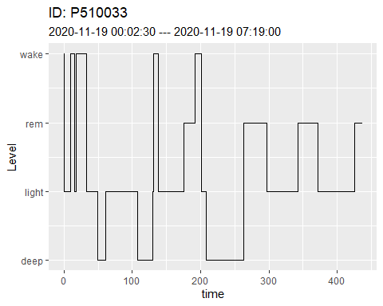

deriving additional Information and creating long format data.frames
Individual Data is used to derive additional information
getNightStats<-function(DF,S,E){
LogIds<-levels((factor(DF$LogId)))
print(LogIds)
DFR<-data.frame(remstart=numeric(),rem1=numeric(), wakeT=numeric(),date=as.Date(character()),Weekday=character(),week=numeric(),LastWeek=logical(),toEnd=numeric(),fromStart=numeric())
for(j in LogIds){
print(j)
sel<-DF$LogId==j
Levels30s<-as.character(DF$SleepLevel[sel] )
v<-rle(as.character(Levels30s))
t_0<-which(v$value=="rem")[1]
if(is.na(t_0)) next
t_rem1<-sum(v$lengths[1:(t_0-1)])
day<- date(DF$Time[sel][1]-hours(5))
w<-DF$week[sel][1]
wday<-weekdays(day)
DFR[j,1]=t_rem1
DFR[j,2]=v$lengths[t_0]
DFR[j,3]=sum(v$lengths[v$values=="wake"])
DFR[j,4]=day
DFR[j,5]<-wday
DFR[j,6]<-w
DFR[j,7]<-DF$LastWeek[sel][1]
DFR[j,8] <- -(dmy(E)-day)
DFR[j,9] <- day-dmy(S)
}
DFR
}
for(i in 1:33){
P<- Uebersicht[i,"Probandennummer"]
if(P=="P510040") next
S<- Uebersicht[i,"X1..EG"]
E<-Uebersicht[i,"X4.EG..Ende"]
DF1<-read30sSleep(P,S,E)
DF<-getNightStats(DF1[,],S,E)
if(nrow(DF)==0) next
DF$PatientID<-P
DF$Post.HAMD<-Uebersicht$Post.HAMD17[i]
DF$Prä.HAMD<-Uebersicht$Prä.HAMD17[i]
DF$Post.BDI<-Uebersicht$Post.BDI[i]
DF$Prä.BDI<-Uebersicht$Prä.BDI[i]
DF$Post.HAMD.GROUP<-"M"
if (Uebersicht$Post.HAMD17[i]<= 11) DF$Post.HAMD.GROUP<-"L"
if (Uebersicht$Post.HAMD17[i]>= 21) DF$Post.HAMD.GROUP<-"S"
DF$Prä.HAMD.GROUP<-"M"
if (Uebersicht$Prä.HAMD17[i]<= 11) DF$Prä.HAMD.GROUP<-"L"
if (Uebersicht$Prä.HAMD17[i]>= 21) DF$Prä.HAMD.GROUP<-"S"
if(i ==1) DFALL<-DF else DFALL<-rbind(DFALL,DF)
}
## [1] "28725452296" "28725452299" "28725452300" "28815137450" "28815137451"
## [1] "28725452296"
## [1] "28725452299"
## [1] "28725452300"
## [1] "28815137450"
## [1] "28815137451"
## [1] "28542591122" "28542591123" "28607467143" "28607467144" "28607467145"
## [6] "28705488454" "28705488455" "28705488456" "28705488459"
## [1] "28542591122"
## [1] "28542591123"
## [1] "28607467143"
## [1] "28607467144"
## [1] "28607467145"
## [1] "28705488454"
## [1] "28705488455"
## [1] "28705488456"
## [1] "28705488459"
## Warning in min(Weeks): kein nicht-fehlendes Argument für min; gebe Inf zurück
## character(0)
## [1] "29734730120" "29824911661"
## [1] "29734730120"
## [1] "29824911661"
## [1] "29800960094" "29800960096" "29800960098" "29887496916" "29887496918"
## [6] "29907036115" "29934580146"
## [1] "29800960094"
## [1] "29800960096"
## [1] "29800960098"
## [1] "29887496916"
## [1] "29887496918"
## [1] "29907036115"
## [1] "29934580146"
## [1] "29996915928" "29996915929" "29996915930" "29996915933" "29996915935"
## [6] "30024341367" "30093874116" "30179091360" "30179091361"
## [1] "29996915928"
## [1] "29996915929"
## [1] "29996915930"
## [1] "29996915933"
## [1] "29996915935"
## [1] "30024341367"
## [1] "30093874116"
## [1] "30179091360"
## [1] "30179091361"
## [1] "31469611109" "31469611113" "31561545457" "31561545462" "31561545464"
## [6] "31561545466" "31676346055" "31676346058" "31676346059" "31676346060"
## [1] "31469611109"
## [1] "31469611113"
## [1] "31561545457"
## [1] "31561545462"
## [1] "31561545464"
## [1] "31561545466"
## [1] "31676346055"
## [1] "31676346058"
## [1] "31676346059"
## [1] "31676346060"
## [1] "24707148769" "24707148770" "24707148771" "24707148776" "24707148777"
## [6] "24707148779" "24707148780"
## [1] "24707148769"
## [1] "24707148770"
## [1] "24707148771"
## [1] "24707148776"
## [1] "24707148777"
## [1] "24707148779"
## [1] "24707148780"
## [1] "24511238918" "24511238919" "24511238921" "24511238922" "24511238923"
## [6] "24707163952" "24707163954" "24707163955" "24707163956"
## [1] "24511238918"
## [1] "24511238919"
## [1] "24511238921"
## [1] "24511238922"
## [1] "24511238923"
## [1] "24707163952"
## [1] "24707163954"
## [1] "24707163955"
## [1] "24707163956"
## [1] "25941166424" "25941166425" "25941166426" "25941166427" "25941166428"
## [6] "25941166429" "25941166430" "26176112958" "26176112959" "26176112960"
## [11] "26176112962"
## [1] "25941166424"
## [1] "25941166425"
## [1] "25941166426"
## [1] "25941166427"
## [1] "25941166428"
## [1] "25941166429"
## [1] "25941166430"
## [1] "26176112958"
## [1] "26176112959"
## [1] "26176112960"
## [1] "26176112962"
## [1] "27148842781" "27148842782" "27148842783" "27148842784" "27148842785"
## [6] "27367352219" "27367352220" "27367352221" "27367352222" "27367352223"
## [11] "27367352224" "27367352225" "27396272412"
## [1] "27148842781"
## [1] "27148842782"
## [1] "27148842783"
## [1] "27148842784"
## [1] "27148842785"
## [1] "27367352219"
## [1] "27367352220"
## [1] "27367352221"
## [1] "27367352222"
## [1] "27367352223"
## [1] "27367352224"
## [1] "27367352225"
## [1] "27396272412"
## [1] "27972513803" "27972513804" "27972513805" "27972513806" "27972513808"
## [6] "27972513810"
## [1] "27972513803"
## [1] "27972513804"
## [1] "27972513805"
## [1] "27972513806"
## [1] "27972513808"
## [1] "27972513810"
## [1] "28070226781" "28070226782" "28070226784" "28070226785" "28070226787"
## [6] "28162844811" "28162844813" "28162844814" "28162844815" "28227771644"
## [11] "28227771650" "28227771652" "28227771653"
## [1] "28070226781"
## [1] "28070226782"
## [1] "28070226784"
## [1] "28070226785"
## [1] "28070226787"
## [1] "28162844811"
## [1] "28162844813"
## [1] "28162844814"
## [1] "28162844815"
## [1] "28227771644"
## [1] "28227771650"
## [1] "28227771652"
## [1] "28227771653"
## [1] "28069852356" "28069852357" "28135494965" "28135494967" "28254202411"
## [6] "28254202413" "28254202415" "28254202416"
## [1] "28069852356"
## [1] "28069852357"
## [1] "28135494965"
## [1] "28135494967"
## [1] "28254202411"
## [1] "28254202413"
## [1] "28254202415"
## [1] "28254202416"
## [1] "28486462507" "28486462508" "28486462510" "28486462511" "28605453388"
## [6] "28605453389" "28605453390" "28605453391" "28636551984" "28636551986"
## [1] "28486462507"
## [1] "28486462508"
## [1] "28486462510"
## [1] "28486462511"
## [1] "28605453388"
## [1] "28605453389"
## [1] "28605453390"
## [1] "28605453391"
## [1] "28636551984"
## [1] "28636551986"
## [1] "28636979797" "28720237288" "28720237292" "28831689384" "28831689386"
## [1] "28636979797"
## [1] "28720237288"
## [1] "28720237292"
## [1] "28831689384"
## [1] "28831689386"
## [1] "28635139237" "28635139239" "28635139240" "28635139241" "28635139242"
## [6] "28635139243" "28635139244" "28720257294" "28814636472" "28814636473"
## [11] "28814636478" "28814636482" "28814636486"
## [1] "28635139237"
## [1] "28635139239"
## [1] "28635139240"
## [1] "28635139241"
## [1] "28635139242"
## [1] "28635139243"
## [1] "28635139244"
## [1] "28720257294"
## [1] "28814636472"
## [1] "28814636473"
## [1] "28814636478"
## [1] "28814636482"
## [1] "28814636486"
## [1] "29285296236" "29285296240" "29285296241" "29387404108" "29387404109"
## [6] "29387404110" "29387404111"
## [1] "29285296236"
## [1] "29285296240"
## [1] "29285296241"
## [1] "29387404108"
## [1] "29387404109"
## [1] "29387404110"
## [1] "29387404111"
## [1] "31455817675" "31455817676" "31548426163" "31548426164" "31548426165"
## [6] "31548426166" "31548426167" "31548426170" "31645696968" "31645696969"
## [1] "31455817675"
## [1] "31455817676"
## [1] "31548426163"
## [1] "31548426164"
## [1] "31548426165"
## [1] "31548426166"
## [1] "31548426167"
## [1] "31548426170"
## [1] "31645696968"
## [1] "31645696969"
## [1] "31564357729" "31676463252" "31676463253" "31676463256" "31748664588"
## [6] "31748664589"
## [1] "31564357729"
## [1] "31676463252"
## [1] "31676463253"
## [1] "31676463256"
## [1] "31748664588"
## [1] "31748664589"
## [1] "31763666930" "31938826981" "31938826983"
## [1] "31763666930"
## [1] "31938826981"
## [1] "31938826983"
## [1] "31765274630" "31765274635" "31847714641" "31847714645" "31939818481"
## [6] "31939818485" "31939818486" "31939818487" "31939818488"
## [1] "31765274630"
## [1] "31765274635"
## [1] "31847714641"
## [1] "31847714645"
## [1] "31939818481"
## [1] "31939818485"
## [1] "31939818486"
## [1] "31939818487"
## [1] "31939818488"
## [1] "31847322301" "31847322302" "31847322303"
## [1] "31847322301"
## [1] "31847322302"
## [1] "31847322303"
## [1] "31816999134" "31816999135" "31816999136" "31816999138" "31913762553"
## [6] "31913762554" "31913762556" "32051399188" "32051399191"
## [1] "31816999134"
## [1] "31816999135"
## [1] "31816999136"
## [1] "31816999138"
## [1] "31913762553"
## [1] "31913762554"
## [1] "31913762556"
## [1] "32051399188"
## [1] "32051399191"
## [1] "25419174306" "25419174308" "25419174309" "25419174311" "25419174312"
## [6] "25461706996" "25461706998"
## [1] "25419174306"
## [1] "25419174308"
## [1] "25419174309"
## [1] "25419174311"
## [1] "25419174312"
## [1] "25461706996"
## [1] "25461706998"
## [1] "25537883734" "25537883735" "25537883736" "25537883737" "25537883738"
## [6] "25537883739" "25640233267" "25640233269" "25640233270" "25640233271"
## [11] "25640233272" "25640233273" "25640233274" "25783604120" "25783604121"
## [16] "25783604123" "25783604124" "25783604125"
## [1] "25537883734"
## [1] "25537883735"
## [1] "25537883736"
## [1] "25537883737"
## [1] "25537883738"
## [1] "25537883739"
## [1] "25640233267"
## [1] "25640233269"
## [1] "25640233270"
## [1] "25640233271"
## [1] "25640233272"
## [1] "25640233273"
## [1] "25640233274"
## [1] "25783604120"
## [1] "25783604121"
## [1] "25783604123"
## [1] "25783604124"
## [1] "25783604125"
## [1] "26148015502" "26148015505" "26148015506" "26148015507" "26148015508"
## [6] "26148015509" "26148015510" "26311588591" "26311588592" "26311588594"
## [11] "26311588595" "26311588597" "26311588598"
## [1] "26148015502"
## [1] "26148015505"
## [1] "26148015506"
## [1] "26148015507"
## [1] "26148015508"
## [1] "26148015509"
## [1] "26148015510"
## [1] "26311588591"
## [1] "26311588592"
## [1] "26311588594"
## [1] "26311588595"
## [1] "26311588597"
## [1] "26311588598"
## [1] "26148253435" "26310387085" "26310387089" "26310387090" "26310387091"
## [6] "26310387093"
## [1] "26148253435"
## [1] "26310387085"
## [1] "26310387089"
## [1] "26310387090"
## [1] "26310387091"
## [1] "26310387093"
## Warning in min(Weeks): kein nicht-fehlendes Argument für min; gebe Inf zurück
## character(0)
## [1] "30433560918" "30495625598" "30565736107" "30565736110" "30598796922"
## [6] "30670515776" "30670515779"
## [1] "30433560918"
## [1] "30495625598"
## [1] "30565736107"
## [1] "30565736110"
## [1] "30598796922"
## [1] "30670515776"
## [1] "30670515779"
## [1] "30493748804" "30493748805" "30542472524" "30643407747" "30643407748"
## [6] "30643407751" "30643407755" "30643407756" "30745001263"
## [1] "30493748804"
## [1] "30493748805"
## [1] "30542472524"
## [1] "30643407747"
## [1] "30643407748"
## [1] "30643407751"
## [1] "30643407755"
## [1] "30643407756"
## [1] "30745001263"
## [1] "30977017350" "30977017351" "30977017352" "31062459470" "31062459475"
## [6] "31062459476" "31062459477" "31132709160" "31132709161" "31179819292"
## [1] "30977017350"
## [1] "30977017351"
## [1] "30977017352"
## [1] "31062459470"
## [1] "31062459475"
## [1] "31062459476"
## [1] "31062459477"
## [1] "31132709160"
## [1] "31132709161"
## [1] "31179819292"
DFALLSleep30s<-DFALL
Similar to the daily summaries there are many missing records in the sleep data. (Potentially fixable errors dont add much)
t1<-table(DFALLSleep30s$PatientID)
print(t1)
##
## P510001 P510002 P510005 P510006 P510007 P510008 P510009 P510011 P510014 P510017
## 6 8 6 18 11 13 6 13 6 13
## P510018 P510021 P510022 P510023 P510025 P510026 P510030 P510032 P510033 P510036
## 8 9 5 9 4 12 6 1 7 9
## P510037 P510038 P510039 P510041 P510042 P510043 P510044 P510045 P510046 P510047
## 6 9 9 9 9 6 3 9 3 8
mean(t1)
## [1] 8.033333

