Intent-To-Treat analysis sample

Primary outcomes
The results of the group × time (2 × 2) ANCOVA showed significant interactions in the SCPS Probability bias total score: F(1, 47) = 8.90, p < .01; SCPS Probability bias in the negative cognition generated when paying attention to others: F(1, 47) = 19.04, p < .01. Simple effect analyses using Bonferroni’s method for these variables showed significant differences. For these variables, the post-test revealed significantly lower scores than the pre-test in the intervention group (p < .01). At the post-test, the intervention group had significantly lower scores than the control group for these variables (p < .01). Conversely, no interactions were observed in the LSAS total score: F(1, 47) = .29, p = .59, anxiety: F(1, 47) = .18, p = .67, and avoidance behavior: F(1, 47) = .46，p = .50; the SCPS Cost bias total score: F(1, 47) = .34, p = .56; SCPS Cost bias in the negative cognition from one’s performance: F(1, 47) = .02, p = .88; SCPS Cost bias in the negative cognition generated when paying attention to others: F(1, 47) = 3.64, p = .06; SCPS Probability bias in the negative cognition from one’s performance: F(1, 47) = 3.60, p = .06. Significant main effects were evident between the pre-test and post-test within participants in the LSAS total score, avoidance behavior, SCPS Cost bias total score, SCPS Cost bias in the negative cognition from one’s performance, SCPS Cost bias in the negative cognition generated when paying attention to others, and SCPS Probability bias in the negative cognition from one’s performance (p < .05), except for anxiety (p = .09). Multiple comparisons using Bonferroni’s method for the LSAS total score, avoidance behavior, SCPS Cost bias total score, SCPS Cost bias in the negative cognition from one’s performance, SCPS Cost bias in the negative cognition generated when paying attention to others, and SCPS Probability bias in the negative cognition from one’s performance showed significant differences. In the LSAS total score, avoidance behavior, SCPS Cost bias in the negative cognition generated when paying attention to others, and SCPS Probability bias in the negative cognition from one’s performance, the post-test had significantly lower scores than the pre-test (p < .05). No significant main effect was observed in the LSAS total score (p = .59), anxiety (p = .67), avoidance behavior (p = .50), SCPS Cost bias total score (p = .56), SCPS Cost bias in the negative cognition from one’s performance (p = .88), SCPS Cost bias in the negative cognition generated when paying attention to others (p = .06), and SCPS Probability bias in the negative cognition from one’s performance (p = .06).
The results of the group × time (2 × 3) ANCOVA showed significant interactions in the SCPS Probability bias total score: F(2, 94)=3.93, p <.05; SCPS Probability bias in the negative cognition generated when paying attention to others: F(2, 94) = 7.86, p < .01. Simple effect analyses using Bonferroni’s method for these variables showed significant differences. For these variables, the post-test and follow-up had significantly lower scores than the pre-test in the intervention group (p < .05). The post-test revealed that the intervention group had significantly lower scores in the SCPS Probability bias total score than the control group and significantly lower scores than the control group in the SCPS Probability bias in the negative cognition generated when paying attention to others at the post-test and follow-up (p < .01). However, no interactions were found in the LSAS total score: F(2, 94) = .66, p = .52, anxiety: F(2, 94) = .43, p = .66, and avoidance behavior: F(2, 94) = .80, p = .46; the SCPS Cost bias total sore: F(2, 94) = 1.96, p = .15; SCPS Cost bias in the negative cognition from one’s performance: F(2, 94) = 1.57, p = .21; SCPS Cost bias in the negative cognition generated when paying attention to others: F(2, 94) = 2.69, p = .07；SCPS Probability bias in the negative cognition from one’s performance: F(2, 94) = 1.84, p = .16. There were significant main effects between the pre-test, post-test, and follow-up within participants in the LSAS total score, avoidance behavior, SCPS Cost bias total score, SCPS Cost bias in the negative cognition from one’s performance, SCPS Cost bias in the negative cognition generated when paying attention to others, and SCPS Probability bias in the negative cognition from one’s performance (p < .05), except for anxiety (p = .11). Multiple comparisons using Bonferroni’s method were performed for the LSAS total score, avoidance behavior, SCPS Cost bias total score, SCPS Cost bias in the negative cognition from one’s performance, SCPS Cost bias in the negative cognition generated when paying attention to others, and SCPS Probability bias in the negative cognition from one’s performance, and these comparisons showed significant differences. In the SCPS Cost bias in the negative cognition generated when paying attention to others and SCPS Probability bias in the negative cognition from one’s performance, the post-test and follow-up had significantly lower scores than the pre-test (p < .05). In the SCPS Cost bias total score, the post-test had significantly lower scores than the pre-test (p < .05). A significant main effect was observed between the intervention and control groups in the SCPS Cost bias in the negative cognition generated when paying attention to others (p < .05); however, no significant main effect was found in the LSAS total score (p = .38), anxiety (p = .47), avoidance behavior (p = .31), SCPS Cost bias total score (p = .15), SCPS Cost bias in the negative cognition from one’s performance (p = .43), and SCPS Probability bias in the negative cognition from one’s performance (p = .21). Multiple comparisons using Bonferroni’s method were performed for the SCPS Cost bias in the negative cognition generated when paying attention to others; the intervention group had significantly higher scores than the control group (p < .05).

Secondary outcomes
The results of the group × time (2 × 2) ANCOVA showed significant interactions in the SFNE total score: F(1, 47) = 6.46, p < .05; SFNE forward-item: F(1, 47) = 6.38, p < .05; SFNE reversed-item: F(1, 47) = 4.78, p < .05. Simple effect analyses using Bonferroni’s method for these variables showed significant differences. For these variables, the post-test had significantly lower scores than the pre-test in the intervention group (p < .01). The post-test revealed that the intervention group had significantly lower scores than the control group for these variables (p < .05). Conversely, no interactions were observed in the SFA total score: F(1, 47) = .12, p = .73; SFA arousal: F(1, 47) = .13, p = .72; SFA behavior: F(1, 47) = 1.56, p = .22. There were significant main effects between the pre-test and post-test within participants for these variables (p < .05). Multiple comparisons using Bonferroni’s method were performed for these variables between the pre-test and post-test; the post-test had significantly lower scores than the pre-test for the SFA total score (p < .05). No significant main effect was found between the intervention and control groups for the SFA total score (p = .73), SFA arousal (p = .72), and SFA behavior (p = .22).
The results of the group × time (2 × 3) ANCOVA showed significant interactions in the SFNE total score: F(1.60, 75.13) = 8.91, p < .01; SFNE forward-item: F(1.71, 80.26) = 8.22, p < .01; SFNE reversed-item: F(1.71, 80.25) = 5.40, p < .01. Simple effect analyses using Bonferroni’s method for these variables showed significant differences. For these variables, the post-test and follow-up had significantly lower scores than the pre-test in the intervention group (p < .01). At the post-test and follow-up, the intervention group had significantly lower scores than the control group for these variables (p < .05). However, no interactions were evident in the SFA total score: F(2, 94) = .38, p = .69; SFA arousal: F(2, 94) = .22, p = .80; SFA behavior: F(2, 94) = 1.26, p = .29. Significant main effects were observed between the pre-test, post-test, and follow-up within participants in the SFA total score and SFA behavior (p < .05), but not for the SFA arousal (p = .08). Multiple comparisons using Bonferroni’s method were performed for the SFA total score and SFA behavior between the pre-test, post-test, and follow-up; the follow-up had significantly lower scores than the pre-test in the SFA total score and SFA behavior (p < .01). No significant main effect was found between the intervention and control groups in the SFA total score (p = .51), SFA arousal (p = .99), and SFA behavior (p = .10).
Additional outcomes
The results of the group × time (2 × 2) ANCOVA showed significant interactions in the FFMQ: F(1, 47) = 33.27, p < .01; SDS: F(1, 47) = 13.31, p < .01; and SHS: F(1, 47) = 17.56, p < .01. Simple effect analyses using Bonferroni’s method for these variables showed significant differences. In the FFMQ and SHS, the post-test had significantly higher scores than the pre-test in the intervention group (p < .01) and the post-test had significantly lower scores than the pre-test in the SDS (p < .01). At the post-test, the intervention group had significantly higher scores than the control group in the FFMQ and SHS and the intervention group had significantly lower scores than the control group in the SDS (p < .01).
The results of the group × time (2 × 3) ANCOVA showed significant interactions in the FFMQ: F(1.50, 70.48) = 22.29, p < .01; SDS: F(1.73, 81.19) = 10.54, p < .01; and SHS: F(1.46, 68.83) = 13.15, p < .01. Simple effect analyses using Bonferroni’s method for these variables showed significant differences. In the FFMQ and SHS, the post-test and follow-up had significantly higher scores than the pre-test in the intervention group (p < .01) and the post-test and follow-up had significantly lower scores than the pre-test in the SDS (p < .01). At the post-test and follow-up, the intervention group had significantly higher scores than the control group in the FFMQ and SHS and the intervention group had significantly lower scores than the control group in the SDS (p < .01).

Figure S1
Changes in the total score of the Liebowitz Social Anxiety Scale in the intent-to-treat analysis.
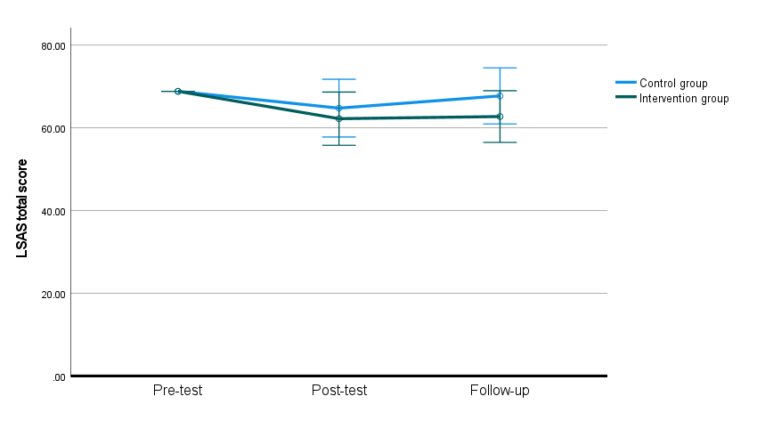
Note. Covariates appearing in the model are evaluated at Pre-test = 68.82; Error bars = 95% confidence interval; LSAS = Liebowitz Social Anxiety Scale.

Figure S2
Changes in the anxiety score of the Liebowitz Social Anxiety Scale in the intent-to-treat analysis.
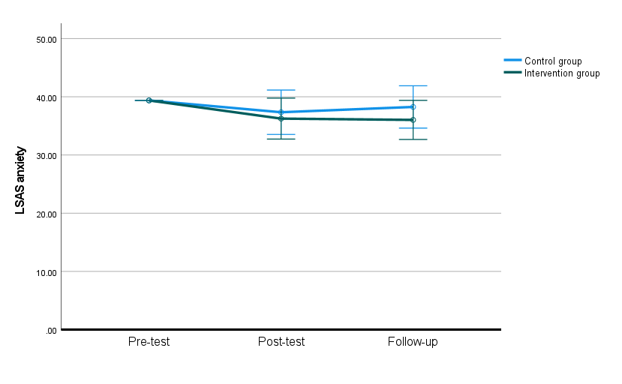
Note. Covariates appearing in the model are evaluated at Pre-test = 39.38; Error bars = 95% confidence interval; LSAS = Liebowitz Social Anxiety Scale.

Figure S3
Changes in the avoidance behavior score of the Liebowitz Social Anxiety Scale in the intent-to-treat analysis.
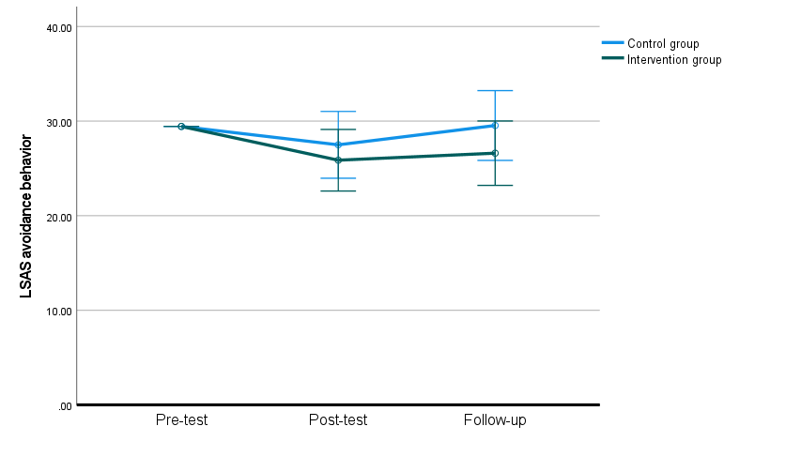
Note. Covariates appearing in the model are evaluated at Pre-test = 29.44; Error bars = 95% confidence interval; LSAS = Liebowitz Social Anxiety Scale.

Figure S4
Changes in the total score of the Speech Cost/Probability bias Scale cost bias in the intent-to-treat analysis.
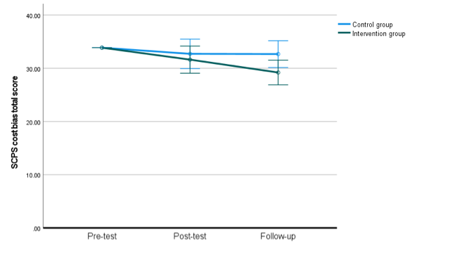
Note. Covariates appearing in the model are evaluated at Pre-test = 33.86; Error bars = 95% confidence interval; SCPS = Speech Cost/Probability bias Scale.

Figure S5
Changes in the negative cognition from one’s performance score of the Speech Cost/Probability bias Scale cost bias in the intent-to-treat analysis.
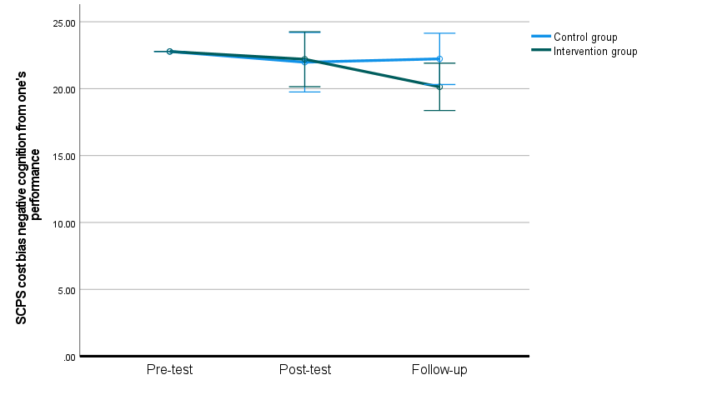
Note. Covariates appearing in the model are evaluated at Pre-test = 22.78; Error bars = 95% confidence interval; SCPS = Speech Cost/Probability bias Scale.

Figure S6
Changes in the negative cognition generated when paying attention to others score of the Speech Cost/Probability bias Scale cost bias in the intent-to-treat analysis.

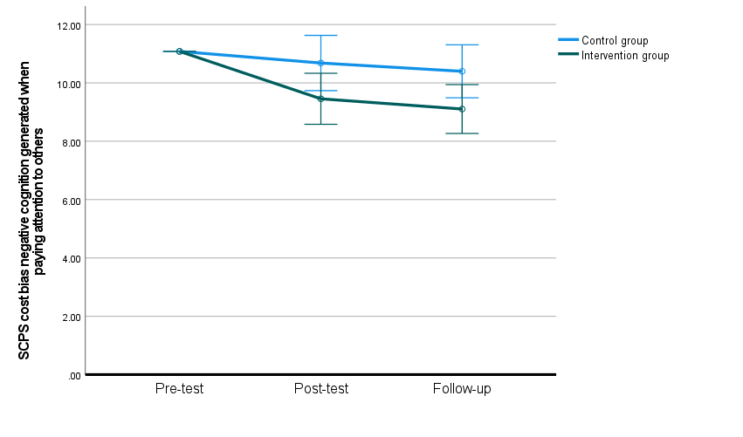
Note. Covariates appearing in the model are evaluated at Pre-test = 11.08; Error bars = 95% confidence interval; SCPS = Speech Cost/Probability bias Scale.

Figure S7
Changes in the total score of the Speech Cost/Probability bias Scale probability bias in the intent-to-treat analysis.
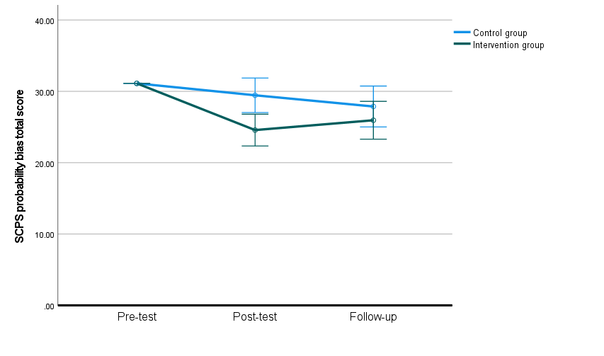
Note. Covariates appearing in the model are evaluated at Pre-test = 31.12; Error bars = 95% confidence interval; SCPS = Speech Cost/Probability bias Scale.

Figure S8
Changes in the negative cognition from one’s performance score of the Speech Cost/Probability bias Scale probability bias in the intent-to-treat analysis.
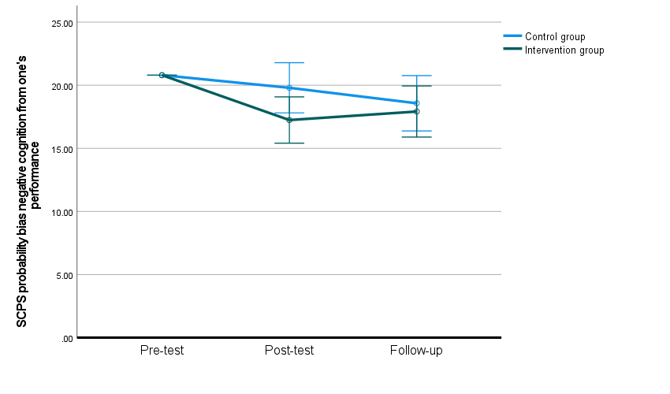
Note. Covariates appearing in the model are evaluated at Pre-test = 20.80; Error bars = 95% confidence interval; SCPS = Speech Cost/Probability bias Scale.

Figure S9
Changes in the negative cognition generated when paying attention to others score of the Speech Cost/Probability bias Scale probability bias in the intent-to-treat analysis.
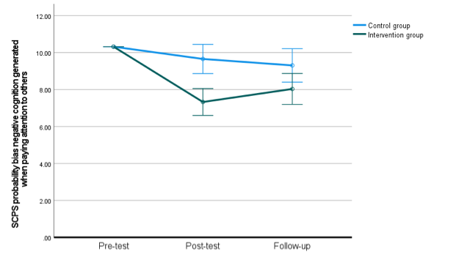
Note. Covariates appearing in the model are evaluated at Pre-test = 10.32; Error bars = 95% confidence interval; SCPS = Speech Cost/Probability bias Scale.

Figure S10
Changes in the total score of the Self-Focused Attention scale in the intent-to-treat analysis.
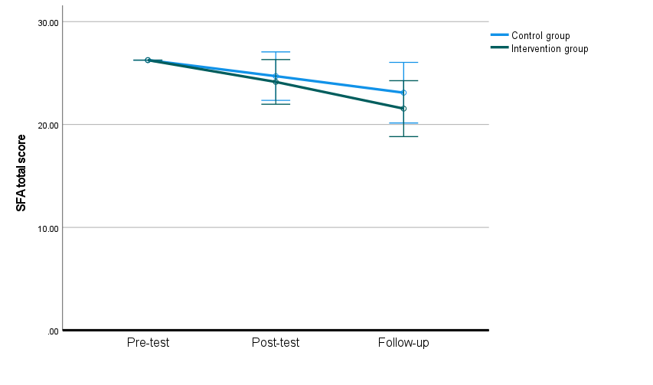
Note. Covariates appearing in the model are evaluated at Pre-test = 26.26; Error bars = 95% confidence interval; SFA = Self-Focused Attention scale.

Figure S11
Changes in the arousal score of the Self-Focused Attention scale in the intent-to-treat analysis.
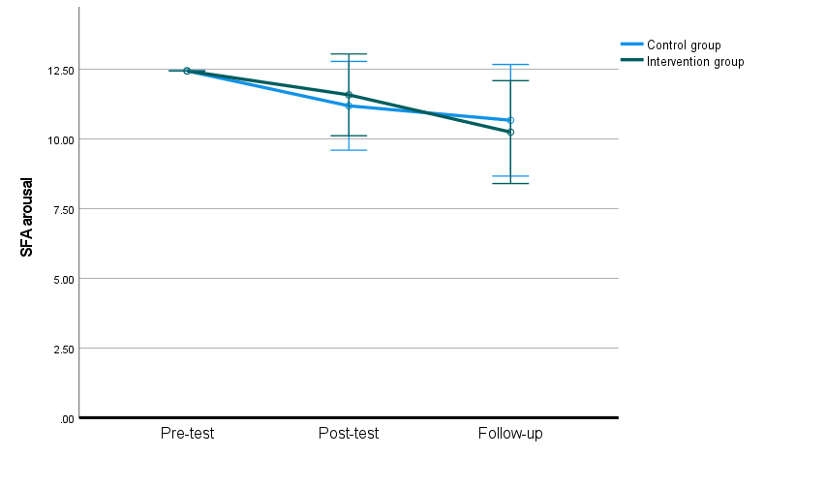
Note. Covariates appearing in the model are evaluated at Pre-test = 12.44; Error bars = 95% confidence interval; SFA = Self-Focused Attention scale.

Figure S12
Changes in the behavior score of the Self-Focused Attention scale in the intent-to-treat analysis.
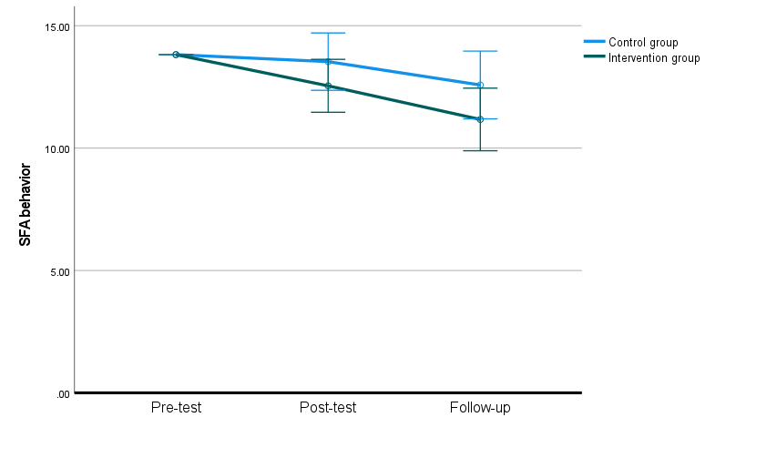
Note. Covariates appearing in the model are evaluated at Pre-test = 13.82; Error bars = 95% confidence interval; SFA = Self-Focused Attention scale.

Figure S13
Changes in the total score of the Short Fear of Negative Evaluation scale in the intent-to-treat analysis.
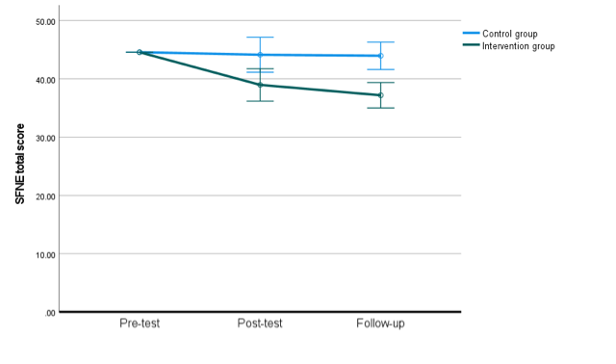
Note. Covariates appearing in the model are evaluated at Pre-test = 44.56; Error bars = 95% confidence interval; SFNE = Short Fear of Negative Evaluation scale.

Figure S14
Changes in the forward-item score of the Short Fear of Negative Evaluation scale in the intent-to-treat analysis.
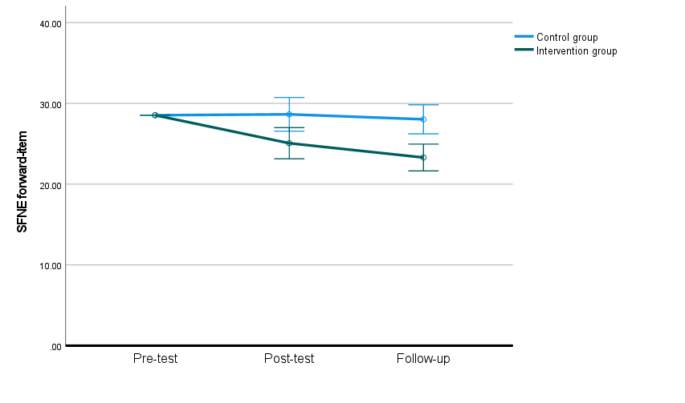
Note. Covariates appearing in the model are evaluated at Pre-test = 28.54; Error bars = 95% confidence interval; SFNE = Short Fear of Negative Evaluation scale.

Figure S15
Changes in the reversed-item score of the Short Fear of Negative Evaluation scale in the intent-to-treat analysis.
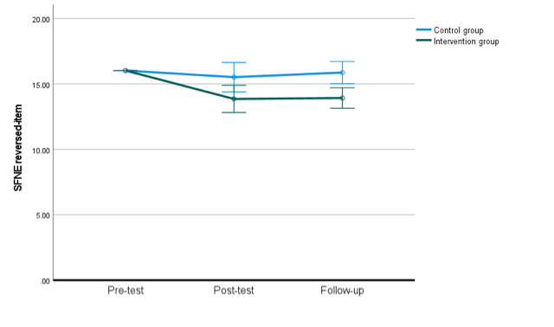
Note. Covariates appearing in the model are evaluated at Pre-test = 16.02; Error bars = 95% confidence interval; SFNE = Short Fear of Negative Evaluation scale.

Figure S16
Changes in the total score of the Five Facet Mindfulness Questionnaire in the intent-to-treat analysis.
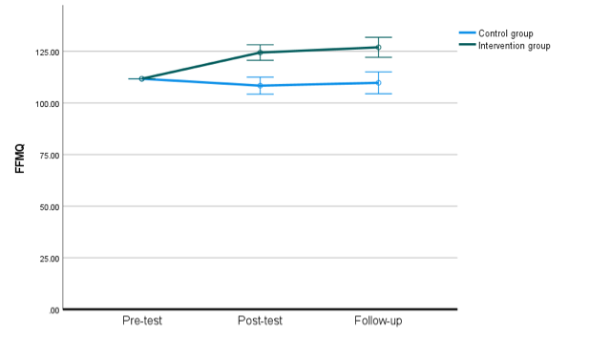
Note. Covariates appearing in the model are evaluated at Pre-test = 111.72; Error bars = 95% confidence interval; FFMQ = Five Facet Mindfulness Questionnaire.

Figure S17
Changes in the total score of the Self-rating Depression Scale in the intent-to-treat analysis.
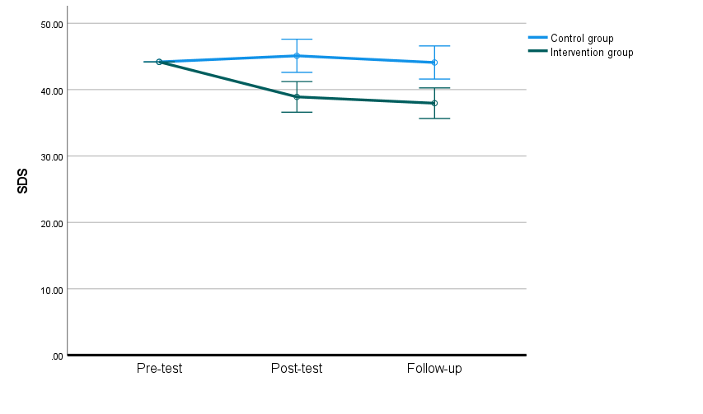
Note. Covariates appearing in the model are evaluated at Pre-test = 44.18; Error bars = 95% confidence interval; SDS = Self-rating Depression Scale.

Figure S18
Changes in the total score of the Subjective Happiness Scale in the intent-to-treat analysis.
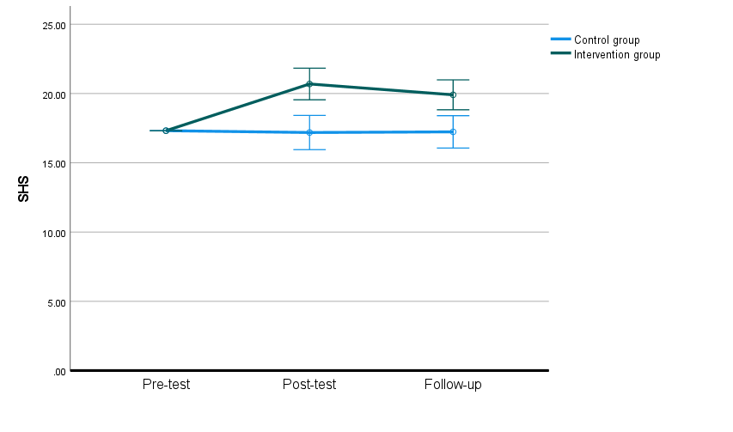
Note. Covariates appearing in the model are evaluated at Pre-test = 17.32; Error bars = 95% confidence interval; SHS = Subjective Happiness Scale.

