Supplementary Material

Appendix
The following figures provide results for network edge weights and edge differences using non-parametric bootstrapping method.
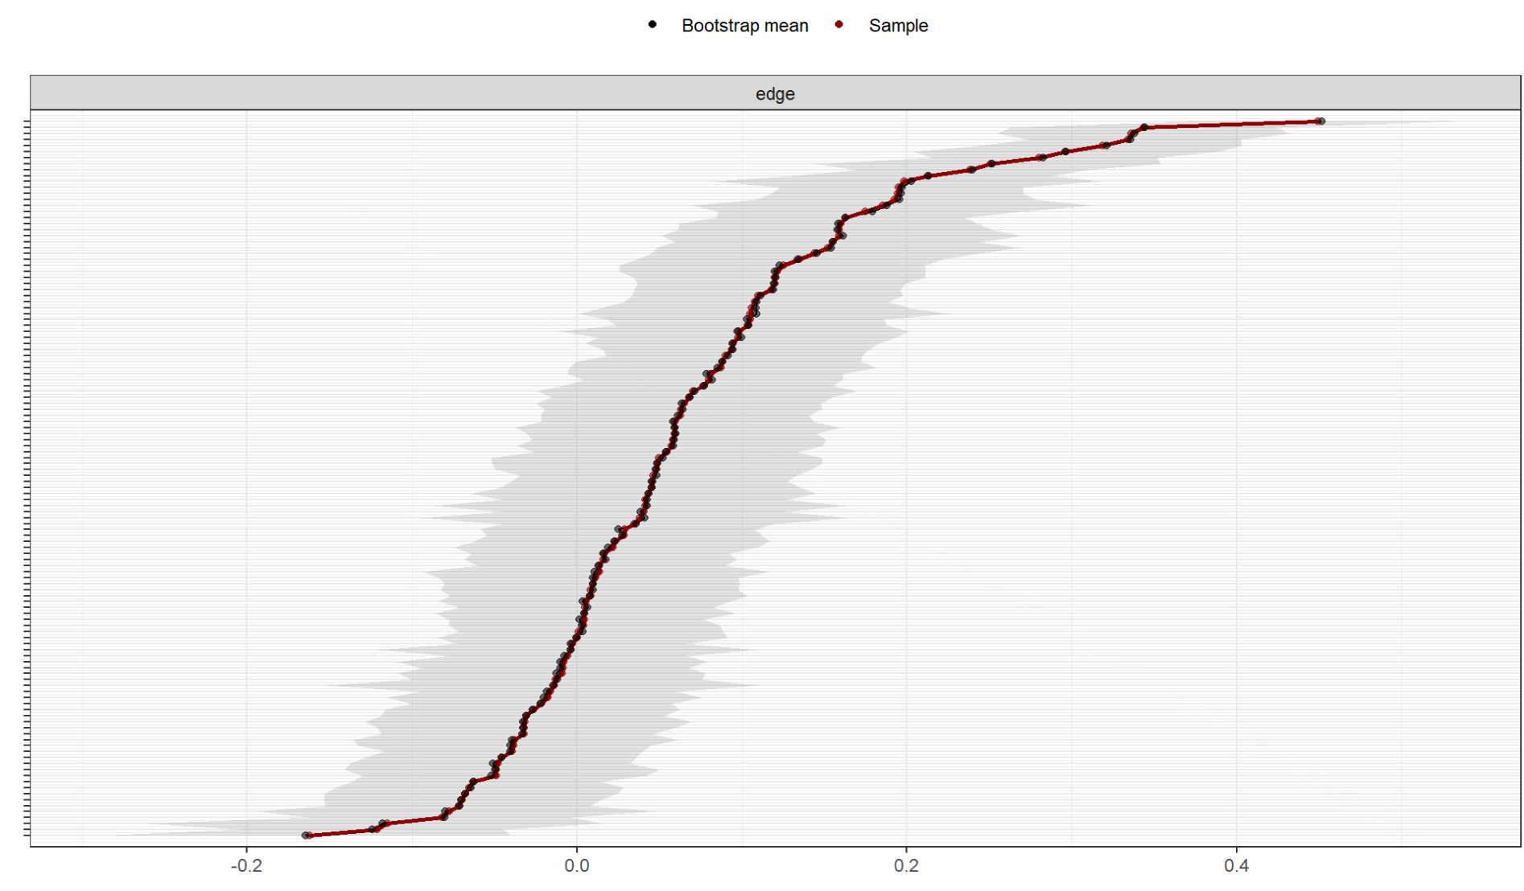
A1 95% bootstrapped confidence interval with non-parametric bootstrapping method

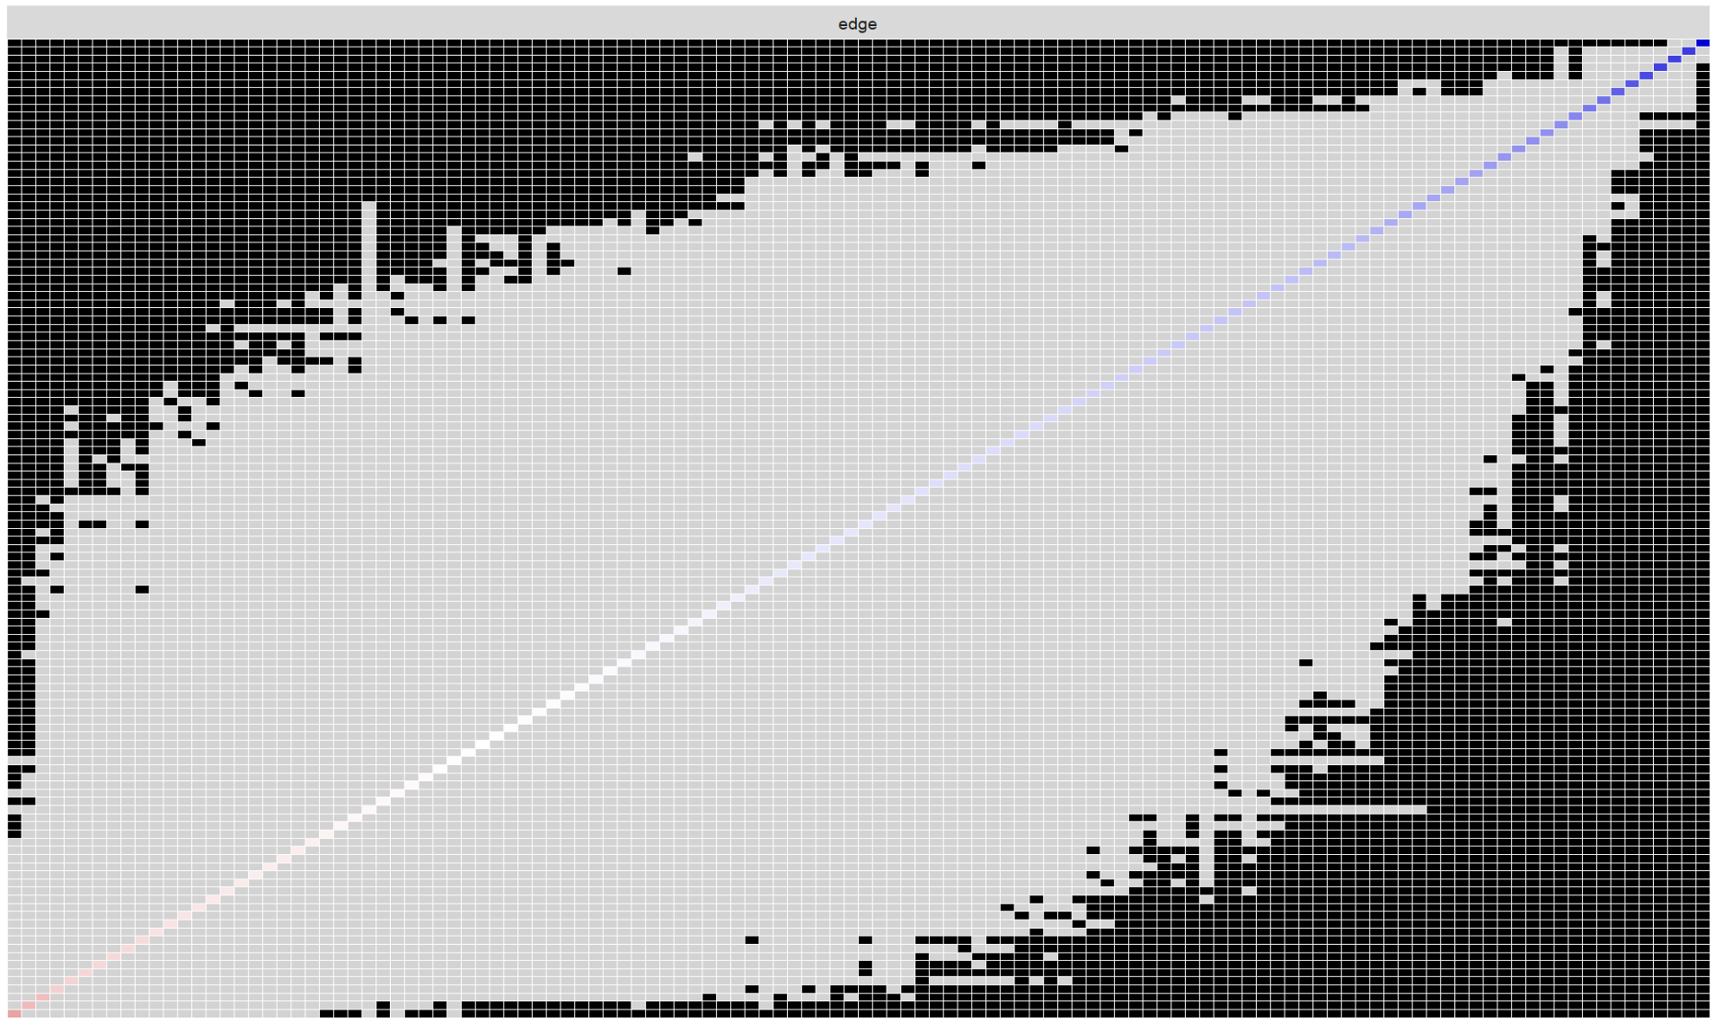
A2 Bootstrapped difference tests for edges among symptoms
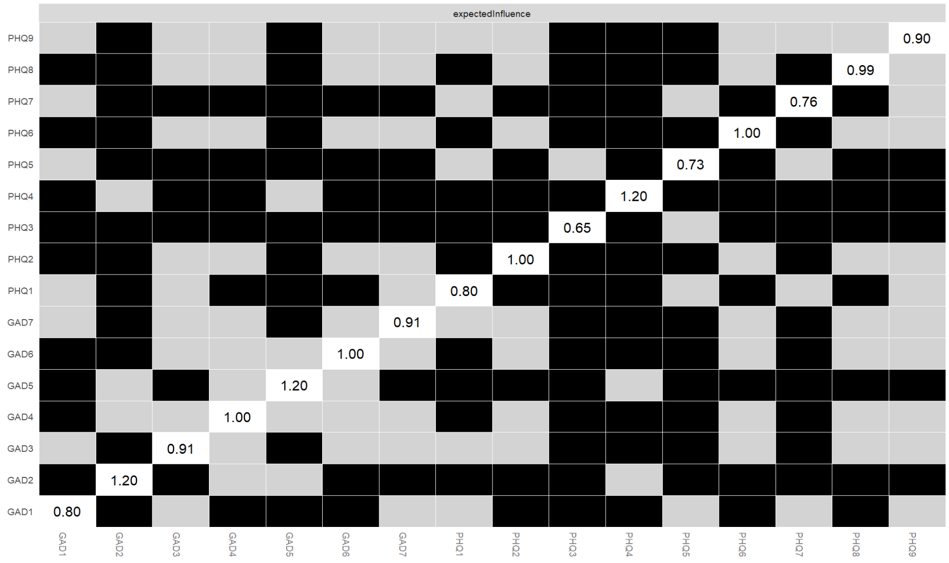
A3 Bootstrapped difference tests for Nodes’ expected influence

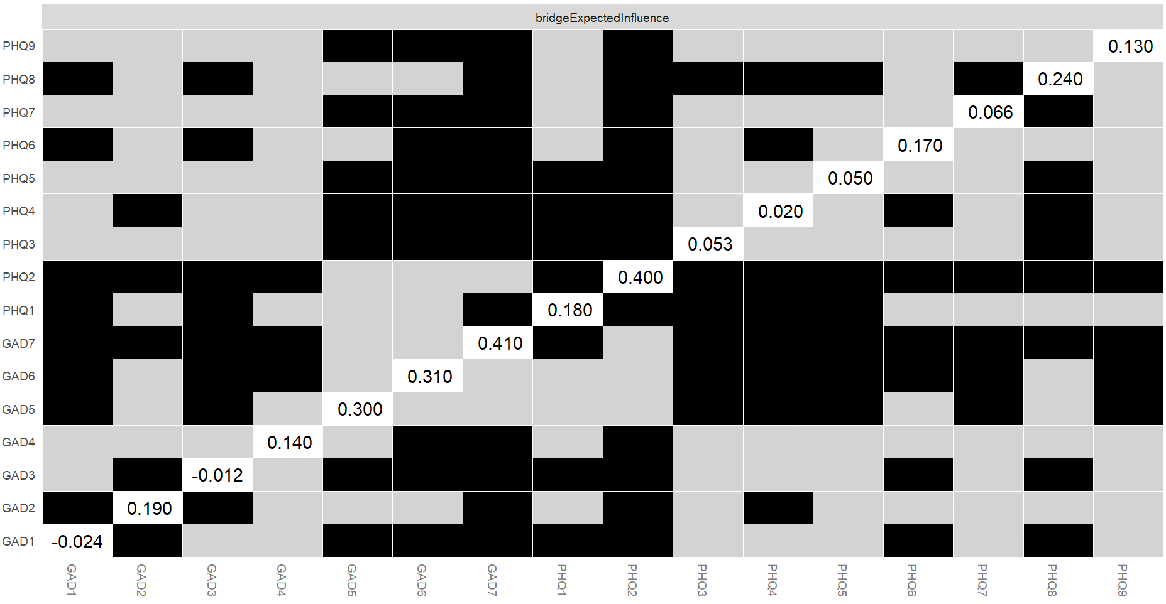
A4 Bootstrapped difference tests for bridging expected influence

