Supplementary Material
The influence of Life's Essential 8 on the link between socioeconomic status and depression in adults: a mediation analysis
Heming Zhang, ^{1, 2, †} Lin Zhang, ^{3,4, †} Jiangjing Li, ¹ Hongxia Xiang, ² Yongfei Liu, ¹ Changjun Gao, ¹ and Xude Sun, ^{1, *}

1 Department of Anesthesiology, The Second Affiliated Hospital of Air Force Medical University, Xi’an, China.
2 Department of Anesthesiology, Hospital 963 of the PLA joint logistics support force, Jiamusi, China.
3 Department of Geriatric Cardiology, The 2nd Medical Center, Chinese PLA General Hospital, Beijing, China.
4 Department of Cardiology, National Center of Gerontology, Institute of Geriatric Medicine, Beijing Hospital, Chinese Academy of Medical Sciences, Beijing, China.
*Correspondence:
Xude Sun: sunxudes@163.com
†These authors have contributed equally to this work and share first authorship

Supplementary Figures
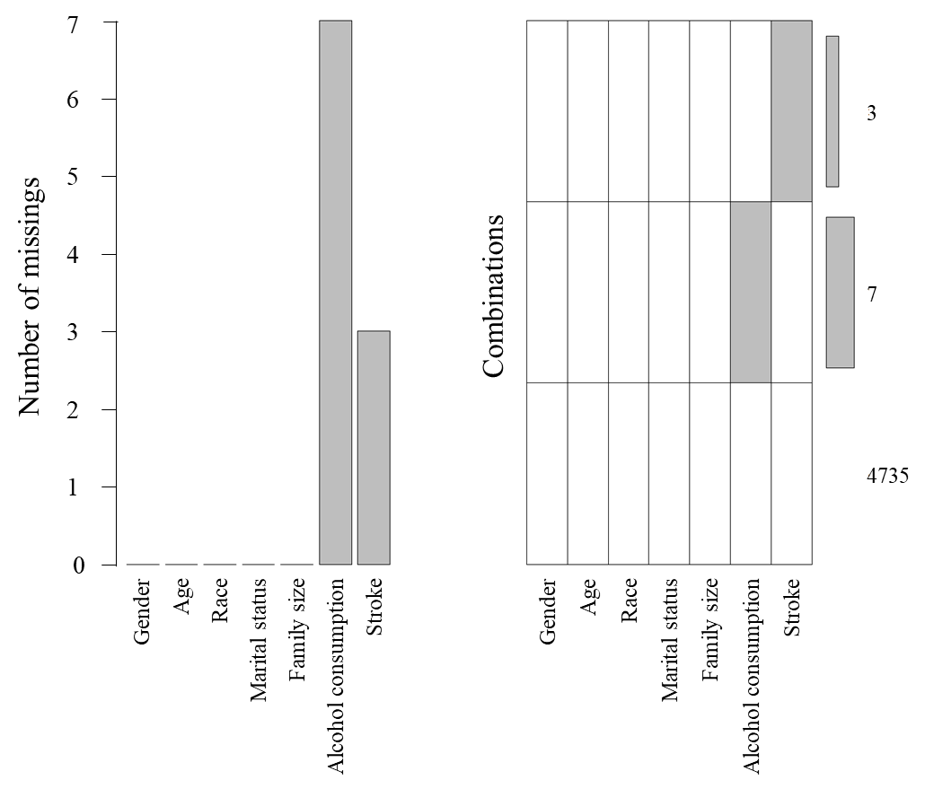
Supplementary Figure S1. Missing data of included participants.

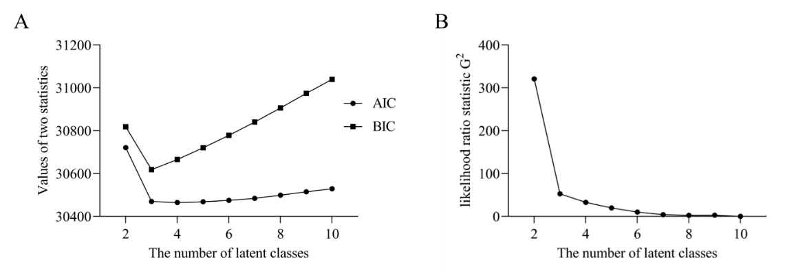
Supplementary Figure S2. (A) AIC, BIC, and (B) G2 in models with different numbers of latent classes in NHANES.
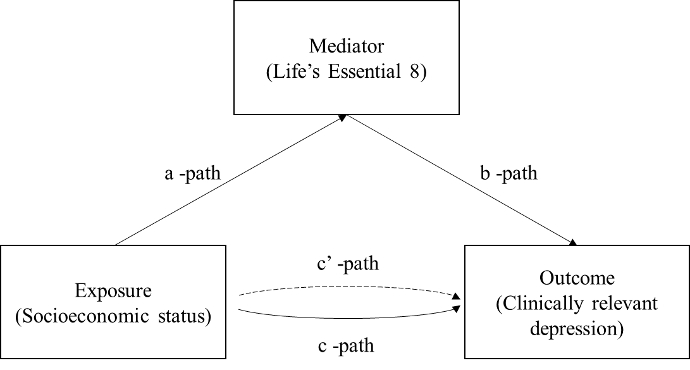
Supplementary Figure S3. Path diagram of the mediation analysis models.

Supplementary Tables
Supplementary Table S1. Definition and scoring approach for quantifying cardiovascular health, as per the American Heart Association’s Life’s Essential 8 score, and as applied in the NHANES, 2013-2018.
Domain | CVH Metric | Method of Measurement | Quantification of CVH Metric
Health Behavior | Diet | Measurement: Self-reported daily intake of a DASH-style eating pattern | Quantiles of DASH-style diet adherence
Health Behavior | Diet |  | Scoring (Population):
Health Behavior | Diet |  | Points | Quantile
Health Behavior | Diet |  | 100 | ≥95th%ile (top/ideal diet)
Health Behavior | Diet | Example tools for measurement: DASH diet score (populations) | 80 | 75th - 94th %ile
Health Behavior | Diet | Example tools for measurement: DASH diet score (populations) | 50 | 50th - 74th %ile
Health Behavior | Diet | Example tools for measurement: DASH diet score (populations) | 25 | 25th - 49th %ile
Health Behavior | Diet | Example tools for measurement: DASH diet score (populations) | 0 | 1th - 24th %ile (bottom/least ideal quartile)
Health Behavior | Physical activity | Measurement: Self-reported minutes of moderate or vigorous physical activity per week | Metric: Minutes of moderate (or greater) intensity activity per week
Health Behavior | Physical activity |  | Scoring:
Health Behavior | Physical activity |  | Points | Minutes
Health Behavior | Physical activity |  | 100 | ≥150
Health Behavior | Physical activity | Example tools for measurement: NHANES PAQ-K questionnaire | 90 | 120 - 149
Health Behavior | Physical activity | Example tools for measurement: NHANES PAQ-K questionnaire | 80 | 90 - 119
Health Behavior | Physical activity | Example tools for measurement: NHANES PAQ-K questionnaire | 60 | 60 - 89
Health Behavior | Physical activity | Example tools for measurement: NHANES PAQ-K questionnaire | 40 | 30 - 59
Health Behavior | Physical activity | Example tools for measurement: NHANES PAQ-K questionnaire | 20 | 1 - 29
Health Behavior | Physical activity | Example tools for measurement: NHANES PAQ-K questionnaire | 0 | 0
Health Behavior | Nicotine exposure | Measurement: Self-reported use of cigarettes or inhaled nicotine-delivery system | Metric: Combustible tobacco use and/or inhaled NDS use; or secondhand smoke exposure
Health Behavior | Nicotine exposure |  | Scoring:
Health Behavior | Nicotine exposure |  | Points | Status
Health Behavior | Nicotine exposure | Example tools for measurement: NHANES SMQ | 100 | Never smoker
Health Behavior | Nicotine exposure | Example tools for measurement: NHANES SMQ | 75 | Former smoker, quit ≥ 5 yrs
Health Behavior | Nicotine exposure | Example tools for measurement: NHANES SMQ | 50 | Former smoker, quit 1 - <5 yrs
Health Behavior | Nicotine exposure | Example tools for measurement: NHANES SMQ | 25 | Former smoker, quit < 1 year,
Health Behavior | Nicotine exposure | Example tools for measurement: NHANES SMQ |  | or currently using inhaled NDS
Health Behavior | Nicotine exposure | Example tools for measurement: NHANES SMQ | 0 | Current smoker
Health Behavior | Nicotine exposure | Example tools for measurement: NHANES SMQ | Subtract 20 points (unless score is 0) for living with active indoor smoker in home
Health Behavior | Sleep health | Measurement: Self-reported average hours of sleep per night | Metric: Average hours of sleep per night
Health Behavior | Sleep health | Measurement: Self-reported average hours of sleep per night | Scoring:
Health Behavior | Sleep health | Measurement: Self-reported average hours of sleep per night | Points | Level
Health Behavior | Sleep health | Example tools for measurement: "On average, how many hours of sleep do you get per night?" | 100 | 7 to <9
Health Behavior | Sleep health |  | 90 | 9 to <10
Health Behavior | Sleep health |  | 70 | 6 to <7
Health Behavior | Sleep health |  | 40 | 5 to <6 or ≥10
Health Behavior | Sleep health |  | 20 | 4 to <5
Health Behavior | Sleep health |  | 0 | <4
Health Factors | Body mass index | Measurement: Body weight (kg) divided by height squared (m²) | Metric: Body mass index (kg/m2)
Health Factors | Body mass index | Measurement: Body weight (kg) divided by height squared (m²) | Scoring:
Health Factors | Body mass index | Measurement: Body weight (kg) divided by height squared (m²) | Points | Level
Health Factors | Body mass index | Example tools for measurement: Objective measurement of height and weight | 100 | <25
Health Factors | Body mass index |  | 70 | 25 to <30
Health Factors | Body mass index |  | 30 | 30 to <35
Health Factors | Body mass index |  | 15 | 35 to <40
Health Factors | Body mass index |  | 0 | ≥40
Health Factors | Blood lipids | Measurement: Plasma total and HDL-cholesterol with calculation of non-HDL-cholesterol | Metric: Non-HDL-cholesterol (mg/dL)
Health Factors | Blood lipids |  | Scoring:
Health Factors | Blood lipids |  | Points | Level
Health Factors | Blood lipids |  | 100 | <130
Health Factors | Blood lipids |  | 60 | 130 to <160
Health Factors | Blood lipids | Example tools for measurement: Objective measurement of height and weight | 40 | 150 to <190
Health Factors | Blood lipids |  | 20 | 190 to <220
Health Factors | Blood lipids |  | 0 | ≥220
Health Factors | Blood lipids |  | If drug-treated level, subtract 20 points
Health Factors | Blood glucose | Measurement: Fasting blood glucose or casual hemoglobin A1c | Metric: Fasting blood glucose (mg/dL) or Hemoglobin A1c (%)
Health Factors | Blood glucose | Measurement: Fasting blood glucose or casual hemoglobin A1c | Scoring:
Health Factors | Blood glucose | Example tools for measurement: Fasting (FBG, HbA1c) or non-fasting (HbA1c) blood sample | Points | Level
Health Factors | Blood glucose |  | 100 | No history of diabetes and FBG <100 (or HbA1c <5.7)
Health Factors | Blood glucose |  | 60 | No diabetes and FBG 100 - 125 (or HbA1c 5.7 - 6.4) (Pre-diabetes)
Health Factors | Blood glucose |  | 40 | Diabetes with HbA1c <7.0
Health Factors | Blood glucose |  | 30 | Diabetes with HbA1c 7.0 to < 8.0
Health Factors | Blood glucose |  | 20 | Diabetes with HbA1c 8.0 to < 9.0
Health Factors | Blood glucose |  | 10 | Diabetes with HbA1c 9.0 to < 10.0
Health Factors | Blood glucose |  | 0 | Diabetes with HbA1c ≥ 10.0
Health Factors | Blood pressure | Measurement: Appropriately measured systolic and diastolic blood pressure | Metric: Systolic and diastolic blood pressure (mmHg)
Health Factors | Blood pressure |  | Scoring:
Health Factors | Blood pressure |  | Points | Level
Health Factors | Blood pressure |  | 100 | <120 / <80 (Optimal)
Health Factors | Blood pressure | Example tools for measurement: Appropriately sized blood pressure cuff | 75 | 120 - 129 / <80 (Elevated)
Health Factors | Blood pressure |  | 50 | 130 - 139 or 80 - 89 (Stage I HTN)
Health Factors | Blood pressure |  | 25 | 140 - 159 or 90 - 99
Health Factors | Blood pressure |  | 0 | ≥160 or ≥100
Health Factors | Blood pressure |  | Subtract 20 points if treated level

Supplementary Table S2. The classifications of variables related to socioeconomic status.
Covariates | Classifications
FIPR | <1; 1 to < 4; ≥4
Occupation | Employment (including retirees and students); unemployment.
Educational level | below high school (less than 9th grade or 9-11th grade including 12th grade with no diploma); high school (high school graduate, GED, or equivalent); and college or above (college, AA degree or above)
Health insurance | private health insurance (private health insurance, Medi-Gap, or single-service plan); public health insurance (Medicare, Medicaid, State Children’s Healthcare Plan, military healthcare, Indian Health Service, State Sponsored Health Plan, or other government programme); no health insurance
Abbreviations: FIPR, the ratio of family income to poverty.

Supplementary Table S3. Practical definitions of high, medium, and low socioeconomic status.
 |  | Employment |  |  | Unemployment
 |  | FIPR≥4 | FIPR≥1 to < 4 | FIPR<1 | FIPR≥4 | FIPR≥1 to < 4 | FIPR<1
Private health insurance | College or above | 3 | 2 | 2 | 3 | 2 | 1
Private health insurance | High school | 3 | 2 | 2 | 3 | 2 | 1
Private health insurance | Below high school | 3 | 2 | 1 | 3 | 2 | 1
Public health insurance | College or above | 3 | 2 | 1 | 3 | 1 | 1
Public health insurance | High school | 3 | 2 | 1 | 1 | 1 | 1
Public health insurance | Below high school | 1 | 1 | 1 | 1 | 1 | 1
No health insurance | College or above | 3 | 2 | 1 | 1 | 1 | 1
No health insurance | High school | 2 | 2 | 1 | 1 | 1 | 1
No health insurance | Below high school | 1 | 1 | 1 | NA | 1 | 1
3 = High SES; 2 = Medium SES; 1 = Low SES; NA = no participants in this group
Abbreviations: FIPR, the ratio of family income to poverty.

Supplementary Table S4. The classifications of covariates.
Covariates | Classifications
Sex | Male; female
Age (year) | 21–39; 40–59; ≥60
Race | MA; Hispanic; NHW; NHB; Other Race
Marital status | Never married; Married; Divorced; Widowed; Other
Family size | 1-2; 3-5; >5
Alcohol consumption | Never; Former; Current
Stroke | No; Yes
Abbreviations: MA, mexican american; NHW, non-hispanic white; NHB, non-hispanic black.

Supplementary Table S5. Associations of Life’s Essential 8 score with clinically relevant depression in participants with different socioeconomic status.
 | Model 1 |  | Model 2 |  | Model 3
 | β (95% CI) | P-Value | β (95% CI) | P-Value | β (95% CI) | P-Value
SES
Low SES | 0.979 (0.969 to 0.99) | < 0.01 | 0.984 (0.973 to 0.995) | < 0.01 | 0.985 (0.974 to 0.996) | < 0.01
Medium SES | 0.956 (0.944 to 0.969) | < 0.01 | 0.953 (0.94 to 0.966) | < 0.01 | 0.955 (0.942 to 0.968) | < 0.01
High SES | 0.973 (0.954 to 0.992) | < 0.01 | 0.964 (0.943 to 0.986) | < 0.01 | 0.965 (0.943 to 0.988) | < 0.01
Abbreviations: MA, mexican american; NHW, non-hispanic white; NHB, non-hispanic black; FIPR, the ratio of family income to poverty; CI, confidence interval.

