Supplementary Figures

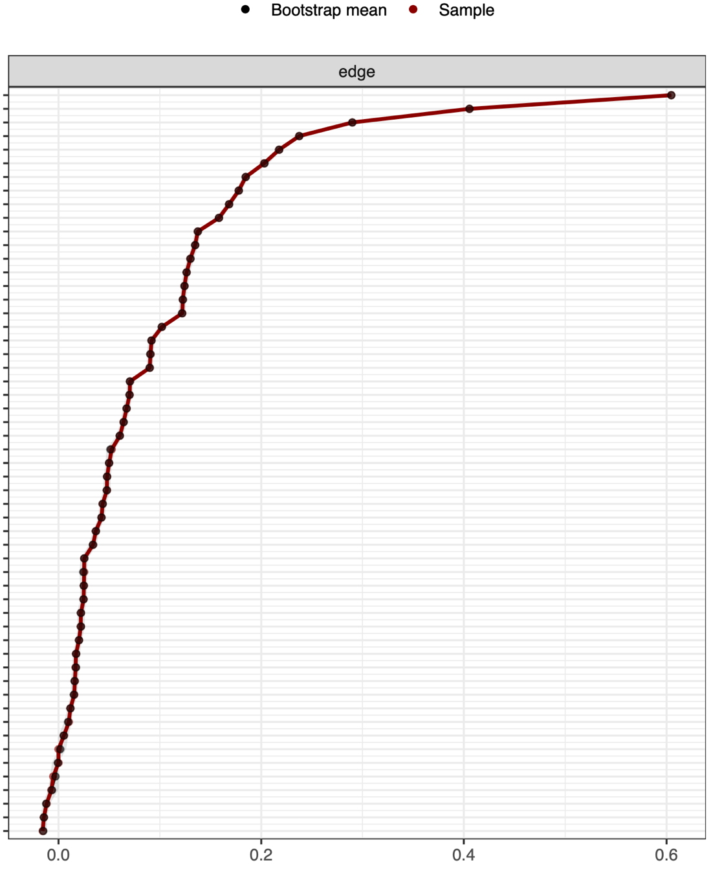

Supplementary Figure 1: Accuracy and stability of the distribution of bootstrap means in Network 1.
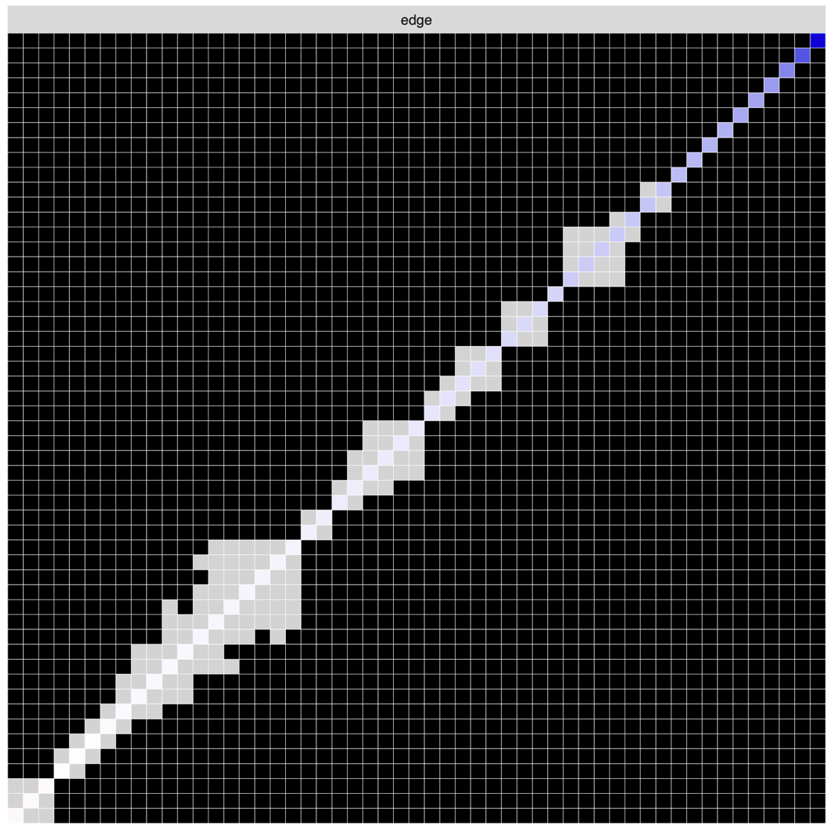
Supplementary Figure 2: Accuracy and stability of edge-estimates in Network 1.
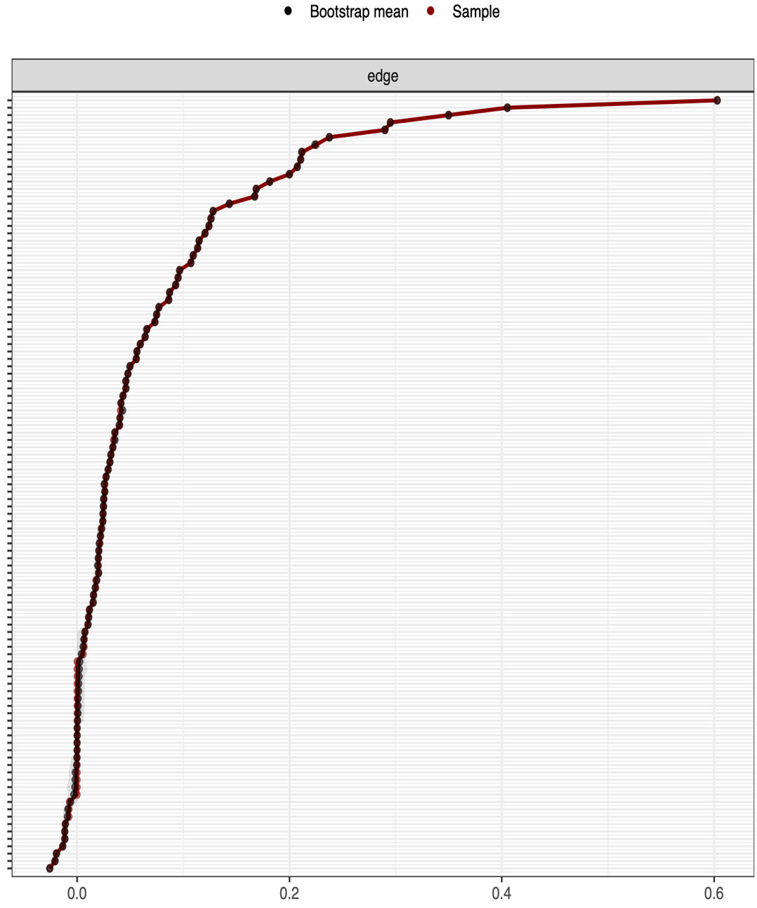
Supplementary Figure 3: Accuracy and stability of the distribution of bootstrap means in Network 2.
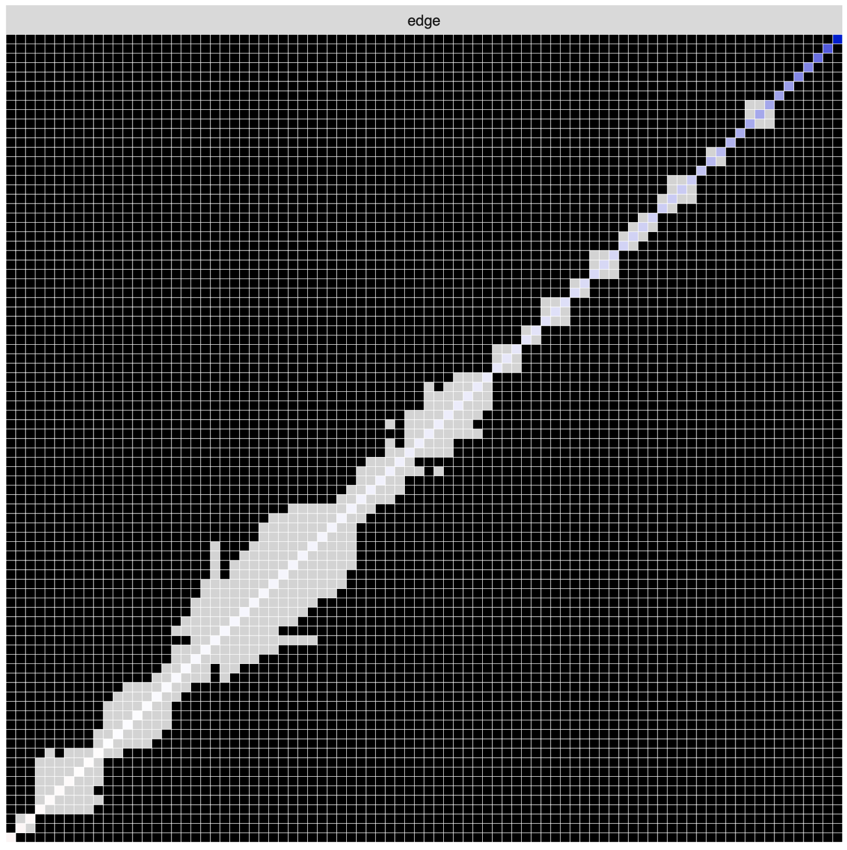
Supplementary Figure 4: Accuracy and stability of edge-estimates in Network 2.

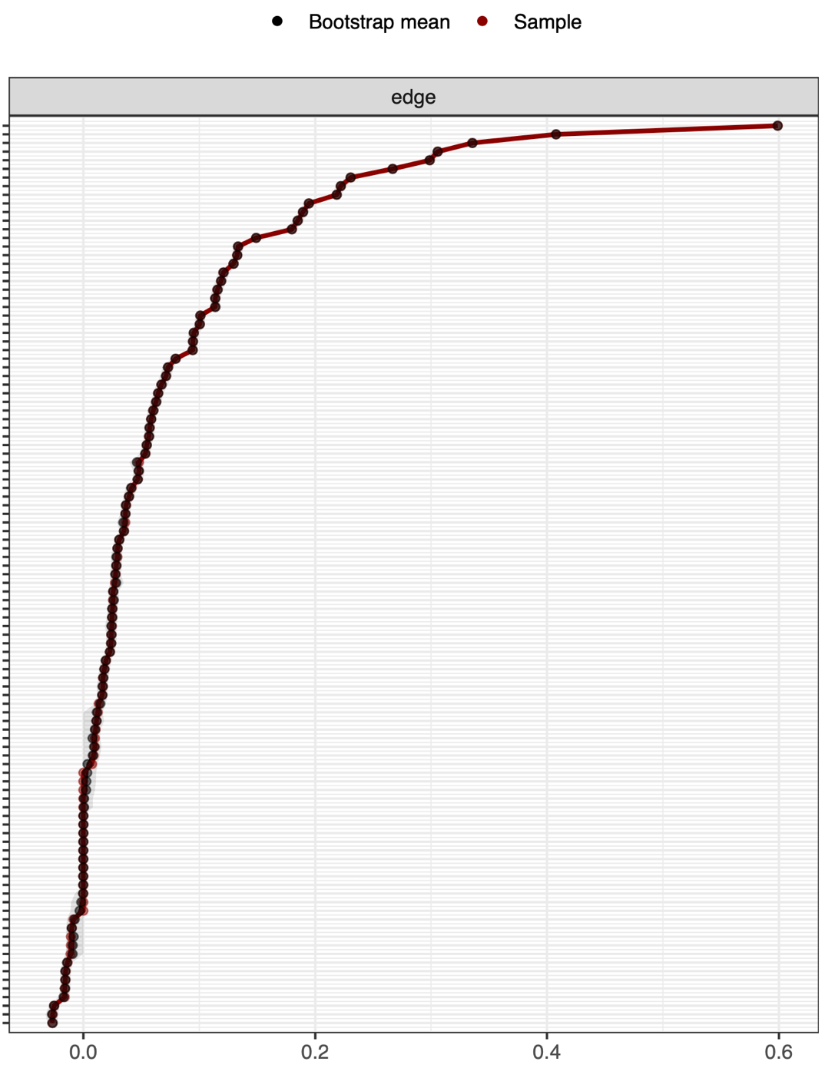
Supplementary Figure 5: Accuracy and stability of the distribution of bootstrap means in the female network.
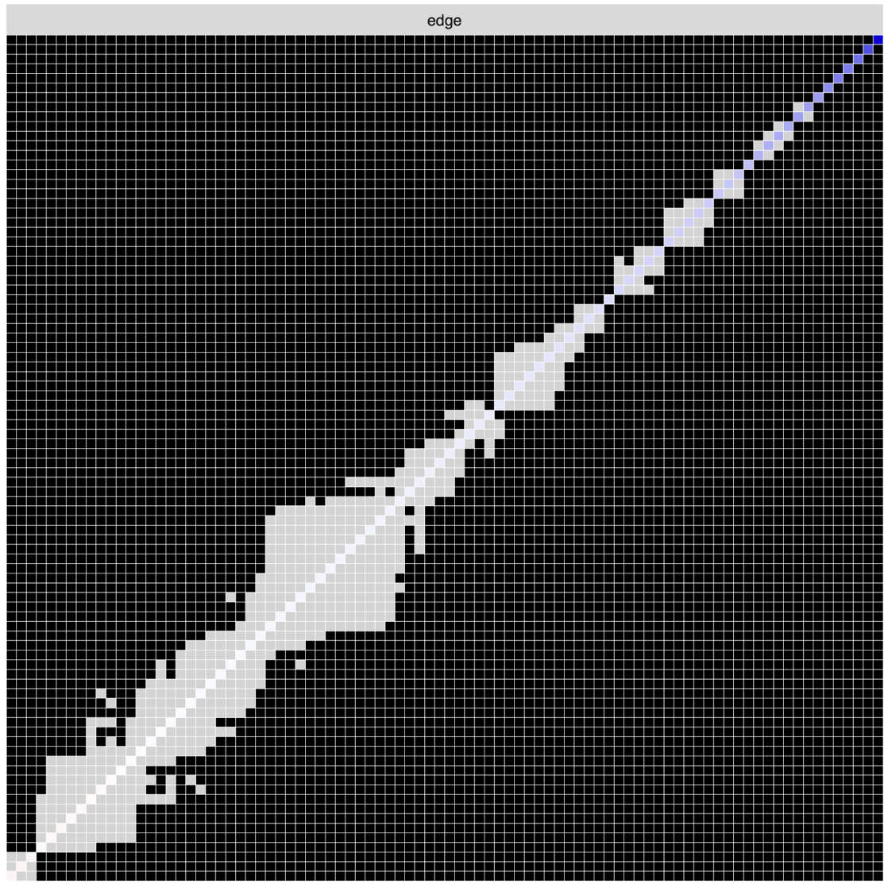
Supplementary Figure 6: Accuracy and stability of edge-estimates in the female network.
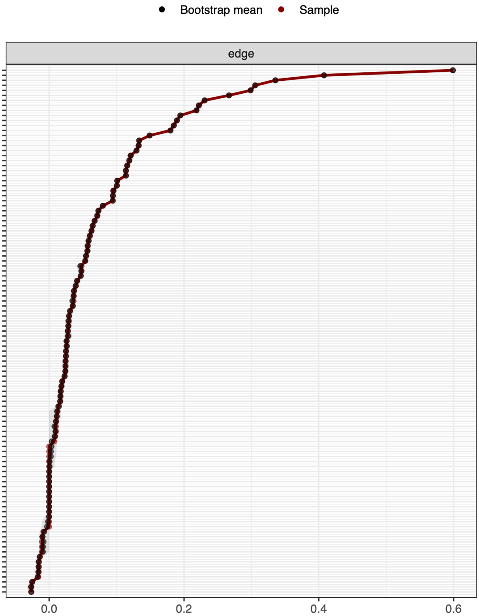
Supplementary Figure 7: Accuracy and stability of the distribution of bootstrap means in the male network.
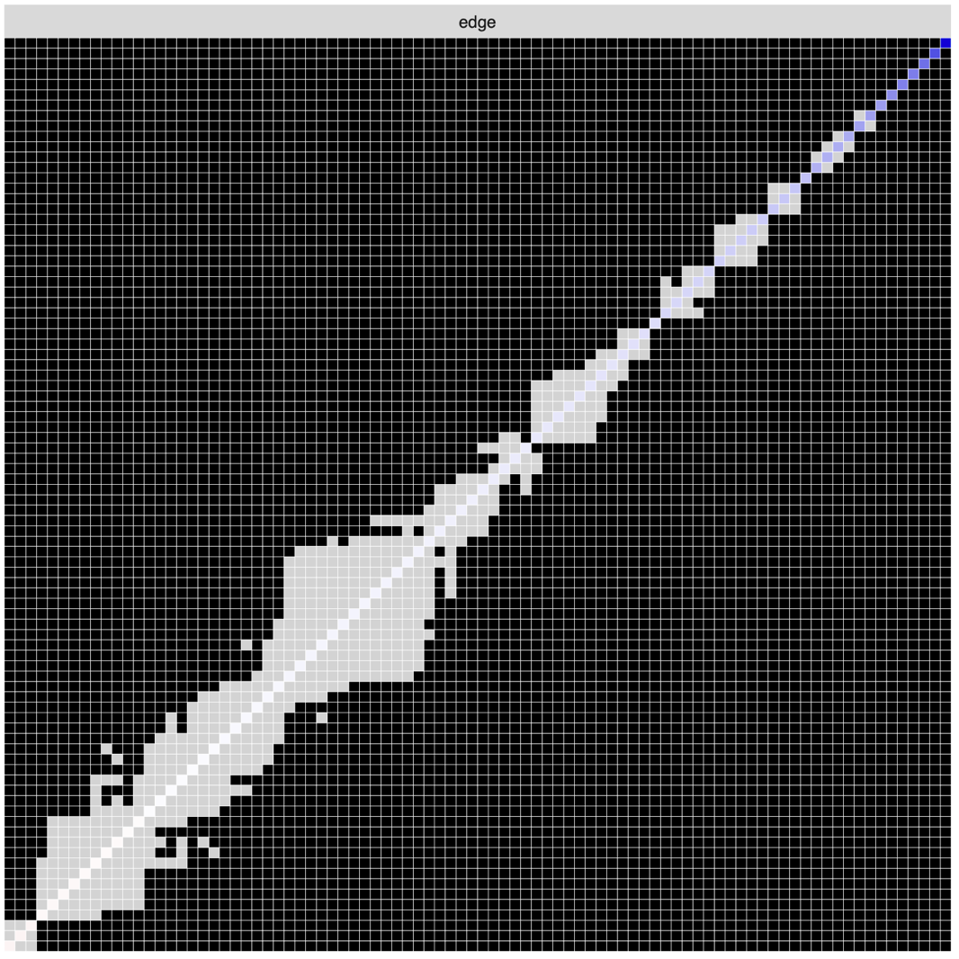
Supplementary Figure 8: Accuracy and stability of edge-estimates in the male network.

Supplementary Figure 9: Expected influence in Network 1, presented in raw scores.

Supplementary Figure 10: Expected Influence in Network 2, presented in raw scores.

Supplementary Figure 11: Expected influence in the female and male networks, presented in raw scores.

Supplementary Figure 12: Network 1 with all edges visualized.

Supplementary Figure 13: Network 2 with all edges visualized.

Supplementary Figure 14: Female network with all edges visualized.

Supplementary Figure 15: Male network with all edges visualized.

