Supplementary Figure.1 Research methodolody design chart

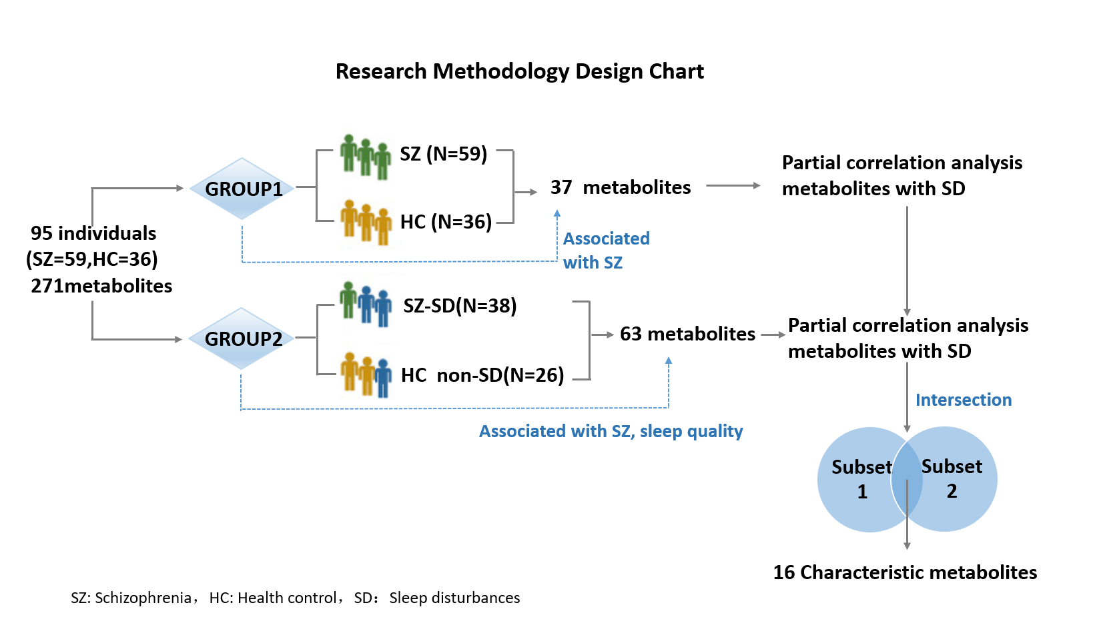

Supplementary Table.1 630 metabolites classification information

Target classification | Total number
Acylcarnitine | 40
Alkaloids | 1
Amine oxide | 1
Amino acids | 20
Amino acid related | 30
Bile acids | 14
Biogenic amines | 9
Carbohydrates and related | 1
Cholesterol esters | 22
Carboxylic acid | 7
Glycerol diacetate | 44
Dihydroceramide | 8
Cresol | 1
Fatty acids | 12
Hormones and related | 4
Indole and its derivatives | 4
Ribonucleases and related | 2
lysophosphatidylcholine | 14
Phosphatidylcholine | 76
Sphingolipids | 15
Ceramides | 28
Ethyl ceramide | 19
Glycerol triglycerides | 242
Vitamins and cofactors | 1
Dihexosyl ceramide | 9
Trihexyl ceramide | 6
Target classification is a categorisation of the targets contained in the kit based on the nature of the metabolite. The total number is the number of targets covered by the kit under that classification.

