Section and Topic | Item # | Checklist item | Location where item is reported
TITLE
Title | 1 | The report is identified as a meta-analysis
ABSTRACT
Abstract | 2 | Title：Influence of Aerobic Exercise on Depression in Young people：A Meta-analysis  OBJECTIVE：To investigate the impact of aerobic exercise on depression among the young people.  DATA SOURCES：PubMed, Web of science, Embase, Cochrane, EBSCO were searched from inception to November 2023.  STUDY SELECTION:RCT studies, assessing aerobic exercise use in young people 6-35 years and then ascertaining development of depression in young people (age 6-35 years) were selected, and mean±sd adjusted for the presence of baseline depression were extracted.  DATA EXTRACTION AND SYNTHESIS: Study quality was assessed using the Review manager 5.4.1 and Cochrane 5.1 item on risk of bias and precision of observational studies. Two reviewers conducted all review stages independently. Selected data were pooled using random-effects meta-analysis.  MAIN OUTCOMES AND MEASURES：The studies assessing aerobic exercise and depression at different points from young people and reporting the corresponding mean±sd were included. In the studies selected, depression was diagnosed according to the depression Correlation Scale.  RESULTS: After screening 2296 articles, 163 articles were selected for full-text review, 8 were selected for further review, and 12 studies comprising 658 individuals were included in the Meta-analysis. Meta-analysis showed that aerobic exercise could improve depression in young people (d=-1.33, 95%CI: -1.78~-0.87,P < 0.05). Subgroup analysis showed that aerobic exercise could both improve depression (d=-2.68, 95%CI: -3.87~-1.48, P < 0.05) and non-depression (d=-0.85, 95%CI: -1.20~-0.51, P < 0.05), and low intensity (d=-0.93, 95%CI: -1.29~0.58,P < 0.05) Both aerobic exercise and moderate intensity (d=-2.08,95%CI:-2.88~-1.27,P < 0.05) Aerobic exercise improved depression in young people for 40 minutes or less (d= -2.00,95%CI: -2.96~-1.04,P < 0.05) Aerobic exercise and more than 40 minutes (d=-0.85,95%CI:-1.47~-0.24,P < 0.05) Aerobic exercise can improve the level of depression in young people, less than 6 weeks (d=-1.27,95%CI: 2.12 ~ 0.14, P < 0.05) aerobic exercise, 6 to 11 weeks (d = 1.55, 95% CI: 2.16 ~ 0.94, P < 0.05) and more than 12 weeks aerobic exercise (d = 1.00, 95% CI: -1.76~-0.24,P < 0.05) Aerobic exercise can improve the level of depression in young people.  CONCLUSIONS: 1)Aerobic exercise can improve depression in young people. 2)6-11 weeks, 3 times a week, 40 minutes of moderate intensity aerobic exercise each time can improve the depression indicator of depressed people.  Keywords：Aerobic Exercise, Young people; Depression
INTRODUCTION
Rationale | 3 | Current research on the effects of aerobic exercise on depression in young people suggests that aerobic exercise may have a positive effect on alleviating depressive symptoms. However, there is some uncertainty in the results of the study, as many factors may affect the conclusions of the study, including study design, sample characteristics, inconsistencies in measurement tools, etc. In addition, individual differences, environmental factors, and lifestyle may also have an impact on the effects of aerobic exercise, adding to the uncertainty in the research field. One of the main objectives of the review was to synthesize and collate current research evidence to gain a comprehensive understanding of the effects of aerobic exercise on depressive conditions in young people. This can help identify consistencies and inconsistencies in existing studies and guide the direction of future research. The review of aerobic exercise for depression may provide support for the development of health policies and the development of interventions. Policymakers can develop more targeted and effective intervention strategies based on the findings of the review. If there are other systematic reviews that address similar issues, the current review may still be considered necessary for reasons including: outdated or inconsistent results: Previous reviews may be out of date, or there are cases where the findings are inconsistent. The new review can fill these knowledge gaps by integrating the latest research findings. The review examined the intervention effects of aerobic exercise, including physiological effects: aerobic exercise may alleviate depressive symptoms by improving cardiovascular health, releasing neurotransmitters and other physiological mechanisms. Psychological effects: Exercise may affect depressive mood by promoting social interaction, improving self-esteem, reducing anxiety and other psychological mechanisms.
Objectives | 4 | To investigate the impact of aerobic exercise on depression among the young people.
METHODS
Eligibility criteria | 5 | Inclusion criteria  Two reviewers (D.J.X and W.T) independently assessed all titles and abstracts along with full texts of potentially relevant articles. Studies were included if they met the following criteria: (1) Include literature that involves study subjects aged 6-35 years[7]; (2) Incorporate literature specifically focused on aerobic exercise as the modality of physical activity; (3) Include literature with outcome measures based on relevant depression assessment scales; (4) Include literature exclusively derived from randomized controlled trials.  Exclusion criteria  Two reviewers (D.J.X and W.T) independently assessed all titles and abstracts along with full texts of potentially relevant articles. Studies were excluded if they did not meet the following criteria: (1) Exclude non-English literature; (2) Exclude conference papers.(3) Exclude review articles and meta-analyses; (4) Exclude animal experiments; (5) Exclude literature involving participants aged 35 years and above; (6) Exclude literature for which the full text cannot be obtained; (7) Exclude literature where outcome measures are not expressed as mean ± standard deviation; (8) Exclude literature wherein the exercise intervention does not encompass aerobic exercise.
Information sources | 6 | Through systematic exploration of the PubMed, Web of Science, Embase, Cochrane, and EBSCO databases,
Search strategy | 7 | The search period spans from the inception of database records to November 2023. Employing a comprehensive search strategy, the approach integrates subject terms and free-text terms into three distinct groups. The first group centers on outcome measures, utilizing "Depression" as the subject term and encompassing associated free-text terms such as (Depressive Symptoms, Depressive Symptom, Symptom, Depressive, Emotional Depression, Depression, Emotional). The second group addresses the study population, employing "Adolescent" as the free-text term and incorporating related terms like (Teenagers, Youths, Adolescence). The third group pertains to intervention methods, utilizing "Exercise" as the subject term and incorporating pertinent free-text terms such as (Aerobic exercise, Exercise Training, Physical Activity). Terms within each group are logically connected using the logical operator OR, while the distinct groups are interconnected with the logical operator AND. Upon completion of the literature retrieval process, a dual-blind methodology will be implemented by two independent reviewers for the purposes of inclusion and exclusion. The retrieved literature will be consolidated within the EndnoteX9 reference management software, which will subsequently facilitate an initial duplicate check through its inherent system. Further scrutiny will ensue through a detailed examination of titles and author years. Subsequent to this, a preliminary screening of identified articles will be executed based on a meticulous review of titles and abstracts. The selected articles following this preliminary screening will be downloaded, and in instances where disparities arise between the two reviewers, a third reviewer will be engaged to deliberate on the inclusion status of the divergent articles.
  Search term classification | Term
  Intervention method | Exercise[Mesh] ; Exercises ; Physical Activity ; Activities, Physical ; Activity, Physical ; Physical Activities ; Exercise, Physical ; Exercises, Physical ; Physical Exercise ; Physical Exercises ; Acute Exercise ; Acute Exercises ; Exercise, Acute ; Exercises, Acute ; Exercise, Isometric ; Exercises, Isometric ; Isometric Exercises ; Isometric Exercise ; Exercise, Aerobic ; Aerobic Exercise ; Aerobic Exercises ; Exercises, Aerobic ; Exercise Training ; Exercise Trainings ; Training, Exercise ; Trainings, Exercise
  Study subjects | Adolescent [Mesh]; Adolescents ; Adolescence ; Teens ; Teenagers ; Teenager ; Youth ; Youths ; Adolescents, Female ; Adolescent, Female ; Female Adolescent ; Female Adolescents ; Adolescents, Male ; Adolescent, Male ; Male Adolescent ; Male Adolescents
  Outcome indicator | Depression[Mesh] ; Depressive Symptoms ; Depressive Symptom ; Symptom, Depressive ; Emotional Depression ; Depression, Emotional
Selection process | 8 | Three researchers （L,wc, D,jx, W,t） independently reviewed titles and abstracts of the 2296 records and discussed inconsistencies until consensus was obtained. Then, in pairs, the researchers independently screened titles and abstracts of all articles retrieved. In case of disagreement, consensus on which articles to screen full-text was reached by discussion. If necessary, the third researcher was consulted to make the final decision. Next, two researchers （L,wc, D,jx,） independently screened full-text articles for inclusion. Again, in case of disagreement, consensus was reached on inclusion or exclusion by discussion and if necessary, the third researcher (W,t) was consulted.
Data collection process | 9 | We designed a data extraction form based on that used by Excel2020, which two review authors (L,wc and D,jx) used to extract data from eligible studies. Extracted data were compared, with any discrepancies being resolved through discussion. L,wc entered data into Review Manager 5.4.1, double checking this for accuracy. When information regarding any of the above was unclear, we contacted authors of the reports to provide further details.
Data items | 10a | In the context of investigating the impact of aerobic exercise on depression indicators in young people, the data collection process was approached comprehensively to encompass various outcome domains relevant to the study's focus. The objective was to ensure a thorough examination of the study findings. The following outcomes were identified and defined for data collection:  1. Depressive Symptoms:  - Definition: Measurement of self-reported or clinically assessed depressive symptoms in young individuals.  - Inclusion of outcomes related to mood, emotions, and overall mental well-being.  2. Psychological Well-being:  - Definition: Assessment of positive psychological factors, such as self-esteem, resilience, and life satisfaction.  - Inclusion of outcomes related to the overall psychological well-being of young individuals.  3. Cognitive Function:  - Definition: Evaluation of cognitive functions, including attention, memory, and executive functions.  - Inclusion of outcomes related to cognitive performance as indicators of mental health.  4. Physical Health:  - Definition: Measurement of physical health parameters, such as cardiovascular fitness and overall physical functioning.  - Inclusion of outcomes related to the impact of aerobic exercise on the physical well-being of young individuals.  5. Quality of Life:  - Definition: Assessment of the overall quality of life, considering both subjective and objective indicators.  - Inclusion of outcomes related to how aerobic exercise influences the overall quality of life in young people.  6. Social Functioning:  - Definition: Examination of social interactions, relationships, and overall social functioning.  - Inclusion of outcomes related to the impact of aerobic exercise on the social aspects of young individuals' lives.
Data items | 10b | We collected data on:  • the report: author, year, and source of publication;  • the study: sample characteristics, social demography, and definition and criteria used for depression;  • the participants: Major depressive disorder, Obese people, Healthy people  • the research design and features: RCT  • the intervention: Aerobic exercise, duration, period and intensity
Study risk of bias assessment | 11 | We assessed risk of bias in the included studies using the revised Cochrane Risk of bias tool for randomised trials employing the additional guidance for cluster-randomised and cross-over trials addresses five specific domains: (1) bias arising from the randomisation process; (2) bias due to deviations from intended interventions; (3）bias due to missing outcome data; (4) bias in measurement of the outcome; and (5) bias in selection of the reported result. Two review authors independently applied the tool to each included study, and recorded supporting information and justifications for judgements of risk of bias for each domain (low; high; some concerns). Any discrepancies in judgements of risk of bias or justifications for judgements were resolved by discussion to reach consensus between the two review authors, with a third review author acting as an arbiter if necessary.
Effect measures | 12 | mean difference
Synthesis methods | 13a | Describe in Results
Synthesis methods | 13b | Describe in Results
Synthesis methods | 13c | Describe in Results
Synthesis methods | 13d | Describe in Results
Synthesis methods | 13e | Describe in Results
Synthesis methods | 13f | Describe in Results
Reporting bias assessment | 14 | To assess study effects, we planned to generate funnel plots for meta-analyses .including 12 trials of varying size. If asymmetry in the funnel plot was detected, we planned to review the characteristics of the trials to assess whether the asymmetry was likely due to publication bias or other factors such as methodological or clinical heterogeneity of the trials. To assess outcome reporting bias, we compared the outcomes specified in trial protocols with the outcomes reported in the corresponding trial publications; if trial protocols were unavailable, we compared the outcomes reported in the methods and results sections of the trial publications
Certainty assessment | 15 | Two people (L,wc, D,jx) independently assessed the certainty of the evidence. We used the five GRADE considerations (study limitations, consistency of effect, imprecision, indirectness, and publication bias) to assess the certainty of the body of evidence as it related to the studies that contributed data to the meta-analyses for the prespecified outcomes. We assessed the certainty of evidence as high, moderate, low, or very low. We considered the following criteria for upgrading the certainty of evidence, appropriate: large effect, dose-response gradient, and plausible confounding effect
RESULTS
Study selection | 16a | 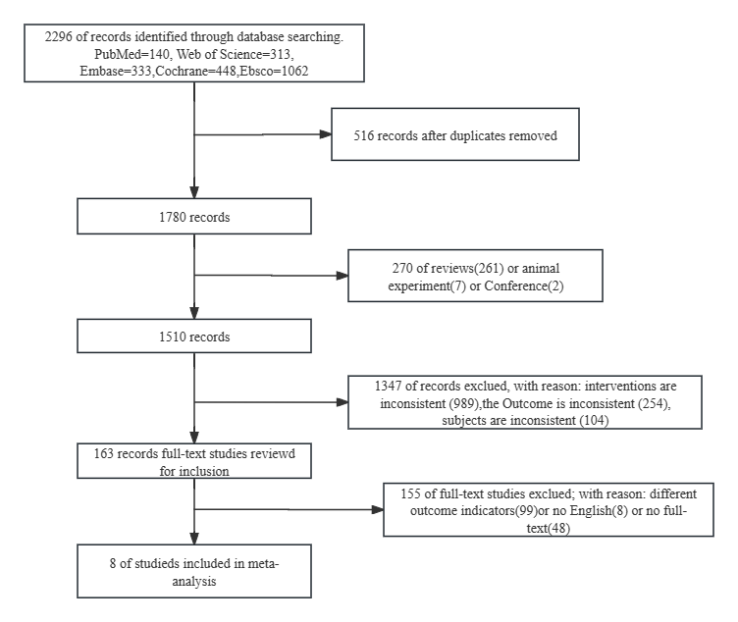
Study selection | 16b | Describe in Study Selection
Study characteristics | 17 | Describe in Table 2 List of basic features of included literatures
Risk of bias in studies | 18 | 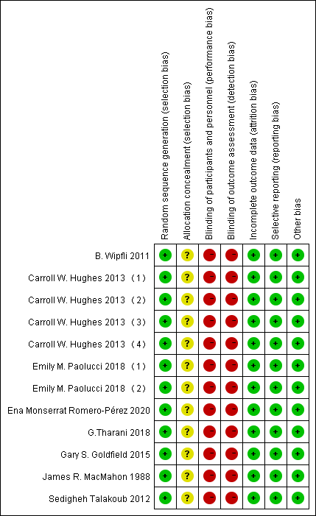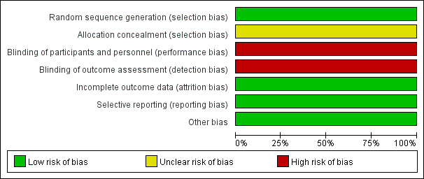
Results of individual studies | 19 | 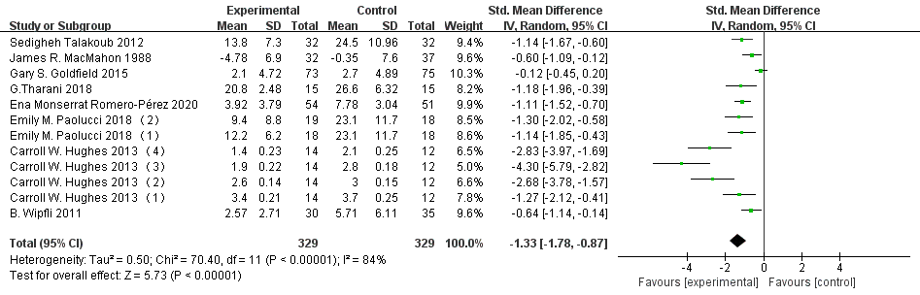Figure 4  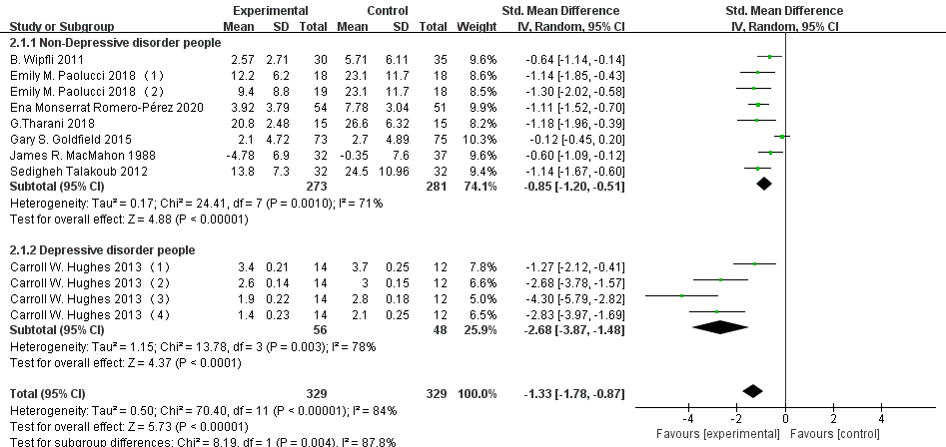Figure 5  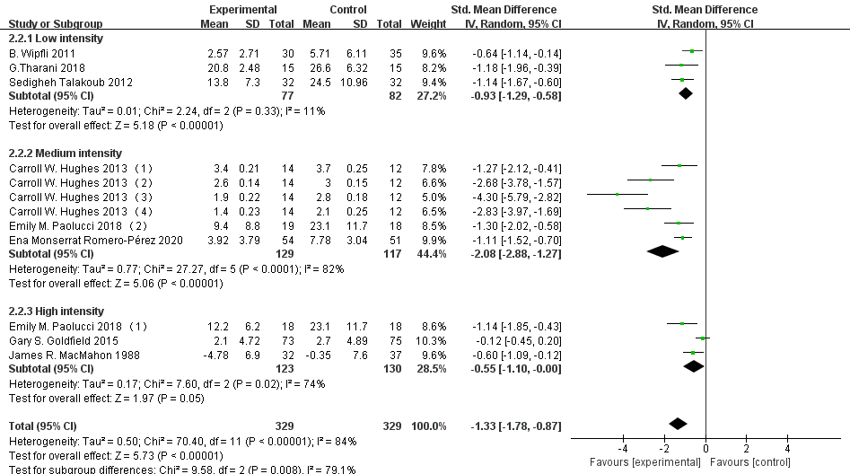Figure 6  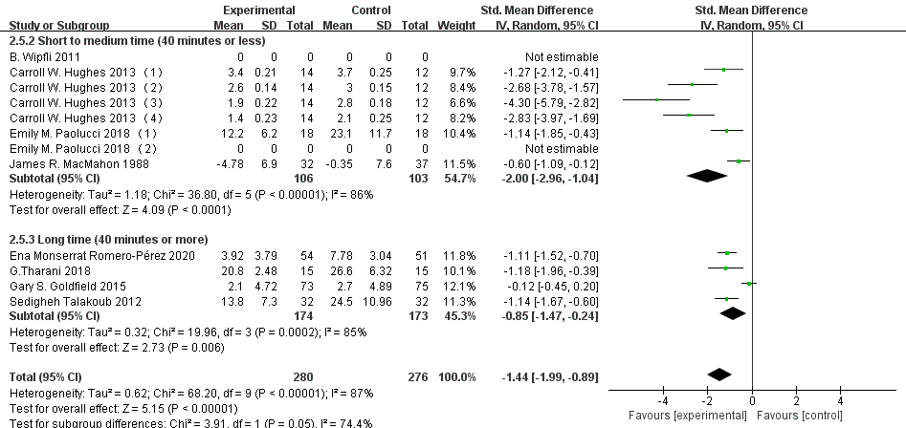Figure 7  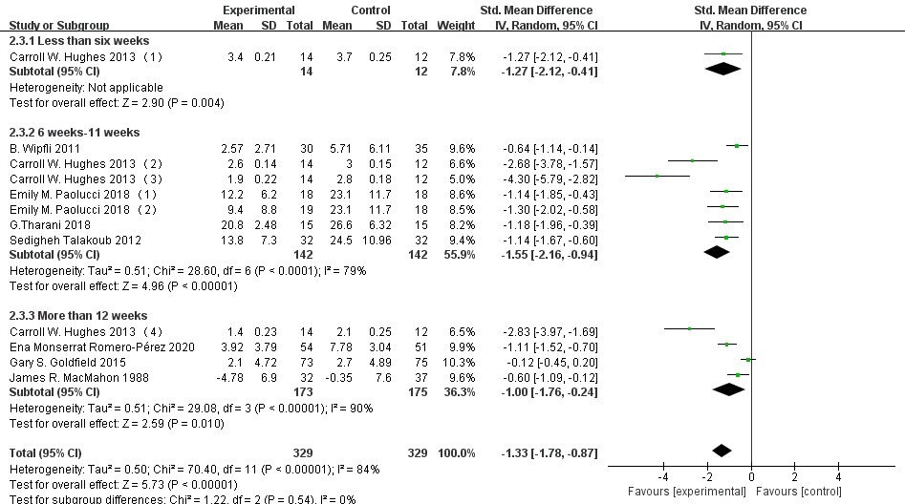Figure 8
Results of syntheses | 20a | Describe in Literature Quality Assessment
Results of syntheses | 20b | Describe in Basic Features of Included Studies
Results of syntheses | 20c | Describe in Effect Size Test
Results of syntheses | 20d | Describe in Sensitivity Analysis
Reporting biases | 21 | Describe in Bias Assessment
Certainty of evidence | 22 | Describe in Effect Size Test
DISCUSSION
Discussion | 23a | Describe in Discussion
Discussion | 23b | Describe in Limitations
Discussion | 23c | Describe in Limitations
Discussion | 23d | Describe in Discussion
OTHER INFORMATION
Registration and protocol | 24a | No yet apply
Registration and protocol | 24b | No
Registration and protocol | 24c | Differences from protocol: We modified the higher limit for age in our eligibility criteria from 24 years of age to 35 years of age because the age of young was increased
Support | 25 | National Social Science Foundation [grant number 22XTY013].
Competing interests | 26 | No
Availability of data, code and other materials | 27 | No

From: Page MJ, McKenzie JE, Bossuyt PM, Boutron I, Hoffmann TC, Mulrow CD, et al. The PRISMA 2020 statement: an updated guideline for reporting systematic reviews. BMJ 2021;372:n71. doi: 10.1136/bmj.n71
For more information, visit: http://www.prisma-statement.org/

