Table S1 Study quality-QUADAS-2
Study | Risk of Bias |  |  |  | Applicability of Concern
Study | Patients  Selection | Index  Test | References  Standard | Flow and  Timing | Patients  Selection | Index  Test | References  Standard
Subah et al 2021 | UR | LR | LR | UR | UR | LR | LR
Alsaade et al 2022 | UR | LR | LR | UR | UR | LR | LR
Ahammed et al 2021 | UR | LR | LR | UR | UR | LR | LR
Lu et al 2021 | UR | LR | LR | UR | UR | LR | LR
Zhang et al 2022 | LR | LR | LR | UR | UR | LR | LR
Wang et al 2021 | UR | LR | LR | UR | UR | LR | LR
Nogay et al 2023 | UR | LR | LR | UR | UR | LR | LR
Alam et al 2022 | UR | LR | LR | UR | UR | LR | LR
Saranya et al 2022 | UR | LR | LR | UR | UR | LR | LR
Ahmed et al 2022 | UR | LR | LR | UR | UR | LR | LR
Hasan et al 2017 | HR | LR | LR | UR | LR | LR | LR
LR, low risk; HR, high risk; UR, unclear risk.

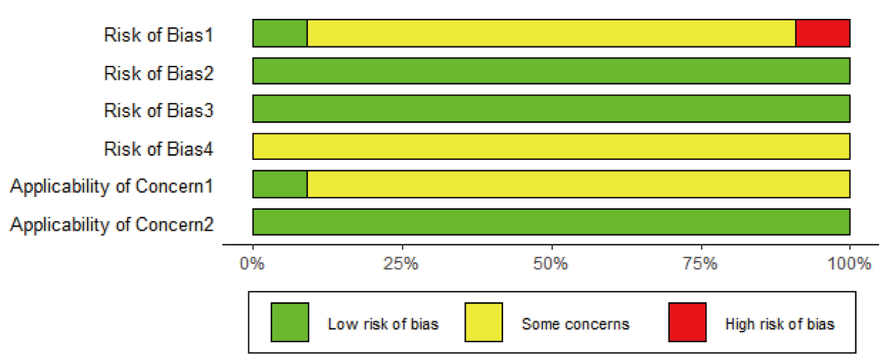Figure S1. Quality assessment of the included studies

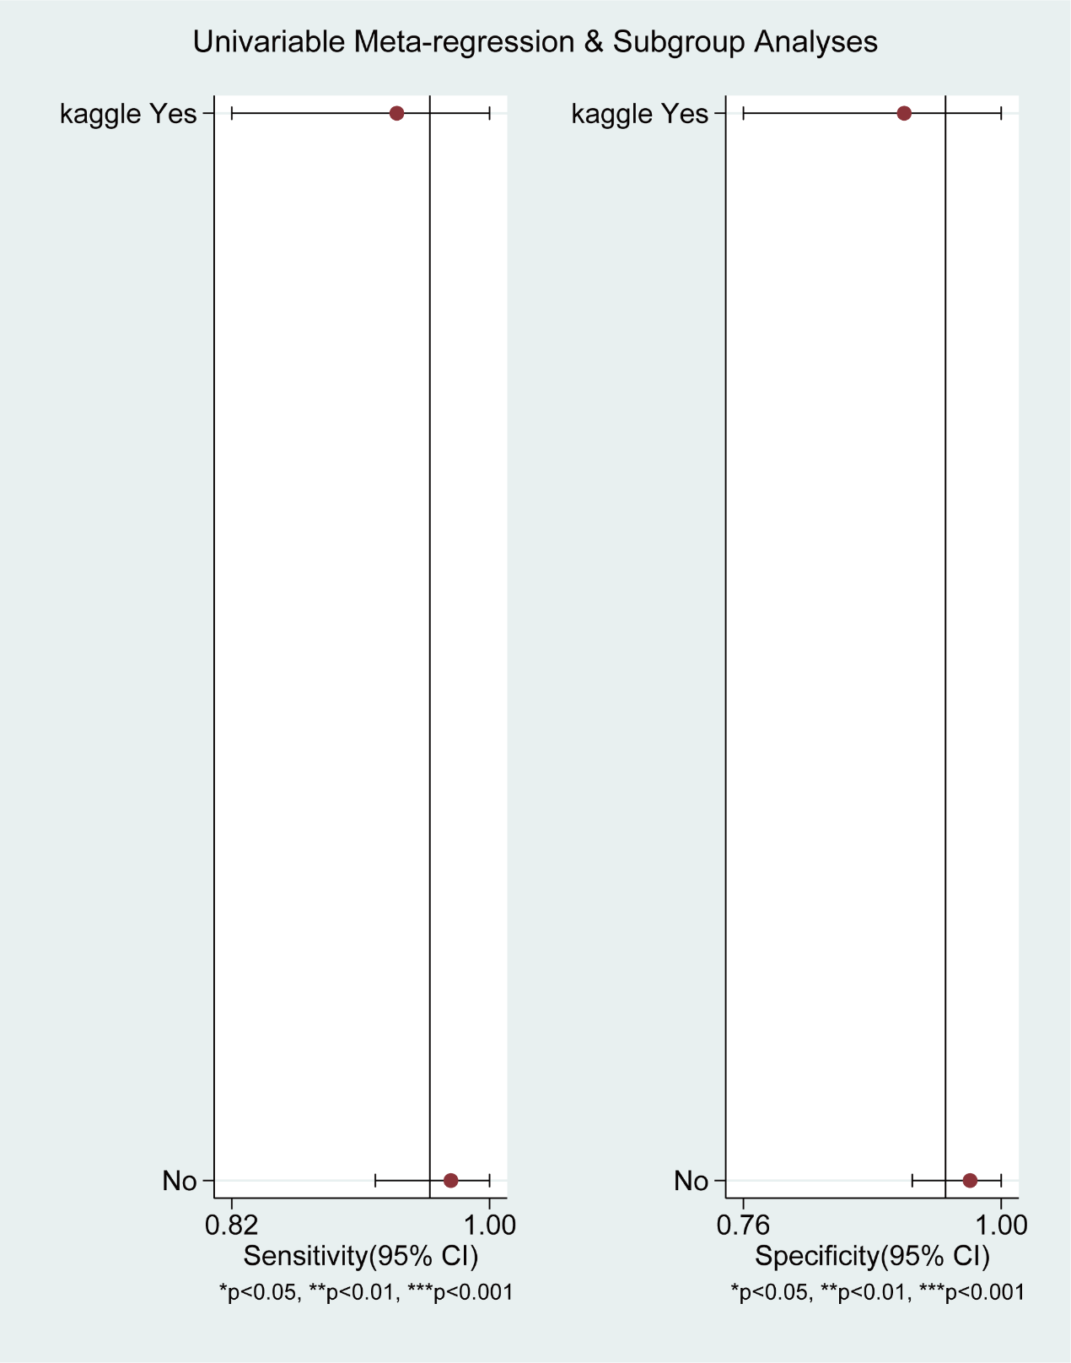
Figure S2. Forest plot of pooled sensitivity and specificity of dataset subgroup analysis.
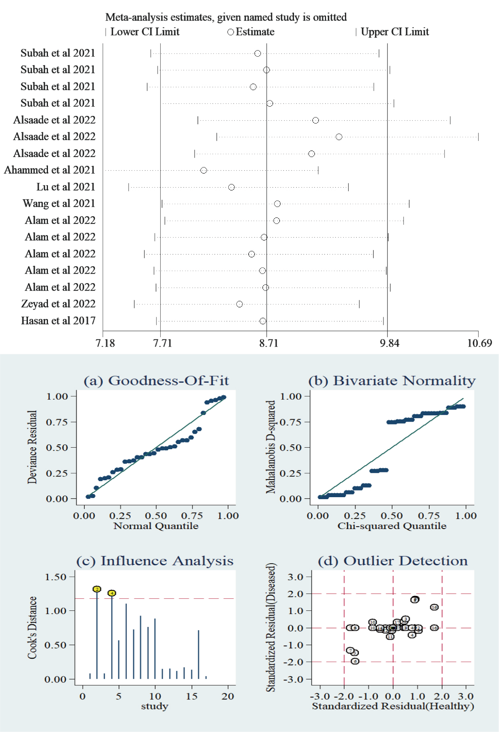
Figure S3. Sensitivity analysis of deep learning for detecting autism spectrum disorder.

