Effects of 6-week olanzapine treatment on serum IL-2, IL-4, IL-8, IL-10, and TNF-α levels in medication-naive individuals with first-episode schizophrenia Research Supplement

STable 1 Serum IL-2, IL-4, IL-8, IL-10, and TNF-α levels in patients with schizophrenia and healthy controls
Cytokine | Patient group  (n=142) | Healthy control  (n=100) | P Value
IL-2 | 1.99 (1.54, 4.28) | 1.95 (1.66, 2.28) | 0.381
IL-4 | 0.38 (0.23, 0.48) | 0.37 (0.23, 0.38) | 0.487
IL-8 | 2.19 (0.91, 34.94) | 197.5 (37.18, 548.5) | ＜0.001
IL-10 | 1.47 (0.58, 4.96) | 1.01 (0.55, 1.73) | 0.001
TNF-α | 10.72 (4.87, 33.24) | 10 (7.71, 12.3) | 0.418
Note: IL, Interleukin; TNF, tumor necrosis factor. Data expressed as median (25th and 75th quantiles).

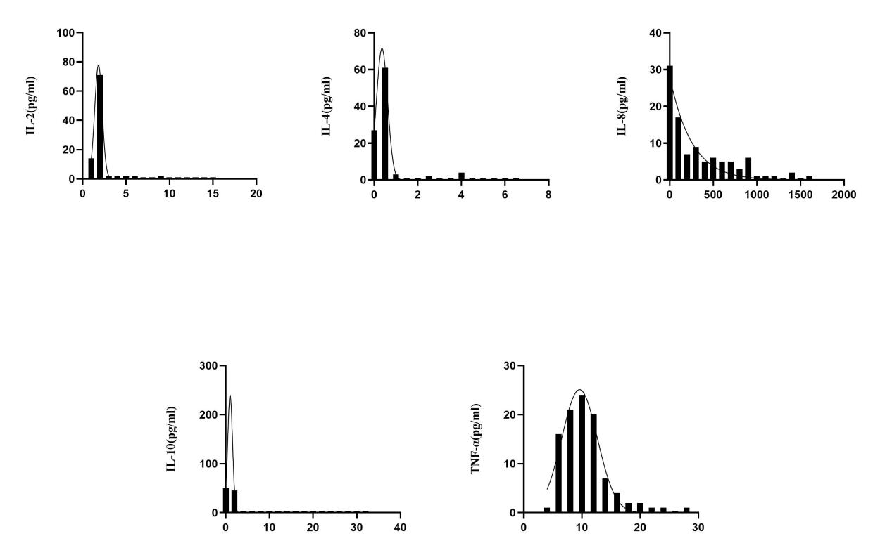
SFigure 1 Normal distribution of IL-2, IL-4, IL-8, IL-10 and TNF-α in healthy controls

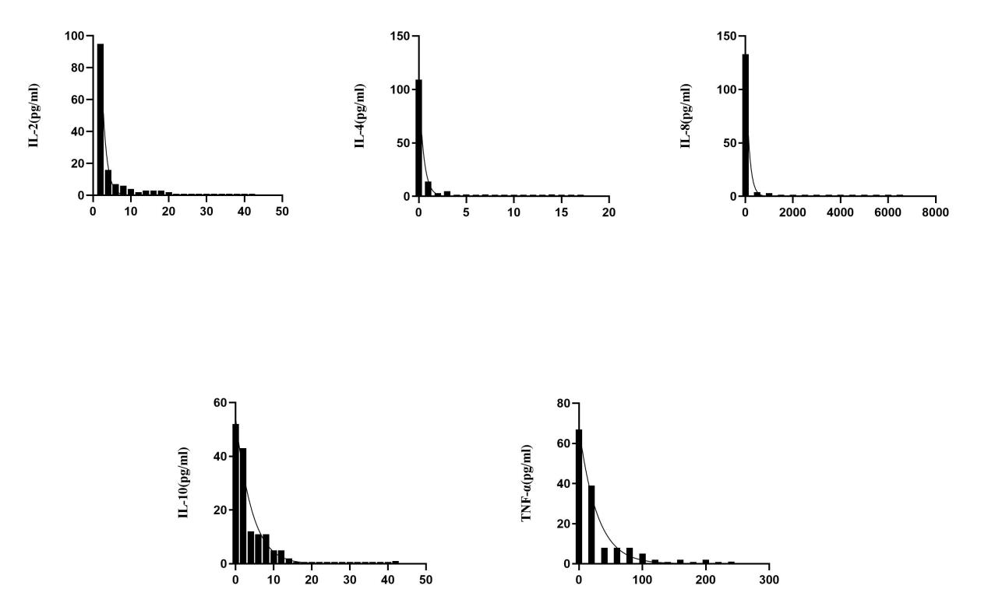
SFigure2 Normal distribution of IL-2, IL-4, IL-8, IL-10 and TNF-α in schizophrenic patients

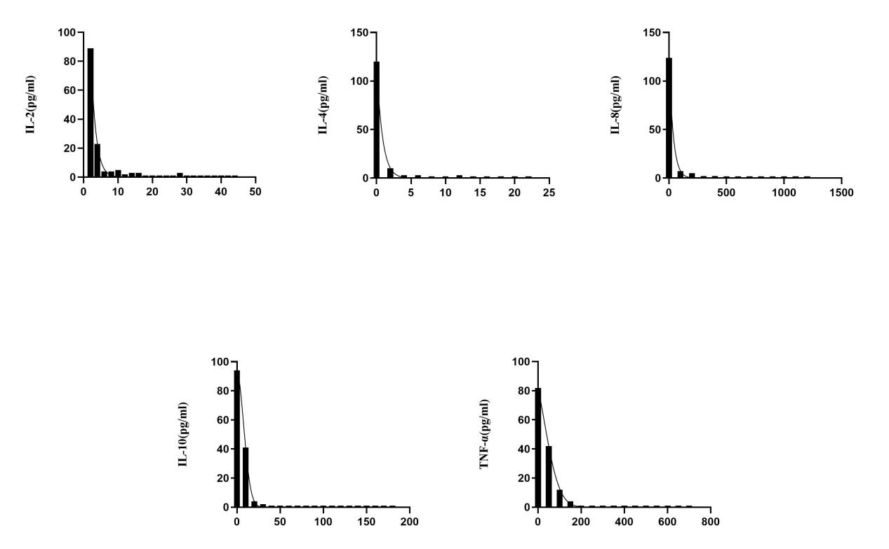
SFigure3 Normal distribution of IL-2, IL-4, IL-8, IL-10 and TNF-α in schizophrenic patients after 6 weeks of treatment

