Supplementary Table 1: Linear Regression Analysis of Depression Among Respondents: Associations with Demographic Variables
Dependent variable: Physical health questionnaire and general anxiety disorder
 |  | Depression |  | Anxiety
 | Variables | AOR (95% CI) | P-Value | AOR (95% CI) | P-Value
 | Age
 | 15-24 Years | 1
 | 25-34 Years | 0.681(0.241-1.121) | 0.002 | 0.452 (0.890- 0.013) | 0.043
 | 35-49 Years | 0.670(0.213-1.127) | 0.004 | 0.514 (0.969- 0.058) | 0.027
 | Marital status
 | Never Married | -0.212(-0.523--0.381) | 0.089
 | Married
 | Widowed/Divorced/Separated | 1.114(0.981- 1.971) | <0.001
 | Place of Residence
 | Urban | 1 |  | 1
 | Rural | -0.126(-0.435-0.181) | 0.420 | -0.129 (-0.436- 0.178) | 0.409
 | Respondent can refuse sex
 | No | 1 |  | 1
 | Yes | 0.346(-0.198- 0.890) | 0.213 | 0.281 (-0.261- 0.823) | 0.310
 | Total lifetime number of sex partner
 | Single | 1 |  | 1
 | Multiple | 0.394(-0.277-1.066) | 0.249 | 0.456 (-0.212- 1.125) | 0.181
 | Ever had a terminated pregnancy
 | No | 1 |  | 1
 | Yes | 0.288(-0.046-0.623) | 0.091 | 0.504 (0.170- 0.837) | 0.003
 | Household wealth status
 | Poor | 0.365(-0.003- 0.734) | 0.052 | 0.469(0.101- 0.837) | 0.012
 | Middle | 0.269(-0.179- 0.718) | 0.240 | 0.401 (-0.046- 0.848) | 0.079
 | Rich | 1 |  | 1
 | Self-reported health status
 | Bad | 2.199(1.739- 2.659) | <0.001 | 2.353 (1.895- 2.812) | <0.001
 | Good | 1
 | Had genital discharge in last 12 months
 | No | 1 |  | 1
 | Yes | 0 .703(0.342- 1.063) | <0.001 | 0.687 (0.328- 1.047) | <0.001
 | Experienced and emotional violence
 | No | 1 |  | 1
 | Yes | 3.201(2.784- 3.617) | <0.001 | 2.770 (2.355- 3.185) | <0.001
 | Smoke cigarettes
 | No | 1 |  | 1
 | Yes | 0.896(0.297-1.496) | 0.003 | 0.883 (0.286- 1.481) | 0.004
 | Frequency of husband/partner being drunk
 | Never | 1 |  | 1
 | yes | 0.414(0.088-0.741) | 0.013 | 0.451 (0.126- 0.776) | 0.007
 | Visited health facility in last 12 months
 | No | 1 |  | 1
 | Yes | 0.253(-.097-0.604) | 0.158 | 0.194 (-0.155- 0.544) | 0.275
 | Had genital sore/ulcer in last 12 months
 | No | 1 |  | 1
 | Yes | 1.046(0.365-1.727) | 0.003 | 0.603(-0.074- 1.281) | 0.081

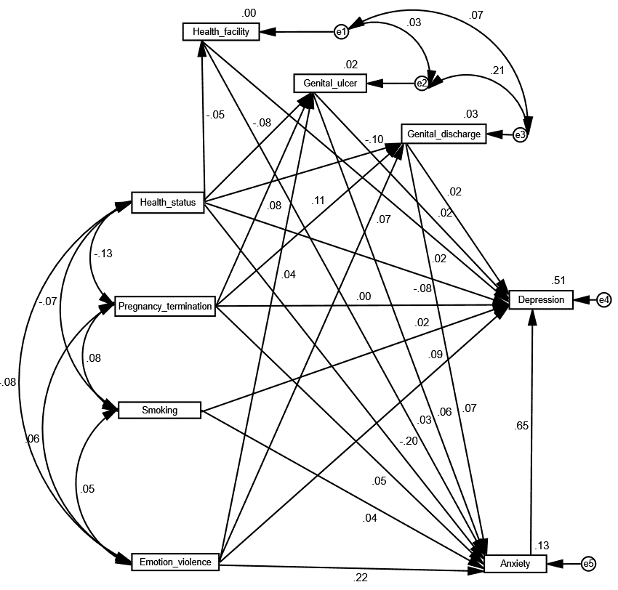
Supplementary figure 1: Amos output picture of SEM model

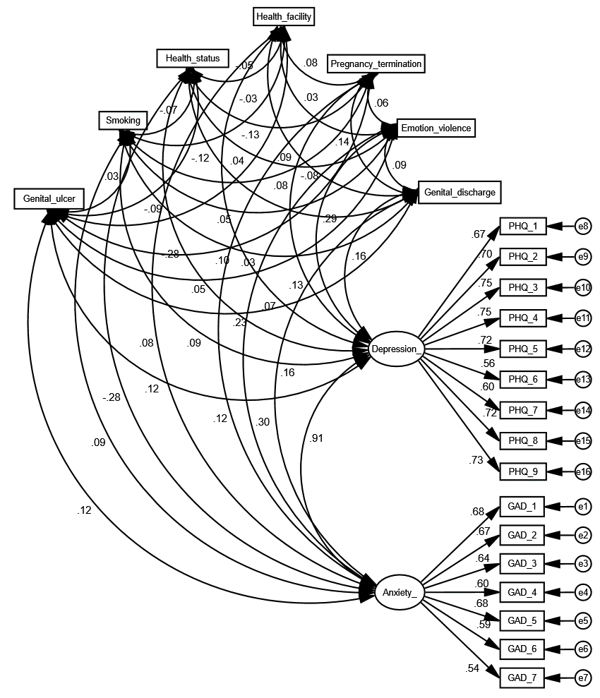
Supplementary figure 2: Confirmatory factor analysis
Note:
-Health_status= Self rated health status; Genital_Discharge= Had genital discharge in last 12 months; Genital_ulcer= Had a genital ulcer in last 12 months; Emotion_violence= Ever faced emotional violence; Health_facility= Had visited health facility in last 12 months; Anxiety= Combined score of GAD scale (1-7) and Depression= Combined score of PGQ scale (1-9).
-All the double headed arrow indicates covariance along with its value

Supplementary Table 2: Model-fit indexes for the confirmatory factor analysis
Fit Index | Recommended value | Obtained value
CMIN/df | 3-5 | 9.797
CFI | >0.90 | 0.937
GFI | >0.90 | 0.921
TLI | >0.90 | 0.917
RMSEA | <0.08 | 0.037
PCLOSE | <0.03 | 0.002

Supplementary Table 3: Composite reliability and average variance test results
Variables | Factor loading | Composite reliability | AVE
General Depression
PHQ_1 | .659 | 0.916 | 0.632
PHQ_2 | .691 | 0.916 | 0.632
PHQ_3 | .737 | 0.916 | 0.632
PHQ_4 | .736 | 0.916 | 0.632
PHQ_5 | .715 | 0.916 | 0.632
PHQ_6 | .545 | 0.916 | 0.632
PHQ_7 | .590 | 0.916 | 0.632
PHQ_8 | .714 | 0.916 | 0.632
PHQ_9 | .723 | 0.916 | 0.632
General Anxiety Disorder
GAD_1 | .678 | 0.877 | 0.589
GAD_2 | .665 | 0.877 | 0.589
GAD_3 | .638 | 0.877 | 0.589
GAD_4 | .597 | 0.877 | 0.589
GAD_5 | .684 | 0.877 | 0.589
GAD_6 | .592 | 0.877 | 0.589
GAD_7 | .532 | 0.877 | 0.589

